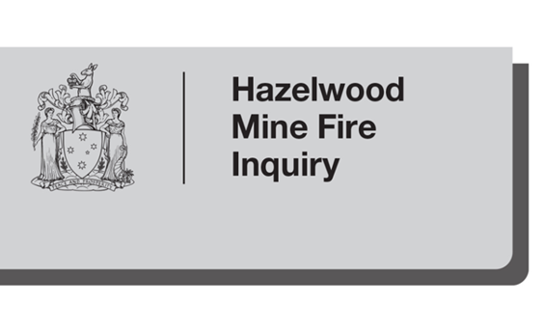

**Morwell Community Consultation – Kernot Hall, 6.00pm, 10 April 2014**

**Summary of discussion**

**Background**

The Hazelwood Mine Fire Inquiry held its second community consultation at Kernot Hall in Morwell at 6.00pm on Thursday, 10 April 2014. The community consultation was attended by 29 people. The following summary reports key themes and issues that were raised by community members during the consultation discussions. This summary reports on what was stated and does not attribute views to any or all community members.

**What worked well**

* The firefighters, CFA volunteers, and the on the ground firefighting response
* Emergency services, their response and door-knocking
* ABC radio updates
* Internet radio, which provided the best/most reliable reception
* CFA and VicRoads websites
* Social media communications, particularly Facebook and SMS contact (emergency text from the CFA)
* Updates from the Incident Controller
* Free taxis and buses for evacuation
* Community banding together
* Meals on wheels for the volunteers

**What didn’t work well**

* Fire breaks were not managed well in the lead up to the fire
* Use of firefighting crews from outside the local area meant that local expertise and experience in fighting a coal mine fire was not sought or used
* More could have been done to better manage the risk and response to fire prevention inside and adjoining the mine by the mine owner, especially in relation to the dis-used parts of the mine
* Lack of duty of care by the mine owner, particularly regarding rehabilitation of the mine and removal of the fire sprinklers
* Firefighters were not trained to effectively fight a coal mine fire, nor adequately equipped with the appropriate breathing apparatus in a timely manner
* The use of water-bombing to fight the coal fire increased the amount of ash and smoke in the air – water spraying is the most effective way to fight a coal fire
* It took too long to get the fire under control in the most critical period
* The operational process of CFA/Command and how this intersects with the mine operators and local CFA volunteers
* Fire information and notification came too late for local residents
* Confusion caused by lack of communications co-ordination, and mixed messages from all levels of government and on all aspects of the fire
* Information from all government authorities, including the EPA and the Department of Health, was not provided quickly enough and was contradictory or misleading
* Local, state and federal government agencies were too slow in responding to community needs
* Lack of information, response and assistance from the mine owner
* Confused information on road closures and lack of directions when visibility was poor due to smoke, hindered evacuations
* The evacuation notice came too late and did not give any direction to businesses
* Concern about the stability of the highway/road due to current fire activities and past work done on the mine site, where previous piping and drilling has occurred
* Concerns about air and water quality, and the monitoring of both – the EPA didn’t start monitoring until two weeks after the fire started
* Concerns about long term health impacts for residents as well as firefighters (extended exposure to smoke/ash, firefighters using contaminated water, inadequate breathing apparatus provided to residents)
* Dust masks that were issued were inadequate and out of date
* Insufficient information about pets and livestock
* Accurate information wasn’t readily available to all – inconsistent advice was given to residents/businesses about respite, schools were left to make their own decisions about relocation, some residents found out about the public meetings after they had been held
* Poor clean up assistance - buckets are inadequate and the use of pressure hoses inappropriate in the presence of asbestos
* Local community being divided by selective treatment and support of some, mostly notably in relation to financial support and relocation assistance
* The lack of assistance regarding devaluation of property and assets (residential property has been valued at 30% less than pre-fire value)
* Additional financial strain placed on people who are out of pocket, some significantly, due to paying for clean-up, forced time off work, relocation, medical bills, etc
* Issues regarding insurances that won’t cover clean up costs (ceilings/vents/fans)
* Lack of an emergency plan for the town of Morwell
* Stigma – Morwell is now referred to as Smoketown

**What should be done differently**

* Establish a well-run, well-managed and properly resourced fire-fighting capacity at the mine
* Ensure the firefighting agencies have appropriate fire-fighting capability specific to a coal mine fire
* Improve government regulation to ensure the mine owner undertakes full remediation at the mine, covers the exposed batters, improves management of the dis-used parts of the mine, and meets its obligations to regenerate
* Regulate the regulators who regulate the mine
* Improve coordination between government agencies so there is clarity on where help can be sought, what help is available and who is responsible for providing information and assistance
* Categorise the event as a disaster so more assistance is available
* Increase the buffer zones adjacent to the mine
* Improve maintenance of vegetation on approaches to the mine
* Establish an emergency plan that provides equal treatment for all
* Improve evacuation advice, communications, options and assistance for both people and animals
* Locate the recovery centre outside the affected area
* Establish a register of all those exposed to the smoke as part of a long term health register, implement a mandatory health questionnaire for all Latrobe Valley residents to be used for a health review, and monitor the health of Latrobe Valley residents on a long term basis
* Establish a more thorough clean up process, mindful of the risks of disturbing asbestos
* Fairer distribution of funds and assistance, not just limited to Health Care Card holders
* Financial and other contributions from the mine owner, such as a buy-back scheme, so people can leave the Valley
* Increase the rehabilitation bond ($15 million is not sufficient)