**Hazelwood Mine Fire Inquiry Sub mission Cover Sheet**

### l8J Post or email your submission with this cover sheet to:

Hazelwood Mine Fire Inquiry PO Box 24

Flinders Lane Vic 8009 **Email @>** [info@hazelwoodinquiry.vic](mailto:info@hazelwoodinquiry.vic) .gov.au

|  |  |  |  |
| --- | --- | --- | --- |
| Tit le Mr | First Name  Jeff | Surname Lynn | |
| Organisation represented  AGL Loy Yang Pty Ltd | | | |
| Email address | | | |
| Postal address Ashurst Australia  Level 26, 181 William St  MELBOURNE VIC 3000 | | | |
| Telephone Mobile | | |  |

Content of submission (you can choose multiple)



**0** Anglesea Mine: Terms of Reference 11

0 Health: Terms of Reference 6 and 7

***if*** Mine Rehabilitation : Terms of Reference 8, 9 and 10

**0** Other (please state here)

#### Confidentiality

The Inquiry will consider all requests for confidentiality. Should you wish for your submission or parts of your submission, to be treated as confidential, please clarify and state the reason in the space provided below. If you require more room, please attached a separate page and provide together with your submission.

Should the Inquiry consider the request for confidentiality not to be appropriate you will be provided with an opportunity to withdra w your submission or re-submit in a form suitable for publication.

#### Please select one of the following options

**Hazelwood Mine Fire Inquiry Submission Cover Sheet**

**O** I acknowledge that my submission will be treated as a public document and may be published,

quoted or summarised by the Inquiry.

Or

request that my submission or parts of my submission, be treated as confidential, and not published quoted or summarised by the Inquiry, for reasons stated below.

The information on page 95 of the Submission of AGL Loy Yang Pty Ltd on the Mine Rehabilitation Terms of Reference, should be treated as confidential, and not published quoted or summarised by the Inquiry, given that the nature and subject matter of the information is commercially sensitive .

**Acknowledgements**

**I understand that:**

* I can be contacted by the Inquiry in relation to my submission .
* Anonymous submissions will not be accepted .
* The name or town or suburb of each submitter will be identified as part of every published submission. Other contact details will be removed before publishing.
* The Inquiry will not publish submissions, if it believes that the submission material is or could be defamatory, offensive, contravenes anti-discrimination or anti-vilification legislation or is outside the scope of the Inquiry's terms of reference

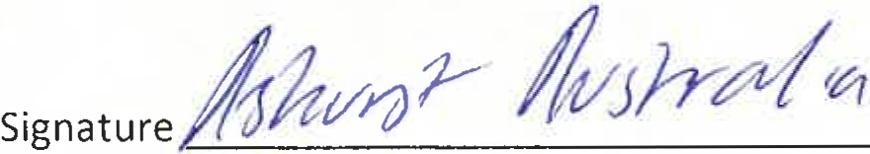 

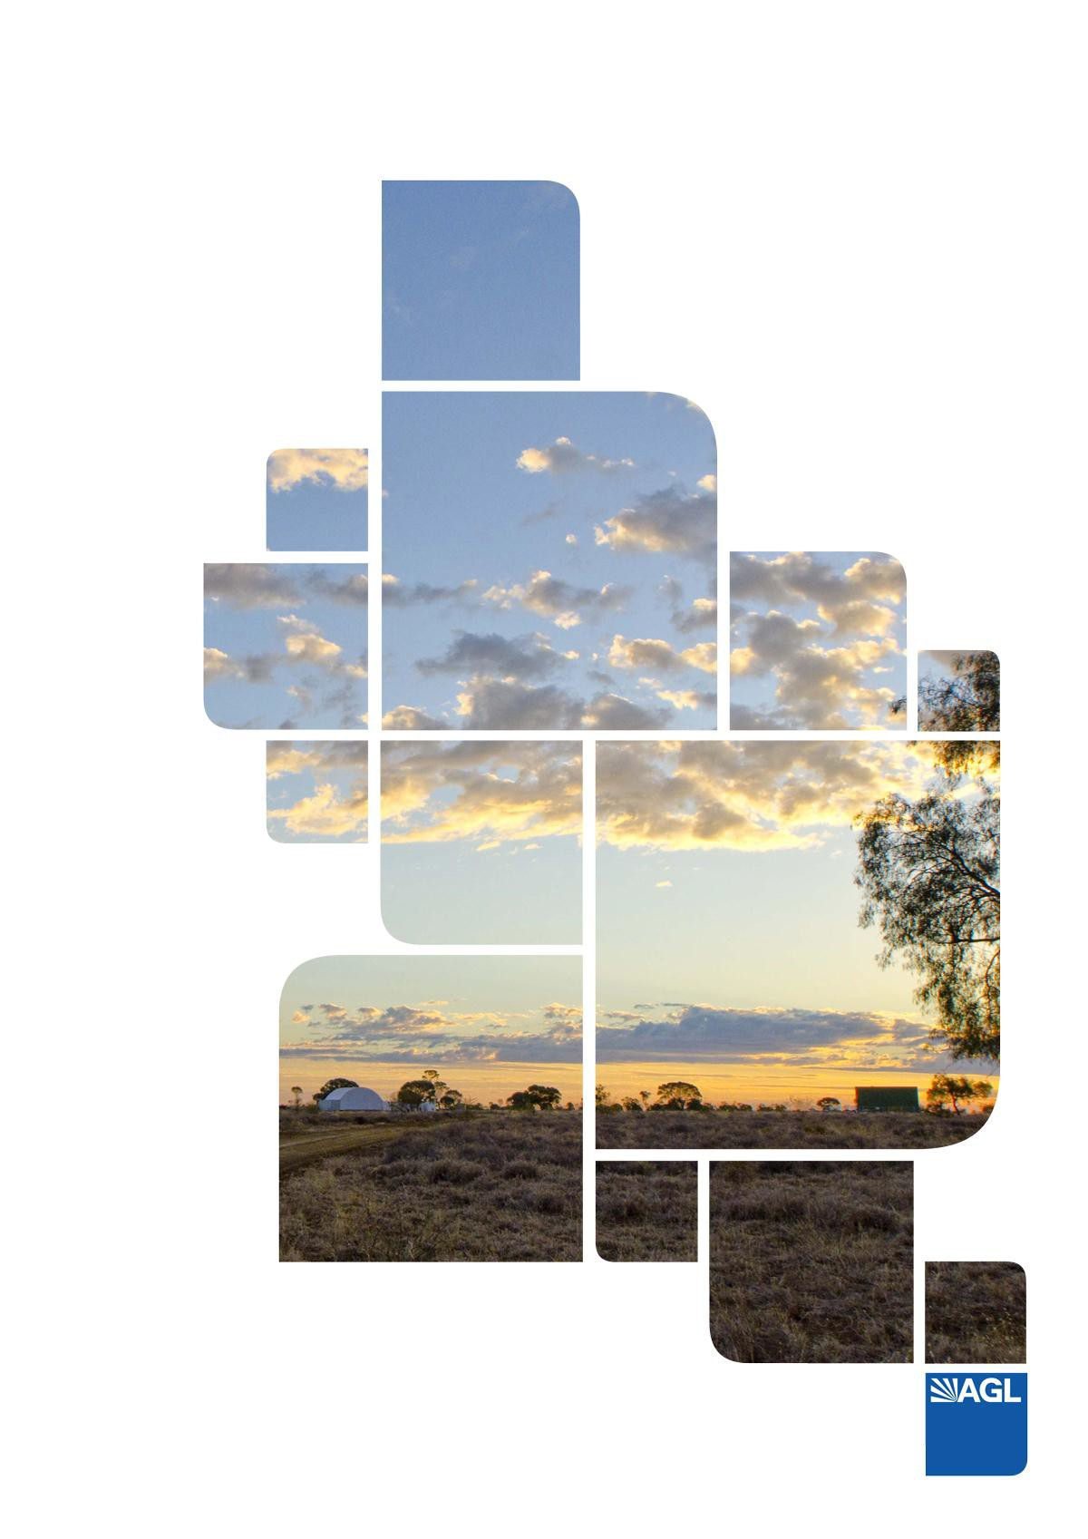

The Hazelwood Coal Mine Fire Inquiry - Submission of AGL Loy Yang Pty Ltd

Mine Rehabilitation Terms of Reference Date: 24 August 2015

# Table of Contents

Submission background 7

#### About AGL 10

#### What We Stand For 10

#### Sustainability 10

#### AGL Loy Yang 10

#### AGL Loy Yang Operations 11

#### AGL Policies 12

AGL Greenhouse Gas Policy 12

Climate Change Science 12

Emission Reductions 12

AGL Commitment 12

Corporate governance & AGL’s approach 13

The AGL Loy Yang Mine 14

#### History and future 14

#### Mining operations 17

Mining sequence 17

#### Site infrastructure 19

Ash system and saline waste disposal 19

Fencing and security 20

Parking 20

Roads 20

#### Water Infrastructure 21

#### Fire service systems 21

Surface drainage 22

Drainage - dewatering and wash down systems 23

Overburden runoff system 23

Aquifer depressurisation (Artesian) collection system 23

Power distribution 24

Cultural Heritage sites 24

New Opportunities for Brown Coal 24

#### The Coal Resource 25

Geological setting 25

AGL LY Mine Coal Resource 26

Loy Yang Mine hydrogeology 27

AGL LY Mine Geotechnical conditions 28

Overburden 28

Coal Reactivity and Fire Risk 29

Interseam 29

Regulatory Regime 30

Mineral Resources (Sustainable Development) Act 30

AGL Loy Yang Tenements 30

Mining Licence MIN5189 31

Work Plan 32

Rehabilitation bond 33

Risk Assessments 33

Loy Yang contractual arrangements 34

Previous Mine Fires and Responses 36

Overview 36

Fire Risk Management 36

Experience with recent significant fire events in the region 38

Fire Risk and Management Plan 45

Fire Mitigation 46

AGL Loy Yang Emergency Management Plan 49

Emergency Management Network 50

Geotechnical Events in the Latrobe Valley 51

Latrobe Planning Scheme 53

Preamble 56

Mine Rehabilitation 57

Introduction 57

Rehabilitation/Mine Design Process 57

Rehabilitation Considerations 58

Mine rehabilitation 60

Historic mine rehabilitation 60

Future mine rehabilitation 61

Mine rehabilitation Principles 62

Geotechnical and hydrogeological challenges 64

Geological and Geotechnical 64

Hydrogeology 64

Surface water and flooding 65

Impacts on rehabilitation 65

Operational constraints on rehabilitation 67

Overview of rehabilitation plans 68

Mine Development Strategy and Stages 68

Mining Stage B - Rehabilitation up to present (2015) 68

Mining Stage C - Rehabilitation during the operating life of the mine 69

Mining Stage D - Rehabilitation during the operating life of the mine 71

Mining Stage E- to E, Rehabilitation during the operating life of the mine (end of mining) .. 72 Mining Stage - Rehabilitation Stage Plan at Mine Closure 73

Analysis of Mine Rehabilitation Options 74

Rehabilitation (land use) options 75

Rehabilitation option 1 – return to pasture/grazing 76

Rehabilitation option 2 – Return to Native Vegetation 79

Rehabilitation option 3 – Partial Industrial use 82

Rehabilitation option 4 – Landfill 86

Rehabilitation Liability Assessments and Bonds 89

Rehabilitation liability assessment (2015) 89

Overview 89

Rehabilitation Bond and Liability 89

Preliminary Rehabilitation Concept and Cost Model 90

Bond system effectiveness 96

Rehabilitation Bond Conclusion 96

Conclusions 98

Figures 100

Figures

Figure 1 Regional Plan 100

Figure 2 Site Plan – AGL Infrastructure 101

Figure 3 Site Plan – Electrical Infrastructure 102

Figure 4 Development Stage B 103

Figure 5 Development Stage C 104

Figure 6 Development Stage D 105

Figure 7 Development Stage E- 106

Figure 8 Development Stage E 107

Figure 9 Development Stage Final (Mine Closure) 108

Figure 10 Site Plan – Geological Information 109

Figure 11 Site Plan – Geological Information 110

Figure 12a Site Plan – AGL Loy Yang Grid Map 111

Figure 12b Site Plan –AGL Loy Yang Grid Plan ………………………………… 112

# Tables

Table 1 Relevant legislation - Mining 15

Table 2 Relevant Regulatory Legislation - Fire 15

Table 3 AGL Loy Yang – Owners and Operating Entities 16

Table 4 Staged Mine Development 18

Table 5 Surface Water Drainage System Classification 22

Table 6 Coal resources and Reserves 27

Table 7 Groundwater Licence 2007440 – Extraction Volumes 28

Table 8 AGL Loy Yang Licence Details 31

Table 9 Approved Variations to Work Plan 1997 32

Table 10 AGL Loy Yang Contractual Arrangements 34

Table 11 Fire/Smoulder Events 37

Table 12 Hazelwood Mine Fire 39

Table 13 Hazelwood Mine Fire Inquiry – 2014 Recommendations and Affirmations 39

Table 14 – Delburn Fire 43

Table 15 – Black Saturday 44

Table 16 – L100 head End Fire 45

Table 17 Key commitments in the Fire Risk and Management Plan 45

Table 18 Latrobe Road Cracking, 2014 51

Table 19 Princes Freeway cracking, 2011 51

Table 20 Morwell River Diversion in the Yallourn mine, 2012 52

Table 21 Yallourn batter failure, 2007 52

Table 22 AGL LY Mine, Southern Batter block movement, 2007 53

Table 23 AGL LY Mine Rehabilitation Design Process 58

Table 24 - Rehabilitation – issues and impacts 59

Table 25 Progressive Rehabilitation – to Mining Stage B (2015) 69

Table 26 Progressive Rehabilitation – to Mining Stage C 70

Table 27 Progressive Rehabilitation – to Mining Stage D 71

Table 28 Progressive Rehabilitation – to Mining Stage E- (end of mining) 73

Table 29 Assessment Criteria - Return to Pasture 76

Table 30 Assessment Criteria – return to native vegetation 79

Table 31 Assessment Criteria – partial industrial use 82

Table 32 Assessment Criteria – landfill 86

# Submission background

AGL Energy Ltd (**AGL**) is the parent company of AGL Loy Yang Pty Ltd (**AGL Loy Yang**) owns and operates the Loy Yang coal mine (**AGL LY Mine**) and Loy Yang A power station (**AGL LYA**) at Traralgon, Victoria.

This submission is made to the Board of Inquiry (**Board**) in respect of paragraph 8, 9 and 10 of the terms of reference (**ToR**) for the Hazelwood Mine Fire Inquiry (**HMFI**):

* 1. Short, medium and long term options to rehabilitate:
     1. land on which work has been, is being or may lawfully be done in accordance with a Work Plan approved for the Hazelwood Mine, the Yallourn Mine, and the Loy Yang Mine; and
     2. land in relation to which an application for variation of the Work Plan is under consideration for the Hazelwood Mine, the Yallourn Mine, or the Loy Yang Mine;
  2. For each rehabilitation option identified under paragraph 8:
     1. whether, and to what extent, the option would decrease the risk of a fire that could impact the mine and if so, the cost of the option relative to the cost of other fire prevention measures;
     2. whether, and to what extent, the option would affect the stability of the mine;
     3. whether, and to what extent, the option would create a stable landform and minimise long term environmental degradation;
     4. whether, and to what extent, the option would ensure that progressive rehabilitation is carried out as required under the *Mineral Resources (Sustainable Development) Act 1990*;
     5. the estimated timeframe for implementing the option;
     6. the option’s viability, any associated limitations and its estimated cost;
     7. the impact of the option on any current rehabilitation plans for each mine;
     8. whether, and to what extent, the option would impact the future beneficial use of land areas impacted by the mines; and
     9. whether the option is otherwise sustainable, practicable and effective;
  3. Having regard to the rehabilitation liability assessments that have been or will be reported in 2015 by the operators of each of the Hazelwood Mine, the Yallourn Mine, and the Loy Yang Mine, as required by the *Mineral Resources (Sustainable Development) Act 1990*, and to the outcome of the Rehabilitation Bond Review Project:
     1. whether the rehabilitation liability assessments referred to above are adequate;
     2. whether the current rehabilitation bond system, being one of the measures to provide for progressive rehabilitation by end of mine life as required under the *Mineral Resources (Sustainable Development) Act 1990*, is, or is likely to be, effective for the Hazelwood Mine, the Yallourn Mine, and the Loy Yang Mine; and
     3. any practical, sustainable, efficient and effective alternative mechanisms to ensure rehabilitation of the mines as required by the *Mineral Resources (Sustainable Development) Act 1990*;

This submission is divided into two parts.

**Part A** (Background) – this section provides background information about AGL, the AGL LY Mine; the regulatory environment within which AGL Loy Yang operates the AGL LY Mine; previous mine fires and AGL Loy Yang management responses; AGL Loy Yang’s current practices to manage fire risk and past practices with respect to rehabilitation of the AGL LY Mine. This information is only relevant to the Board to the extent this background information provides a context to understand AGL's submission in respect of paragraph 8, 9 and 10 of the ToR which is set out in Part B

**Part B** (AGL's submissions in respect of ToR 8, 9, 10) – this section directly responds to these ToR.

# PART A - BACKGROUND

This section provides a summary of AGL Loy Yang operations and is provided as background information to this submission to the Hazelwood Mine Fire Inquiry. Further details may be found in the AGL Loy Yang Work Plan Variation submitted in 2015 (**WPV 2015**) and the suite of controlled documents in the AGL Loy Yang Document Information System (FIDO).

## About AGL

1. AGL Energy Ltd (**AGL**) is one of Australia’s leading integrated energy companies. It is taking action to responsibly reduce its greenhouse gas emissions while providing secure and affordable energy to its customers.
2. Drawing on over 175 years of experience, AGL serves its customers throughout eastern Australia with meeting their energy requirements, including gas, electricity, solar PV and related products and services.
3. AGL has a diverse power generation portfolio including base, peaking and intermediate generation plants, spread across traditional thermal generation as well as renewable sources including hydro, wind, solar, landfill gas and biomass.
4. AGL maintains a BBB (stable) investment grade credit rating from Standard & Poor's.

## What We Stand For

1. AGL’s number one priority is the safety of our employees and the local community. All AGL operations across Australia operate within this overarching principle.
2. At AGL we are very aware of our responsibility to the community and the environment as well as our customers and shareholders. “Actions, not words” sums up the way AGL does business with all its stakeholders.
3. This commitment springs from a set of wider values that work as an ethical compass guiding our people in their behaviour and decision-making processes.
4. AGL formal values system is critical to the way in which the company operates as a business. The values guide AGL in delivering strategies and ensure that we perform and deliver for our communities and stakeholders in a challenging environment. "Safe and Sustainable" is AGL’s overarching value, and incorporates not only the safety of our employees but a strong commitment to the protection of our environment and the communities in which we operate.

## Sustainability

1. At AGL, sustainability means thinking about the responsibilities we have to all our stakeholders – our employees, our customers, our investors, the community and the environment. In addition to our economic performance, AGL recognises that our future success and reputational standing is also shaped and measured by the social and environmental consequences, which our decisions and actions have for all our stakeholders.

## AGL Loy Yang

1. Great Energy Alliance Corporation (**GEAC**) consortium completed the acquisition of Victoria's Loy Yang Project in April 2004. The acquisition was led by AGL in partnership with the Tokyo Electric Power Company, and a group of investors facilitated by the Commonwealth Bank.
2. In May 2012 AGL increased its ownership stake in GEAC from 32.54% to 100%, making AGL Loy Yang a key asset in AGL’s electricity generation portfolio.
3. AGL Loy Yang:

› Has been a significant business and contributor to the Latrobe Valley for the past 35 years.

› The uninterrupted supply of base load electricity is essential to Victoria with AGL LY Mine currently supplying 50% of Victoria’s power needs making the AGL LY Mine critical infrastructure for Victoria and the National Energy Market (**NEM**).

› The AGL LY Mine undertakes regular and timely progressive rehabilitation, as areas become available. To date, some 530 ha of disturbed land has been progressively rehabilitated.

› AGL Loy Yang directly employs 722 full time equivalent people on the site; 365 of these are based in the AGL LY Mine. In addition AGL Loy Yang has some 400 on- site contractors.

› AGL Loy Yang significantly contributes to the local and state community. Each year AGL Loy Yang injects more than $300 million into the economy via wages and payments to contractors and suppliers.

› AGL makes annual donations to the community in excess of $100,000 through its community support program. This includes an annual partnership with The Smith Family for the Kurnai Education Hub pilot project which is aimed at improving the retention of students to Year 12 at Kurnai College. The partnership includes initiatives such as work experience, career days, site tours and volunteering. AGL provides all employees with one paid day a year to volunteer with a charity or community organisation.

› Established operating procedures have resulted in the AGL Loy Yang Mine not having either a major geotechnical failure, or a mine fire, that have had a significant impact on power supply or public infrastructure in 33 years of life of the AGL LY Mine.

## AGL Loy Yang Operations

1. The power station includes four 500+ Megawatt generators which were brought into service between 1984 and 1988. Until the year 2000 Loy Yang had a base generating nameplate capacity of 2000MW. Upgrades through major maintenance programs and plant enhancements have taken generation capability to over 2200 megawatts.
2. A seven year, $60 million Integrated Control Management System (**ICMS**) conversion project completed in October 2014, converted all AGL LYA operating units from an ageing analogue system to a modern digital control system. The project has been vital to ensuring energy security and reliability of supply to Victoria.
3. AGL Loy Yang is currently executing the transfer of a traveling stacker into the AGL LY Mine. The project is planned to be delivered in 2017, at a cost of $65 million. The completion of this transfer will see the placement of overburden and inter-burden into the base of AGL LY Mine as part of the AGL LY Mine rehabilitation plan.
4. AGL Loy Yang has also committed to detailed rehabilitation (landform) trials on the Southern and Western slopes of the AGL LY Mine. The $5m trials involve academic support from GHERG, Monash and Federation Universities and will be conducted during the next 5 years.

## AGL Policies

### AGL Greenhouse Gas Policy

1. AGL agrees that deteriorating air quality and climate change are critical issues facing the global community. Currently, fossil fuels provide 88% of Australia’s electricity generation. However, with the development of new technologies such as embedded solar PV, battery storage, large-scale renewables and carbon capture and storage (**CCS**), the electricity sector is likely to undergo significant change over coming decades.
2. AGL is an integrated energy company providing reliable and affordable energy to millions of homes and businesses. AGL’s assets include large emitters of greenhouse gases (**GHG**). However, AGL is also Australia’s largest private owner and operator of renewable energy assets.
3. AGL is committed to responsibly engaging with all our stakeholders (customers, investors, communities, policymakers and employees) to develop a shared understanding of the best ways for Australia to reduce its GHG emissions.

### Climate Change Science

1. The Intergovernmental Panel on Climate Change *Fifth Assessment Report* (**AR5**) states:

› Warming of the climate is unequivocal;

› Anthropogenic emissions are extremely likely to be the cause; and

› Risks associated with climate change are reduced substantially if warming is limited to less than 2°C above pre-industrial levels.

1. Achieving this outcome would require emission reductions of up to 70% by 2050 and complete decarbonisation of the world economy by 2100.

### Emission Reductions

1. AGL supports the Commonwealth Government’s commitment to work towards a global agreement to limit global warming to less than 2°C above pre-industrial levels (2°C goal). Continued use of coal and gas for power generation by mid-century is likely to be dependent upon cost-effective deployment of very low emissions technology. Long- term policy certainty is a pre-requisite for decarbonisation to occur efficiently and affordably for consumers. Both renewable and lower-emission fossil fuel generation will form an integral part of the energy generation mix throughout the transition to a low emission global economy.

### AGL Commitment

1. AGL has committed to being a transparent and constructive stakeholder in the greenhouse gas discussion. Our public policy advocacy and internal approach to GHG mitigation will be reported in our Annual Sustainability Report. AGL specifically makes the following commitments:

› AGL will continue to provide the market with safe, reliable, affordable and sustainable energy options;

› AGL will not build, finance or acquire new conventional coal-fired power stations in Australia (i.e. without CCS);

› AGL will not extend the operating life of any of its existing coal-fired power stations;

› by 2050, AGL will close all existing coal-fired power stations in its portfolio;

› AGL will improve the greenhouse gas efficiency of our operations, and those in which we have an influence;

› AGL will continue to invest in new renewable and near-zero emission technologies;

› AGL will make available innovative and cost-effective solutions for our customers such as distributed renewable generation, battery storage, and demand management solutions;

› AGL will incorporate a forecast of future carbon pricing into all generation capital expenditure decisions; and

› AGL will continue to be an advocate for effective long-term government policy to reduce Australia’s emissions in a manner that is consistent with the long-term interests of consumers and investors.

### Corporate governance & AGL’s approach

1. The AGL Board considers best practice corporate governance standards support sustainable performance by AGL over time. The AGL board is committed to using the following best practice standards of governance to underpin how AGL conducts its business:

› Principle 1: Lay solid foundations for management and oversight;

› Principle 2: Structure the board to add value;

› Principle 3: Promote ethical and responsible decision making;

› Principle 4: Safeguard integrity and corporate reporting;

› Principle 5: Make timely and balanced disclosure;

› Principle 6: Respect the rights of shareholders;

› Principle 7: Recognise and manage risk; and

› Principle 8: Remunerate fairly and responsibly.

# The AGL Loy Yang Mine

## History and future

1. The State Electricity Commission of Victoria (**SECV**) commenced planning for the Loy Yang Project in 1974 and sought formal ministerial approval for commencement in 1976. The Project encompassed the establishment of a new open cut coal mine and 2 new 2,000MW power stations (AGL LYA and Loy Yang B power station (**LYB**)). Only the first two units of ENGIE LYB (1,000MW) were developed.
2. As a major “Greenfield” project the Victorian Government commissioned a parliamentary Public Works Committee (**PPWC**) Inquiry1. Particular consideration was given to “The effects of the proposed project on the environment and whether these effects are acceptable having regards to the public interests”.
3. Throughout the investigation and planning phases of the Project, the SECV encouraged community involvement2. Information and progress reports were made freely available and advice was sought from all those likely to be concerned.
4. The SECV engaged with a wide range of stakeholders prior to, and during the development of the Loy Yang Project, which established a solid foundation for the project. The Loy Yang Project was framed to deliver significant economic benefits to the broader Victorian community, with due consideration to the impact of the Loy Yang Project on the local community.
5. The subsequent design of the Loy Yang Project including the mine and power station developments considered a wide range of factors including location, buffers, emissions, security (fire protection and earth movements) and management of water and waste products.
6. The design brief considered international best practice and economic, technical, environmental and social factors. While acknowledging that a project of this scale does have an impact on the environment, the Loy Yang Project was developed to minimise environmental impacts from the perspective of stack emissions, waste discharges, visual impacts, land use and noise.
7. Rehabilitation of the AGL LY Mine was also considered during the project approval phase, acknowledging that “The permanent batters of the open cut will be progressively stabilised as the open cut advances.” “When operations are complete the land surface cannot be restored to the original levels as the overburden is less than 20% of the total excavated material”3.
8. This philosophy of active engagement with the community and government stakeholders has been continued by respective owners since privatisation.
9. The AGL LY Mine has operated under a series of different mining related legislation as shown in Table 1 and Table 2 and operates under Mining Licence MIN5189 (**Mining Licence**).

1 SECV – Report on the proposed extension of the State Generating System – Loy Yang Project (1976) – Ref 62, Pg 8.

2 SECV – Report on the proposed extension of the State Generating System – Loy Yang Project (1976) – Ref 70-77 Pg 9.

3 SECV – Report on the proposed extension of the State Generating System – Loy Yang Project (1976) – Ref Pg 47

#### Table 1 Relevant legislation - Mining

|  |  |
| --- | --- |
| **Period** | **Relevant Act** |
| 1982 - 1993 | State Electricity Commission Act 1958 (Vic) |
| 1993 - 1995 | Electricity Industry Act 1993 (Vic) |
| 1995- present | Mineral Resources (Sustainable Development) Act 1990 (Vic) and its predecessor the Mineral Resources (Development) Act 1990 (Vic) |
| 2001 - present | Electricity Industry (Residual Provisions) Act 1993 (Vic) |

**Table 2 Relevant Regulatory Legislation - Fire**

|  |  |
| --- | --- |
| Legislation | Requirements |
| *Local Government Act (1989)* | Obligations and requirements with respect to fire |
| *Electricity Safety Act 1998, Electricity Safety (Bushfire Mitigation) Regulations 2013* | Bushfire mitigation plans, inspection of overhead electric lines and supply networks |
| *Country Fire Act 1958* | Sets out powers of Chief Officer, officers at fires, and owners. Outlines reporting and fire prevention requirements |
| *Summary Offences Act 1966* | Obligations and requirements with respect to fire |
| *Emergency Management Act 1986* | Coordination and management of Emergency Management Plan (DISPLAN) |
| *Occupational Health and Safety Act 2004* | Fire risk mitigation responsibilities |
| *Occupational Health and Safety (Mine safety regulations) 2007* | Performance based regulations based on operational procedures |
| *Dangerous Goods Act 1985 and Regulations 1989* | Promote the safety and wellbeing of all persons in and around the operating mine. Planning for emergencies and information for fire authorities. |

1. AGL LY Mine has been operated by a number of corporate and government entities since it opened and is currently owned by the AGL Loy Yang Partnership and operated by AGL Loy Yang (Table 3).

#### Table 3 AGL Loy Yang – Owners and Operating Entities

|  |  |
| --- | --- |
| **Period** | **Entity** |
| 1982 to 1995 | SECV |
| 1995 to 1997 | Loy Yang Power Ltd |
| 1997 to July  2003 | Horizon Energy Partners, a partnership comprising the following partners:   1. Horizon Energy Holdings Ltd (ARBN 078 377 527) 2. CMS Generation Horizon Energy Holdings Ltd (ARBN 078 377 572) 3. Horizon Energy Investment (No 2) Pty Ltd (ACN 078 121 187) 4. NRGenerating Holdings (No 4) BV (ARBN 073 074 530)   Loy Yang Power Management Pty Ltd (ABN 62 077 985 758) operated the Loy Yang Mine and Loy Yang A Power Station as agent for Horizon Energy Partners |
| July 2003 to  September 2012 | Loy Yang Power Partnership comprising the following partners:   1. LYP Partner 1 Pty Ltd (ABN 36 078 121 187); 2. LYP Partner 2 Pty Ltd (ABN 26 078 377 572); 3. LYP Partner 3 Pty Ltd (ABN 16 078 377 527) and 4. LYP Partner 4 BV (ARBN 073 074 530).   Loy Yang Power Management Pty Ltd (ABN 62 077 985 758) operated the Loy Yang Mine and the Loy Yang A Power Station in its capacity as agent for the Loy Yang Power Partnership. |
| September 2012 to present | AGL Loy Yang Partnership, comprising the following partners:   1. AGL Loy Yang P 1 Pty Ltd (ABN 36 078 121 187); 2. AGL Loy Yang P 2 Pty Ltd (ABN 26 078 377 572); 3. AGL Loy Yang P 3 Pty Ltd (ABN 16 078 377 527) and 4. AGL Loy Yang P 4 BV (ARBN 073 074 530).   AGL Loy Yang Pty Ltd (ABN 62 077 985 758) operates the Loy Yang Mine and the Loy Yang A Power Station in its capacity as agent for the AGL Loy Yang Partnership. |

**Mining operations**

**Mining sequence**

1. The AGL LY Mine is currently about 175 m deep, 4 km long and 2.5 km wide at its widest. At the completion of mining the pit will be some 6 km long and 4.5 km at its widest.
2. The primary mining operation comprises the excavation of material by Bucket Wheel Excavator (**BWE**), transport via conveyors and dumping of waste by tripper stackers. The mining operation commences with pre-stripping of vegetation and topsoil stripping using conventional mobile plant nominally 250 m (18 months of development) ahead of mining. Topsoil is either used immediately or temporarily stored for later use in rehabilitation.
3. Currently overburden removal process utilises BWE D16, which digs the “silty/sandy/clay” overburden layer (nominally 10 m to 15 m in thickness) and the underlying coal to a total operating single face range of between 0 m to 27 m. The overburden and coal materials are transported to either the external overburden dump or the raw coal bunker using the upper level conveyor system (L100, L110 and L115). Overburden, inferior coals and interseam materials are sent to the overburden dump and are disposed of using one of two travelling tripper stackers TS4 or TS5 in a series of levels. BWE D16 excavates along its face conveyor L100 digging a strip of approximately 50 m to 66 m in width. Individual face heights are generally 12 m, or up to 27 m in height.
4. The following stage involves coal mining using three other BWEs (D14, D15 and D27) and supporting conveyor systems (L200, L300 and L400 series). This generally involves mining to the floor of coal. The coal is not continuous and is interspersed with interseam (layers of clay, sand and silt of varying thickness) and inferior coal. Any such interseam material or inferior coal is excavated separately from the clean coal and conveyed to the overburden dump. D14 and D15 operate on a sequence of upper and lower cycles that allow for a vertical excavation range of up to 72 m for each of the L200 and L300 conveyor systems. Individual face heights are nominally either 12 m or 24 m up to a maximum of 27 m. Typically D14 and D15 excavate strips 50 m wide operating on benches up to 12 m above and 12 m below the conveyor grade. At present each upper and lower cycle consists of 3 x 50 m strips. The bottom BWE D27 undertakes base of mine extraction and has an excavation range of 29 m with individual face heights of 5 m, 8 m or 16 m operating on benches 5 m above and 8 m below the conveyor grade. The three BWEs all load to a 2 m wide conveyor transport system. The conveyor systems deliver coal to a 80,000 t raw coal bunker located to the south of the mine. Coal from the raw coal bunker is transported via a series of 1.4 m wide conveyors, through crushers, to the power stations. Mining activities extend to the conveyor transfer points for the power station rising conveyors.
5. AGL Loy Yang's operations run continuously 24 hours per day, 365 days per year. AGL LY Mine operates on “just in time” production principles, with a capacity in the bunker of less than 18 hours. A “stockpile” is maintained at the coal face and is called “operational reserves”. The operational reserve is the coal exposed following the removal of overburden and which is available to be excavated by the BWEs without the need for major conveyor relocation.
6. The BWEs D16, D15 and D14 have a nominal coal capacity of 60,000 tpd while D27 is nominally 30,000 tpd.
7. Post mining rehabilitation of final slopes and levels occurs progressively and uses topsoil from pre-stripping, where possible.

Stages of Mine development

1. The AGL LY Mine development is outlined below (**Table 4**) and discussed in detail in WPV 2015. The current mine development for each of five current and future stages of development are shown in **Figures 4 through to 9**. The figures show the mine development at the completion of each stage from the current Stage B, through Stage C, Stage D, Stage D1 and Stage E1-Mine Closure. The figures show the Mine in terms of areas such as active mining operations, main transport corridors, water management areas, support infrastructure, interim rehabilitation and rehabilitated areas.
2. An additional stage E- has been added to the table to reflect potential completion of coal extraction in 2048, based on a 30Mtpa coal demand.

#### Table 4 Staged Mine Development

|  |  |  |
| --- | --- | --- |
| **Stage** | **Description** | **Indicative completion date** |
| Stage A | This stage represents the open cut development at the time of the 1997 Work Plan. | 1997 |
| Stage B | This stage represents the AGL LY Mine development up to the end of 2014 (Figure 4). This stage involved coal extraction as per the approved 1997 Work Plan, and saw the AGL LY Mine operating faces advancing east some 2,000 m in this period. Stage B is the open cut development at the time of this submission. | 2014 |
| Stage C | During this stage (Figure 5) the AGL LY Mine operating faces will advance to the east between 400 and 1,500 m to near the existing Sheepwash Creek Diversion Stage 1, with the option to swing to be parallel to the eastern boundary of the Mining Licence (during this stage the AGL LY Mine operating faces will advance through the Minniedale Dome with some localised changes to allow for a wider lower bench(s) at the practicable cut off depth for mining of the Minniedale Dome area. This stage will see the development of the permanent slope on the north side of the AGL LY Mine at an overall slope of 1:3 (V:H) (as measured from top of AGL LY Mine crest to the proposed final lake level). | 2022 |
| Stage D | This stage (Figure 6) will see the AGL LY Mine operating faces advance a further 1,400 m to the east beyond Stage C. Mining operations are expected to be similar to those experienced during other stages. Immediately following this stage will see the development of the permanent slope on the east side of the Mining Licence boundary at an overall slope of 1:3 (V:H) (as measured from top of AGL LY Mine crest to the the proposed final lake level). The position of the crest of the permanent slope is subject to the final design for Sheepwash Creek Diversion Stage 2. | 2031 |
| Stage E- | This stage will see operations move into the southern area (Figure 7). Designs for AGL LY Mine development in Stage E- are currently at concept planning level. This stage will see the | 2048 |

|  |  |  |
| --- | --- | --- |
| **Stage** | **Description** | **Indicative completion date** |
|  | development of the operating face slope on the southern edge of mining, which if the AGL LY Mine were to close during this period the final batters would be established at an overall slope of 1:3 (V:H) (as measured from top of AGL LY Mine crest to the toe at the base of the AGL LY Mine or the lake level, whichever is higher). During this stage Sheepwash Creek will be diverted. Detailed designs for this have not been finalised. |  |
| Stage E | This stage will see operations continue in the southern area (Figure 8). Designs for AGL LY Mine development in Stage E are currently at concept planning level. This stage will see the development of the permanent slope on the southern edge of the AGL LY Mine at an overall slope of 1:3 (V:H) (as measured from top of AGL LY Mine crest to the toe at the base of the AGL LY Mine or the lake level, whichever is higher). | 2061 |
| Stage F Closure | Figure 8 shows the current final land use concept for the AGL LY Mine. | Beyond 2071 |

**Site infrastructure**

1. The extent and location of site infrastructure has an impact on the progressive rehabilitation of the Mining Licence area, as the areas that carry the infrastructure are typically used in the production process and consequently rehabilitation of some areas may not be possible during the operational life of the AGL LY Mine. Figures 2 - 7 show, at a high level, the extent and location of site infrastructure for external services and potential development sites, site groundwater pumping infrastructure, electrical infrastructure and surface water drainage systems.

**Ash system and saline waste disposal**

1. Brown coal contains a small amount of inorganic material which is generally referred to as ash. Ash is a by-product of the combustion process, captured as dust from the flue gas flow prior to discharge from the chimneys and as a solid product from the boiler hearth.
2. The ash waste stream is collected within the AGL LYA and ENGIE LYB power stations and transported to ash-ponds as a dilute slurry for leaching.
3. The process involves washing out the soluble components of the ash with recycled saline water. Dual ponds are utilised to allow ash to be dried out and transferred to long-term storage areas in the overburden area.
4. Saline water from the Hazelwood and Yallourn coal mines is also disposed of via this pond. Settling lagoons are established on the ash delta to settle out and contain the ash before removal to a permanent storage site, while retaining volume in the pond for saline water. Disposal of ash currently occurs within the external overburden dump inside the Mining Licence area.
5. Ash storage and disposal is licensed by AGL Loy Yang’s EPA licence 11149 (**EPA Licence**). The ash generated by the power stations is around 500,000 cubic metres per annum, which traditionally has been removed by mobile plant (excavated and

loaded into a fleet of trucks) and dumped under licence into nominated areas on the external overburden dump.

1. The saline water (decant) is recirculated through the power station ash systems until the salinity increases to a level where it is pumped to the saline waste outfall pipeline (SWOP) for disposal to the ocean under Central Gippsland Region Water Corporation’s (Gippsland Water) EPA Licence 74253.

### Fencing and security

1. The AGL Loy Yang site is enclosed within a continuously fenced boundary that is appropriately signed to prohibit unauthorised access. Fencing adjacent to public access areas is generally chain wire security fencing, while other areas of the site are post and wire farm fencing. The area is extensively covered (24/7) with CCTV surveillance and mobile patrols.
2. Access to the AGL LY Mine site is controlled. Vehicle access is generally confined to a single controlled access gate on Bartons Lane. An electronic card system is used by AGL Loy Yang personnel and contractors who regularly require access to the site. All other visitors and contractors requiring access to the site must obtain authorisation from appropriate AGL Loy Yang personnel and are issued with visitor’s permits at the access gate. Everyone entering site must undertake an induction appropriate to their level of site access.

### Parking

1. To limit the number of vehicles accessing the LYA power station and AGL LY Mine sites, parking areas for workers, contractors and visitors are provided adjacent to the AGL LY Mine and LYA power station sites and are external to the site. Access to the parking areas is from Bartons Lane, and access into the power station and AGL LY Mine sites is via pedestrian gates.

### Roads

1. Primary road access to the AGL Loy Yang site is obtained from Bartons Lane (figure 1). Bartons Lane was originally a private road constructed for the AGL Loy Yang site and was converted to a public road. In 2001/2 the easterly development of the AGL LY Mine cut the existing Hyland Highway (Gormandale Road) and deviation of this highway was required. The Hyland Highway was deviated to utilise the existing Traralgon Creek Road, Bartons Lane and an eastern extension of Barton’s Lane reconnecting with the existing Hyland Highway near Flynns Creek Road (figure 1).
2. Road access within the AGL Loy Yang site is provided by a number of different classes of roads:

› permanent sealed roads are provided around the LYA power station and AGL LY Mine building and facility complexes;

› an all-weather, heavy traffic, crushed rock road is provided around the perimeter of the permanent slopes;

› permanent roads are constructed along the trunk conveyors to the outlet area, these provide one of the main access points into the various levels of the AGL LY Mine;

› crushed rock roads of a semi-permanent nature are provided along the worked out benches of the AGL LY Mine. These roads provide access to the working faces and various infrastructure facilities; and

› other transitory roads are used within the AGL LY Mine to provide access to the working faces. These roads may be on coal, clay-covered coal or a crushed rock cover, depending on the conditions and duration of use.

1. All crushed rock roads are regularly graded and repaired to maintain the standard of access and watered to minimise fugitive dust.

## Water Infrastructure

1. The management of water that falls as rain on, or collects within, the AGL LY Mine presents a challenge for AGL Loy Yang. The AGL LY Mine has water supply infrastructure for fire fighting and fugitive dust management purposes, and drainage and pumping infrastructure for surface and groundwater management purposes. The AGL LY Mine manages water through surface water drainage systems, an overburden surface water runoff system and groundwater pumping systems. We set out more detail about these systems below.

## Fire service systems

1. The AGL LY Mine has areas of raw brown coal exposed. With a moisture content of around 60%, raw in situ coal is not highly flammable, but loose dry coal is. Strategies for the management of fugitive dust, fire prevention and fire response capability is a primary consideration for the safe operation of the AGL LY Mine.
2. Potential causes of fires are sparks and embers from bush fires, maintenance processes, plant and equipment faults or vehicle exhausts. Coal may also spontaneously combust and so coal is managed so that we do not leave it stockpiled for extended periods of time and we have procedures in place to identify and manage any "hotspots" that develop, before they reach the point of combustion.
3. Fire protection of exposed coal in the operating areas is primarily provided by sprays (large scale sprinklers) and hydrants attached to a pipe reticulation system with water supply from the fire service reservoir. Spraying commences when indicated by meteorological conditions for fire risk or dust control.
4. The AGL LY Mine fire service system is designed to be inherently failsafe as the main fire water supply to the site is gravity fed through a dual pipeline system. A backup water supply is available from the high level storage dam- low quality water (**LQW**) system. The system can be activated through a combination of manual and remotely switchable valves. The fire service system within the AGL LY Mine is gravity fed with the pressure levels of the lower systems maintained using pressure reduction valves. Booster pump systems have built in redundancy and are used to feed the outlet area, rising conveyors, raw coal bunker and the conveyor system for the external overburden dump.
5. The fire services system / drainage system is a closed loop where the surface run off water from within the AGL LY Mine is pumped to the Fire Services Reservoir before returning for use in the AGL LY Mine forming a closed system. This maximises the water usage within the fire system and minimises the requirement for make-up water.
6. Protection on plant and conveyor systems is via sprays and hydrants and hose reels.
7. Sprays are also used to keep the coal damp thus minimising dust emissions during high wind events.
8. The fire service reservoir and reticulation system capacity is based on the requirements of the AGL Loy Yang Fire Service Design Guidelines. The fire service reservoir also has additional storage capacity to accommodate a significant storm event.
9. AGL Loy Yang maintains fire service infrastructure associated with critical infrastructure in line with AS1851-2012. This infrastructure includes the Power Station, Raw Coal Bunker, Crusher House and associated infrastructure. The application of AS1851-2012 to the AGL LY Mine fire service system is not practicable, however AGL Loy Yang undertakes regular maintenance and testing of in AGL LY Mine fire services. There currently is no Australian Standard for fire protection or routine servicing of protection systems and equipment in brown coal mines.

### Surface drainage

1. A primary control on stability within and adjacent to the AGL LY Mine is surface groundwater control. The surface drainage system is designed based on risk based guidelines. The design guidelines are based on the design rainfall (both magnitude and duration), the surface storm water sub-catchment areas to determine an Average Recurrence Interval (**ARI**) and the potential consequences of failure.
2. A 100 year ARI event is equivalent to a one in 100 year event, that is, 1:100 Annual Exceedance Probability (**AEP**).
3. AGL LY Mine uses the ARI criteria set out as its design standard for the surface water drainage system
4. Table 5).

#### Table 5 Surface Water Drainage System Classification

|  |  |  |
| --- | --- | --- |
| **Drainage System Consequence Category** | | **Design ARI** |
| **Category No** | **Description** |
| 1 | Localised flooding which does not impact upon any significant structure i.e., infrastructure that do not have any significant impact upon failure | 2 year or less |
| 2 | Inundation of infrastructure such as minor roads and mine access tracks i.e., roads and access tracks indicated by AGL LY Mine to be of lesser import | 2 year |
| 3a | Inundation of structure such as major roads i.e., main access tracks indicated by AGL LY Mine as the highest priority roads | 20 year |
| 3b | Inundation of major infrastructure such as permanent conveyor formations i.e. conveyors that run down the three 50 metre wide berms on the southern mine face. | 100 year |

1. Given the appropriate ARI the design of the surface drainage system follows guidelines set out in VicRoads, *Road Design Guidelines 1999*.
2. Within the pit, the surface water drainage system entails a series of drainage trenches (longitudinal drains) excavated in coal and running parallel to the slopes on each mining level. These are linked via culverts (cross drains), forming a T intersection with pipes laid in backfilled trenches under the roads, taking water from the upper benches to a sump on the AGL LY Mine floor. From there it is pumped to the fire service reservoir. The drainage systems are monitored as per the requirements of the Ground

Control Management Plan (**GCMP**), which include regular inspection of drains (both open and closed) or as triggered by the Trigger, Action, Response Plan (**TARP**).

1. The surface water drainage system will be extended and evolve as the AGL LY Mine develops following the same design guidelines.

### Drainage - dewatering and wash down systems

1. Drainage collection and wash down systems handle dirty water from within the AGL LY Mine. The drainage system comprises the pump stations and pipelines used to pump dirty water from the bottom of the AGL LY Mine to the fire services reservoir (Figure 2). The pumping effort is provided using a three stage pumping system:

› First Stage – pumps in sumps at the bottom of the AGL LY Mine. These pumps cater for a variable depth of water resulting from rainfall runoff and pump to semi-permanent staging sumps at higher levels;

› Second Stage – sled-mounted pumps that pump from staging sumps to a permanent sump near the outlet area via a dewatering main; and

› Final Stage – high capacity pumps at a permanent concrete sump, that pump to the fire service reservoir.

1. Dewatering pumps will be progressively moved to match AGL LY Mine development.
2. Part of the AGL LY Mine dewatering system is the wash down facilities for the outlet area. Spillage from the outlet area conveyors is washed into a drainage system and directed to the permanent concrete sump. On route to the sump, water passes through a corral/rotary screen system to remove the larger coal and clay lumps.

### Overburden runoff system

1. Rainfall runoff and wash down water from the external overburden dump is collected and treated to meet EPA licence conditions prior to discharge into Traralgon Creek. This water is treated through a three-stage settlement system. The first stage is a retention pond which enables the larger particles time to settle out. The second stage includes the injection of liquid polymer to assist settlement of the suspended clay and coal particles in either of two flocculation ponds. The third stage provides additional settlement time before final discharge.

### Aquifer depressurisation (Artesian) collection system

1. Groundwater is pumped from the aquifers underlying the pit to maintain stability of the base levels of the AGL LY Mine. Currently there are between fifteen and seventeen groundwater pumps. This water is of good quality and is collected separately, wherever practicable, and pumped into the power station’s low quality water system for use as cooling tower make up water, reducing the use of Latrobe River water.
2. Aquifer pressures in the Traralgon and Morwell formation aquifer systems (TFAS and MFAS) have declined in response to a range of extractions associated with oil, natural gas, agriculture and AGL LY Mine depressurisation activities. Farmers draw on these local aquifers for stock and agricultural purposes.
3. During mining, the aquifer pressures are maintained by groundwater pumping as required to avoid floor heave. Some aquifers do not require active depressurisation as pressure is controlled by seepage to the AGL LY Mine drainage through outcrops in the AGL LY Mine floor. AGL LY Mine stability risks associated with Aquifer depressurisation is managed in line with the GCMP.
4. The groundwater depressurisation system currently is defined in the groundwater extraction licence (Groundwater Licence 2007440) that is administered by Southern Rural Water.
5. The current artesian pump bore network consists of 5 Traralgon Aquifer pump bores: 3 bores extract water from the Upper Traralgon Aquifer across the northern slopes; and 2 bores extract water from the Mid Traralgon Aquifer in the western part of the AGL LY Mine. In addition, around 10 to 12 pump bores are required to achieve the drawdown necessary for the current AGL LY Mine size from the Morwell (M2C) Aquifer. The depressurisation network is planned to develop eastwards with the AGL LY Mine and internal overburden dump advancement.
6. A long term issue for operations and rehabilitation at AGL LY Mine is the impact that may arise if other major coal mines in the area close and shut down their pumping system before AGL Loy Yang. As a result AGL LY Mine may have to modify the aquifer depressurisation systems to maintain dry and stable conditions within the pit. Following the completion of mining, AGL LY Mine planning for closure includes maintaining mine stability while progressively ceasing aquifer pumping.

### Power distribution

1. All of the major conveying plant, coal excavation plant and pump stations are electrically driven. A 22 kV electrical distribution network extends around the perimeter of the AGL LY Mine, with regular spur lines feeding down to plant items (Figure 3). Duplicate electricity supplies are provided to key infrastructure for improved reliability.

### Cultural Heritage sites

1. An assessment of heritage sites in the AGL Loy Yang area was undertaken as part of the original project approval process for the AGL LY Mine.
2. A Registered Aboriginal Party (**RAP**) approved Cultural Heritage Management Plan (**CHMP**), has been developed for the AGL LY Mine. This plan involves the clearance and recovery of any artefacts that may be damaged by the mining activity. CHMPs are generally developed 5 to 7 years ahead of the mining operations to allow for any variations to the mining sequence, clearance of artefacts and recovery of topsoil.

### New Opportunities for Brown Coal

1. AGL Loy Yang is working with developers, research and academic institutions to establish new projects in the Latrobe Valley that could potentially:

› improve performance and reduce emissions from the existing power station; and

› transform brown coal into new value added energy products.

1. Future projects will provide economic and social benefits for the region and the State of Victoria through the provision of employment, electricity generation, taxes and fees. Developments will also need to be consistent with AGL’s Greenhouse Gas policy.

## The Coal Resource

1. A detailed discussion of the coal resource, regional geology and structures is given in WPV 2015. A summary is provided below as background information to this submission.

### Geological setting

1. The Mining Licence tenement lies within the Gippsland Basin of south eastern Australia. This basin is notable for both its brown coal, oil and gas resources. The Latrobe Valley brown coals occur within an on-shore extension of the Gippsland Basin known as the Latrobe Valley Depression and in which up to 1,000 m of terrestrial sediments including a series of thick brown coal seams were deposited. Both during, and after deposition of the coal, the Gippsland Basin has been subject to significant regional deformation resulting in large scale folding and faulting.
2. The Latrobe Valley Group coal seams are notable for their thickness and lateral extent with individual seams commonly exceeding 100 m thickness and are traceable laterally for more than 50 km). The coal seams within the Latrobe Valley Group occur, for the most part, within a sequence of sands, clays and gravels. The Latrobe Valley Group is subdivided into three stratigraphic units - the Traralgon, Morwell and Yallourn Formations, which are unconformably overlain by the unconsolidated sediments of the Haunted Hills Formation, forming a thin veneer over the Latrobe Valley Group.
3. Non-coal deposits between seams are termed interseam and are named after the coal seam immediately above. The Latrobe Valley Group interseam sediments consist for the most part of semi-consolidated kaolinitic clays, silty clays, silts, sands and gravels and, in places, host major aquifer systems. Interseam lithology can change rapidly due to the mode of its formation, which included fluvial channels and over-bank deposits. Interseam is thin or absent in some areas resulting in large thicknesses of continuous coal. Interseam is important to coal utilisation, local hydrogeology and geotechnical stability. Thin non-coal intervals within coal seams are termed coal partings. Coal partings are modelled as part of the seam.
4. The AGL LY Mine is located in the Latrobe Valley Depression on the south limb of the Latrobe Syncline, with beds generally dipping at 6 to 8 to the north.
5. The Latrobe Valley Depression is divided into a number of blocks by large-scale sub- parallel structures, notably the Yallourn, Morwell and Rosedale monoclines and the Baragwanath Anticline (Figure 9). It is considered that the major monoclines developed in response to faulting in the underlying ‘basement’ rocks. This faulting is sub-vertical and for the most part oriented in a northeast-southwest direction. Continued folding resulted in widespread erosion of uplifted areas in the Latrobe Valley Depression and the truncation of coal seams in many areas. Later, smaller scale differential movements rejuvenated streams in the surrounding areas, resulting in deposition of the Haunted Hill Gravels.
6. Between the major structures, three smaller structures are recognised within the Loy Yang mining area; these are an unnamed monocline, the Loy Yang Dome and the Flynns Creek Syncline (figure 9). The Minniedale Dome is a smaller, 3 km-long structure that lies between the monocline and Loy Yang Dome. The Loy Yang Dome is considered to be a natural high formed during coal deposition. The sediments between the coal seams tend to thin and pinch out over the Loy Yang Dome. The AGL LYA and LYB power stations are strategically located on the dome to avoid sterilising potential coal resources.
7. Two main fault sets are recorded at the AGL LY Mine. Normal faulting occurs in a 600 m zone along the north flank of the Loy Yang Dome in the west of AGL LY Mine. These

strike to 153 and dip east and west, with a predominant dip of 70 towards the east. These faults connect to those exposed on the northern slopes. Two small displacement reverse faults are mapped at the toe of the northern slopes. The displacement is in the order of 0.7 to 2.0 m. Strike is approximately east to northeast and dip is 10° to 34° north.

1. At AGL LY Mine the Yallourn coal seam overlies the Morwell Formation and is separated by the Yallourn interseam. Yallourn Formation seams are only preserved in the northern part of the AGL LY Mine, where they sub crop north of the Minniedale Dome and then steepen to a dip of 30° on the northern edge of the unnamed monocline.
2. The Morwell Formation seams comprise the majority of the mineable coal reserves within the mining area. They consist of the M2C (oldest), M2B, M2A, M1B and the M1A coal seams, which are generally separated by interseam sediments identified by the overlying coal seam. Morwell Formation seams sub crop throughout most of the AGL LY Mine and have been eroded in the core of the Loy Yang Dome.
3. The Traralgon Formation at Loy Yang consists of the T1 and T2 seams, with the T1 seam split into the Traralgon Upper and Traralgon Lower seams. The T2 seam is a thin (up to 2m) remnant at the edge of the basin, whereas the T1 seam is significantly thicker. Traralgon Formation seams are present at depth throughout the entire mining area, however, they sub crop within the Loy Yang Dome. In the Mining Licence area they are either too deep or to high an incremental strip ratio to be mined at present.
4. The coal seams are generally separated by interseams that tend to thicken towards the north and east. Interseams are named according to the overlying coal seam and their lithology can change rapidly due to the mode of formation, which includes fluvial channels and over-bank deposits.
5. The regional geological and tectonic forces responsible for the development of the major structures also gave rise to jointing within the coal seams. Most of this jointing is close to vertical, with individual joints sometimes extending through the full thickness of the coal seam and able to be traced laterally for up to a kilometre.
6. Extensive coal joint mapping from 1996 to 2013 at the AGL LY Mine indicates that the predominant major joint direction (strike) is approximately grid north, and the dip is sub-vertical (Defect Sets 1, 2 and 3). In the east-west direction (Defect Sets 4, 5 and 6), the joints are less frequent and flatter.

### AGL LY Mine Coal Resource

1. The area of the Mining Licence and surrounds has been extensively drilled with around 2,800 bores. Coal samples from these bores have been analysed for quality, including moisture and ash (samples taken over 3-m intervals), minerals and inorganics (over 6- m intervals) and proximates and ultimates (over 12-m intervals). Most drilling was carried out to an ‘economic mining’ depth; however, six bores have been drilled into Strzelecki Group basement.
2. The latest JORC report completed in March 2012, for the Mining Licence reports coal reserves shown in Table 6. The JORC Code is the *Australasian Code for Reporting of Exploration Results, Mineral Resources and Ore Reserves*; the JORC Code sets out minimum standards, recommendations and guidelines for the classification and reporting of Exploration Results, Mineral Resources and Ore Reserves in Australasia.

### Table 6 Coal resources and Reserves

|  |  |  |  |  |
| --- | --- | --- | --- | --- |
| **Resource** | **Inferred (Mt)** | **Indicated (Mt)** | **Measured (Mt)** | **Total (Mt)** |
| 118 | 948 | 4028 | 5094 |
| **Reserve** |  | **Probable (Mt)** | **Proven (Mt)** | **Total (Mt)** |
|  | 18 | 1762 | 1780 |

* 1. *Estimates are based on coal with less than 10% (db) ash and a 3 m minimum seam thickness. No account of other qualities has been made in assessing coal for inclusion in the estimate.*
  2. *Coal reserves located within Mining Licence 5189 assume mining to the eastern boundary of the Mining Licence.*

1. The Latrobe Valley Group coal is a soft brown coal. The coal seams have high moisture content (50% to 65%) and low wet specific energy (8 to 10 MJ/kg). Energy content measured on a dry basis generally between 24.1 and 27.6 MJ/kg (db). Ash content of the coal is generally between 0.2% and 5% (db). This is very low. Significant changes in physical and chemical properties occur both laterally and vertically.

### Loy Yang Mine hydrogeology

1. The hydrogeology of the AGL LY Mine area is complex even though most of the sand bodies are readily identified and traced. The system is complicated by the number of small and large throw faults that disrupt the general stratigraphic sequence. The regional aquifers have been grouped into:

› Shallow Aquifer System (**SAS**) - consists of unconfined to semi-confined aquifers within the Haunted Hill Formation, recent alluvial sediments and between the Yallourn and M1 coal seams (Yallourn Interseam). In the Loy Yang area, the SAS is generally comprised of low permeability sediments with no significant sand units present.

› Morwell Formation Aquifer System (**MFAS**) - is a confined aquifer system that consists of interbedded sands and clays within main Morwell Formation coal seams. In the Loy Yang area, sand beds up to 30 m thick within the M2C and M2B aquifers have been historically depressurised and groundwater extraction from the M2C aquifer will continue as the AGL LY Mine expands. The M2B aquifer is no longer actively depressurised as it is now unconfined and exposed in the base of AGL LY Mine area. The M1B interseam sand becomes a significant aquifer to the east of the current AGL LY Mine and is typically a medium to fine-grained sand up to a thickness of 25 m.

› Traralgon Formation Aquifer System (**TFAS**) - a regionally extensive, confined, high-permeability aquifer located at depths of around 120 m below the AGL LY Mine floor. The TFAS extends across the Gippsland Basin and consists of interbedded sands, clays, coals and fractured basalts of the Older Volcanics.

Groundwater is extracted from this aquifer system as part of mining operations at AGL Loy Yang and Hazelwood mines for agricultural and industrial supplies in the southern Gippsland Basin, and offshore for oil and gas production activities. The

bulk of groundwater currently pumped as part of the AGL LY Mine depressurisation program to maintain floor stability is extracted from this aquifer with bore pump flow rates of between 75 and 120 L/sec, totalling up to 450 L/sec. Apart from structural highs on the basin margins where these sediments may be exposed, aquifers belonging to this system occur between 150 and 1,500 m beneath the present surface. The groundwater extractions from the TFAS at AGL LY Mine fall within the Stratford groundwater management area (GMA) – Zone 1.

1. The withdrawal of groundwater from the aquifers associated with the Tertiary sediments in the Loy Yang field is essential for allowing coal mining to proceed at depth and reduce the potential for floor heave.
2. The pressure drawdown of these deep aquifers and the large size and depth of open cut development activities will result in subsidence. Horizontal strain and subsidence at and beyond the AGL LY Mine crest are measured and considered in engineering designs.
3. Potential large-scale slope instability can also result from large coal blocks, defined by coal joints, faults or sub horizontal cracking or shearing, sliding on interseam clays and sands as a result of raised hydrostatic forces in joints behind the slopes.
4. AGL LY Mine depressurisation is required to lower aquifer pressures of the major aquifers in co-ordination with the AGL LY Mine development plan and maintain stable geotechnical conditions. Under s51 of the *Water Act 1989* (Vic), AGL LY Mine and the other Latrobe Valley mines have obtained a groundwater extraction licence for the operation and management of their respective depressurisation systems.
5. Groundwater pumped from aquifers is of good quality and is collected separately, wherever practicable, and pumped into the power station’s low quality water system for use as cooling tower make up water, thereby reducing the use of Latrobe River water.

#### Table 7 Groundwater Licence 2007440 – Extraction Volumes

|  |  |  |  |  |  |  |  |
| --- | --- | --- | --- | --- | --- | --- | --- |
| **Year** | **M2B Aquifer** | | **M2C Aquifer** | | **Tr Aquifer** | | **Total** |
| **ML/mth** | **ML/y** | **ML/mth** | **ML/y** | **ML/mth** | **ML/y** | **ML/y** |
| 2012 - 2019 | 105 | 1262 | 184 | 2208 | 1377 | 16527 | 19996 |
| 2020 - 2025 | 110 | 1325 | 184 | 2208 | 1314 | 15770 | 19302 |

## AGL LY Mine Geotechnical conditions

1. A significant aspect in assessing long term stability is the definition of the geotechnical properties of the materials exposed in and around the open cut. The major geotechnical regimes within the AGL LY Mine relate to the primary lithology. The properties of these lithologies are well known.
2. AGL LY Mine has prepared a Ground Control Management Plan (**GCMP**). The GCMP documents and describes geotechnical and hydrogeological risks and the processes or controls to eliminate or reduce these risks to an acceptable level.

### Overburden

1. Overburden dumps comprise a mixture of disturbed overburden, power station ash, interseam and inferior coal materials. The properties of this material have been

determined from field and laboratory testing and back-analysis of existing overburden dump behaviour.

1. Material properties are regularly determined and published as part of the geotechnical program undertaken at the AGL LY Mine.

### Coal Reactivity and Fire Risk

1. Victorian brown coals are significantly more reactive and pose greater fire risk than higher rank (black) coals in Queensland and NSW. While brown coals from the Latrobe Valley are similar, several important differences have been noted between the coal resources in the respective mines.
2. A consistent ranking of ignition reactivity of the major Latrobe Valley coal fields has been observed in tests ranging from low temperature self-heating and spontaneous combustion to single particle combustion and flame stability in a pulverised fuel furnace. While there is no test specifically to assess the risk of fires in open cuts, the consistent pattern observed across this wide range of oxidation and combustion conditions provides confidence that the sequence of the reactivity for fires in these coalfields would be similar to that observed in these tests.
3. Coals from the AGL LY Mine have consistently displayed a lower ignition and combustion reactivity than Hazelwood and Yallourn area coals, as determined in a range of laboratory tests and surveys of coalfield properties under both high and low temperature ignition conditions.
4. While these laboratory tests cannot be directly applied to fires in open cuts, it is reasonable to expect that for coal mine faces exposed to similar conditions, Loy Yang coals would require a stronger source of ignition to start a fire and the fire would be slower to develop and spread. One could expect that this conclusion would translate into reduced incidents of fires at the AGL LY Mine. While AGL Loy Yang takes some comfort from these findings, appropriate due care and diligence is applied to all aspects of fire mitigation and suppression.
5. This conclusion is consistent with the widely held view in the SECV from early in Loy Yang's history that Loy Yang coal was less reactive than the Yallourn and Hazelwood/ Morwell coals. This was confirmed in feedback from mine operations and fire services staff in the Latrobe Valley who unanimously agreed that the frequency of combustion incidents in the mines and power stations increased in the following order:

#### [Lower] Loy Yang Yallourn Hazelwood [Higher]

### Interseam

1. Interseam sediments vary in thickness and are expected to consist of silty sand material with minor clay partings (i.e. minor separating layers). These clay layers when saturated are potentially the bedding plains of lowest strength.
2. Interseam properties have been determined from extensive field and laboratory testing programs and back-analysis of permanent and AGL LY Mine operating batter stability. Sampling and testing is on-going to monitor variation in interseam properties.

# Regulatory Regime

## Mineral Resources (Sustainable Development) Act

1. The *Mineral Resources (Sustainable Development) Act 1990* (Vic) (**MRSD Act**) seeks to "encourage and facilitate exploration for minerals and foster the establishment of mining operations" but also includes objectives aimed at ensuring that:

› mineral and stone resources are developed in ways that minimise adverse impacts on the environment and the community;

› the health and safety of the public is protected in relation to work being done under a licence; and

› land that has been mined is rehabilitated.

1. Significantly since 2006, the MRSD Act has included the principles of sustainable development in section 2A. These principles include the principles of intergenerational equity, and the precautionary principle, as well as:

› recognition of the need to develop a strong, growing, diversified and internationally competitive economy that can enhance the capacity for environment protection;

› measures to be adopted should be cost effective and flexible, not disproportionate to the issues being addressed, including improved valuation , pricing and incentive mechanisms; and

› both long and short term economic, environmental, social and equity considerations should be effectively integrated into decision making.

1. These objectives and principles indicate the importance of considering economic, environmental, social and equity considerations and that the provisions of the statute should be interpreted in light of these objectives and principles.
2. Under the MRSD Act the key operating authorisations are the Mining Licence and the approved Work Plan.

## AGL Loy Yang Tenements

1. The AGL LY Mine operates under its Mining Licence, which runs through to 2037. At the time of privatisation the proposed project life was through to 2048, however, under the MRSDA Act it was only possible to grant a Mining Licence for a maximum of 40 years. An extension of the Mining Licence may be sought to enable AGL LYA to operate through to its planned closure of 2048 in accordance with the AGL Greenhouse Policy. LYB is entitled to seek an extended coal supply beyond 2048 in accordance with the Coal Procurement Agreement (**CPA**).
2. AGL Loy Yang is also the holder of Exploration Licence - EL 4683 (**EL**), which was granted in 2005 over private land, roads and road reserves. The EL is located east of the existing Mining Licence. AGL Loy Yang has applied for a Retention Licence (**RL 2015**) over the resources contained in EL 4683, which places a hold over the EL area while the RL 2015 application is current. The RL 2015 external boundary is identical to that of EL 4683.
3. Retention licences are a relatively new form of licence in Victoria, and were introduced by amendment to the MRSD Act in February 2012. A retention licence provides for the retention of rights while licensees undertake intensive exploration, research and other non-mining activities to demonstrate the economic viability of mining an identified

mineral resource (in AGL Loy Yang’s case, brown coal) that may not be economically viable to mine now, but which may become so in the future.

1. RL 2015 is intended to be an intermediate licence between EL 4683, and any future mining licence that is applied for over the area.

## Mining Licence MIN5189

1. AGL Loy Yang holds the Mining Licence in the Loy Yang Coal Field, to the southeast of Traralgon, Victoria. Licence details are provided in Table 8 – AGL Loy Yang Licence Details and the licence boundaries are shown on the plan in Figure 1. This Mining Licence was granted on the 6th of May 1997 and expires 6th of May 2037 (40 years).

#### Table 8 AGL Loy Yang Licence Details

|  |  |  |  |  |
| --- | --- | --- | --- | --- |
| **Tenement** | **Type** | **Owner** | **Issue date** | **Expiry date** |
| MIN 5189 | Mining Licence | 1. AGL Loy Yang P 1 Pty Ltd (ABN 36 078 121 187); 2. AGL Loy Yang P 2 Pty Ltd (ABN 26 078 377 572); 3. AGL Loy Yang P 3 Pty Ltd (ABN 16 078 377 527) 4. AGL Loy Yang P 4 BV (ARBN 073 074 530). | 6/5/1997 | 6/5/2037 |

1. The Mining Licence includes conditions which:

› provide an authority to undertake work;

› approve the Work Plan 1997 (**WP 1997**) and Master Rehabilitation Plans;

› require a rehabilitation bond of $15M (in the form of a bank guarantee) by Loy Yang Power Limited;

› require an Environmental Review Committee (**ERC**) which includes State government, local government and community representatives, and reporting of environmental monitoring under the Environmental Management Plan to the ERC;

› require all existing vegetation outside of the area subject to surface disturbance to be preserved and maintained provided due regard is taken of fire protection arrangements;

› require progressive reclamation (or rehabilitation) to occur as per the rehabilitation plan; and

› require a royalty to be paid on the energy of coal on a per gigajoule unit basis.

1. AGL will seek to extend the Mining Licence beyond 2037, consistent with AGL Loy Yang’s proposed project life consistent with AGL’s Greenhouse Gas Policy and obligations to LYB.

## Work Plan

1. A work plan is the key operating document required to be approved under the MRSD Act. A work plan supports the Mining Licence conditions and provides government with further detail as to the activities planned for the site, key commitments and rehabilitation and end use concept plans.
2. AGL Loy Yang is currently working to WP 1997, since that time some five work plan variations (as set out in Table 9) have been registered. Since the last of these approved variations, in December 2007, a number of operational and legislative changes have occurred. One of these operational changes, overburden dumping on the northern slopes, was partially addressed in a work plan variation approved on 15 January 2001. However, other changes have also necessitated a more recent work plan variation (WPV 2015).

### Table 9 Approved Variations to Work Plan 1997

|  |  |  |
| --- | --- | --- |
| **Register Number** | **Approval Date** | **Nature of Work** |
| F11,094 | 15 Jan 2001 | To cover overburden removal by bucket wheel excavation and conveyor to an external dump. |
| F13,842 | 27 May 2005 | Approval for ash storage |
| F15,018 | 21 Nov 2006 | Blasting |
| F15,436 | 23 Apr 2007 | Blasting |
| F16,052 | 31 Dec 2007 | Blasting |

1. WPV 2015 was submitted to the Department of Economic Development, Jobs, Tourism and Resources (**DEDJTR**) in early June, 2015. The new work plan is a comprehensive replacement of the approved WP1997 and includes, amongst other things, a more detailed rehabilitation plan and a section on fire risk management.
2. Detailed in two volumes, the plan has been developed in response to recent geotechnical and fire events, changes in legislation and additional information gathered and management processes developed since 1997.
3. Since the Hazelwood Mine Fire in 2014, AGL LY Mine has reviewed the way it manages fire risk and is committed to identifying, controlling and monitoring all fire risks associated with the AGL LY Mine.
4. AGL LY Mine is further developing and currently maintains a *Fire Risk Assessment and Management Plan,* and this is being updated as a result of recent changes to Condition 1A of the Mining Licence.
5. The main objectives of the AGL LY Mine Fire Risk Management Plan under the “plan, do, check” cycle are to:

› protect health and safety, life, property and assets;

› minimise the risks to the integrity of the AGL LY Mine and its ability to supply coal to its customers; and

› minimise the risks from fires within the Mining Licence on the local community and local infrastructure.

1. WPV 2015 also details AGL Loy Yang rehabilitation plans and closure approach.
2. WPV 2015 has been submitted and is under consideration by the DEDJTR (as at 20 August 2015). AGL Loy Yang understands that DEDJTR has referred WPV 2015 to the following government bodies:

› Latrobe City Council.

› Country Fire Authority.

› Worksafe Victoria.

› Gippsland Water.

› Southern Rural Water.

› Department of Environment, Land, Water and Planning.

› Environmental Protection Authority.

## Rehabilitation bond

1. The bond for rehabilitation of the AGL LY Mine was set at $15 million in 1996. This bond was agreed between government and the owners of the Loy Yang facility at the time of the SECV’s dis-aggregation and privatisation.
2. Rehabilitation works to date have been compliant with the approved work plan (as at the relevant point in time) or approved variations to the plan.
3. In addition to the rehabilitation bond, AGL Loy Yang is also bound by a tri-partite agreement (between AGL Loy Yang, the Victorian Government and the owners of Loy Yang B) to create a rehabilitation trust fund in the year 2023. The agreement, the Loy Yang Complex Agreement (LYCA), requires the owners of Loy Yang A and B to contribute to a cash fund estimated to be equal to the whole rehabilitation liability over the ten years following 2023. The trust fund is accessible, with the approval of LYB and the Victorian Government, to undertake mine rehabilitation works at the AGL LY Mine.

## Risk Assessments

1. In response to the first Hazelwood Mine Fire Inquiry and associated recommendations the Minister for Energy and Resources, Lily D’Ambrosio, amended the Mining Licence to include provisions to undertake comprehensive Risk Assessments on fire, geotechnical stability, noise and dust. This requirement and associated guidelines have been designed to assist the mines in quantifying risks outside the Mining Licence boundary.
2. Whilst AGL Loy Yang already undertake detailed risk assessments in accordance with comprehensive Risk Management framework and process that complies with ISO31000:2009, AGL Loy Yang is revising its risk assessment criteria to meet the DEDJTR Resource Rights Allocation and Management (**RRAM**) database framework. AGL Loy Yang has been provided with draft *Requirements for Compliance with Risk Management Conditions* by DEDJTR which provide guidance regarding the development of the risk assessment and management plan, and the associated work plan variation and compliance standards. AGL Loy Yang is currently preparing its first risk assessment and management plan in response to the amended Mining Licence, and is due to provide it to DEDJTR on the 31 October 2015.

## Loy Yang contractual arrangements

1. When the AGL LY Mine, AGL LYA and ENGIE LYB were developed they were all owned by the SECV. At that time the AGL LY Mine provided coal to both power stations and the Loy Yang A power station provided ash and saline water management and disposal services to LYB. Following privatisation, LYB was in separate ownership to the AGL LY Mine and the Loy Yang A power station, and consequently various contractual arrangements were put in place to ensure continuity in the provision of services to LYB.
2. AGL LY Mine supplies coal to LYB under a CPA dated 29 March 1997. A related contract to the CPA is the LYCA also dated 29 March 1997, which is a tripartite agreement between the State of Victoria, and the then owners of AGL LYA and LYB.

AGL LY Mine's key contractual arrangements, which have some impacts on AGL LY Mine development and AGL LY Mine rehabilitation planning are set out below in Table 10.

### Table 10 AGL Loy Yang Contractual Arrangements

|  |  |
| --- | --- |
| **Arrangement** | **Implications on operations and rehabilitation** |
| Coal Procurement Agreement | The CPA sets out the requirement for the continuous supply, from the AGL LY Mine, of coal to meet a quality specification to Loy Yang B power station. This impacts short term mine planning (from production benches) and means that overburden stripping (to expose coal) must be a continuous operation and hence the pre-strip area along with the external and internal overburden dumps will be in constant operation, limiting areas for rehabilitation. |
| Infrastructure Supply Agreement | The ISA sets out the requirement for the supply of critical infrastructure to all power stations in the Latrobe Valley. This includes: disposal of saline water; supply of raw water; and the disposal of power station ash. |
| Loy Yang Complex Agreement | The LYCA sets out numerous arrangements for the current operations of the AGL LYA and LYB power stations and future development at the site. Provides for the creation of another financial instrument to fund mine rehabilitation from 2023 onwards. |

1. An important aspect of the LYCA, is an agreement between the owners of AGL LY Mine and LYB to establish a trust fund for the purpose of accumulating funds to meet AGL LY Mine site rehabilitation expenses. From 30 June 2023, the parties are to annually contribute 10% of the total site rehabilitation expenses until 30 June 2032. It is important to note that this rehabilitation fund is a private arrangement between the parties, separate to any government bond requirements. The funds set aside can be drawn upon from 2023 onwards.
2. The obligations to continue to supply coal under the CPA and infrastructure services under the ISA may have impacts on rehabilitation planning and timing. For example the AGL LY Mine operates under its Mining Licence, which runs through to 2037. An extension of the Mining Licence may be sought to enable AGL LYA to operate through

to its planned closure of 2048 in accordance with the AGL Greenhouse Policy. LYB is entitled to seek an extended coal supply beyond 2048 in accordance with the CPA.

# Previous Mine Fires and Responses

## Overview

1. Coal fires can be a naturally occurring phenomenon. There are some examples of very long running underground coal seam fires at Burning Mountain in NSW and Smoky Hills in Canada.
2. In Victoria key coal mine fire events at Morwell in 1902, Yallourn in 1944, and Hazelwood in 1977 and 2006, led to a number of Victorian Government inquiries and regulatory responses. These events and the policy responses that followed have all contributed to a long history of evolving knowledge about fire prevention, mitigation and suppression in coal mines.
3. In simple terms, the key lessons from some of these historic fires include the utility of appropriate buffers between townships and mines, the need for co-ordinated emergency management plans, the need for sufficient personnel, and the importance of water supply and spray systems.
4. Unfortunately some of the causal factors that were identified in historic coal mine fires in Victoria, also played a contributory role in the Hazelwood Mine Fire of 2014.
5. In this part of the submission, AGL Loy Yang outlines its general approach to fire:

› risk management and key learnings from recent regional and local fires;

› prevention and mitigation; and

› suppression.

## Fire Risk Management

1. AGL Loy Yang recognises the inherent risk of exposed coal, particularly during periods of elevated fire risk. In response AGL Loy Yang has developed comprehensive preparedness plans and procedures that deliver a fast and determined response to any outbreak of fire. These plans are based on the original operators (**SECV**) experience, recent regional events as well as AGL Loy Yang’s experience.
2. AGL LY Mine has, on average, between ten to twenty smouldering coal/fire events in any one year. Fire events are reported to the CFA, DEDJTR and Worksafe. Smouldering events, that do not lead to a fire event, are recorded and investigated but are not reported as fire events to government departments. Table 11 sets out the recorded events within the AGL LY Mine Licence area since July 2012. The events recorded range from the identification of an identified hazard to smouldering coal on the site to an external bushfire threat, such as Black Saturday. Five spontaneous combustion events have been recorded and, in all cases, these were minor oxidation events only with steam being observed during periods when climatic conditions are wet and cold.
3. In the recording period no external bushfire events have resulted in fires within the Mining Licence area. Since operations began no significant fires have occurred from other sources in the AGL LY Mine Licence area this has in part been contributed to by the setting and implementation of fire management policies.
4. At AGL LY Mine there are varying levels of internal and external investigation. AGL Loy Yang uses an in house system called My Health, Safety and Environment (**MyHSE**) to capture data, information, learnings and actions. Investigation techniques range from

basic to ‘5 whys’, to detailed Incident Causation Analysis Methodology (**ICAM**) analyses.

1. The ICAM process is a systematic incident investigation analysis method designed to inquire into the events leading up to and surrounding an incident. Investigations of this nature encompass the systems and work practices in place in order to identify the factors that contributed to the incident, enabling the organisation to rectify the deficiencies and share the key learnings.

### Table 11 Fire/Smoulder Events

|  |  |  |  |  |
| --- | --- | --- | --- | --- |
| **Cause** | **2012/2013** | **2013/2014** | **2014/2015** | **Total** |
| Vehicles | 1 | 1 | 2 | **5** |
| Conveyor Bearing | 1 |  | 1 | **2** |
| Hot Work | 1 |  | 1 | **2** |
| Electrical Fault | 1 | 2 |  | **3** |
| External threat |  | 3 | 1 | **4** |
| Hot Idler |  |  | 1 | **1** |
| Oxidisation | 1 | 1 | 3 | **5** |
| Belt Rubbing/Slip | 3 | 1 | 1 | **5** |
| Conveyor Brake |  |  | 2 | **2** |
| Coal Build-up | 1 |  | 2 | **3** |
| Unknown | 1 | 2 | 5 | **8** |
| Engine Exhaust |  |  |  | **0** |
| Rotary Heater Shaft | 1 |  |  | **1** |
| Turbine Oil/Hot Surface |  |  |  | **0** |
| Bearing Failure |  |  |  | **0** |
| Cigarette Butt | 1 |  |  | **1** |
| **TOTAL** | **12** | **10** | **19** |  |

## Experience with recent significant fire events in the region

1. AGL Loy Yang's fire management processes have been enhanced as a direct result of the three significant fire events that occurred post 1996, and the more recent Hazelwood Mine Fire Inquiry (2014). A summary of these events, and AGL Loy Yang’s responses, are summarised in Table 12, Table 13, Table 15, and Table 16.
2. Since last year’s Hazelwood Mine Fire AGL Loy Yang undertook a comprehensive review of its Community Engagement Plan (**CEP**) and stakeholder database. The CMP details how, who and when we engage with community as well as mechanisms and pathways for the community and stakeholders to engage with AGL Loy Yang. The stakeholder database has in excess of 240 individuals representing numerous organisations. The data base is utilised to provide targeted information to AGL’s identified stakeholders.
3. These individuals represent:

› Neighbouring properties to AGL Loy Yang

› Community groups, associations, clubs and houses

› AGL Loy Yang’s ERC members

› Indigenous groups with Native Title

› Schools And universities

› Hospitals

› Media (print, television, radio and social)

› Training facilities

› Local business owners and association leaders

› Government agencies and departments (local, state and federal)

› Support functions (lifeline, GARDS etc…)

› Religious groups

› Sporting groups, leagues, clubs and associations

› Emergency response partners

› Landcare Groups and Friends of

› Energy market representatives and authorities

1. AGL Loy Yang is an active participant of the Mine Fire Task Force and has hosted numerous site visits by:

› Members, of both State and Federal Parliament.

› Worksafe.

› DEDJTR.

› Mine Fire Task Force; and

› Community and Environment groups including Voices of the Valley, Environment Victoria and the Australian Conservation Foundation.

1. A recent quarterly ERC meeting was run as a Public Forum (including Q&A) with a focus on AGL LY Mine fire preparedness, AGL Loy Yang Environmental performance, and AGL’s approach to AGL LY Mine Risk Management.
2. The role of AGL’s ERC is to review environmental and rehabilitation targets and processes. The ERC includes community and regulator representatives who meet on a quarterly basis.

#### Table 12 Hazelwood Mine Fire

|  |  |
| --- | --- |
| 2014, Hazelwood Mine Fire  On 9 February 2014 the largest and longest burning mine fire in the Latrobe Valley occurred. The fire started as a series of smaller fires that ignited in the northern, eastern and south-eastern slopes and floor of the mine. The most likely cause of the Hazelwood mine fire was embers spotting from one or both bushfires outside the mine. | |
| **Issue** | **Response** |
| Personnel and equipment | AGL LY Mine’s involvement to the Hazelwood mine fire included the supply of support equipment (crane mounted monitors, land based monitors through to pipes and fittings) and experienced fire services engineers to assist GDF Hazelwood in responding to the event. |
| AGL LY Mine response | AGL LY Mine was on alert for the period before and during the fire. The Incident Control Centre (ICC) was placed on stand-by. System and capacity checks were undertaken on key fire services and associated infrastructure.  Improved communications systems to include direct (push button) communication with ESTA for immediate notification of fire location and equipment required. The system also tethers to local CFA communications channels. Enabling clear and effective communications between site and CFA units. |

**Table 13 Hazelwood Mine Fire Inquiry – 2014 Recommendations and Affirmations**

|  |  |  |
| --- | --- | --- |
| 2014, Hazelwood Mine Fire Inquiry  The Hazelwood Mine Fire Inquiry was held over 2014 as a result of the Hazelwood Mine fire. The Board of Inquiry published a number of recommendations and affirmed a number of actions that GDF Suez intends to take as a result of the fire investigation. Relevant recommendations from the Inquiry report have been adopted by AGL Loy Yang for the AGL LY Mine. | | |
| **HMFI 2014 Recommendation** | | **Response** |
| Recommendation 13 | Require an increase state of readiness on days of total fire ban | Already in place prior to Hazelwood 2014 fire |
| Require pre-establishment of an emergency command centre | AGL Loy Yang has a dedicated Incident Control Centre in place |
| Require pre-positioning of an accredited incident controller as emergency commander | Already in place prior to Hazelwood 2014 fire |
|  | Require any person to be nominated as emergency commander to have incident | AGL Loy Yang now has over twenty trained and accredited incident controller personnel (to |

2014, Hazelwood Mine Fire Inquiry

The Hazelwood Mine Fire Inquiry was held over 2014 as a result of the Hazelwood Mine fire. The Board of Inquiry published a number of recommendations and affirmed a number of actions that GDF Suez intends to take as a result of the fire investigation. Relevant recommendations from the Inquiry report have been adopted by AGL Loy Yang for the AGL LY Mine.

#### HMFI 2014 Recommendation Response

controller accreditations and proficiency in the use of the Australasian Inter-Service Incident Management System(AIIMS)

AIIMS Level 2).

Recommendation 14 Provide backup power supply to

emergency command centre

Already in place prior to Hazelwood 2014 fire

Ensure reticulated fire services water system can operate with minimal disruption if mains power is lost

Already in place prior to Hazelwood 2014 fire. AGL LY Mine Fire Water Reticulation System is fed by gravity from two locations (fire service dam and high level storage dam).

Recommendation 15 Conduct a risk assessment of

the fire and the consequences of the fire in worked out areas of the mine

Already in place prior to Hazelwood 2014 fire

Prepare an implementation plan to ensure the most effective and reasonably practicable controls are in place to eliminate or reduce the risk of fire

Already in place prior to Hazelwood 2014 fire. Some 4 km of additional fire services pipe was placed on the northern slopes.

Recommendation 16 Review the mine fire service

policy and code of practice

Already in place prior to Hazelwood 2014 fire. Review was initiated in 2012 and further revised in 2014 leading to the publication of the AGL Loy Yang Fire Service Design Guidelines, Total Fire Ban Day Notifications and an update of the Mine Fire Instructions and Mine Fire Alert procedures. AGL LY Mine is also updating the Environmental Management Plan with respect to vegetation management.

Incorporate the revised mine fire service policy and code of practice into the revised work

Incorporated in current WPV 2015.

2014, Hazelwood Mine Fire Inquiry

The Hazelwood Mine Fire Inquiry was held over 2014 as a result of the Hazelwood Mine fire. The Board of Inquiry published a number of recommendations and affirmed a number of actions that GDF Suez intends to take as a result of the fire investigation. Relevant recommendations from the Inquiry report have been adopted by AGL Loy Yang for the AGL LY Mine.

#### HMFI 2014 Recommendation Response

plan

Recommendation 17 Adopt and apply the fire fighter

carbon monoxide response protocol

CFA protocols adopted

Recommendation 18 Review crisis management

communications strategies

Reviewed and updated the AGL Loy Yang Crisis Management Plan. Updated stakeholder database (comprising some 240 stakeholder groups) for contact details. AGL Loy Yang will be pro-active in communications with stakeholder groups.

Affirmations (as applicable to AGL LY Mine)

Nominate a group of staff to be trained in Phoenix Rapidfire modelling tool prior to 2014/2105 fire season

Some four senior personnel have been exposed to the Phoenix Rapidfire modelling tool. Three of the four are accredited Incident Controllers. AGL Loy Yang intend to expose all current AIIMS accredited Incident Controllers to the tool over the coming months. DELWP will be facilitating this session for AGL LY Mine.

Offer enhanced training prior to the 2014/2015 fire season and on an on-going basis to personnel who intend to perform a role under the emergency command structure

AGL Loy Yang now has over eighteen trained and accredited incident controller personnel (to AIIMS Level 2).

Establish an emergency command structure at the mine to deal with Extreme Fire danger days

Already in place prior to Hazelwood 2014 fire

Notify CFA of the identity and contact details of those personnel holding those roles

Already in place prior to Hazelwood 2014 fire

On Extreme Fire danger days ensure more personnel are rostered on and additional

Already in place prior to Hazelwood 2014 fire

2014, Hazelwood Mine Fire Inquiry

The Hazelwood Mine Fire Inquiry was held over 2014 as a result of the Hazelwood Mine fire. The Board of Inquiry published a number of recommendations and affirmed a number of actions that GDF Suez intends to take as a result of the fire investigation. Relevant recommendations from the Inquiry report have been adopted by AGL Loy Yang for the AGL LY Mine.

#### HMFI 2014 Recommendation Response

contractors are available for dedicated fire protection duties

Upgrade signage within the mine to make orientation easier for non-mine personnel

Signage upgraded and laminated maps (incorporating new site grid) available at the gatehouse for emergency services personnel.

Initiate a programme for reducing vegetation

In addition to the planned annual fuel reduction program, a further

$300,000 program of fuel reduction work was undertaken in 2014.

On Extreme Fire Danger days instigate wetting down of non- operational areas

Already in place prior to Hazelwood 2014 fire and also instituted for at risk fugitive dust days.

Nominate a representative to attend meetings of the Municipal Fire Prevention Committee

Already in place prior to Hazelwood 2014 fire. In addition, AGL Head of Security and Emergency management is currently President and Chair of the Central Gippsland Essential Industries Group (CGEIG), a member of the Regional Emergency Management Committee (REMC) and also a member of the Gippsland Arson Prevention Program (GAPP).

Nominate designated people to be in attendance at the CFA Incident Control centre during an emergency which threatens the mine

Already in place prior to Hazelwood 2014 fire

Review communications protocol to ensure that during the response to a fire which is capable of impacting the community, it is able to communicate messages to the

A comprehensive communications protocol is in place.

2014, Hazelwood Mine Fire Inquiry

The Hazelwood Mine Fire Inquiry was held over 2014 as a result of the Hazelwood Mine fire. The Board of Inquiry published a number of recommendations and affirmed a number of actions that GDF Suez intends to take as a result of the fire investigation. Relevant recommendations from the Inquiry report have been adopted by AGL Loy Yang for the AGL LY Mine.

**HMFI 2014 Recommendation**

community

**Response**

Work with Victorian WorkCover Comprehensive review and

Authority (VWA) to review its verification audit was undertaken Safety Assessment and Safety by WorkSafe and DEDJTR on AGL Management System LY Mine fire preparedness. Email

advice received indicates no major issues.

Develop a carbon monoxide Adopted CFA protocols. management protocols for fire-

fighter and mine employee safety prior to the 2014/2015 fire season

#### Table 14 – Delburn Fire

|  |  |
| --- | --- |
| 2009, Delburn Fire  A fire near Melburn threatened the coal mine assuming the wind direction changed. The fire continued to burn until Black Saturday fire. | |
| **Issue** | **Response** |
| Incident response | Site placed on high alert, Incident Control Centre on standby and Incident Controllers alerted. Wetting down of site was undertaken.  Normal fire preparedness operations were instituted. |

**Table 15 – Black Saturday**

|  |  |
| --- | --- |
| 2009, Black Saturday  In February 2009 a major fire centred on Churchill posed as significant threat to the coal mine. The fires devastated local townships and the fire extended onto the mine licence area in the far southern corner near a local peat swamp area. AGL LY Mine and MFB responded and controlled the fire. The fire however ignited the peat swamp and this continued to smoulder for weeks. This was eventually extinguished by creating and filling a moat surrounding the area. | |
| **Issue** | **Response** |
| Incident response | Site placed on high alert, Incident Control Centre and Incident Management Team (IMT) activated and six MFB/CFA units stationed at site. Wetting down of site was undertaken. Once the fire was established on site aerial bombing was requested and made available. |
| Fire Management Procedures | As a result of this devastating fire, AGL Loy Yang:  › Created a Bushfire Management Plan.  › Increased the number of and training of Emergency Services Liaison Officers (ESLO).  › Increased the operational fire training and competence testing of mine employees  › Invested in additional mobile spray units  › Created additional fire breaks within adjacent properties and plantations.  › Replaced and increased fire surveillance using CCTV around the mine perimeter  › Expended significant expenditure in upgrading radio control systems to improve communications.  The Royal Commission following the fire commended AGL Loy Yang on its preparedness for a major fire event, communications and timely response to the devastating fire conditions. |

**Table 16 – L100 head End Fire**

|  |  |
| --- | --- |
| 2011, L100 Head End fire  On the morning of the 4th March the L100 Head End (conveyor drive), L110 and L100 conveyors were extensively damaged by fire. Eight CFA units and 45 fire-fighters attended the mines southern batters, working in conjunction with onsite crews to extinguish the fire, during which the conditions were windy and drizzling. No injuries occurred as a result of the incident and DPI and WorkSafe Victoria were notified of the event. An ICAM investigation was undertaken resulting in a number of actions. | |
| **Issue** | **Response** |
| Incident response | Site placed on high alert, Incident Control Centre activated. |
| Fire Management Procedures | › Automatic fire detection instituted.  › Feeder hoses upgraded.  › Introduced CO2 fire suppression to the switch room.  › Updated Safety management System and Major Mining Hazard Control |

## Fire Risk and Management Plan

1. AGL LY Mine key commitments, as part of the recently submitted WPV 2015, to minimising fire risk are included in the Fire Risk Management Plan (FRMP). This plan contains details as set out in Table 17 below.

#### Table 17 Key commitments in the Fire Risk and Management Plan

|  |  |
| --- | --- |
| **Issue** | **Commitment** |
| Emergency Management Plan | Ensure fire response is quick, effective and coordinated. Provide full time coverage for Fire Crew and Incident Controller on site. |
| Mine Fire Design Guidelines | Comply with AGL LY Mine Fire Design Guidelines |
| Mine Fire Instructions | Comply with AGL LY Mine’s fire instructions |
| Fire Risk Assessments | Maintain a Fire Risk Assessment on a three year basis or earlier if requested by DEDJTR or within three months of a Reportable Event described in Section 41AB of the MRSD Act. This process complies with AS/NZS 31000:2009 |
| Safe working environment | AGL Loy Yang is committed, so far as is reasonably practicable, to provide and maintain a working environment that is safe. |
| Elimination of hazards | AGL Loy Yang actively pursues the elimination of all hazards under the control of AGL Loy Yang and works to minimise the |

|  |  |
| --- | --- |
|  | number and magnitude of fire risks |
| Fire risk management plan | Maintain a Fire Risk Management Plan on a three year basis or earlier if requested by DEDJTR or within three months of a Reportable Event described in Section 41AB of the MRSD Act. |

### Fire Mitigation

1. AGL Loy Yang maintains and operates a number of fire mitigation systems and procedures for the AGL LY Mine:

› Comprehensive water reticulation system.

› The requirements of the Country Fire Authority are adhered to, in particular, the declaration of total fire ban periods. AGL Loy Yang may also declare additional Fire Alert days, based on local conditions.

› Special permit system for all hot works performed within the AGL LY Mine.

› All vehicles operating on coal surfaces have appropriately modified exhausts and brakes and other vehicles operating on grassed areas surrounding the AGL LY Mine have extinguishers in accordance with AGL Loy Yang’s Vehicle Standards Procedure.

› AGL Loy Yang operates and maintains fire suppression equipment, including tankers, for use within and adjacent to the site.

› Employees and contractors receive basic training on the fire service systems and emergency management as part of the induction process and undertake regular refresher courses where appropriate.

› Fire breaks are established and maintained around the AGL LY Mine and vegetation is managed within the operating buffer.

› Automatic detection systems are used in designated high risk areas, for example, the raw coal bunker.

1. AGL Loy Yang maintains a Major Mining Hazard bow tie diagram for all identified fire hazards both within the Mining Licence area and identified fire pathways in compliance with the requirements of the *Occupational Health and Safety Act 2004* (Vic). The bow tie diagram records risk mitigation processes and responsibilities for implementing mitigations. This process also complies with AS/NZS 31000:2009.
2. Water for fire protection for the AGL LY Mine is provided from the fire service reservoir and the high level storage dam and distributed to sprays through a pipe reticulation system. The fire service system is gravity fed and, in the open cut, is not reliant on the availability of other power sources. It has two booster pumps used to feed the outlet area, rising conveyors, raw coal bunker and above grass level overburden system. Within the open cut the fire service system is divided into a number of pressure levels that maintain operating pressures below an upper safety limit. The upper pressure system is gravity fed, with the pressure of the lower systems maintained using pressure reduction valves. Protection on plant is via rotary sprays.
3. As the AGL LY Mine develops (Stages C to E) the fire suppression network will be extended to continue to meet the Fire Services Design Standards (including maximum demand scenarios, storage capacity, the restoration of storage, water pressures, system reliability and system monitoring. System maximum delivery volumes are defined in the maximum demand scenarios. Water storage capacity is estimated to be sufficient for AGL LY Mine expansion to the end of Stage C at which time the internal overburden

dump will cover exposed coal in the floor of the pit and allow expansion of the system to continue of the exposed coal in Stage D to F.

1. Wash down water and rainfall runoff from within the AGL LY Mine and its immediate surrounds is collected in ponds within the AGL LY Mine. The settled water is pumped to the fire service reservoir for further settlement of particles. The reservoir provides a gravity fed water supply, boosted by pumps where appropriate, to the AGL LY Mine and overburden dump. The reservoir water level of the fire service reservoir is checked daily and managed to maintain a balanced system.
2. The reservoirs have sufficient capacity to meet the requirements of the Fire Service Design Guidelines and hold drainage water from significant storms (1 in 100 ARI).

## Fire Preparedness

1. AGL Loy Yang is very well prepared to combat any fire incident in the AGL LY Mine and has implemented a range of strategies to ensure a high level of fire preparedness in the AGL LY Mine to ensure we are "Fire ready".
2. The strategies are framed to provide an integrated approach to fire management at the site that considers fire preparedness, rapid response capability, incident control and management and post incident continuous improvement.
3. AGL Loy Yang has reinforced fire preparedness by:

› Investing in new equipment and technology to combat any outbreak; and

› Developing an improved Rapid Response capability by equipping in excess of 70 vehicles with fire combatting equipment.

1. The main objectives of the AGL LY Mine Fire Risk Management Plan are to:

› Protect health and safety, life, property and assets within the Mining Licence from fire.

› Minimise the risks to the integrity of the AGL LY Mine and its ability to supply coal to its customers.

› Minimise the risks from fires within the Mining Licence on the local community and local infrastructure (including the adjacent Loy Yang B Power Station).

1. AGL Loy Yang is committed to giving priority for the suppression of fires over all other business activities. All appropriate operational employees will be made available for firefighting response on immediate notice. The combination of competent, trained personnel, tools and equipment and support from the CFA ultimately means AGL Loy Yang can provide a fast and determined response to any fire event.
2. Fire suppression includes all activities involved in extinguishing a fire. As a result of the experiences above, AGL Loy Yang has taken a responsible and pro-active approach to fire risk management. New initiatives include:

› Purchased a new fire truck. This is state of the art including in-cabin air supply for tactical fire suppression capability. This is the first of its type in Australia. This unit compliments other firefighting trucks already on site.

› Purchased four new slip-on tanks with compressed air foam (**CAF**) capability

› Implemented an on-site Breathing Apparatus training facility and refilling station.

› Implemented in the site’s Vehicle Standards a defined requirement for light vehicles to carry additional firefighting equipment for fast and determined attack

› Ran basic refresher firefighting training for AGL Loy Yang personnel. Where front line staff are asked to extinguish a coal fire under controlled conditions.

› Acquired two new tandem hose trailers, three new crane mounted monitors for elevated fire attack (six now operational)

› Constructed eleven new portable truck fill points with CFA hydrants.

› Replaced all wooden power poles. Only one non-essential wooden pole remains within the control of AGL Loy Yang and is due for change-out before the end of 2015.

1. AGL Loy Yang maintains an extensive network of fixed fire suppression infrastructure, with a high degree of redundancy to ensure a high degree of preparedness. The current AGL LY Mine Fire Services include:

› Maintenance of competent, trained personnel that are well equipped to respond to a fire event. AGL LY Mine site personnel and key contract staff are trained in mine firefighting techniques and emergency event notification.

› Maintenance and extension of the extensive network of fixed fire suppression infrastructure which provides water spray coverage on approximately 50% of the exposed coal operational area (93kms of fire service pipe).

› Provision of a water main (900-1200mm diameter pipeline) feed around AGL LY Mine on all non-operating areas which provides improved access to water

› Development and maintenance of gravity feed water supply from two locations (fire water storage dam and the high level storage dam).

› Recently (2012/13) upgraded fire service pump stations (FSPS 1, 2 and 3) to boost water pressure to assets above grass level.

› Duplicated power supply to all key assets.

› Maximum Fire Service Supply of 6,400 litres/second.

› All light vehicles have extinguishers and CFA equivalent hoses and branches.

› All required vehicles comply with requirements for spark/heat source suppression as prescribed in the Country Fire Act 1958.

› Site based Emergency Crews available 24 hours x 7 days.

› Equipped for fast and determined attack.

› CFA and SES equivalent vehicles and trained personnel.

› Site based earth moving equipment.

› Three water carts (2 x 30,000l & 1 x 10,000).

› 2 graders.

› Numerous excavators and trucks.

› An Incident Control Centre (ICC) with back-up power supply.

› A permit system is used for all hot works performed within the AGL LY Mine.

› Fire breaks are established and maintained around the AGL LY Mine. Vegetation is managed within the perimeter buffer and within any land outside that, which is under the control of AGL Loy Yang. In 2014/2015 works included:

» 500 Ha Fuel Reduction Slashing (Approximately);

» 30km (12m Wide) Mineral Earth Break;

» 27km Slashed Roadside Fire Breaks;

» 150Ha Vegetation Mulched/Cleared;

» 665Ha Fuel Reduction Spraying;

» Crash grazing for fuel reduction; and

» De-vegetation around transformers & Power Distribution Centres;

› Clay Capping Benches, OB & Waste Dumps.

› Automated fire detection systems are used in designated high risk areas, such as the raw coal bunker.

### AGL Loy Yang Emergency Management Plan

1. AGL Loy Yang has a comprehensive, detailed and rehearsed Crisis Management Plan (**CMP**) and Emergency Management Plan (**EMP**). The plans align with and adopt the Australasian Inter-Service Incident management System (**AIMMS**). This system is a nationally recognised system for the nation's fire and emergency service agencies organisational principles and structures to manage large emergencies.
2. The objective of AGL Loy Yang's EMP is to outline a plan for prevention of, preparedness for, responding to, and recovering from, emergencies that may threaten any asset vested in the control of AGL Loy Yang or that may threaten AGL Loy Yang's ability to continue operation.
3. The EMP does not change any of the fundamental procedures that AGL Loy Yang already has in place. The EMP provides guidelines on interfacing with external authorities and conforms to the requirements of the *Emergency Management Act 1986* (Vic) and the Victoria State Disaster Response Plan (Emergency Management Committee) 1992. The terminology and titles used throughout the EMP are also compatible with those found within the AIMMS.
4. The EMP has been prepared in consultation with the Victorian State Emergency Service and in accordance with the *Occupational Health and Safety Act 2004* (Vic) and Australian Standard AS3745 1995 and Part 3 Division 2 of the *Dangerous Goods (Storage and Handling) Regulations 1989* (Vic).
5. This EMP was based on the industry model developed by the Victoria State Emergency Service. The plan comprehensively covers large emergencies, including: fire, plant failure, earthquake, motor vehicle collision, flooding, terrorism and other incidents deemed as a large emergencies.
6. AGL Loy Yang’s Emergency Service Provider exercises all identified elements within the EMP at least annually. Progress against the schedule is reported on a monthly basis to AGL’s Head of Security and Emergency to ensure compliance.
7. From a staffing perspective:

› Employees are training on the EMP and the EMP is regularly exercised with learnings form the exercises integrated into the EMP through updates;

› AGL Loy Yang has 8 Emergency Service Liaison Officers, whom train regularly and are responsible for ensuring the EMP is current;

› AGL Loy Yang has 18 nationally accredited level 2 Incident Controllers within the staff; and

› All contractors and visitors to AGL Loy Yang must undergo a site induction which highlights the emergency management arrangements, prior to access a knowledge test on the arrangement must first be successfully passed.

### Emergency Management Network

1. AGL Loy Yang plays key roles in the regional and industry Emergency Management Network, as:

› Chair of the Central Gippsland Essential Industries Group and sits on a number of regional and state Emergency Management committees;

› AGL Loy Yang participates in joint exercises of Emergency Management arrangements with Emergency Services and conducts site familiarisation tours and briefings with agencies and government;

› AGL Loy Yang is a member of the International Association of Emergency Managers and a sponsor of the Centre for Disaster Management and Public Safety with the University of Melbourne.; and

› AGL Loy Yang is a member of the Trusted Information Network and the Security Continuity Networks.

# Geotechnical Events in the Latrobe Valley

1. There have been a number of significant geotechnical events in the Latrobe Valley over recent years. The events have been linked to the development of mine open pits and thus draw strong themes between mining and infrastructure placement. Note that whilst these events have occurred in recent times, local mining in the area, in some cases, ceased in past decades.
2. These events were summarised in the expert report by Tim Sullivan of Pells Sullivan Meynink dated 14 April 2015, submitted by AGL Loy Yang Pty Ltd to the Planning Panel considering Latrobe Planning Scheme Amendment C87: Traralgon Growth Areas Review.

### Table 18 Latrobe Road Cracking, 2014

|  |  |
| --- | --- |
| **Event:** 2014, Latrobe Road Cracking  In 2014 significant cracking across the Latrobe Road, which spread over a month to over a kilometre length, and a sinkhole were observed, adjacent to the Yallourn coal mine.  Latrobe Road was closed once the issue was identified and the road surface and substructures repaired. | |
| **Issue** | **Response** |
| Public infrastructure proximity to pit crests | AGL Loy Yang has adopted a minimum buffer distance of at least 250 metres inside the Mining Licence boundary to the pit crest (as is or as designed).  AGL Loy Yang recently reviewed its public asset risk register and the Geotechnical Risk Zone. No elevated risks were identified. |

**Table 19 Princes Freeway cracking, 2011**

|  |  |
| --- | --- |
| **Event:** 2011, Princes Freeway cracking  In 2011 surface cracking appeared in the Freeway adjacent to the northern batters of the Hazelwood coal mine. The Hazelwood mine had ceased coal wining in the area mid last century. The Princess Freeway was constructed during the 1980’s.  Local authorities closed the freeway for approximately 6 months (Feb – Sept). The event had a significant impact on local communities and transport links between Central Victoria and East Gippsland. Road and drainage repairs were undertaken and the freeway was reopened in September 2011. | |
| **Issue** | **Response** |
| Public infrastructure proximity to pit crests | AGL Loy Yang has adopted a minimum buffer distance of at least 250 metres inside the Mining Licence boundary to the pit crest (as is or as designed).  AGL Loy Yang recently reviewed its public asset risk register and the |

|  |  |
| --- | --- |
|  | Geotechnical Risk Zone. No elevated risks were identified.  AGL Loy Yang has taken a pro-active approach to limit potential encroachment of public facilities around the Loy Yang site. |
| Surface drainage | AGL Loy Yang does not have major surface drainage channels within the Geotechnical Risk Zone as defined. |
| Mine slope characterisation and monitoring | AGL Loy Yang monitors surface deformation at many locations around its perimeter. AGL Loy Yang has undertaken geotechnical domaining to better characterise slope behaviour. |

**Table 20 Morwell River Diversion in the Yallourn mine, 2012**

|  |  |
| --- | --- |
| **Event:** 2012, Morwell River Diversion in the Yallourn mine  The diversion failed causing flooding of the Yallourn mine. Subsequent investigation found the failure was the result of water ingress in to coal fractures in the zone between the river diversion and the final batter. | |
| **Issue** | **Response** |
| Slope monitoring | AGL Loy Yang does not have major surface drainage channels within the Geotechnical Risk Zone as defined. |

**Table 21 Yallourn batter failure, 2007**

|  |  |
| --- | --- |
| **Event:** 2007, Yallourn batter failure.  In 2007 the northeast batter of the Yallourn mine collapsed which encompassed the Latrobe River and caused flooding of the Yallourn mine. A Mining Warden’s investigation, amendments to the MRSD Act and the creation of the Technical Review Board resulted from the failure. | |
| **Issue** | **Response** |
| Slope monitoring | AGL Loy Yang does not have major surface drainage channels within the Geotechnical Risk Zone as defined. |
| Technical Review Board | AGL Loy Yang supports the Technical Review Board and provides detailed updates on mine behaviour. |

**Table 22 AGL LY Mine, Southern Batter block movement, 2007**

|  |  |
| --- | --- |
| **Event:** 2007, AGL LY Mine, Southern Batter block movement  Following a significant rainfall event, a block of coal moved some 0.5 metre into the pit. This extended over about 150 metres. There was no impact to production, the trunk conveyors or personnel. | |
| **Issue** | **Response** |
| Surface Drainage | AGL Loy Yang undertook a risk assessment and identified surface drainage as a contributing issue.  Surface drainage and in-situ batter drain holes in the area were improved. |

1. In response to these events, industry and government have also funded the Geotechnical and Hydrogeological Engineering Research Group (**GHERG**) as well as Monash and Federation Universities to research geotechnical and hydrogeological issues in the coal mines. AGL Loy Yang is a strong supporter of this group having commissioned post graduate students from GHERG to undertake research into a number of mine rehabilitation/stability activities, including:

› The development of artificial topsoil’s for the purpose of beneficial use of power station ash.

› Slope options, for the purpose of developing stable, well drained long term slopes.

1. Recently industry and government have developed draft Geotechnical Guidelines for Latrobe Valley Coal Mines. AGL Loy Yang has contributed to this development. The intent of the guidelines is to capture past and present practices, geotechnical events, and opportunities for the purpose of sharing knowledge and management practices throughout the Latrobe Valley.

## Latrobe Planning Scheme

1. The Latrobe Planning Scheme (**Scheme**) includes the majority of the Mining Licence area in a Special Use Zone 1 ‘Brown Coal’ (Clause 37.01). The purposes of the Special Use Zone relate specifically to the mining of brown coal and associated uses and electricity generation, as well as “*to provide for interim and non-urban uses which protect brown coal resources and to discourage the use or development of land incompatible with future brown coal mining and industry*”. The Special Use Zone 1 provides planning permit exemptions for extractive industry and mining use and development if specific conditions are met.
2. The Scheme makes provision for buffers around open cut coal mines located near urban settlements. The buffer is imposed through the Environmental Significance Overlay (Clause 42.01) – Schedule 1 ‘Urban Buffer’ (**ESO1**) which applies to land in the Mining Licence boundary and exploration licence area, as well as the land generally between the Mining Licence area and the Traralgon Township boundary (broadly to the north of the mine crest, between the mine and the township for a distance of 1km). The ESO1 seeks to ensure that development in the area provides “*mutual protection of urban amenity and coal resource development and the continued social and economic productive use of land*”.
3. The Latrobe City Council recently proposed Amendment C87 – Traralgon Growth Areas Review to the Scheme. Amendment C87 proposed changes to the Scheme that would allow the township boundary of Traralgon to push further south, closer to the mine. AGL Loy Yang was invited to comment on the proposed amendment and subsequently objected to the proposed amendment to the Scheme. A Planning Panel was appointed to consider Amendment C87. The Planning Panel concluded that a southerly extension of the town boundary should not be supported and that the one kilometre buffer between Traralgon and AGL LY Mine should be retained and potentially increased. In

our view an increase in this buffer would be beneficial as a land use strategy to minimise any potential environmental and health impacts to residential and urban areas.

# PART B – AGL Submission in respect to Terms of Reference 8, 9 and 10

This section is AGL’s response to Terms of Reference 8, 9 and 10.

## Preamble

1. AGL Loy Yang proposes that any consideration of short medium and long term rehabilitation options must be addressed around two concepts:
2. Creating a safe and stable landform; and
3. Developing suitable land use options given that landform.
4. The base assumption is that, for mine rehabilitation to be successful, the landform created must be stable. Instability in the long term in the created landforms may undermine future land use options.
5. Multiple land use options are considered at the AGL LY Mine, however, these are based on the assumption that there is basically only one land form option.
6. The approved mining processes (WP 1996) created a landform that comprises:

› The creation of an extensive area of deep extraction (up to 200 metres)

› The creation of a large external overburden dump south of the open pit.

1. AGL Loy Yang has submitted a WPV 2015 that will see:

› A similar mine footprint and depths of mining

› The initiation of in pit placement of overburden placement.

1. Overburden must be placed to a depth in the pit that counteracts hydrostatic pressures for long term stability. With the limited volume of overburden available this depth can only be achieved in the western half of the pit, leaving the eastern half an open void. AGL LY Mine proposes that this area become a lake and be filled to a level that assists with recovering hydrostatic pressures (modelled to achieve weight balance -22.5 RL). On this basis the whole area of the pit will have long term stability from groundwater pressures. Thus at closure the landform will be a partially water-filled lowered landform.
2. This landform is that proposed in the AGL LY Mine WPV 2015. With that landform AGL Loy Yang has considered a number of land use options, including:

|  |  |
| --- | --- |
| › Grazing | › Forestry |
| › Native Vegetation | › Horticulture |
| › Solar power generation | › Wind power generation |
| › Hydro power generation | › Aquaculture |
| › Animal/Plant/Bird sanctuary | › Cattle/stock dams |
| › Flood management | › Hydroponics |
| › Water Storages | › Landfill |
| › Community Recreation facilities | |

Subject to a detailed technical assessment, many of these land use options may be possible on the landform proposed by AGL Loy Yang for the AGL LY Mine.

# Mine Rehabilitation

## Introduction

1. As outlined in the AGL LY Mine history the rehabilitation of the AGL LY Mine was considered during the project approval phase, acknowledging that the permanent slopes of the open cut will be progressively stabilised as the open cut advances.
2. AGL Loy Yang has in place a program of progressive rehabilitation, on areas not required by production (such as those areas supporting the trunk conveyor, artesian pumps, dams and pipelines, mine production faces and floors areas and operating dumps). AGL Loy Yang has a good record of rehabilitation, within those areas of the AGL LY Mine which are available for rehabilitation.
3. AGL Loy Yang has a well-defined development strategy for accessing remaining coal resources in the Mining Licence. It should however be noted that the rate of extraction is determined by customer demand for coal, which at this stage limited to electricity production. During the operating life of AGL LY Mine coal may be supplied to new projects capable of transforming brown coal into new value added energy products. Any future development will be subject to environment and regulatory approvals and be consistent with AGL’s Greenhouse Gas policy.
4. Progressive rehabilitation plans have been developed for AGL LY Mine, which have evolved over the life of the project based on learnings from rehabilitation trials, improved understanding of hydrogeological factors and community expectations.
5. AGL Loy Yang has a final landform concept for the site which could, pending technical assessment, accommodate multiple land uses such as energy production (solar/wind/hydro), agriculture and cropping, return to native vegetation or industrial developments. AGL LY Mine’s current end use concept is to return the site to primarily agricultural land use.
6. The AGL LY Mine differs from other coal mines in the Latrobe Valley in that the landform created by mining over the past 33 years has had no significant geotechnical failures in the landforms created to date. Future mine development plans will continue the practices that have resulted in this long term stability.

## Rehabilitation/Mine Design Process

1. Progressive rehabilitation is undertaken as part of the ongoing AGL LY Mine development. The development and infrastructure requirements of the AGL LY Mine governs the timing and nature of rehabilitation that can be undertaken. Key considerations include:

› Active production areas - Areas reserved for coal winning and coal conveyor transport corridors;

› Water Management areas – Temporary water storage areas with graded surface to direct water to fixed and mobile pump stations;

› Infrastructure corridors – for access roads, machine transport corridors, water and electricity supply networks;

› Maintenance areas – Hard stand areas established to undertake major maintenance activities in the AGL LY Mine.

› Interim Rehabilitation areas - reserved for the placement of overburden material prior to rehabilitation.

1. The factors are key determinants of progressive rehabilitation and determine which slopes are available for rehabilitation at any given point in time, establishing the location and extent of the final pit slopes, floor areas and overburden placement areas that are available for progressive rehabilitation
2. Progressive rehabilitation can only be planned and undertaken in response to a number of influences, mine design, on-going access, fire mitigation, stability and proposed final land use.
3. The mine design process at AGL LY Mine is centred on the creation of the final landform as proposed in the WPV 2015.
4. AGL LY Mine’s rehabilitation design process is shown in table 23 (below).

#### Table 23 AGL LY Mine Rehabilitation Design Process

Post-mining **Land form** is determined by:

* Setting
* Geology
* Hydrogeology
* Mining Fleet and Practice
* Inherited mine rehabilitation
* Material properties

**Land Use** is determined by AGL LY Mine’s rehabilitation principles:

* Create a safe and stable landform
* Return the land in the Mining Licence to uses that are sympathetic to the pre-mining land use
* Minimise exposed overburden to mitigate dust
* Cover exposed coal

Which results in the **final rehabilitation option (WPV 2015)**:

* A lowered land form within the open pit containing replaced overburden and a lake. The overburden is returned to pasture/grazing.
* Levels for the overburden and lake are set to ensure long term stability by balancing aquifer pressures. This means that long term aquifer pumping is not required.
* A reduced height external overburden dump returned to pasture/grazing.
* Areas outside the pit/overburden dump to continue as a variety of pasture/grazing and plantation areas.

## Rehabilitation Considerations

1. The rehabilitation process at AGL LY Mine is impacted by a number operational and design issues. These issues and their impact are summarised in Table 24.

#### Table 24 - Rehabilitation – issues and impacts

|  |  |
| --- | --- |
| **Issue** | **Impact on rehabilitation** |
| Ensure security of coal supply | Must maintain sufficient exposed coal, that is, overburden stripping must be well in advance of coal recovery. This area is in the order of some 60 ha and is typically exposed for up to 18 months. |
| The volume and availability of interseam materials is controlled by the coal and inter-seam geology such that coal production rate is maintained. These materials need to be stored in the external and internal overburden dumps. |
| Ash is a product of the operation of the power station and needs to be stored and eventually buried. The ash ponds and burial cells need to be maintained as long as the power plants are in operation. At Loy Yang the ash disposal system is contracted under the ISA to take ash from the AGL LYA and LYB and saline water from AGL LYA, LYB, Hazelwood and Yallourn Power Stations for as long as they remain in operation. |
| Infrastructure | Road access has to be maintained to all slopes to allow fire access, fire services pipelines and mine and artesian dewatering pumps and pipelines. Access to the areas hosting this infrastructure is required until mine closure. |
| Access to the pit floor is required to maintain the artesian pumps and pipelines and water storages. The areas that host this infrastructure is required until hydraulic balance can be achieved either through backfilling (internal overburden dump) or lake filling. |
| All coal produced is transported on conveyors that are placed on the southern slopes. Access to the slopes is required to maintain the conveyors, the power distribution network and fire services that protect the conveyors to the cessation of mining. |
| Stable Landform | All permanent slopes are required to be safe and stable. Slope design includes slopes and geometries that have proven to be safe and stable over the past 33 years of operation. |
| Surface drainage systems are a critical component to maintain slope stability and these systems must remain in place during the operating life of the mine. |
| Pit slope dewatering, though horizontals bores is a critical component to maintain slope stability and these systems must be extended and maintained as the mine develops. The systems and areas they cover are required to be in place until the cessation of mining and until closure. |
| Land Use | The Latrobe Planning Scheme currently maintains a minimum 1000 metre coal buffer between the Mining Licence and Traralgon through the application of an Environmental Significance Overlay – Schedule 1 (ESO1). AGL Loy Yang has also purchased much of this buffer land to ensure that the buffer is maintained. Within this buffer no significant operations are allowed. AGL Loy Yang maintains a minimum 250 metre buffer inside the Mining Licence for all extraction limits. |

## Mine rehabilitation

1. Mine rehabilitation is considered in this submission as progressive or final:

› ***Progressive rehabilitation*** takes place as and when areas become available, that is the area is free from production or that does not carry significant mine infrastructure required for ongoing operations (conveyors, artesian and surface dewatering pump stations etc.).

› ***Final rehabilitation*** takes place after the extraction of coal is complete.

Completion of mining will release all significant mine infrastructure areas as well as the pit floor and mine plant areas for rehabilitation.

## Historic mine rehabilitation

1. To date, mining operations have disturbed some 2070 hectares of land. Of this, some 630 hectares is available for rehabilitation and 530 hectares of land (or 84% of available land) has been successfully rehabilitated. This progressive rehabilitation is conducted at a rate of approximately 16 ha/year.
2. To date AGL Loy Yang has progressively rehabilitated all available final overburden slopes above the coal. Examples of this rehabilitation are shown in Plate 4. Progressive rehabilitation is typically undertaken within 18 months of exposing the area. The treated areas continue to improve and no failures have occurred. The slopes are grazed or slashed and regular inspections are undertaken as part of the geotechnical inspection program.
3. Since its inception in 1982, the external overburden dump has been developed up to Level 4. Rehabilitation commenced in the late 1980s. The external overburden dump has a current area of 550 hectares and some 220 hectares (42%) have been rehabilitated. All rehabilitation has included re-contouring, coverage with topsoil and re- grassing (Plates 1, 2, 3, 7 and 8). No significant failure has been reported on the rehabilitated slopes or in the dump itself, and all key objectives continue to be met. The slopes are grazed or slashed and regular inspections are undertaken as part of the geotechnical inspection program.
4. In the early 2000s a rehabilitation trial was conducted on the western slopes in the open pit (Figure 11, Grid D9 and Plate 10). The trial extended over a length of some 120 metres along the slope and extended down some 60 metres of the slope. The slope was dozed down to a 1:3 (V:H) slope and a 0.6 metre clay layer placed over the exposed coal. A top soil layer (100 mm) was placed over that and seeded with pasture grass. Key learnings and experience from this trial includes:

› The slope has remained intact for the period to date.

› The grass needs annual maintenance (slashing etc…) to mitigate fire risks and manage the quality of the vegetation.

› The slope allows wheeled machinery to run up and down the slope, however, erosion gullies form as a result of this activity on the slope, resulting in the degradation of the slope.

› Horizontal borehole drains have not been able to be placed in the rehabilitated slope, due to the nature of the fill material used and this has resulted in a localised increase in pore water pressure behind the slope.

› The fire service pipes on the berm required relocation which means they provide poorer coverage of the exposed coal on the batter above during construction.

› Batter toe drains fill up with silt and are rendered ineffective without periodical maintenance.

› The clay and top soil layer has slumped on the coal in localised areas, encroaching on the berm below and reducing vehicular access for fire and maintenance vehicles on the berm. The slumping also locally increases slope angles to more than 1:3 (V:H) and makes vehicular access, on the slope, problematic.

› At the 1:3 (V:H) overall slope angle, wheeled machinery or firefighting trucks are restricted from traversing the slope or undertaking an active ground based fire fight.

› The horizontal holes in the slope adjacent to the trial have provided some dewatering of the slope.

In summary, the rehabilitation trial has demonstrated that long-term rehabilitation can be effectively undertaken in the AGL LY Mine, with the range of materials available at the site. However, the trial also indicates that there are multiple interacting issues and that rehabilitation can be a complex and dynamic exercise.

## Future mine rehabilitation

1. AGL LY Mine is a very long term development with a total operating life of over 60 years, with an estimated 35 years of production remaining. Recognising this AGL LY Mine rehabilitation planning process must be flexible enough to accommodate changes to mine planning, new technologies and evolving stakeholder expectations. This contrasts with many other types of mines that may on average, have much shorter operating lives.
2. AGL Loy Yang’s rehabilitation strategy creates a final landform that has the potential to support multiple end use options that can be developed for the Mining Licence area. Strategic planning in 2003 identified a range of end use options within the Mine Licence boundary, these include:

|  |  |
| --- | --- |
| › Grazing | › Forestry |
| › Native Vegetation | › Horticulture |
| › Solar power generation | › Wind power generation |
| › Hydro power generation | › Aquaculture |
| › Animal/Plant/Bird sanctuary | › Cattle/stock dams |
| › Flood management | › Hydroponics |
| › Water Storages | › Landfill |
| › Community Recreation facilities | |

Subject to a detailed technical assessment, many of these land use options may be possible on the landform proposed by AGL LY Mine.

1. Whilst the variety of potential end uses is large, effective planning for site rehabilitation draws heavily on the physical attributes of the site; key considerations for the AGL LY Mine site include:

› The proposed depth of the AGL LY Mine (~200m deep) is considerably deeper that the other Latrobe Valley Mines;

› A temperate climate with annual average evaporation (942 mm) exceeding rainfall (743 mm);

› A small catchment area surrounding the Mining Licence area;

› The presence of a large, generally steep sided mine void;

› A prevailing wind direction (south-west);

› Several large water dams on site;

› Perched water tables relative to the base of the open pit and consequent high hydrological head;

› Tall structures in the general vicinity (chimneys and cooling towers); and

› Buildings and roads.

1. AGL Loy Yang currently plans to return the site to agricultural use. This conforms to the MRSD Act requirements of the Mining Licence to return agricultural land to a state that is as close as is reasonably possible to its state before the mining licence was granted. However, AGL Loy Yang recognises that as community expectations change other end use options may be preferable. AGL Loy Yang’s rehabilitation plan will create a landform that has the potential to support these other options.
2. AGL Loy Yang is committed to the progressive and long term rehabilitation of the open cut mine and its key objectives for long term rehabilitation are to:

› Eliminate long term exposed coal to reduce fire risk;

› Create a geotechnical stable landform;

› Complete the majority of the rehabilitation works within 15 years of closure; with a subsequent period of monitoring and maintenance as required; and

› Create a land form that provides access for maintenance and end use purposes.

## Mine rehabilitation Principles

1. AGL Loy Yang recognises that there are challenges in achieving the key objectives as outlined above. As a result AGL Loy Yang commits to work with government bodies, researchers and the operators of the Yallourn and Hazelwood mines to better understand the risks. AGL Loy Yang also has a substantial rehabilitation trial program planned that will assist in informing land form and use decisions.
2. AGL Loy Yang has adopted a set of rehabilitation principles to provide a framework for planning and undertaking rehabilitation activities and for setting appropriate objectives and targets. The principles are outlined below:

› Rehabilitation will be conducted such that all statutory requirements are met, commitments to stakeholders honoured and corporate policy implemented.

› Planning for rehabilitation will be fully integrated onto project planning and decision making.

› Rehabilitation will be planned and undertaken in orderly, cost effective and timely manner.

› The rehabilitation planning process will be responsive to changing technical, environmental, social, economic and political circumstances.

› Rehabilitation costs will be regularly revised and adequate accounting provision maintained.

› Multi-criteria decision analysis will be used to evaluate rehabilitation options and land uses to ensure that the decision making process is transparent, readily understandable and fully documented.

› Sustainability and land use principles:

» Wherever practical, AGL LY Mine’s rehabilitation strategy will be consistent with the principles of sustainability and of multiple land uses.

» Post closure land use planning will take into account land use constraints such as climate, topography, hydrology and soils.

» Land will be returned to its pre-mining capability wherever practicable, unless otherwise agreed.

» Designated land uses will seek to maximise and sustain economic, social and environmental returns to the local community.

» Final landforms will need to be geotechnically and geochemically stable, compatible with the surrounding landscape and able to support designated post closure land uses.

› Environmental and socio-economic principles:

» The rehabilitation strategy will seek to return the land back to its previous use, within the limits imposed by technical achievability and economic viability.

» Rehabilitation activities will be conducted to minimise residual environmental, social and economic liabilities as practicable to lease relinquishment.

» Regular consultation will be conducted with stakeholders during the rehabilitation planning process and their interest taken into account.

» Land will be progressively rehabilitated to minimise the time between disturbance and rehabilitation.

1. Progressive rehabilitation will take into account future mining development and designated final land uses to maximise the efficient use of resources.
2. Land will be rehabilitated, hazardous materials removed or remediated and structures dismantled or stabilised, such that post closure risks to public health and safety are minimised.
3. Materials available at the site from demolition activities, where appropriate, will be used re-utilised in the rehabilitation process to improve long-term stability and weathering. A good example is concrete materials from demolition that could be utilised to buffer wave action at the intersection between rehabilitated surfaces and any lake development.
4. Progressive rehabilitation of the coal mine is carried out as and when final pit batters and floor areas become available, that is, are no longer required for production purposes.
5. AGL Loy Yang’s plans for the progressive rehabilitation of the coal exposed in the final slopes mine (above the overburden fill level) is determined by the on-going access, infrastructure layout and geotechnical stability of the coal batters. AGL Loy Yang’s experience with coal slope rehabilitation shows that there are competing issues still to be resolved in determining the design for progressive coal slope rehabilitation. In order to assist in resolving some of these technical issues, AGL Loy Yang will conduct, during Stage C, a comprehensive trial of rehabilitation options on sections along (Figure 12 - west of grid I12) the west and north western permanent slopes. The trials will assist in determining the final rehabilitation design (inter-slope angle, clay and topsoil coverage, infrastructure layout, drainage and maintenance) for the existing slopes and maintenance requirements.
6. Following the transition through Stage C, all future permanent batters will be designed for an overall slope of 1:3 (V:H), or flatter, as measured from top of mine crest to the toe at the Base of Mine (BoM). The results from the aforementioned trials will be used to

inform the rehabilitation design for these permanent batters on the northern, eastern and southern slopes (about 14 km).

1. The current final end use concept is to partially flood the final open cut to form a lake and return the remaining disturbed land to agricultural use. This conforms to the requirements of the MRSDA Act to return agricultural land to a state that is as close as is reasonably possible to its state before the Mining Licence was granted. It is AGL LY Mine’s intention that the land will remain in private ownership at the completion of mining.

## Geotechnical and hydrogeological challenges

1. Rehabilitation (progressive and final) requires a stable landform both before and after rehabilitation. Stability in the AGL LY Mine is dictated by geological, geotechnical and hydrogeological conditions and the final slope design.
2. The AGL LY Mine has been operational since 1982 and no significant final slope failures or floor heave has been recorded in that time. This shows that the current mine design, monitoring, dewatering and management practices adopted by the SECV up to 1996 and then enhanced by AGL LY Mine have resulted in the stability of the evolving landform.

### Geological and Geotechnical

1. Three main structures are recognised within the mining area, these are an unnamed monocline, the Loy Yang Dome and the Flynns Creek Syncline. The Minniedale Dome is a smaller, 3 km-long structure that lies between the monocline and Loy Yang Dome. The Loy Yang Dome is considered to be a natural high formed during coal deposition. The sediments between the coal seams tend to thin and pinch out over the Loy Yang Dome.
2. Over the full extent of the mining extraction limits through to Stage D1 the geological conditions are expected to remain as currently experienced. However, mining through the Minniedale Dome will see different and localised geological conditions. Typically the coal seams dip gently over the Mining Licence area (as part of the Flynn’s Creek syncline). However in the localised Minniedale Dome region coal seam dips will steepen around the dome structure. Locally this will result in a change to the mine design. In this local area increased monitoring will determine any significant change to stability of the final slopes. No change to the progressive rehabilitation design for the final slopes in this local area is expected.
3. The regional geological and tectonic forces responsible for the development of the major structures also gave rise to jointing within the coal seams. Most of this jointing is close to vertical, with individual joints sometimes extending through the full thickness of the coal seam and able to be traced laterally for up to 1 kilometre.
4. Overall slope geometry is also constrained by exposed material properties, geological structures and their stability, given accepted modes of failure and analysis. The AGL LY Mine has been operating since 1982 and has not recorded any significant slope failures during that time.
5. Thus, these current final slopes are stable and, given the geological and geotechnical conditions are not expected to change significantly in the areas to be mined, the final slopes in Stage D are also expected to be stable.

### Hydrogeology

1. Hydrogeological issues can affect floor heave in the open pit, stability of the final slopes and subsidence.
2. The AGL LY Mine is developed in the vicinity of three regional aquifers. The withdrawal of groundwater from these aquifers is essential for allowing coal mining to proceed at depth and to reduce the potential for floor heave and geotechnical stability. The three key regional aquifers identified earlier in this submission are the SAS, MFAS and TFAS.
3. Within the pit floor, no records of significant floor heave (from groundwater pressure) have been reported to date. This operational record reflects the efficacy of the existing slope and regional dewatering programs. WP 1997 sets out the requirements to continue to dewater the area as required as the pit expands through to Stage D1. Thus the final slopes and floor are expected to remain stable throughout the life of the mine.
4. Mine dewatering requirements will change as overburden is introduced onto the final pit floor. This overburden provides a weight on the floor to counteract the groundwater pressures from the underlying aquifers and consequently as internal dumping progresses dewatering requirements may reduce. On the section of the pit floor covered by the internal overburden dump that balance will be achieved with a fill level at 20 m RL to 40 m RL. However, over the remainder of the pit floor mining dewatering will have to be continued until a final groundwater pressure balance is achieved through lake filling. Once that balance (weight balance has been modelled at -22.5 RL) is achieved a stable condition will exist and the groundwater pumps can be de-commissioned.
5. The pressure drawdown of these deep aquifers and the large size and depth of open cut development activities will result in subsidence. Horizontal strain and subsidence at and beyond the mine crest are monitored and influence the dewatering program. Once dewatering ceases subsidence will stop and some rebound may occur as groundwater levels rebound/recover in the long term.

### Surface water and flooding

1. Sumps are developed and maintained on the pit floor to accommodate surface runoff. These storages are designed to withstand 100 year ARI events. As the mine expands in Stages C through D the sumps will be developed and maintained to prevent flooding. Once mining ceases surface runoff will contribute to lake filling.

### Impacts on rehabilitation

1. The geological/geotechnical, surface water and groundwater issues impact on rehabilitation in the following ways:

› Surface water must be controlled to avoid erosion and seepage into slopes. Failure to control erosion results in poorer rehabilitation outcomes. Failure to control water seepage can result in instability in the landform. All surface water within the lowered landform is currently directed to sumps at the base of the mine.

Sheepwash Creek is diverted around the open pit and future diversionswill be needed as the pit expands will be outside the Geotechnical Risk Zone for the open pit. Other creeks in the region including Traralgon Creek and Flynns Creek remain in their original water courses.

› Permanent sumps and dewatering pumping stations must be maintained on the pit floor to accommodate both groundwater pumping and surface water flows into the pit. These sump areas are not available for progressive rehabilitation. As the mine develops in the future the area of the sumps will increase commensurate with the increased floor area.

› Dewatering will have to be maintained until mining ceases to prevent floor heave. Potential large-scale slope instability can also result from large coal blocks, defined by coal joints, faults or sub horizontal cracking or shearing, sliding on interseam clays and sands as a result of raised hydrostatic forces in joints behind the slopes.

After coal extraction operations cease, the pumps will be required to continue to operate to maintain a stable landform for rehabilitation until a balance of pressures is obtained. This balance of pressures can be developed through either backfilling with overburden (internal overburden dump) or allowing the pit void to fill with water. Internal dumping of overburden will commence in Stage C and will see the development of an internal dump progressing north from the southern slopes toe. This internal dump will expand northwards and eastwards, at a rate dictated by the overall production rate of the mine, and covering the pit floor at the conclusion of Stage D. This depth will achieve sufficient pressure balance on the pit floor to balance the groundwater pressures. This development means that the pit floor at the west end of the pit will only become available for rehabilitation at the conclusion of Stage D. Similarly, the final pit slopes below the nominal level will be covered with overburden at the conclusion of Stage D.

› Small to medium-scale slope instability is likely to be governed by the local geological structural setting, consisting of planar slides or wedges.

› Whilst interseam is expected to be predominantly silty or sandy, where clay layers exist they are assessed in detail, as their low shear strength is likely to impact large scale slope stability. Controlling surface water, monitoring of movement and crack water pressures and using horizontal drains is part of the on-going management strategy.

› The Minniedale Dome will be exposed in the open cut over an area of about 2km (E-W) x 1km (N-S) adjacent to the northern batters during Stage C (Figure 5). In this area the local geological conditions will vary from that exposed in the current open cut. In the area the local bedding dip of the coal and interseams will increase and the strike will also change around the dome. In this area coal mining will not proceed to the base of the M2B seam as this will:

» be uneconomic due to the increased stripping ratio, and

» impose an increased risk of floor heave resulting from the exposure of aquifers below the M2B seam.

› As a result, the planned permanent slope will incorporate a wide berm at depth over the centre of the dome. Consequently, the overall slope gradient will decrease from that created in the adjacent Stage B operations.

## Operational constraints on rehabilitation

1. Both progressive and final rehabilitation are affected by a number of operational constraints:

› Continuity of supply requires that the mine supply coal to the power stations. Areas that are in use as part of the production process are not available for rehabilitation until production ceases.

› The eastern batters are the current production faces.

› The southern permanent slopes are currently unavailable for rehabilitation. The permanent coal conveyor system is located on the southern slopes (east of grid I12, Ref 11). These slopes carry the trunk conveyors, electrical and fire services infrastructure for the conveyors. Access is required to all conveyor benches for periodic maintenance. The existing trunk conveyor system will be extended along the southern slopes during Stages C and D.

› The floor adjacent to the northern slopes and the northern slopes themselves contain significant operational assets including flood retention areas, artesian and surface dewatering pumps, pipelines and major road access. The northern slopes will also provide future ramp access for the travelling stackers to be relocated into the open pit. The progressive rehabilitation of the worked out slopes in the coal cannot be completed as that process may compromise those assets on the slope and below.

› The rehabilitation of the north western corner of the western slopes is constrained by the need to maintain an operational artesian bore and pump station.

› The pit floor carries operational infrastructure such as water storages, artesian pump systems and pipelines and access roads which can-not currently be rehabilitated.

› The external overburden dump is active and areas required for use as future lift areas are currently unavailable for rehabilitation.

› Power supply to the mining operation is supplied from the ring main which lies beyond the pit crest. Spur feeder lines regularly run down the slopes and these prevent rehabilitation of the slopes at these locations.

## Overview of rehabilitation plans

### Mine Development Strategy and Stages

1. The mine development strategy is framed on the forecast demand for coal for current power generation projects, which is impacted by the market demand for electricity. The strategy has been outlined in detail in Part A of this submission. An overview of rehabilitation plans in the key mining stages of Stage B, Stage C, Stage D, Stage E- and Stage E is set out below.
2. An overview of the key mining stages follows.

### Mining Stage B - Rehabilitation up to present (2015)

1. The progressive rehabilitation undertaken to date (July 2015) is shown in Figure 4. The areas are superimposed over the most recent aerial photograph of the site (Nov 2014), and categorised as: mining operations, main transport corridors, water management areas, support infrastructure, interim rehabilitation and rehabilitated areas.
2. Progressive rehabilitation to date has included:

› Overburden bunds placed outside the northern slope crest;

› Most exposed in-situ overburden above coal on the northern and western slopes;

› Clay capping on overburden placed in the south-east corner of the pit floor;

› Return to pasture grasses for the works areas south of the southern slopes, and

› Small rehabilitation trials on the western slopes.

1. Active production areas include:

› Eastern production slopes;

› Proposed new ramp access for tracker/stacker access (Stage C) on northern slopes;

› Southern slopes carrying the trunk conveyors and artesian pipelines;

› Northern slopes;

› Pit floor (water storage, artesian pumps and pipelines, conveyors, roads)

1. The pit floor hosts a water storage area that collects storm water against a groyne in the base of the mine. This water storage will be extended using new groynes several times as the bottom mine operating slope moves eastwards. These water storages are primarily to keep storm water out of mine operating areas and away from internal dumping.
2. Water storages also provide additional water for fire protection as the mine area increases and add to the weight balance required to resist the uplift forces generated by the confined M2C and Traralgon aquifers below. The water storages have been designed to provide retention for a 1:100 year ARI storm event. A geotechnical investigation of the groyne has confirmed the stability of both the groyne and the nearby permanent slopes.
3. Table 25 summarises the respective areas in the base categories at the conclusion of Stage B (current operations).

#### Table 25 Progressive Rehabilitation – to Mining Stage B (2015)

|  |  |  |  |  |  |
| --- | --- | --- | --- | --- | --- |
|  | **Mining Stage** | **Stage B - Current** | | | |
| **Area** | **Outside Pit Crest and External Overburden Boundaries** | **Main Pit** | **External Overburden Dump** | **Total Mining Licence Area** |
| **Total Area** | 3152 Ha | 877 Ha | 531 Ha | 4560 Ha |
| **Undisturbed** | 2803 Ha |  |  | 2803 Ha |
| **Rehabilitated** | 198 Ha | 45 Ha | 222 Ha | 465 Ha |
| **Interim Rehabilitation** |  | 70 Ha | 309 Ha | 379 Ha |
| **Production Area** | **Mining Operation** |  | 320 Ha |  | 320 Ha |
| **Transport Corridors** | 151 Ha | 134 Ha |  | 285 Ha |
| **Water Management** |  | 164 Ha |  | 164 Ha |
| **Support Infrastructure** |  | 144 Ha |  | 144 Ha |

### Mining Stage C - Rehabilitation during the operating life of the mine

1. The progressive rehabilitation to be undertaken in Stage C is shown in figure 5. The areas are superimposed over the most recent aerial photograph of the site (Nov 2014), and categorised as: mining operations, main transport corridors, water management areas, support infrastructure, interim rehabilitation and rehabilitated areas.
2. The progressive rehabilitation in Stage C will include:

› conducting rehabilitation trials on the western and south western corner of the southern slopes.

› rehabilitation of part of the northern slopes; and

› extending the rehabilitation of the external overburden dump as the relocation of the tripper/stacker makes area available for rehabilitation.

1. Active production areas will include:

› Eastern production slopes.

› Proposed new ramp access for tracker/stacker access (Stage C) on northern slopes.

› Southern slopes carrying the trunk conveyors.

› Northern slopes.

› Pit floor (water storage, artesian pumps and pipelines, conveyors, roads).

1. In Mining Stage C:

› The pit continues to expand to the east.

› A rehabilitation trial will be undertaken on the western slopes and will consist of multiple (6-8) trial strips of approximately 0.6Ha each over the next 5 years.

› The final lift on the external overburden dump using the second travelling stacker continues.

› Internal dumping of overburden onto the pit floor will commence. This will progressively cover the pit floor and the lower coal final slopes on the southern (Figure 11), western and northern slopes (Figure 11).

1. Table 26 provides an overview of the areas in the respective categories at the conclusion of Stage C (approximately 2023).

#### Table 26 Progressive Rehabilitation – to Mining Stage C

|  |  |  |  |  |  |
| --- | --- | --- | --- | --- | --- |
|  | **Mining Stage** | **Stage C** |  | | |
| **Area** | **Outside Pit Crest and External Overburden Boundaries** | **Main Pit** | **External Overburden Dump** | **Total Mining Licence Area** |
| **Total Area** | 2775 Ha | 1095 Ha | 690 Ha | 4560 Ha |
| **Undisturbed** | 2426 Ha |  |  | 2426 Ha |
| **Rehabilitated** | 198 Ha | 102 Ha | 296 Ha | 596 Ha |
| **Interim Rehabilitation** |  | 205 Ha | 394 Ha | 599 Ha |
| **Production Area** | **Mining Operation** |  | 437 Ha |  | 437 Ha |
| **Transport Corridors** | 151 Ha | 139 Ha |  | 290 Ha |
| **Water Management** |  | 154 Ha |  | 154 Ha |
| **Support Infrastructure** |  | 58 Ha |  | 58 Ha |

### Mining Stage D - Rehabilitation during the operating life of the mine

1. The progressive rehabilitation to be undertaken in Stage D is shown in Figure 6. The areas are superimposed over the most recent aerial photograph of the site (Nov 2014), categorised as: mining operations, main transport corridors, water management areas, support infrastructure, interim rehabilitation and rehabilitated areas.
2. The progressive rehabilitation in Stage D will include:

› Rehabilitation of the northern slopes.

› Complete rehabilitation of the external overburden dump.

› Initial rehabilitation of the toe of the internal overburden dump.

1. Active production areas will include:

› Eastern production slopes.

› Southern slopes carrying the trunk conveyors.

› Northern slopes.

› Pit floor (water storage, artesian pumps and pipelines, conveyors, roads).

1. The pit further expands to the east to the final extraction limit.
2. Overburden dumping on the external overburden dump is complete and progressive rehabilitation of the external dump is complete.
3. A small area of the initial in-pit dump will be rehabilitated.
4. Table 27 provides an overview of the areas in the respective categories at the conclusion of Stage D (2030).

#### Table 27 Progressive Rehabilitation – to Mining Stage D

|  |  |  |  |  |  |
| --- | --- | --- | --- | --- | --- |
|  | **Mining Stage** | **Stage D** | | | |
| **Area** | **Outside Pit Crest and Ext Overburden Boundaries** | **Main Pit** | **External Overburden Dump** | **Total Mining Licence Area** |
| **Total Area** | 2441 Ha | 1443 Ha | 676 Ha | 4560 Ha |
| **Undisturbed** | 2092 Ha |  |  | 2092 Ha |
| **Rehabilitated** | 198 Ha | 139 Ha | 632 Ha | 969 Ha |
| **Interim Rehabilitation** |  | 399 Ha | 44 Ha | 443 Ha |
| **Production Area** | **Mining Operation** |  | 570 Ha |  | 570 Ha |
| **Transport Corridors** | 151 Ha | 156 Ha |  | 307 Ha |
| **Water Management** |  | 76 Ha |  | 76 Ha |
| **Support Infrastructure** |  | 103 Ha |  | 103 Ha |

**Mining Stage E- to E, Rehabilitation during the operating life of the mine (end of mining)**

1. The progressive rehabilitation to be undertaken in Stage E- to E is shown in Figure 7. The figure categorises land into a number of categories: mining operations, main transport corridors, water management areas, support infrastructure, interim rehabilitation and rehabilitated areas.
2. The progressive rehabilitation in Stage E- to E will include:

› Rehabilitation of all final slopes with the exception of a small area on the southern slopes containing trunk conveyors.

› Rehabilitation of the upper berm in the south eastern corner.

› Completion of rehabilitation of the external overburden dump.

1. Active production ceases at the end of this stage with some trunk conveyors still in place.
2. A new artesian pumping area is established on the pit floor; this will continue to operate until artesian pumping ceases.
3. Stage E- to E is taken as the cessation of coal mining, which will depend on coal demand over the life of the Loy Yang Project. During the stage the final southern slopes will be created. Note that in this area the pit shallows following the coal seams. To accommodate this two large berms will be created, the lowermost of which will remain unrehabilitated as the area will be flooded (under the current closure concept) while the uppermost will be rehabilitated. At the completion of this stage coal is no longer being extracted and the conveyors and coal bunker have been removed. However, the artesian pumping and dams and fire service dam and ash ponds are required and will remain operational. The plant is not considered as part of this submission as it lies outside the Mining Licence.
4. Table 28 provides an overview of the areas in the respective categories at the conclusion of Stage E- (end of mining).

#### Table 28 Progressive Rehabilitation – to Mining Stage E- (end of mining)

|  |  |  |  |  |  |
| --- | --- | --- | --- | --- | --- |
|  | **Mining Stage** | **Stage E-** | | | |
| **Area** | **Outside Pit Crest and External Overburden Boundaries** | **Main Pit** | **External Overburden Dump** | **Total Mining Licence Area** |
| **Total Area** | 4560 Ha | 1798 Ha | 676 Ha | 4560 Ha |
| **Undisturbed** | 4211 Ha |  |  | 2086 Ha |
| **Rehabilitated** | 198 Ha | 355 Ha | 632 Ha | 987 Ha |
| **Interim Rehabilitation** |  | 399 Ha | 44 Ha | 443 Ha |
| **Production Area** | **Mining Operation** |  | 570 Ha |  | 570 Ha |
| **Transport Corridors** | 151 Ha | 295 Ha |  | 295 Ha |
| **Water Management** |  | 76 Ha |  | 76 Ha |
| **Support Infrastructure** |  | 103 Ha |  | 103 Ha |

**Mining Stage - Rehabilitation Stage Plan at Mine Closure**

1. Following cessation of production, final mine closure operations will begin. The operations will be determined by the closure concept that has been adopted.
2. The current concept is shown in Figure 8. The end use concept is to partially flood the final open cut to form a lake and return the remaining land to agricultural use.
3. Artesian pumping will continue after mining, with the return of the water into the open pit void left after completion and shaping of the final internal overburden dump. It is estimated that when the resulting lake reaches -22.5 m RL that hydrostatic balance will be achieved and that the dewatering operation can be stopped. This will free up the artesian system areas (198 hectares) for rehabilitation.
4. The current concept is based on all existing water licences and entitlements being available to flood the pit. On this basis, modelling shows the lake level will be at –18 m RL to -20 m RL, 15 years after flooding commences (depending on a range of expected climatic conditions). The modelling also shows that the final lake level, could be achieved within a further 70 years, will be up to RL 0 (assuming historical climate conditions). This could be accelerated by the introduction of sources of water other than rainfall, for example, diversion of flood water from Traralgon Creek, Sheepwash Creek and the continued use of artesian pumping and current water entitlements.
5. Rehabilitation works will also be undertaken at the lake level to ensure wave erosion is not a long term issue.
6. The internal overburden dump will be rehabilitated at this time.
7. The ash pond will be drained and the area rehabilitated and returned to pasture.
8. During the closure stage the fire services pond will be discontinued. The fires services pond will be drained and the area rehabilitated and returned to pasture.

# Analysis of Mine Rehabilitation Options

1. As discussed in the Overview of Rehabilitation plans, AGL Loy Yang is currently rehabilitating areas of the AGL LY Mine that become available as they are no longer required for production.
2. The current planned rehabilitation concept is to:

› Return the western half of the open pit to a topography and vegetation system that complements the existing agricultural uses of the adjoining land. This is predominantly timber production and cattle grazing.

› Backfill the eastern end of the open pit to a level that will counteract groundwater pressures. At that point in time the depressurisation pumps will be shut off and removed leaving further lake filling to be from natural sources.

This rehabilitation option is reflected in the currently approved WP 1997 for the mine.

1. Whilst some variations in actual shapes and levels is to be expected in planning of the final landform to be created over the next 25 or more years, this broad concept is the only option currently being pursued.
2. Other options for the final land use still relay on having the landform created by overburden dumping into the open pit and coverage of exposed coal as soon as is practicable. This is true with the exception of using the open pit as water storage for hydro-electric power generation in conjunction with the high level water storage dam. That option may require a larger volume (but as yet undefined) lake to be left in the open pit than the current end use concept.
3. The HMFI 2015, Mine Rehabilitation Terms of Reference (9) set out the following criteria for assessing the proposed progressive and final rehabilitation options:
4. Whether and to what extent the option would decrease the risk of fire that could impact the mine and if so, the cost of the option relative to the cost of other fire prevention measures;
5. Whether, and to what extent, the option would affect the stability of the mine;
6. Whether, and to what extent, the option would create a stable landform and minimise long term environmental degradation;
7. Whether, and to what extent, the option would ensure progressive rehabilitation is carried out as required under the Act;
8. The expected timeframe for implementing the option;
9. The option's viability, and any associated limitations and its estimated cost;
10. The impact of the option on any current rehabilitation plans for each mine;
11. Whether, and to what extent, the option would impact the future beneficial use of land areas impacted by the mines; and
12. Whether the option is otherwise sustainable, practical and effective.
13. In addition AGL LY Mine recognise a number of other criteria for assessing the proposed progressive and final rehabilitation options;
14. Health and safety;
15. Job creation; and
16. Risk profile.
17. These criteria are discussed in regard to the land use options in the sections below, for the period during the operating life of the mine, the period immediately following the end of mining and beyond the mine closure.

### Rehabilitation (land use) options

1. During the operating life of the mine that is during the period of coal extraction rehabilitation is focussed on the creation of the final landform. Significant material movements around the Mining Licence area are not planned after coal extraction ceases.
2. Progressive rehabilitation of areas of the site is based on creating a stable landform and sowing pasture. Operational constraints preclude many land uses as summarised below.
3. The Hazelwood Mine Fire Inquiry refers to short, medium and long term rehabilitation options. AGL LY Mine understands that The Hazelwood Mine Fire Inquiry Board considers that these periods are defined as:

#### Table 29 – HMFI Term definitions:

|  |  |
| --- | --- |
| Short term | Current production to the cessation of coal extraction |
| Medium term | From the cessation of coal extraction for a period of a further 15 years |
| Long term | From the cessation of coal extraction for the period beyond 15 years |

### Rehabilitation option 1 – return to pasture/grazing

1. The areas available to progressively return to pasture are defined in WP 1996 and the WPV 2015. The plan to return to pasture follows the principle of returning the land to its pre-mining land use as outlined by the MRSD Act and the associated guidelines for mine rehabilitation.
2. Progressive rehabilitation is undertaken on all areas that are not required for production and on landforms that have been re-contoured to have overall slopes of 1:3 (V:H) or flatter.

#### Table 29 Assessment Criteria - Return to Pasture

|  |  |  |  |
| --- | --- | --- | --- |
| **Criteria** | **Short term** | **Medium term** | **Long term** |
| Decrease in fire risk | Fire risk in the area is reduced by regular mine maintenance of grassed areas. | Grazing allowed on areas on which grass is well established (typically 2 years after sowing). Controls the fire risk to low levels. Limited coal fire risk as coal is covered. | Grazing allowed on areas on which grass is well established (typically 2 years after sowing) controls the fire risk to low levels. Limited coal fire risk as coal is covered. |
| Cost in relation to other measures | Low cost. | Low cost. | Low cost. |
| Effect on stability | Grassing improves stability as it reduces surface water run-off that may enter the pit and cause slope erosion and water ingress into faults/joints in the slope. | The landform is designed for long term macro stability. | The landform is designed for long term stability. Pasture establishment will minimise localised areas of settlement and instability. |
| Create a stable landform | All grassed areas are contoured so that side slopes are less than 1:3 (V:H), considered the long term stable slope angle. | All grassed areas are contoured so that side slopes are less than 1:3 (V:H), considered the long term stable slope angle. | All grassed areas are contoured so that side slopes are less than 1:3 (V:H), considered the long term stable slope angle. |
| Minimise long term environmental degradation | Reduces fugitive dust and erosion potential. | Reduces fugitive dust and erosion potential. Water impacts are considered low. | Reduces fugitive dust and erosion potential. Water impacts are considered low. |
| Enables | Progressive rehabilitation of available areas | All exposed areas are rehabilitated | Pasture gazing will maintain pasture |

|  |  |  |  |
| --- | --- | --- | --- |
| **Criteria** | **Short term** | **Medium term** | **Long term** |
| progressive rehabilitation | is undertaken quickly usually within 12 months of exposure. Top soil is taken from current pre-stripping operations to cover the bunds. | during this period. Top soil is taken from current pre-stripping operations to cover the bunds. The dredger erection site will be available for rehabilitation at mine closure. | cover. |
| Time frame | Progressively rehabilitation of available areas is undertaken quickly usually within 12 months of exposure. | All exposed areas are progressively rehabilitated during this period. | Pasture gazing will maintain pasture cover. |
| Viability, limitations and cost | Current experience shows the progressive pasture rehabilitation of the exposed areas and bunds is successful in the long term with some bunds being rehabilitated in 1997 and these remain stable and grassed. Surface drainage channels need to be protected from damage due to grazing. | Positive economic returns could be expected in the medium term. | Positive economic returns could be expected in the long term. |
| Impact on current rehabilitation | Pasture rehabilitation is consistent with the current rehabilitation and end use concepts. | No Impact. | No Impact. |
| Impact on future beneficial use of land areas | Pasture/grazing is a beneficial use providing both local employment and supporting the economy. | Pasture/grazing is a beneficial use providing both local employment and supporting the economy. | Pasture/grazing is a beneficial use providing both local employment and supporting the economy. This land use does not preclude other possible long term end uses including:  › Native vegetation  › Cropping  › Forestry  › Horticulture |
| Sustainable, | Pasture grazing is self-sustaining, and the | Pasture grazing is self-sustaining, and | Pasture grazing is self-sustaining, and |

|  |  |  |  |
| --- | --- | --- | --- |
| **Criteria** | **Short term** | **Medium term** | **Long term** |
| practical and effective | rehabilitation practices are practical and effective. | the rehabilitation practices are practical and effective. | the rehabilitation practices are practical and effective. |
| Health and safety | Reduces fugitive dust and fire risk for the operations and the wider community. | Reduces fugitive dust and fire risk for the operations and the wider community. | Reduces fugitive dust and fire risk for the operations and the wider community. |
| Job creation | Rehabilitation works are accommodated by the currently budgeted workforce. | Rehabilitation works are accommodated by the currently budgeted workforce. | Workforce required to manage this end use option is considered low. |
| Risk profile | Lowers both fire risk and stability risk profiles | Lowers both general fire risk and stability risk profiles. Limited coal fire risk as coal is covered. | Lowers both general fire risk and stability risk profiles. Limited coal fire risk as coal is covered. |

### Rehabilitation option 2 – Return to Native Vegetation

1. The Mine Licence area covers some 4560 hectares of land that could be developed as a large area of native flora and fauna habitat site that could contribute significantly to local regional biodiversity. This would see the site redeveloped to approximate vegetation pre-settlement and provide habitat for local native flora and fauna. Rehabilitation planning would include research studies into local flora species that would be compatible with the range of slopes and environmental conditions provided by the final landform and soils. At this point in time this option has not been researched beyond noting that it is a possible rehabilitation option. It would require considerable effort to design the site to provide public access, conservation areas, and integration with the local farming and grazing community.
2. Re-contouring to achieve desired localised habitats to support proposed ecosystems may be required. These would be undertaken during the last stages of mining as the overburden stripping task comes to an end. The overburden stripping capabilities would be re-directed to localised earth moving to create such planned local environments. This could include waterways, basins etc.

#### Table 30 Assessment Criteria – return to native vegetation

|  |  |  |  |
| --- | --- | --- | --- |
| **Criteria** | **Short term** | **Medium term** | **Long term** |
| Decrease in fire risk | During operations the planting of native vegetation is not possible as it may pose a significantly higher fire risk adjacent to open coal workings. Species would be selected as low fire risk but species compatible with the long term aims of returning the land to native vegetation cover. Limited coal fire risk as coal is covered. Reduced access. | At the completion of mining the mine licence area would be planted with species suited to the local landforms. Increased fire risk to local communities would have to be considered. Limited coal fire risk as coal is covered. | During this period native vegetation is expected to be well established and sustainable. The fire risk of the development would need to be managed. Limited coal fire risk as coal is covered. |
| Cost in relation to other measures | Same cost as grazing because native vegetation is not established during this phase | Increased costs over pasture option as pasture needs to be established in the short term and then replaced with native vegetation. | Lower cost than pasture - self- sustaining but does not generate any income (as pasture may). |
| Effect on stability | Planting improves stability as it reduces surface water run-off that may enter the pit and cause slope erosion and water ingress into faults/joints in the slope. Penetration of surface capping may result in ingress of | Expected to be similar to pasture. Penetration of surface capping may result in ingress of surface water resulting in land instability. | Expected to be similar to pasture. Vegetation types and required drainage systems to be considered. Penetration of surface capping may result in ingress of surface water resulting in |

|  |  |  |  |
| --- | --- | --- | --- |
| **Criteria** | **Short term** | **Medium term** | **Long term** |
|  | surface water resulting in land instability. |  | land instability. |
| Create a stable landform | All grassed areas are contoured so that side slopes are less than 1:3 (V:H), considered the long term stable slope angle. It is expected that current overburden stripping equipment will be available for local re- contouring and other earthworks in the last few years of the mining operation. | Re-contouring is not expected on a large scale, however, local environmental conditions may be created through additional earthworks. | Expected to be stable. |
| Minimise long term environmental degradation | Reduces fugitive dust and erosion potential. | Reduces fugitive dust and increases biodiversity. | Reduces fugitive dust and increases biodiversity. |
| Enables progressive rehabilitation | Progressive rehabilitation of available areas to pasture is undertaken within 12 months of exposure. Top soil is taken from current pre-stripping operations to cover the bunds. | All areas are to be re-planted with native flora species in this phase. | Native vegetation will be self- sustaining. |
| Time frame | Progressively rehabilitation of available areas is undertaken within 12 months of exposure. | Native flora species will be established post mining with planting undertaken over the 15 year timeframe. | Native fauna species could be re- introduced. |
| Viability, limitations and cost | Current experience shows the progressive pasture rehabilitation of the exposed areas and bunds is successful in the long term with some bunds being rehabilitated in 1997 and these remain stable and grassed. Surface drainage channels need to be protected from damage due to grazing. | Significant additional rehabilitation costs will be incurred in the medium term for localised re-contouring, and vegetation. Limitations on the location and extent of flora species and habitats set by local conditions. | Once established, native vegetation will require minimal maintenance. |
| Impact on current | Some impact on short term land form design in the latter stages of mining to | All areas are to be re-planted with | Once established, native vegetation will |

|  |  |  |  |
| --- | --- | --- | --- |
| **Criteria** | **Short term** | **Medium term** | **Long term** |
| rehabilitation | create appropriate landforms for establishment of native vegetation. | native flora species in this phase. | require minimal maintenance. |
| Impact on future beneficial use of land areas | Pasture/grazing is a beneficial use providing both local employment and supporting the economy. | The proposed land use of the land for native flora and fauna habitat would preclude some other beneficial uses. This land use could be compatible with public access. | Use of the land for native flora and fauna habitat would preclude some other beneficial uses. This land could be compatible with public access. |
| Sustainable, practical and effective | The area is self-sustaining, and the rehabilitation practices are practical and effective. | The primary aim of establishing an area of flora and fauna habitat would be for it to become self-sustaining. | Native vegetation will be self- sustaining with some maintenance to control fire risk. |
| Health and safety | Reduces fugitive dust and fire risk for the operations and the wider community. | May increase fire risk to the wider community. The fore risk would need to be managed. | May increase fire risk to the wider community. The fore risk would need to be managed. |
| Job creation | Works are accommodated with the currently budgeted workforce | Additional workforce required for planting. | Self-sustaining environment should require no additional employment. |
| Risk profile | Lowers both fire risk and stability profiles. | Increased general fire risk. Limited coal fire risk as coal is covered. | Increased general fire risk. Limited coal fire risk as coal is covered. |

### Rehabilitation option 3 – Partial Industrial use

1. Partial industrial use may include the following commercial uses:

› Wind generation – for topographic highs such as the external overburden dump. The areas available for wind power may be limited by off set standards for residences that are applicable in the future;

› Solar generation – all areas of the Mine Licence;

› Hydropower generation – utilising the elevation difference (circa 100m) between the proposed mine lake and the High level Storage Dam. Storage of around 7,000 Ml could be available;

› Plantations - all areas of the Mine Licence; and

› Aquaculture – within the permanent lake to be created Suitability of water quality would need to be confirmed.

1. The Mine Licence area covers some 4,560 hectares of land that could, dependent on technical review, be developed, in part, as industrial, power generation and water management areas.
2. A potential rehabilitation option is to convert part of the Mine Licence area to industrial use. Areas with suitable topography and access would be prime locations (plant site, sites external to the pit crest etc.) for industrial use. However there are significant in pit areas that could also become available for industrial uses that would be hidden below grass level. Options include:

#### Table 31 Assessment Criteria – partial industrial use

|  |  |  |  |
| --- | --- | --- | --- |
| **Criteria** | **Short term** | **Medium term** | **Long term** |
| Decrease in fire risk | Power: Not planned on any installations ground would be rehabilitated as for pasture.  Plantation: would create a significant fire risk so would not be planned for short term rehabilitation  Aquaculture: No impact  Limited coal fire risk as coal is covered. | Power: Wind and solar power installations require minimal ground vegetation to reduce fire risk.  Plantation: Increases fire risk Aquaculture: No impact  Limited coal fire risk as coal is covered. | Power: Wind and solar power installations require minimal ground vegetation to reduce fire risk.  Plantation: Increases fire risk Aquaculture: No impact  Limited coal fire risk as coal is covered. |
| Cost in relation to other | Same as grazing as native vegetation not established during this phase | Power: Wind and solar power installations require minimal ground | Power: Wind and solar power installations require minimal ground |

|  |  |  |  |
| --- | --- | --- | --- |
| **Criteria** | **Short term** | **Medium term** | **Long term** |
| measures |  | vegetation so same costs as pasture option.  Plantation: Increased costs as plantations are established  Aquaculture: Increased costs as aquaculture sites are established | vegetation so same costs as pasture option.  Plantation: Increased costs as plantations are established requiring re-planting.  Aquaculture: Increased costs as aquaculture sites are established. |
| Effect on stability | Improves stability as it reduces surface water run-off that may enter the pit and cause slope erosion and water ingress into faults/joints in the slope thus reducing water pressures in the slope itself. | No significant impacts expected.  Hydro power – cyclic loading of water retaining structures may be problematic. | No significant impacts expected.  Hydro power – cyclic loading of water retaining structures may be problematic. |
| Create a stable landform | All grassed areas are contoured so that side slopes are less than 1:3 (V:H), considered the long term stable slope angle. It is expected that current overburden stripping equipment will be available for local re-contouring and other earthworks in the last few years of the mining operation. | Re-contouring is not expected on a large scale; however, local terrains may be created that require additional earthworks. | Expected to be stable. |
| Minimise long term environmental degradation | Reduces fugitive dust and erosion potential. | Power: Wind and solar power installations require minimal ground vegetation.  Plantation: Plantations may be viewed as increasing environmental degradation.  Aquaculture: No impact | Power: Wind and solar power installations require minimal ground vegetation.  Plantation: Plantations may be viewed as increasing environmental degradation.  Aquaculture: No impact |
| Enables | Progressively rehabilitation of available | Power: Wind and solar power | Power: Wind and solar power |

|  |  |  |  |
| --- | --- | --- | --- |
| **Criteria** | **Short term** | **Medium term** | **Long term** |
| progressive rehabilitation | areas is undertaken within 12 months of exposure as pasture. Top soil is taken from current pre-stripping operations to cover the bunds. | installations require minimal changes to ground vegetation.  Plantation: Plantations will require re- planting.  Aquaculture: No impact | installations require minimal changes to ground vegetation.  Plantation: Plantations will require re- planting.  Aquaculture: No impact |
| Time frame | Progressively rehabilitation of available areas is undertaken within 12 months of exposure. | All proposed industrial uses can be established on the pasture during this phase. | All proposed industrial uses can be established on the pasture during this phase. |
| Viability, limitations and cost | Current experience shows the progressive pasture rehabilitation of the exposed areas and bunds is successful in the long term with some bunds being rehabilitated in 1997 and these remain stable and grassed. Surface drainage channels need to be protected from damage due to grazing. | Power: Wind and solar power installations would need to have their viability determined including their proximity to residences. Water storage bodies currently insufficient to be economical for hydro power.  Plantation: Plantations may be difficult to establish on rehabilitated land.  Aquaculture: No impact | Power: Wind and solar power installations would need to have their viability determined. Water storage bodies currently insufficient to be economical for hydro power.  Plantation: Plantations may be difficult to establish on rehabilitated land.  Aquaculture: No impact |
| Impact on current rehabilitation | Some impact on short term land form design in the latter stages of mining to create appropriate landforms. | No impact | No Impact |
| Impact on future beneficial use of land areas | Pasture/grazing is a beneficial use providing both local employment and supporting the economy. | Power: Wind and solar power installations would be compatible with pasture/grazing and other beneficial uses in areas surrounding the installations.  Plantation: Plantations preclude other beneficial uses. | Power: Wind and solar power installations would be compatible with pasture/grazing and other beneficial uses in areas surrounding the installations.  Plantation: Plantations preclude other beneficial uses. |

|  |  |  |  |
| --- | --- | --- | --- |
| **Criteria** | **Short term** | **Medium term** | **Long term** |
|  |  | Aquaculture: No impact | Aquaculture: No impact |
| Sustainable, practical and effective | The area is self-sustaining, and the rehabilitation practices are practical and effective. | Power: Wind and solar power installations would be sustainable.  Plantation: Plantations would be sustainable.  Aquaculture: sustainable | Power: Wind and solar power installations would be sustainable.  Plantation: Plantations would be sustainable.  Aquaculture: sustainable |
| Health and safety | Reduces fugitive dust and fire risk for the operations and the wider community. | Increased health and safety issues associated with industrial construction and maintenance. | Increased health and safety issues associated with industrial construction and maintenance. |
| Job creation | Works are accommodated with the currently budgeted workforce | Additional workforce required for industrial development/construction | Additional maintenance workforce |
| Risk profile | Lowers both fire risk and stability profiles. | Lowers both fire risk and stability profiles. | Lowers both fire risk and stability profiles. |

### Rehabilitation option 4 – Landfill

1. The in–pit dump covers a large area within the final open pit area that could be developed, in part, to store clean and putrescible landfill. The landform created during the in-pit overburden dump will be nominally some 40 to 100 metres below grass level and could be formed to accommodate a large landfill site for the local and possible Melbourne areas. This rehabilitation option would see the landfill site contoured and prepared during the short term operations. It would be impractical to allow this end use whilst coal winning operations were also being undertaken so development of landfill is considered only as a medium and long term option.

#### Table 32 Assessment Criteria – landfill

|  |  |  |  |
| --- | --- | --- | --- |
| **Criteria** | **Short term** | **Medium term** | **Long term** |
| Decrease in fire risk | As progressive rehabilitation of the slopes around the in-pit dump and of the in-pit dump itself will be deferred until the medium term there is an increased short term fire risk due to coal exposure in the slopes. | There is an increased risk of fire in landfill sites. | There is an increased risk of fire in landfill sites. |
| Cost in relation to other measures | Lower cost compared to pasture end use as slopes are not rehabilitated. | Local re-contouring of the in-pit overburden dump would be required to accommodate the landfill site and protect it from regional groundwater etc. | Local re-contouring of the in-pit overburden dump would be required to accommodate the landfill site and protect it from regional groundwater etc. |
| Effect on stability | Improves stability as it reduces surface water run-off that may enter the pit and cause slope erosion and water ingress into faults/joints in the slope thus reducing water pressures in the slope itself. | No significant impacts expected. | No significant impacts expected. |
| Create a stable landform | All grassed areas are contoured so that side slopes are less than 1:3 | Re-contouring is not expected to significantly impact stability. | Expected to be stable. |

|  |  |  |  |
| --- | --- | --- | --- |
| **Criteria** | **Short term** | **Medium term** | **Long term** |
|  | (V:H), considered the long term stable slope angle. It is expected that current overburden stripping equipment will be available for local re-contouring and other earthworks in the last few years of the mining operation. |  |  |
| Minimise long term environmental degradation | Increased fugitive dust and erosion potential on rehabilitated slopes. | Increased degradation of in-pit dump area. May increase long term environmental degradation and sterilises the area for any future uses. Potential impacts on water quality of the proposed lake. | Increased degradation of in-pit dump area. May increase long term environmental degradation and sterilises the area for any future uses. Elevated risk of regional ground water contamination |
| Enables progressive rehabilitation | Progressive rehabilitation of the open pit slopes around the in-pit dump and in-pit dump itself would be deferred until the medium term. | Site would transfer to waste disposal facility. Progressive rehabilitation undertaken in line with appropriate licences and legislation. |  |
| Time frame | Progressively rehabilitation of available areas is undertaken within 12 months of exposure. | All proposed industrial uses can be established on the pasture during this phase. | All proposed industrial uses can be established on the pasture during this phase. |
| Viability, limitations and cost | Land fill within the in-pit dump area has not been tested as economically viable at this point in time. There are significant issues relating to employee and community acceptance of this land use. | Land fill within the in-pit dump area has not been tested as economically viable at this point in time. There are significant issues relating to community acceptance of this land use. | Land fill within the in-pit dump area has not been tested as economically viable at this point in time. There are significant issues relating to community acceptance of this land use. |
| Impact on current rehabilitation | Progressive rehabilitation of the pit slopes around the in-pit dump and of the in-pit dump itself would be deferred Some impact on short | No impact. However may provide fill/surcharge. | No Impact. However may provide fill/surcharge. |

|  |  |  |  |
| --- | --- | --- | --- |
| **Criteria** | **Short term** | **Medium term** | **Long term** |
|  | term land form design in the latter stages of mining to create appropriate landforms. |  |  |
| Impact on future beneficial use of land areas | Impact on future beneficial uses of the in-pit dumps area. | Impact on future beneficial uses of the in-pit dumps area. May only occupy limited area. | Impact on future beneficial uses of the in-pit dumps area. May only occupy limited area. |
| Sustainable, practical and effective | The deferral of rehabilitation of the pit slopes and in-pit dump will leave areas of coal/overburden exposed over the short term. | The deferral of rehabilitation of the pit slopes and in-pit dump will leave areas of coal/overburden exposed over the short term. | The deferral of rehabilitation of the pit slopes and in-pit dump will leave areas of coal/overburden exposed over the short term. |
| Health and safety | Increased fugitive dust form un rehabilitated areas. | Increased health and safety issues associated with operating land fill site. Increased impact on community form odours etc. | Increased health and safety issues associated with operating land fill site. Increased impact on community form odours etc. |
| Job creation | No impact | Increased workforce to manage land fill operations | Increased workforce to manage land fill operations |
| Risk profile | Increased fire and dust risk profiles from greater area of exposed coal/overburden. | Increased odours, fire and dust risk profiles from land fill | Increased odours, fire and dust risk profiles from land fill |

# Rehabilitation Liability Assessments and Bonds

## Rehabilitation liability assessment (2015)

### Overview

1. AGL acknowledges that an appropriate financial security should be in place to ensure that rehabilitation can be undertaken by the State should an operator be unable to meet its rehabilitation obligations. A rehabilitation bond in the form of an unconditional bank guarantee is a very secure mechanism to provide confidence to the State.
2. AGL believes that in assessing rehabilitation bond liabilities a holistic approach should be adopted, that considers all relevant factors. In the case of the AGL LY Mine relevant factors that should form a part of the assessment include:

› AGL LY Mine is Victoria’s largest open-cut mine with an estimated market value in excess of $2B.

› The operating life of AGL LY Mine is in excess of 60 years, with a future operating life in excess of 30 years.

› The AGL LY Mine supplies the energy source (in the form of brown coal) for over 50% of Victoria’s electricity demand.

› Electricity produced by AGL LYA power station is in the lowest quartile of electricity generators in the National Electricity Market from a merit order perspective.

Given these factors, the likelihood of the total closure of AGL LY Mine in the next 10-15 years is extremely unlikely under any plausible scenario.

1. In addition, AGL has existing financial obligations and commitments with respect to the rehabilitation obligations for the AGL LY Mine in the form of the LYCA between AGL, SECV and owners of Loy Yang B (**Parties**). The LYCA requires the Parties to the contract to contribute 10% of the cost of the Loy Yang site rehabilitation expenses into a trust fund on an annual basis for a 10 year period, commencing in June 2023. The contributions are in proportion to the coal usage by each party. This obligation is unique amongst all other brown coal mines in Victoria and provides an additional financial assurance instrument to the State to ensure that rehabilitation will be completed.

### Rehabilitation Bond and Liability

1. A rehabilitation bond was set for the AGL LY Mine in 1997, based on WP 1997 which was the approved work plan at that time. WP 1997 is still the current work plan for the AGL LY Mine.
2. A rehabilitation bond of $15m was declared in 1997, negotiated and agreed with the Department (then DPI) as part of the approval of WP 1997. AGL assessed the rehabilitation liability for the AGL LY Mine Licence area to be $53.7m in WP 1997.
3. AGL understands that the Department has recently commissioned the undertaking of Rehabilitation Bond Review project that included rehabilitation liability assessments for the Latrobe Valley Brown Coal mines. However, AGL did not participate in the review, and is not aware of any conclusions or recommendations from it.
4. The recently submitted WPV 2015 sets out a more comprehensive and advanced progressive rehabilitation plan to that proposed in 1997; WPV 2015 is currently awaiting approval from Department.
5. The key differences between WPV 2015 and WP 1997 are as follows:

› WPV 2015 incorporates learnings from recent fire events including the Hazelwood Mine Fire – for example, covering all exposed coal surfaces to reduce fire risk; and

› WPV 2015 was prepared with an increased understanding of the expected water inflows and available volumes at the time of closure. The modelled water level in the lake based on recent engineering analysis (March 2015) is lower than that anticipated in the 1996 plan and the area of exposed slopes is now considerably higher.

1. Given changes between the respective work plans, the current AGL LY Mine work plan (WP 1997) no longer represents AGL’s current thinking on rehabilitation.

### Preliminary Rehabilitation Concept and Cost Model

#### Rehabilitation Cost Model Overview

1. In recognition of these changes, AGL recently engaged GHD to undertake a preliminary cost estimate based on the base development concept as discussed below in the section Preliminary Rehabilitation Concept and Cost Estimate. The Preliminary Rehabilitation Concept and Cost Estimate Model (**Model**) reflects the planned works described in WPV 2015, but can currently only be considered as indicative, based on a series of assumptions that are yet to be validated through more detailed technical assessments.
2. The cost estimate considers rehabilitation from 2015 through to closure of the AGL LY Mine. This preliminary cost estimate was undertaken after the submission of Schedule 19 Annual Activity Statement in July 2015.
3. Upon the Department’s approval of the WPV 2015, AGL LY Mine will undertake a detailed technical review of the proposed rehabilitation plan, which will result in a revised cost estimate for rehabilitation.
4. The Model is framed on the revised base development concept and is reflective of the planned works described in WPV 2015. The Model can only be considered as indicative, based on a series of assumptions that are yet to be validated through more detailed technical assessments. The Model considers rehabilitation from 2015 through to closure of the mine.
5. This preliminary cost estimate was undertaken after the submission of the Annual Activity Statement (required under Schedule 19 of the *Mineral Resources (Sustainable Development) (Mineral Industries) Regulations 2013*) in July 2015.
6. The Model and key considerations are discussed in the following sections:

› Description of Mine Rehabilitation Cost Model;

› Purpose of Indicative Cost Model;

› Mine Rehabilitation Stage Plans;

› Key Model Considerations and Constraints;

› General Model Approach and Assumptions;

› Notional Stage Timings;

› Rehabilitation Model Outcomes;and

› Discussion of Model Findings.

#### Description of Mine Rehabilitation Cost Model

1. An indicative rehabilitation costing model was prepared to reflect the rehabilitation liability of AGL LY Mine over the life of the project.
2. Key inputs of the model included:

› Whole of Life (**WOL**) Mine Plan and WPV 2015;

› Total area of the Mine;

› Exposed areas – bottom and batter surface areas;

› Area currently covered, but not to final rehabilitation profile;

› Area rehabilitated to final;

› Area required for water storage;

› Current operating area;

› Area reserved for internal overburden dump material placement;

› Area reserved for Stacker Relocation – TS4 / TS5; and

› Area required for infrastructure corridors.

#### Purpose of Indicative Cost Model

1. The aim of the Mine Rehabilitation Cost Model is to end up with an indicative commercial model that reflects the expected rehabilitation liability over the WOL of the AGL LY Mine operation.
2. Key Model considerations are as follows:

› Documentation and plans to be in sync with WPV 2015 and the current rehabilitation plan.

› Model to be underpinned with a visual snapshot of the AGL LY Mine detailing key development, operational and rehabilitated areas.

› A visual representation of the typical batter concepts showing infrastructure for ongoing maintenance (transport corridors and key infrastructure - dewatering, drainage, electricity network, etc).

› Costing to be based on ~100 m linear sections.

› Model should tabulate the changes in liability from period to period including summary of what has been done.

#### Mine Rehabilitation Stage Plans

1. Rehabilitation Stage Plans have been prepared in line with the stages adopted WPV 2015, with 2 additional stages shown:

› **Stage A**: 1997 (Stage Plan not prepared).

› **Stage B:** current (December 2014).

› **Stage C:** part way through block 2 pivoting clockwise.

› **Stage D**: end of block 2 development.

› **Stage E-**: part development into Block 3.

› **Stage E**: End of mining showing planned development at completion of mining, including final rehabilitation activities that cannot be undertaken until mining has ceased.

› **Stage F**: Final rehabilitation.

1. Areas on the stage plans define:

› Mining operations;

› Main transport corridor (conveyors, travel paths);

› Water and support infrastructure;

› Interim rehabilitation (including overburden placement areas); and

› Rehabilitated land.

#### Key Model Considerations and Constraints

1. The cost model is based on staged plans which represent the shape of the development assuming ongoing operation with the exception of Stage E.
2. The stage plans do not represent a closure plan at these earlier points in the development. For example, in an early closure scenario, overburden removal may cease in the order of 5 years ahead of final coal and the coal faces would then compress to achieve the desired overall final shape.
3. If and when a planned closure timing is known, specific strategies to optimise the closure development would be implemented. By way of example, if the closure timing was near stage E-, an alternate development would be implemented to minimise the final batter rehabilitation length.
4. The rehabilitation from surface down to RL 0m is in line with hydrogeological studies undertaken on lake filling with various inputs and climate conditions. In this work RL 0m is considered a reasonable mid-range position of final lake filling. Reference: *AGL Loy Yang, Loy Yang Mine Rehabilitation, Mine Lake Water Balance Modelling, August 2015*.
5. Input cost rates are based on available assumptions, noting that treatment of individual batters will require more extensive modelling to be undertaken based on actual geological models, available materials and agreed end land-use to achieve a safe and stable landform.
6. Remaining liability is the cost modelled to complete all outstanding rehabilitation work to close the site with cessation of mining at the date. That is, the liability at 2030 is based on the development at that date plus all remaining rehabilitation work not yet completed and the closure rehabilitation items.
7. Current liability is the cost modelled to finalise all mined areas but not including the closure costs for that point in time.

#### General Model Approach and Assumptions

1. An overall 1 in 3 slope has been adopted for final rehabilitation of mine batters above RL 0. A 1 m thick covering of clay has been applied for the overall 1 in 3 slope on exposed coal areas for fire protection and rehabilitation purposes. All batters are top soiled and grassed. No detailed consideration has been given to the availability of suitable clay for capping and the availability of suitable topsoil. Topsoil alternatives could be explored to promote growth.
2. Where possible, balanced cut and fill has been adopted, however there are substantial areas of existing worked out batters where balancing of earthworks is not possible and accordingly there is an excess of cut over fill volumes. An opportunity exists to reduce the amount of cut (and therefore reduce earthworks costs, and the ultimate mine footprint) by extending the fill onto the top of the future internal overburden dump, however this would mean deferring much of this work until the internal dump has reached its maximum height adjacent to these batters late in the life of the AGL LY Mine.
3. Earthworks volumes to achieve a 1 in 3 overall slope above the overburden level have been calculated separately from those below, which are generally located on top of coal, as a different cost rate for these 2 activities would apply. Also, the 1 m clay cover is not applied to the cut and fill earthworks at the overburden level, as these areas would not leave exposed coal after reshaping and suitable quantities of clay material is available.
4. The following figure illustrates the general concept for AGL LY Mine batter rehabilitation considered in the model:

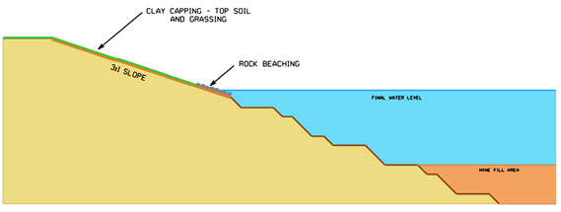

#### Nominal Stage Timings

1. Development is in stages and the timing of the stages is determined by the coal utilisation rate. Four example timings are shown below. The cost model is currently set up with a 30 Mtpa coal usage rate. The duration of the final stage is set manually and is currently set at 10 years.

|  |  |  |  |  |  |  |  |
| --- | --- | --- | --- | --- | --- | --- | --- |
| **Stage Name** | **Total Coal Volume from stage B**  **(Mt)** | **Coal Volume in Stage**  **(Mt)** | **End of Stage Dates Based on Annual Coal Volume** | | | |  |
|  |  |  | Mtpa | Mtpa | Mtpa | Mtpa |
|  | 30 | 27 | 25 | 20 |
| **B** | 0 | 0 | 2015 | 2015 | 2015 | 2015 |
| **C** | 199 | 199 | 2022 | 2022 | 2023 | 2025 |
| **D** | 482 | 283 | 2031 | 2033 | 2034 | 2039 |
| **E-** | 982 | 500 | 2048 | 2051 | 2054 | 2064 |
| **E** | 1369 | 387 | 2061 | 2066 | 2070 | 2083 |
| **F** | 0 | 0 | 2071 | 2076 | 2080 | 2093 | 10 Years |

.

l

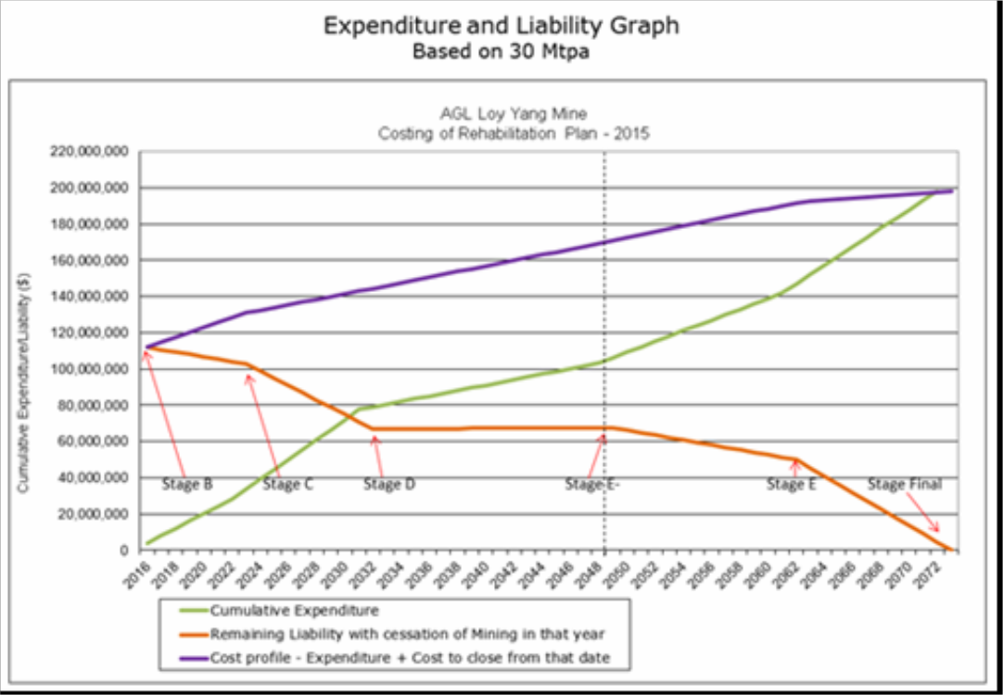

### Bond system effectiveness

1. The bond system/process is an effective way of managing the Government’s exposure to a rehabilitation liability. The current bond system provides a guarantee of funds being available for rehabilitation, by the DEDJTR, in the event that the holder of a mining licence does not meet their rehabilitation obligations as specified in the mining licence, approved work plan or regulatory requirements. Any revision of the bond should account for progressive rehabilitation works already undertaken by the owner, and the risks of default by the holder of a mining licence.
2. Currently AGL Loy Yang funds progressive rehabilitation from operating funds and provisions. AGL Loy Yang has included the continuing availability of funds for this liability in its forward planning.
3. AGL Loy Yang believes, in the case of the AGL LY Mine, the trust fund established under the LYCA is an effective addition to the current statutory bond system and that these two mechanisms together serve as the appropriate financial assurance to cover mine rehabilitation costs for the AGL LY Mine.

### Rehabilitation Bond Conclusion

1. As this discussion demonstrates, the current rehabilitation liability for the AGL LY Mine reduces gradually over its life as progressive rehabilitation is performed. At mine closure, those areas that have not been progressively rehabilitated (generally because of the presence of infrastructure or other operational requirements) will be subject to rehabilitation. AGL Loy Yang has a strong record of performing progressive rehabilitation. Currently AGL Loy Yang funds progressive rehabilitation from operating funds and provisions. AGL Loy Yang has included the continuing availability of funds to continue with this progressive rehabilitation in its forward planning.
2. The bond system is intended to manage the State’s exposure to a rehabilitation liability, in the event that the holder of a mining licence does not meet their legal obligation to undertake rehabilitation. In this sense the bond system operates as a safety net to protect the State from default by the mining licensee.
3. AGL has lodged a $15m rehabilitation bond with DEDJTR. At this point in time AGL Loy Yang has not been involved in and is not aware of the conclusions and recommendations from the Rehabilitation Bond Review project undertaken by DEDJTR.
4. From 2023, AGL Loy Yang, and the owner of LYB will be required under the terms of the LYCA to contribute money into a trust account for the purposes of funding the rehabilitation of the AGL LY Mine. The LYCA requires the owners of the power stations (and the owners of any new projects at the Loy Yang Complex) to contribute 10% of the cost of the Loy Yang Site Rehabilitation Expenses into a trust fund on an annual basis for a 10 year period. The contributions to the LYCA Rehabilitation Trust Fund are in proportion to the coal usage by each party.
5. This LYCA Rehabilitation Trust funding mechanism is unique amongst all other brown coal mines in Victoria and provides additional financial assurance for the State to ensure that rehabilitation is completed. The trust fund is accessible, with the approval of the parties, to undertake rehabilitation works at the AGL LY Mine from 2023 onwards.
6. The existence of the LYCA significantly alters the risk profile for the State in relation to the future rehabilitation of the AGL Loy Yang Mine, as it provides significant additional financial assurance beyond that provided by the current bond. AGL Loy Yang believes, in the case of the AGL LY Mine, the trust fund established under the LYCA is an effective addition to the current statutory bond system and that these two mechanisms together

serve as the appropriate financial tool to cover mine rehabilitation costs for the AGL LY Mine.

1. AGL Loy Yang considers that there is no basis for the Board or DEDJTR to conclude that an increase in the current bond provided by AGL is necessary to adequately protect the State's interest. The bond setting process should recognise the important differences between the Mines, and not adopt a “one size fits all” solution. Any increase in the AGL rehabilitation bond will result in the imposition of costs which is unwarranted having regard to the risks and would divert operating funds otherwise available for physical rehabilitation works.
2. Given the LYCA, an increase in the rehabilitation bond provided by AGL could only be justified if it was accepted that there was a plausible risk of the AGL Loy Yang Mine being subject to a disorderly and permanent shutdown in the period prior to the accumulation of sufficient funds in the LYCA trust fund to cover the cost of rehabilitation. This would require the permanent closure of the AGL LY Mine sometime in the period prior to Stage D (circa 2031).
3. The bond and LYCA Rehabilitation Trust Fund obligations provides a more than adequate commitment considering the contribution of AGL Loy Yang to Victoria’s energy security. As Victoria’s largest electricity generator and a facility of national significance, AGL Loy Yang, is extremely unlikely to default in this respect and AGL's balance sheet strength mean that an early and unfunded closure is highly improbable.
4. The closure of the entire generation fleet based at the Loy Yang Site prior to Stage D (circa 2031) is an extremely unlikely scenario, for the following reasons:

› The AGL Loy Yang assets were purchased in 2012 on a business case premised on a project operating life through to 2048. This has been confirmed by AGL as recently as 2015 in its public AGL Greenhouse Policy statement.

› The AGL LY Mine supplies the energy source (in the form of brown coal) for over 50% of Victoria’s electricity demand.

› There is no commercially viable energy alternative that could deliver in the order of 3,000MW capacity into the National Electricity Market within a 16-year lead time.

› Electricity produced by AGL LYA is in the lowest quartile of electricity generators in the National Electricity Market from a merit order (cost of generation) perspective, therefore other electricity generation projects would become commercially unviable prior to AGL LYA.

1. Early closure of part of AGL LYA between Stage D (circa 2031) and Stage E- (circa 2048) period, could be conceivable under a high greenhouse gas pricing regime. However the AGL LY Mine would still need to continue to operate in order to supply any Loy Yang generating (AGL LYA and LYB) units still in service.

# Conclusions

1. AGL’s core value system is critical to the way in which we operate our facilities. AGL’s overarching value of ‘safe and sustainable’ incorporates the safety of our employees and a strong commitment to the protection of the environment and the communities in which we operate. This value is ingrained in how we conduct business and is directly relevant to the management of the environmental and public health performance of the AGL LY Mine and AGL LYA.
2. AGL’s environmental principles assert that the business will reduce risk to the environment and minimise our environmental impact, by integrating considerations of environmental sustainability in all activities.
3. Accordingly AGL recognises that the issue of Latrobe Valley coal mine rehabilitation must be approached sensitively in order that the environmental and business outcomes can be balanced while maintaining community confidence.
4. AGL intends to deliver a safe and stable landform at the completion of mining in the AGL LY Mine, recognising that landform and land use must be complementary. The final rehabilitation design must respond to a range of complex natural systems.
5. During the operating life of the AGL LY Mine, AGL Loy Yang:

› Has undertaken progressive rehabilitation as part of the overall AGL LY Mine development program. Rehabilitation can only be undertaken on areas not required for production which includes conveyor transport and infrastructure corridors, water management areas, and production faces and floors areas. AGL Loy Yang considers that rehabilitation works undertaken to date is appropriate for the operational stage of the mine.

› Will continue to undertake progressive rehabilitation works including rehabilitation trials and technical studies to inform the rehabilitation plan set out in WPV 2015. On approval of WPV 2015, AGL Loy Yang will begin detailing the progressive rehabilitation and closure plans to achieve a practical final rehabilitation concept for the AGL LY Mine.

› Has optimal fire prevention and suppression plans and resources that effectively mitigate risks of fire in the AGL LY Mine. AGL Loy Yang will maintain a high-level of fire preparedness based on a combination of rehabilitation, land management practices, fire response and mine design. AGL has established a robust emergency management and response capability at the AGL Loy Yang site, and works closely with a range of emergency management agencies to afford maximum preparedness and response capability.

1. The landform created by mining over the past 33 years at AGL LY Mine is stable, with no significant geotechnical failures in the landforms created to date. Future mine development plans will continue and improve the practices that have resulted in this long term stability.
2. AGL Loy Yang has a well-defined development strategy for accessing the remaining coal on the Mining Licence. This allows well-defined progressive rehabilitation plans to be in place as further areas are opened up and made available.
3. On closure, the final landform is expected to be able to accommodate multiple land uses such as energy production (solar/wind), agriculture and cropping, return to native vegetation or industrial developments. These options may change in the future, reflecting contemporary community expectations, and the technical and environmental conditions at the time.
4. AGL believes that the current bond system is an effective way of managing the State’s exposure to rehabilitation liability.
5. AGL Loy Yang funds progressive rehabilitation from operating funds and provisions, and has included the continuing availability of funds for this liability in its forward planning.
6. In addition to the current statutory bond system, AGL Loy Yang has additional obligations in the form of the LYCA Rehabilitation Trust fund, which AGL considers to be an effective addition and that these two mechanisms together serve as the appropriate financial assurance to cover mine rehabilitation costs for the AGL Loy Yang Mine.

# Figures

### Figure 1 Regional Plan

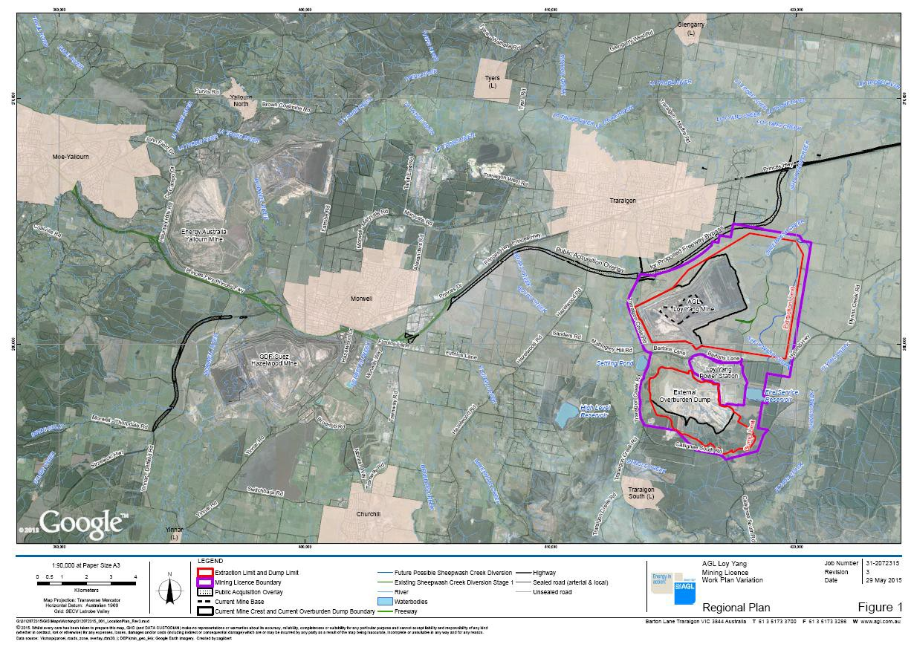

### Figure 2 Site Plan – AGL Infrastructure

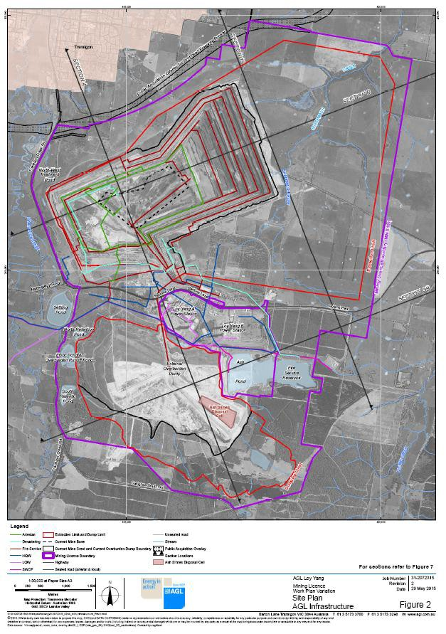

**Figure 3 Site Plan – Electrical Infrastructure**

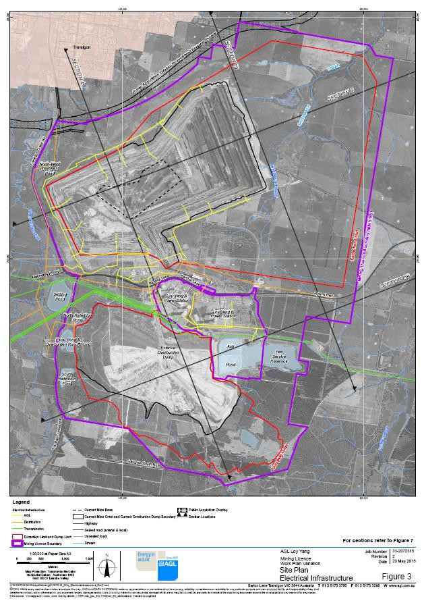

**Figure 4 Development Stage B**

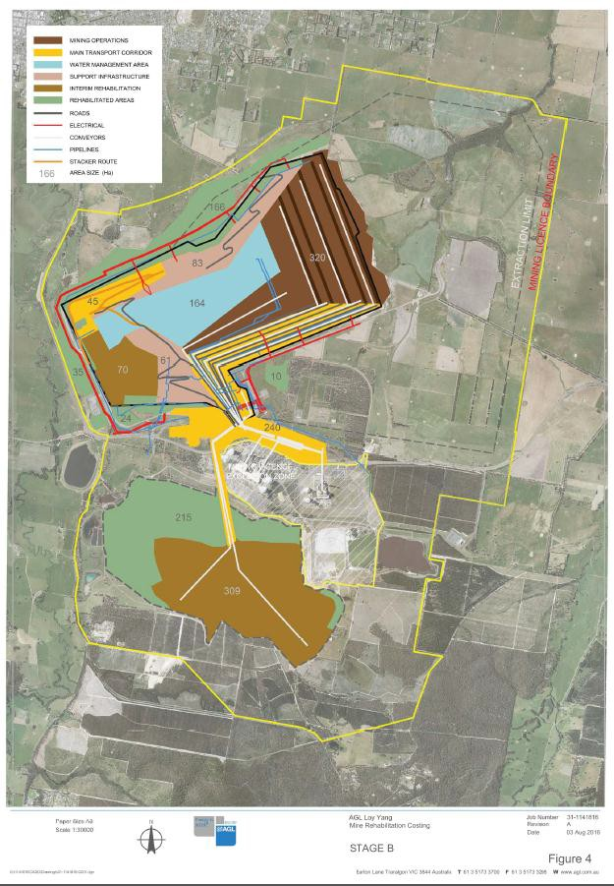

**Figure 5 Development Stage C**

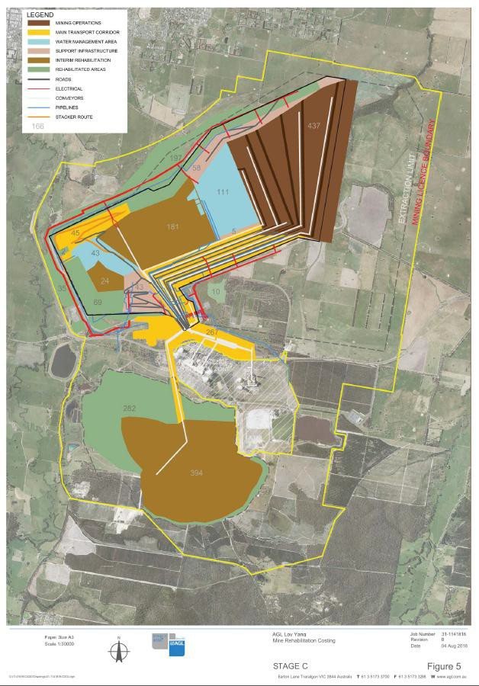

**Figure 6 Development Stage D**

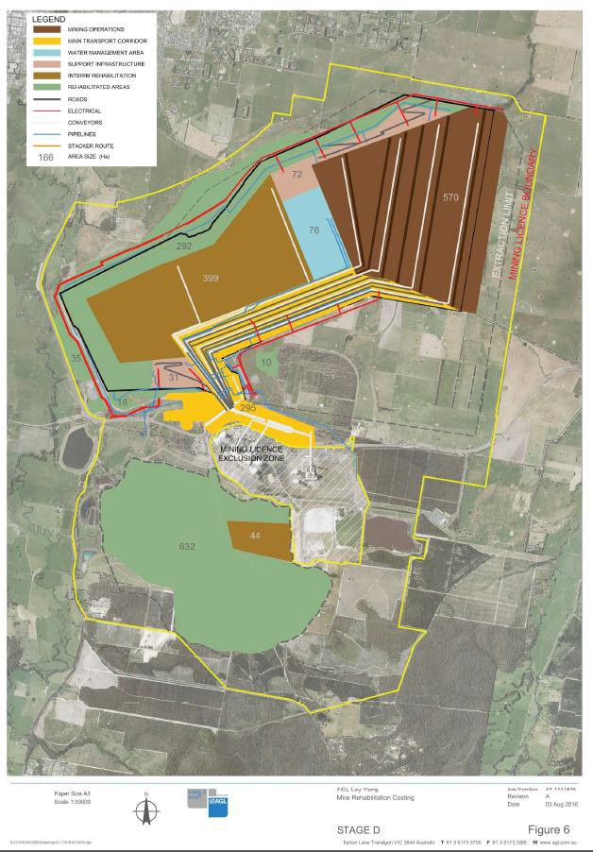

#### Figure 7 Development Stage E-

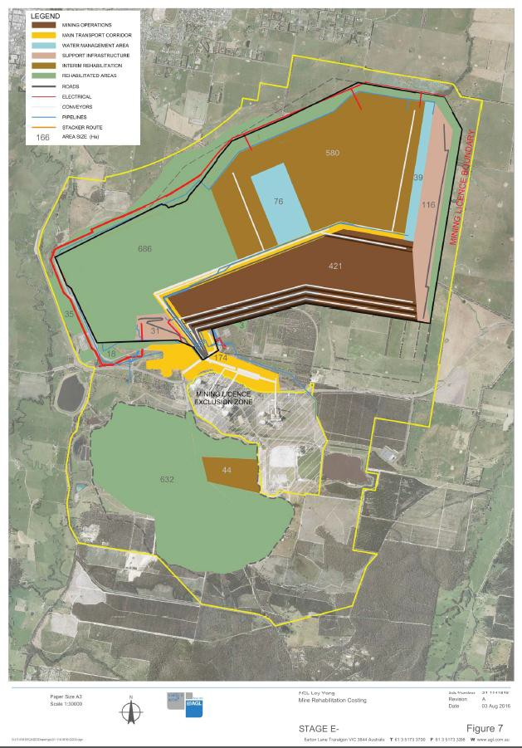

**Figure 8 Development Stage E**

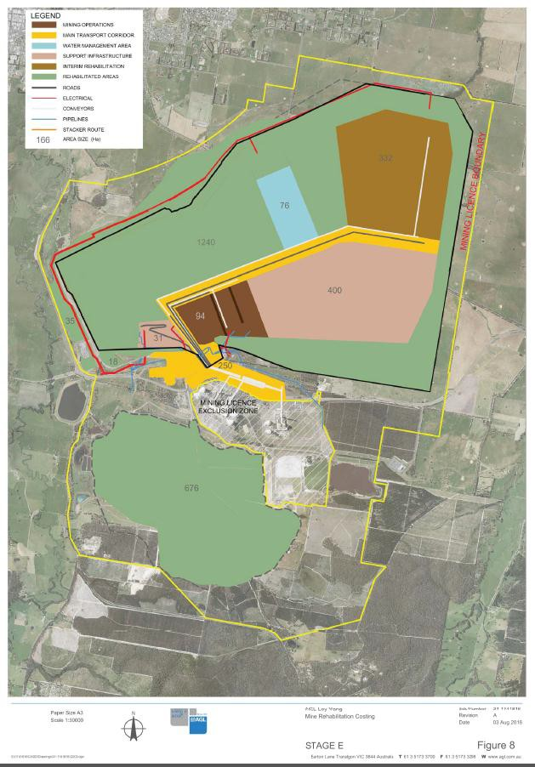

**Figure 9 Development Stage Final (Mine Closure)**

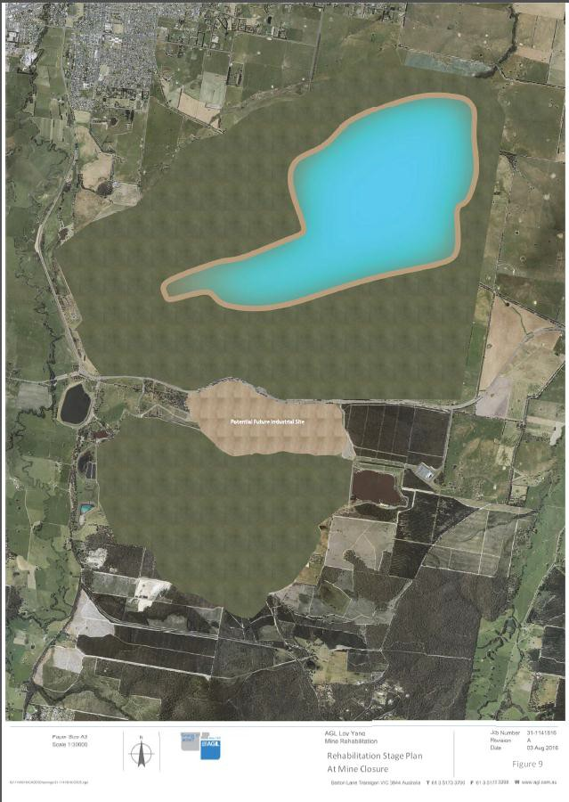

**Figure 10 Site Plan – Geological Information**

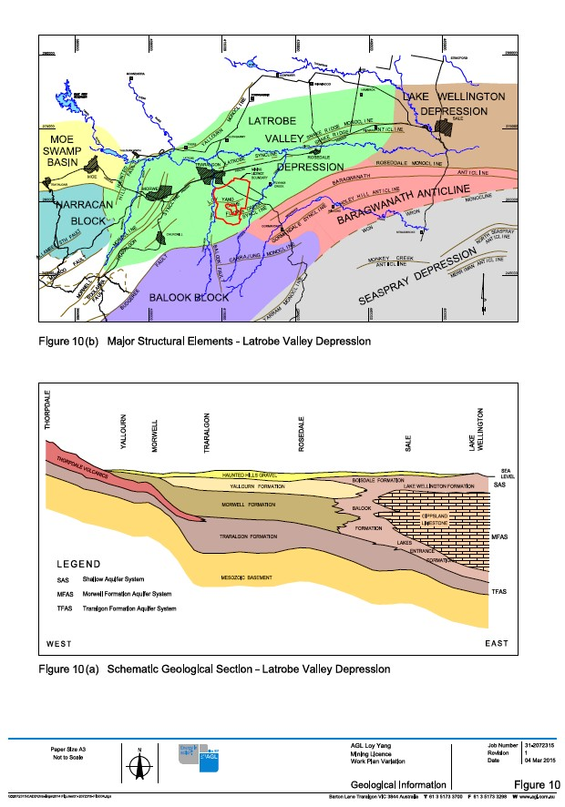

#### Figure 11 Site Plan – Geological Information

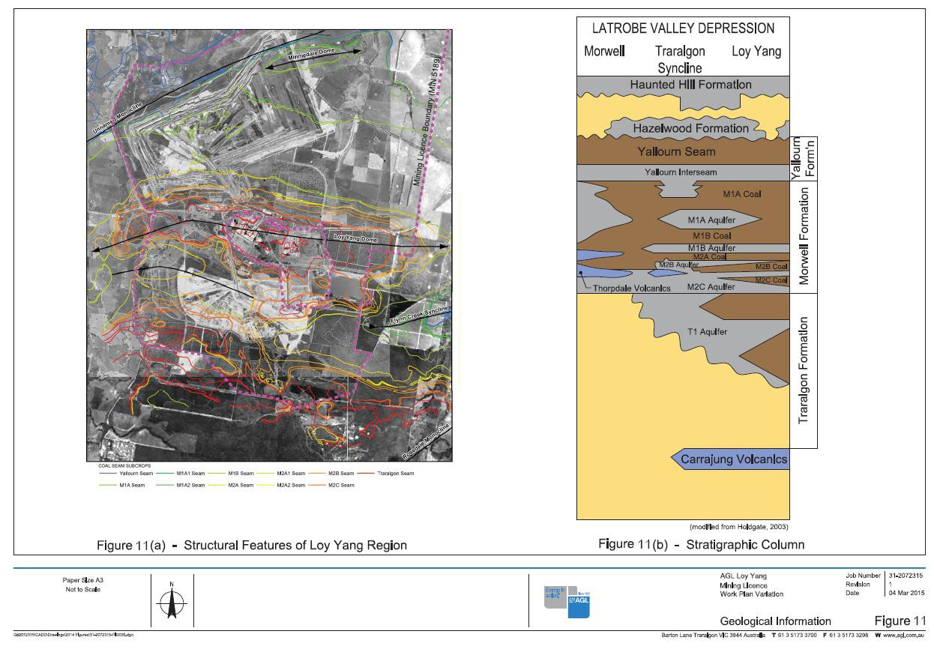

### Figure 12a Site Plan –AGL Loy Yang Grid Plan

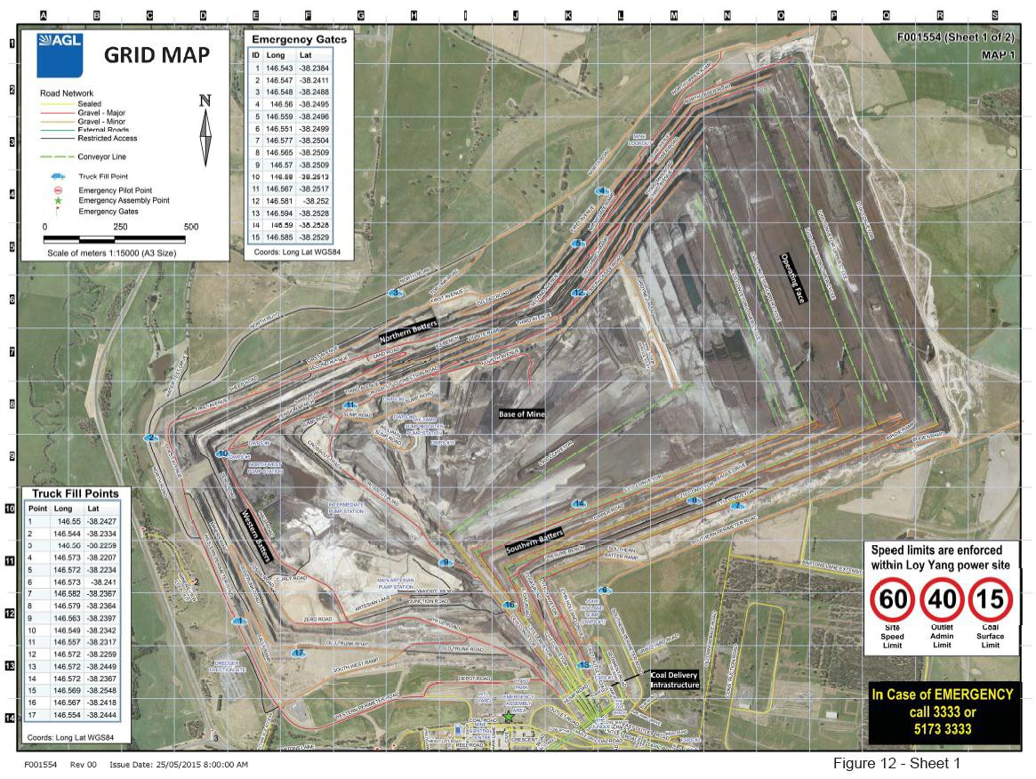

**Figure 12b Site Plan –AGL Loy Yang Grid Plan**

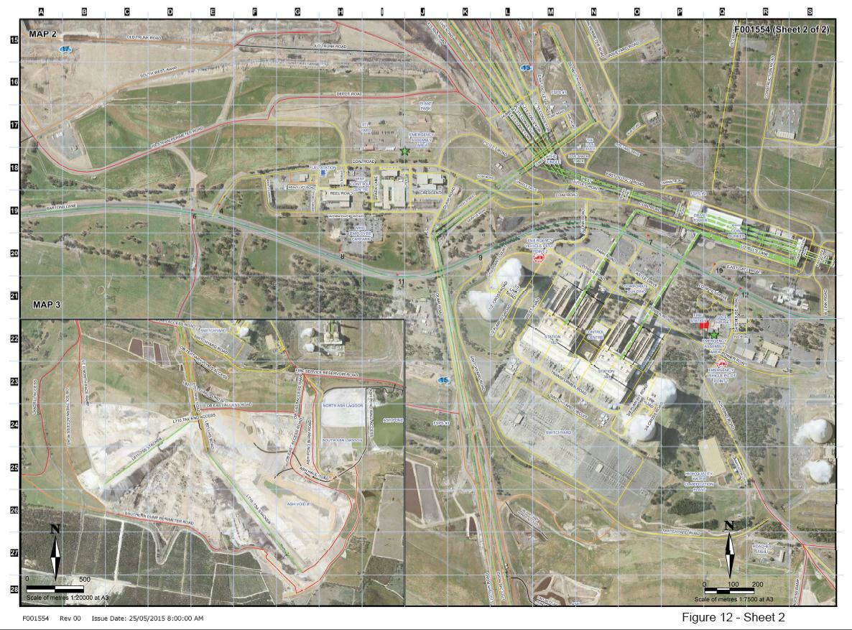

# Appendix 1 - Plates

#### Plate 1 – Rehabilitated final landform - level 1 and 2 of the western section of Level 2 and 3 of external overburden dump, looking south west.

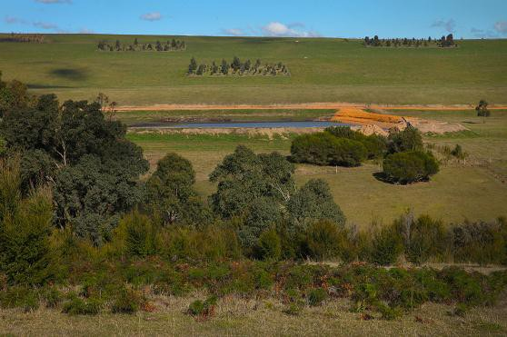**Plate 2 - Rehabilitated final landform – western section of Level 2 and 3 of external overburden dump, looking south.**

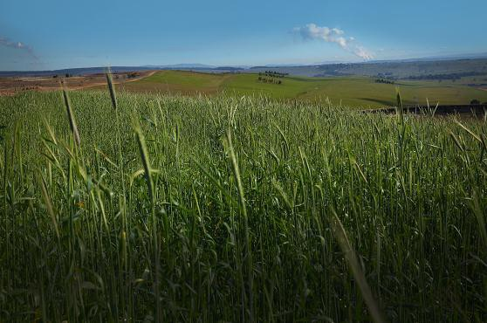**Plate 3 - Final rehabilitated landform – External overburden dump from Level 3,looking north west.**

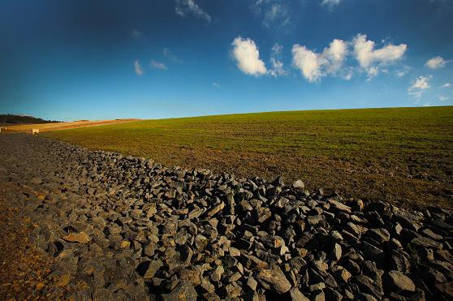**Plate 4 – Progressive rehabilitated landform – down slope drainage, western side of overburden dump looking south.**

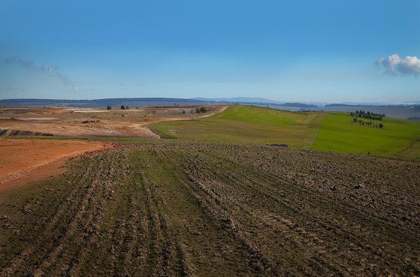**Plate 5 - Progressive rehabilitation landform – with topsoil and grassed and preliminary shaping.**

**Plate 6 - Progressive rehabilitation landform – active mining face of the northern slopes contrast with final landform and land use; looking north.**

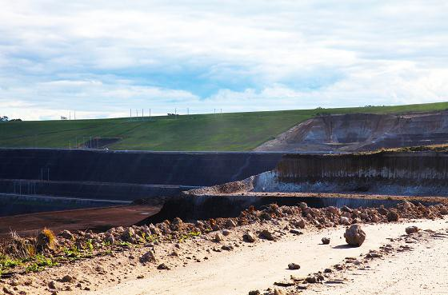

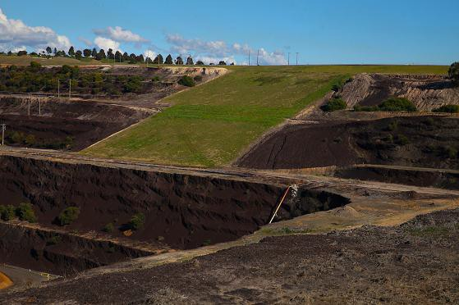**Plate 7 - Progressive rehabilitation landform – western slopes rehabilitation trial of final landform; looking west.**