I am submitting this after the Hazelwood Mine Fire. An incident which exposed significant gaps in Air Quality Standards. There are several points I will address in this submission.
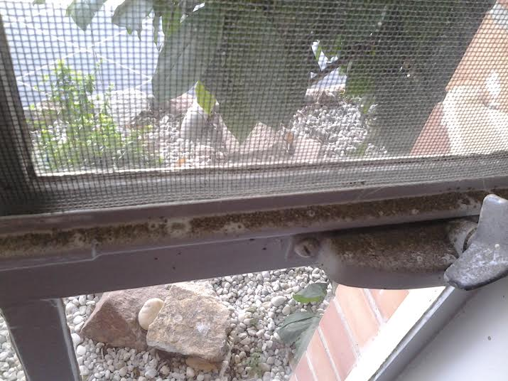
Dust on a Morwell residents window sill from coal fly ash-

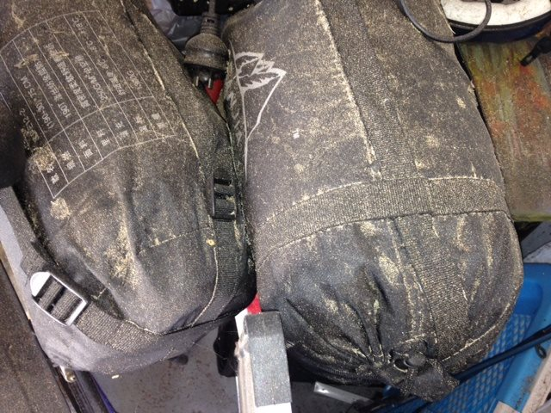
My shed after the fire was covered in fly ash. This contaminated our houses and our lungs.
AIR QUALITY
The Inquiry must prioritise action on the pollution sources which are the greatest contributor to pollution levels and have the biggest impact on human health in Victoria. This is important because the World Health Organisation has announced that Air Pollution is a Group 1 carcinogen.
Source : http://www.iarc.fr/en/media-centre/iarcnews/pdf/pr221_E.pdf
These include bushfire/burn off smoke, diesel engine exhaust, solvents, metals, and dusts. PM2.5 in particular MUST be upgraded from Advisory to a Maximum allowable standard given its real danger to increase mortality in the population as seen after the Hazelwood mine fire.
Source : http://www.abc.net.au/news/2014-09-12/hazelwood-mine-fire-pollution-blamed-for-11-deaths/5740824
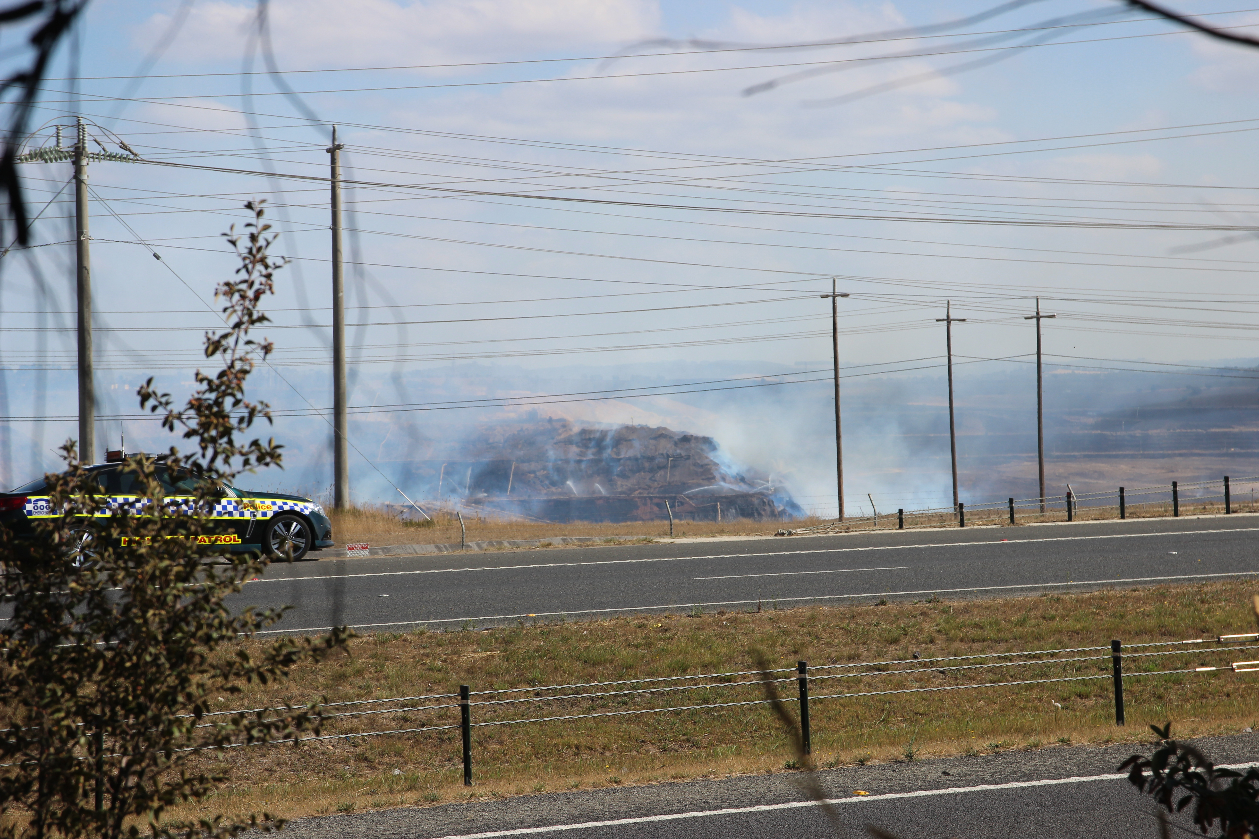
Coal burning into the atmosphere during the Hazelwood Mine Fire

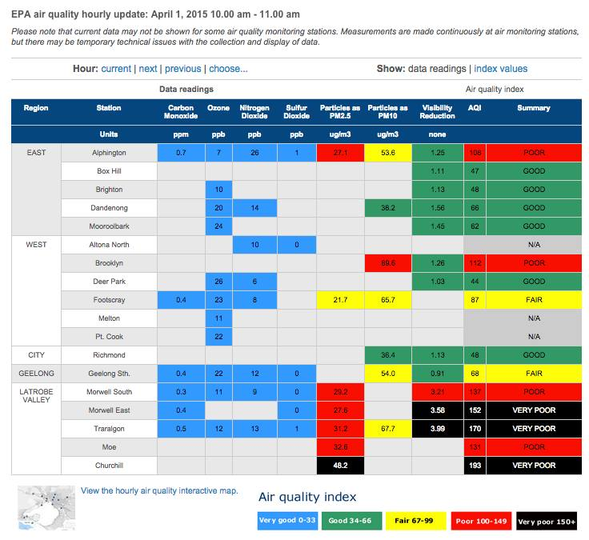
Air pollution readings from the Victorian EPA site during planned burn offs. This is a common occurrence during Autumn and it adds to the pollution load we suffer from other sources such as the Maryvale Paper Mill and coal mining as well as historical asbestos exposure.

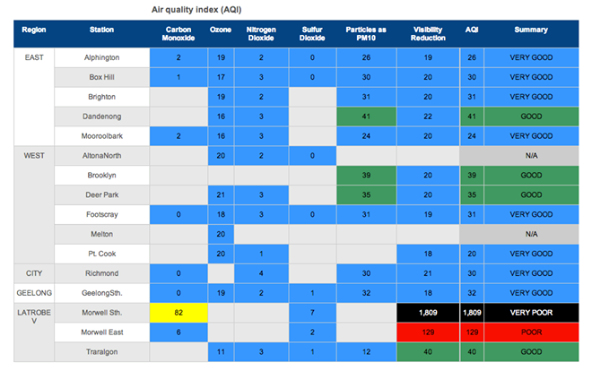The levels of pollution during the fire were astronomical. Locals sat through 45 days of an air pollution event where these readings were common.

The Inquiry must prioritise action on human health rather than focusing on the burden on polluters. The focus must be on the pollutants that create the greatest health impacts on Victorians, and the pollution sources that put an unfair burden on local communities. The current EPA regime is based on self reporting. The Inquiry must recommend enforcement provisions because of the serious externalised costs to the public health system. The state based EPA lack the funding to take large multinational polluters to court. So it’s funding needs to be increased or moved to a national EPA. If possible the EPA headquarters should be moved to Morwell or the Latrobe Valley.

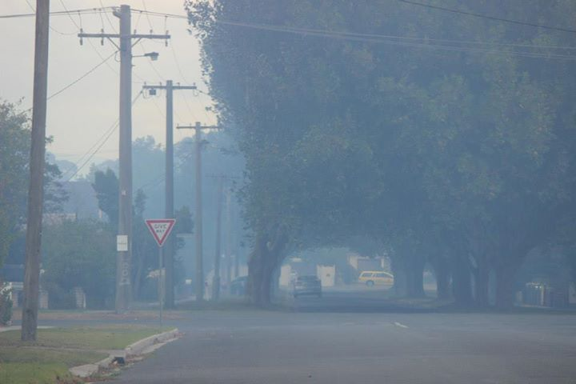
Mclean St, Morwell during the Hazelwood Mine Fire

The Inquiry should recommend new measures that will significantly reduce pollution to protect our health. The government must agree to air pollution reduction measures that will result in significant reductions in pollution levels in Victoria AND commit to implementing them. It is no good introducing standards if they can be changed during pollution events. (The Department of Health changed the CO safe reading to 70ppm instead of 30ppm.)

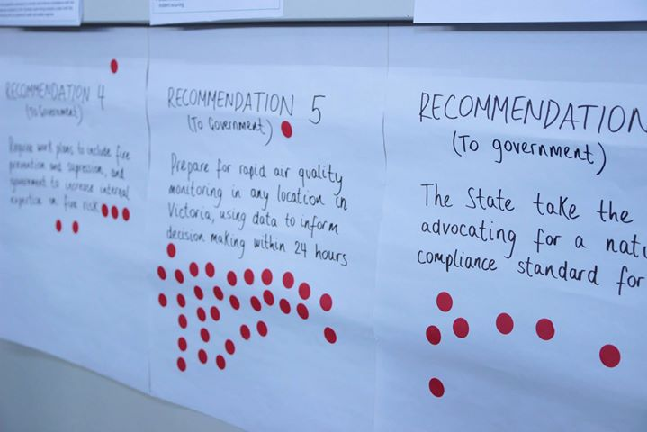
After the Hazelwood Mine Fire Latrobe Valley Residents had a meeting and decided that the State take lead advocating for a national air standard for PM2.5

Government should recognise that our current air pollution standards and laws are failing to protect the heath of Victorians.

Communities have a right to know what toxic pollutants are being put into the air around us. The National Pollutant Inventory must also be strengthened and properly resourced.
ALL governments must give air pollution the priority it deserves, end ongoing delays and commit to actions that will fix the biggest sources of pollution as a priority.

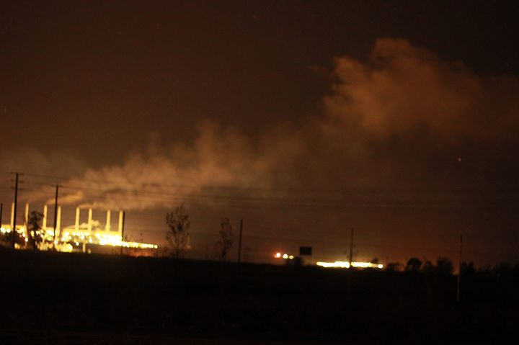
We are subject to pollution 24/7 in Latrobe Valley. We rely on the EPA to enforce regulations so that we are protected from pollution events.

SEE ATTACHMENT 1:
A GIS BASED APPROACH TO THE ESTABLISHMENT OF AN ADEQUATE NETWORK OF AIR QUALITY MONITORING STATIONS IN AREAS SURROUNDING COAL MINES IN THE LATROBE VALLEY

Extract:
The Latrobe Valley is an important source for brown coal in Victoria as it is used to fuel the local coal fired power stations. However a fire which occurred in the Hazelwood mine, a technological disaster, posed a severe risk to residents within the valley particularly in Morwell. Poor efficiency of setting up monitoring equipment meant that the local population was unable to get detailed information about what they were experiencing from the smoke they were inadvertently inhaling. This thesis successfully attempted to determine areas in the Latrobe Valley that were at risk of mine pollution from fire events and suggested an adequate network to be set up for future monitoring of air pollution in the area. The network comprised of five permanent monitoring stations and eight temporary monitoring sites in order to maximise the ability to monitor the risk imposed upon the local population and provide necessary information for future events to assist with risk management, evacuations and to issue warnings.

I have concerns about local pollution reporting and if that is an adequate system.
I am informed by the EPA that “if a business does not fall under the type of industry that the EPA regulates then it must be registered with the local council.”
Therefore complaints about emissions/odours from non-EPA regulated industries should be addressed to the environmental health department of the appropriate local council as, despite reporting complaints to the EPA, the EPA can’t act on it unless the council ask them to, thus rendering EPA reports useless.
Another concern though, could it be that industries which have the potential for significant odour/emissions are slipping through the system because the appropriate environmental assessments are not being completed in the planning permit stage? This occurs via the following ways.
1. Local Council deliberately underplay a planning application to facilitate quick processing for approval
2. Local Council have not done their due diligence to ensure the planning permit application is appropriate, which highlights incompetence and/or;
3. The community are apathetic to the proposal
The recent planning application for the Toongabbie Chicken Broiler Farm is the perfect example. Luckily, this community is not apathetic. There are two permit applications to house 400,000 birds each that are being assessed separately and run concurrently but, cumulatively, total 800,000 birds. The next biggest chicken farm I believe to be 387,000 birds. Yet both applications state that an Odour Environmental Risk Assessment (Odour ERA) is not needed for the separate 400,000 capacity applications.
We are going into unknown territory here with significant odour potential impacting the surrounding community that Wellington Council have not addressed in the permit application. Who will set licensing conditions, EPA or Local Council? If it is Local Council, how will they monitor for compliance, how will it be regulated and how do residents report odour complaints? Under local bylaws would odour complaints be just treated as a nuisance from an 800,000 broiler farm even though there could be multiple environmental hazards from an industry that size that would have numerous origins for odour releases? And will Local Council only know about a problem if it is reported?
Firstly, Wellington Council needs to explain to the community of Toongabbie who the responsible authority will be to manage a farm this size without the appropriate Odour ERA? Secondly, is Wellington Council saying that they have the technical expertise and capacity to know that a broiler farm that size will not have significant odour issues and thirdly, what if they get it wrong?
My question is, where is the information to make informed decisions available to the local ratepayers on these EPA unregulated businesses? Who monitors this on behalf of the local council? Do they have the scientific knowledge available and/or the required equipment to carry out monitoring?
The EPA makes emission reports public so that we are informed but where are the reports sent to council? Where do we find this information and how do council show their ratepayers that they are being transparent?

The Inquiry should recommend fixing the loopholes local councils use to bypass EPA regulations. All businesses should submit an odour risk assessment to the EPA when at the planning stage which has the requisite skills to test and monitor pollution. This responsibility should not pass to local councils.

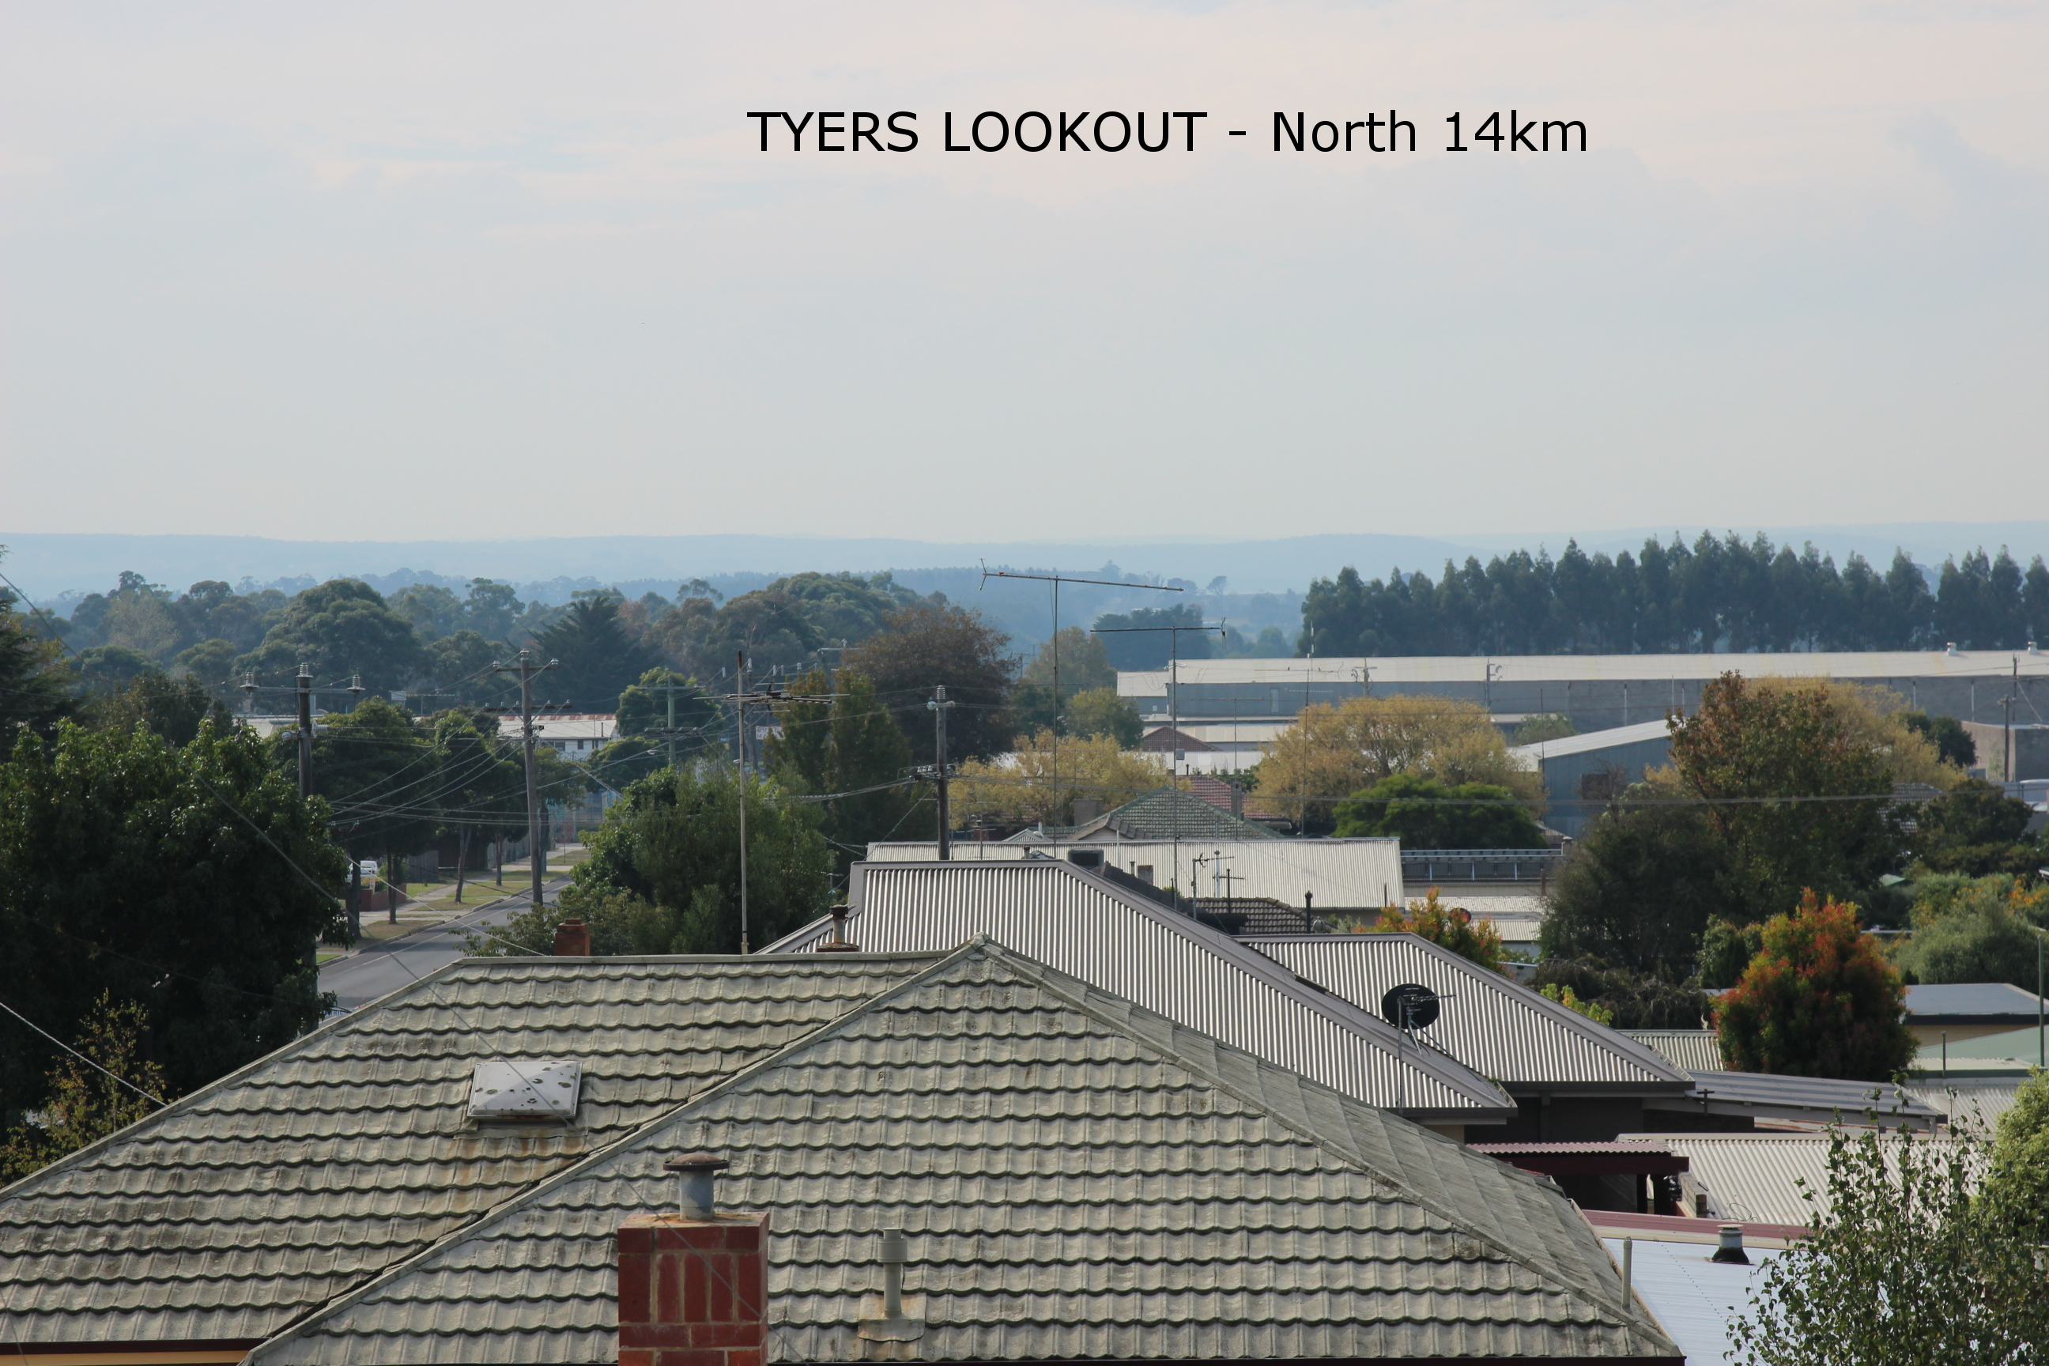
A photo showing air pollution in Morwell during planned burn-offs. High air pollution readings persisted for a week trapped by the inversion layer in the Latrobe Valley.

In Summary
- The Inquiry must prioritise action on the pollution sources which are the greatest contributor to pollution levels and have the biggest impact on human health in Victoria.
- The Inquiry must prioritise action on human health rather than focusing on the burden on polluters. The focus must be on the pollutants that create the greatest health impacts on Victorians, and the pollution sources that put an unfair burden on local communities.
- The government must agree to air pollution reduction measures that will result in significant reductions in pollution levels in Victoria AND commit to implementing them.
- Government should recognise that our current air pollution standards and laws are failing to protect the heath of Victorians. Government must commit to clean air laws.
- Communities have a right to know what toxic pollutants are being put into the air around us.
- Government must give air pollution the priority it deserves, end ongoing delays and commit to actions that will fix the biggest sources of pollution as a priority.
- The Inquiry must establish trigger points for air pollution in the legislation which allow towns such as Morwell to be evacuated during significant air pollution events.
- The Inquiry must address loopholes in planning regulations that let odour complaints be treated as a nuisance.

REHABILITATION
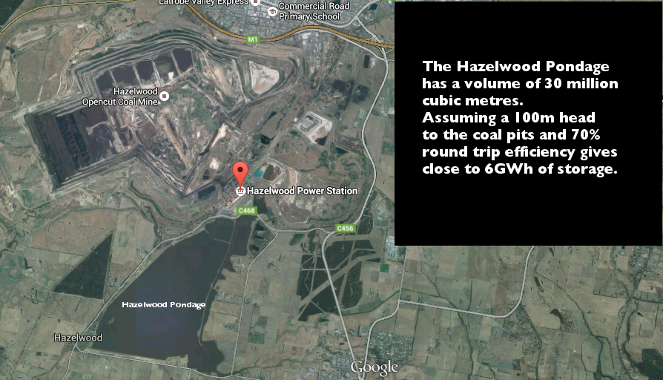

I submit the following link that explains the concept and viability of turning the Hazelwood mine into a Pumped Hydro Storage System when it’s useful life has ended. This has received a lot of positive feedback from the local community.
http://reneweconomy.com.au/2015/lets-turn-latrobe-valley-coal-pits-into-hydro-storage-for-renewables-91630
This plan has many positives for the transition from coal to renewable energy. The Latrobe Valley is situated under the main electrical infrastructure which gives it a unique advantage. The coal pits can be converted into a valuable asset that still generates power and removes the threat of another mine fire to the community nearby while increasing other industries such as tourism. Instead of a stranded asset this would make the coal pits a benefit for the community and the company that owns it. It would also help cover the cost of rehabilitation going forward meaning there is less likelihood of it being abandoned or mothballed.
In addition I ask the inquiry to recommend a renewable energy research centre be built in the Latrobe Valley and funded to explore advances in this field to complement the Pumped Hydro rehabilitation plan.
SUBSIDENCE
The mining industry in Latrobe Valley has extracted water for decades and over time this is leading to subsidence issues around the mines. A successful rehabilitation plan should include the founding of a Land Subsidence Board modelled after the NSW board to compensate local landholders. Decades of dewatering the Latrobe Valley Aquifiers is leading to significant issues with housing such as the constant need to get them restumped. More coal licenses have been granted which means even more extraction of groundwater. This should be funded through a special mine subsidence levy. Currently Latrobe City ratepayers have to subsidise repair work to infrastructure and this is unfair in such a low socio economic area.
Source: http://www.nswmining.com.au/environment/subsidence

EPA HEADQUARTERS
The Victorian EPA headquarters should be moved to Morwell or the Latrobe Valley both to move it to where the greatest pollution levels need monitoring and also to help support the economy with government agency jobs.

EMERGENCY EVACUATION PLANS
The inquiry should recommend to the Government that it design a Local Council Emergency Management Policy for Evacuation Transport and Supervision for Vulnerable Residents. For example Maryvale Crescent, Morwell Residents, Aged and Disabled who do not have their own transport or family to transport them or any means to evacuate to safer places if evacuation is needed for any given situation. During the Hazelwood Mine Fire many of our vulnerable community members were left to fend for themselves.

Appendix.
I am also concerned about workplace safety standards at Hazelwood Power Station. As it ages reliability is dropping and this causes much more pollution during start-up. I am informed by workers that maintenance is being sacrificed in an effort to return income to shareholders. The inquiry should recommend that worksafe victoria completes a full safety audit of the power stations in the Latrobe Valley to allay these concerns.

Thankyou
David Hollis.
Ratepayer
Latrobe City.

