Latrobe Valley

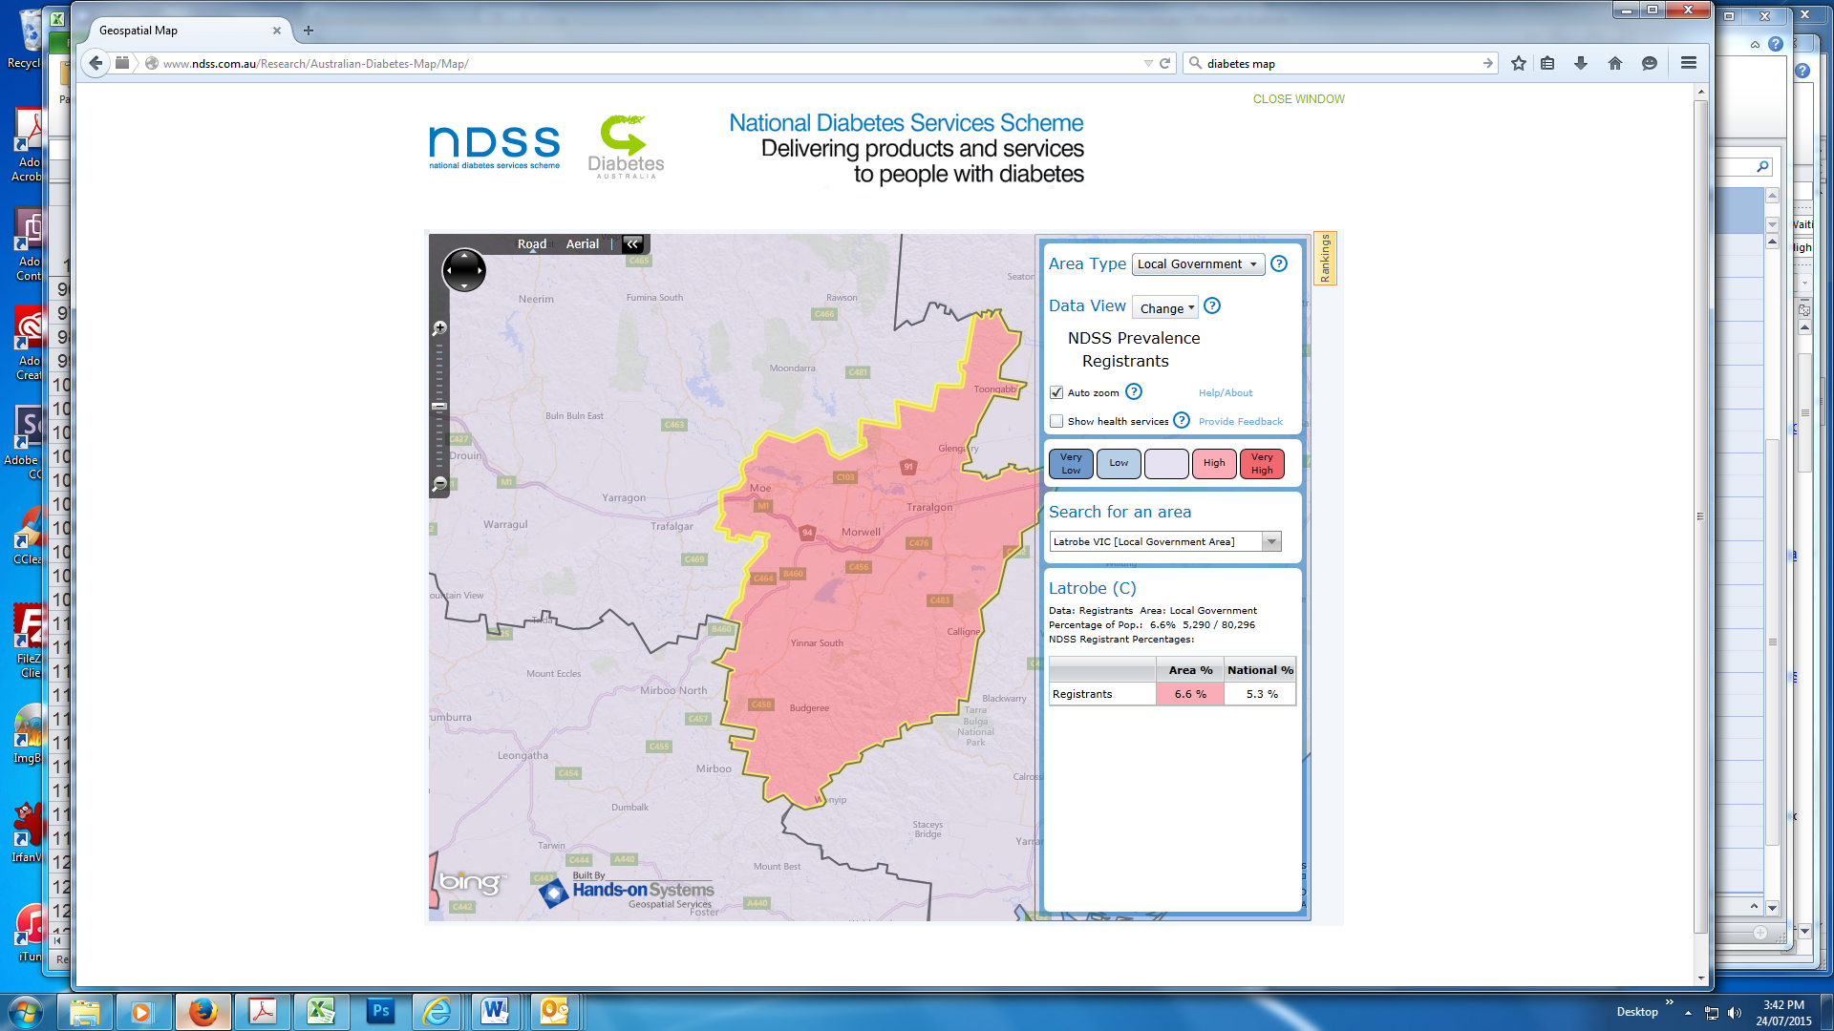

With 5290 people registered on the NDSS, the Latrobe Valley has a high diabetes prevalence with 6.6% of the population affected. This is mainly caused by a higher than national average of type 2 diabetes cases (89.6% in local government area compared to 88.2% national average). Males are with 6.8% (5.5% national) affected more often than females with 6.3% (5.2% national).

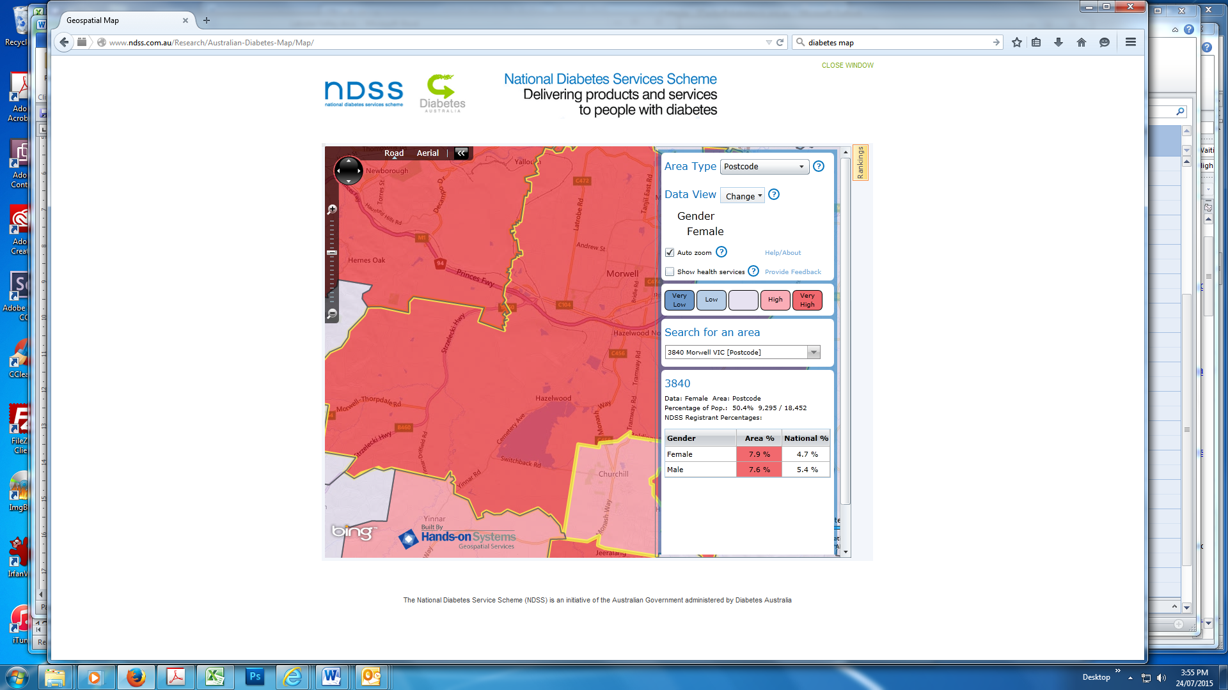

The postcode of Morwell is classified as ‘very high’ diabetes prevalence area. There are 9295 NDSS registrants living in this postcode, which means that 7.8% of the population is directly affected. Interestingly, with 7.9% more females are affected than males with 7.6%. These numbers are mainly driven by type 2 diabetes case numbers.

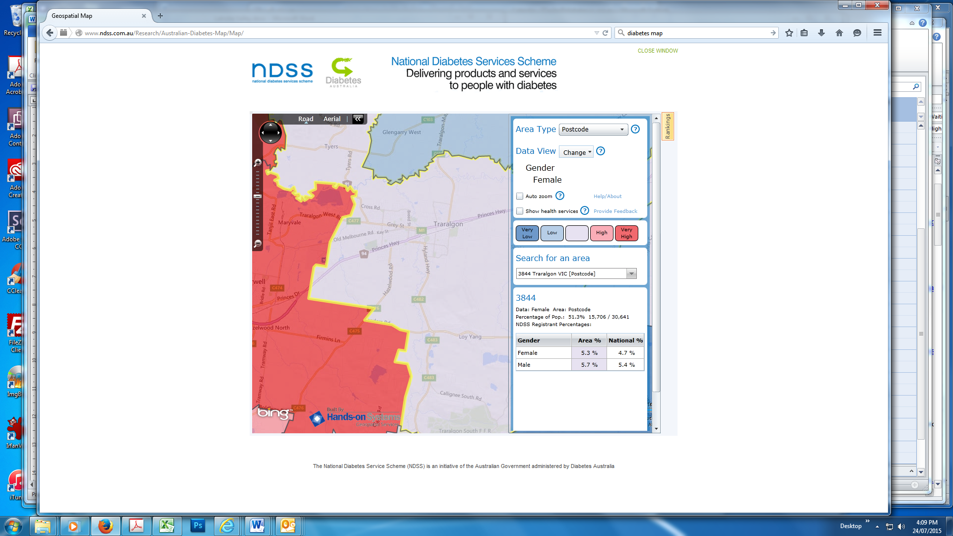

In contrast, the postcode of Traralgon is not classified as a high or very high diabetes prevalence postcode. With 1679 NDSS registrants the postcode has a diabetes prevalence of 5.5%. Males are affected slightly more often than females, again driven by type 2 diabetes case numbers.