VOTV submission to Hazelwood Mine Fire Inquiry re Terms of reference 6

Whether the Hazelwood Coal Mine Fire contributed to an increase in deaths, having regard to any relevant evidence for the period 2009 to 2014;

1. Anecdotes of more deaths than expected in the first half of 2014 led us to try and find out if there was in fact an increase. The newspaper data we could find from the State Library and local sources was not official, but we were able to compare mortality statistic for 2014 with the previous 5 years, and found an increasing death rate in the Latrobe Valley from February 2014.

This first rudimentary analysis was submitted to the original Hazelwood Mine Fire Inquiry for advice.

1. We had also requested information from the Victorian Registry of Births Deaths and Marriages (BDM) for the 5 years 2009-2014 about numbers of deaths within the 4 immediate postcodes (3840-Morwell, 3842-Churchill, 3825-Moe and 3844-Traralgon) for the months of January to June. After considerable discussion, delays and negotiation, BDM released the data just after the HMF Inquiry delivered its report. A comparison showed was a higher than average rate of deaths in early 2014 across all postcodes. It was more pronounced in Moe, and Traralgon and less so in Morwell, although there was a peak in deaths in Morwell in January 2014 corresponding with the record heat wave. This was the first indication that effects were not limited to Morwell.

1. VotV gained the assistance of Professor Adrian Barnett, a statistician and epidemiologist from Queensland, who analysed that data we had obtained and concluded that there was a probability of over 90% that a number of deaths could be directly attributable to the mine fire.
2. We have recently obtained further information from BDM covering 10 years (January –December, 2004-20014) on six postcodes and the whole state for comparison. The 3 smaller postcodes were unusable because the numbers were too small. The data for 2014 in the new information included the whole year, to December and, in summary, showed 22% increase in deaths from the 10 year mean across the Latrobe Valley. Analysis is based on three postcodes, 3825, 3840 and 3844.

During this 10 year period, the number of deaths has increased across the State by 11% from its mean. (Figure 1). Figure 2 shows the sum of deaths in Latrobe Valley postcodes in 2014 compared to the adjusted Latrobe Valley 10-year mean.

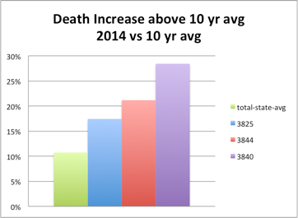

*Figure 1*

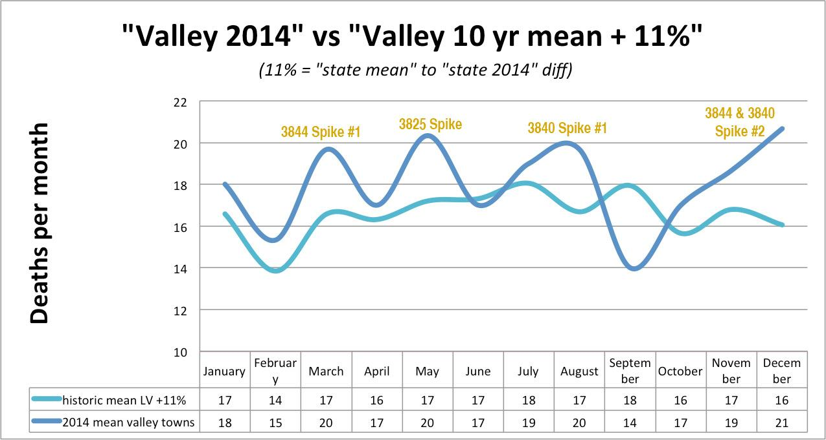*Figure 2*

Across Latrobe Valley:- Cumulative Death tolls go up by 22%. Peaks occurring at various times depending on type of exposure, distance from source & preparedness.

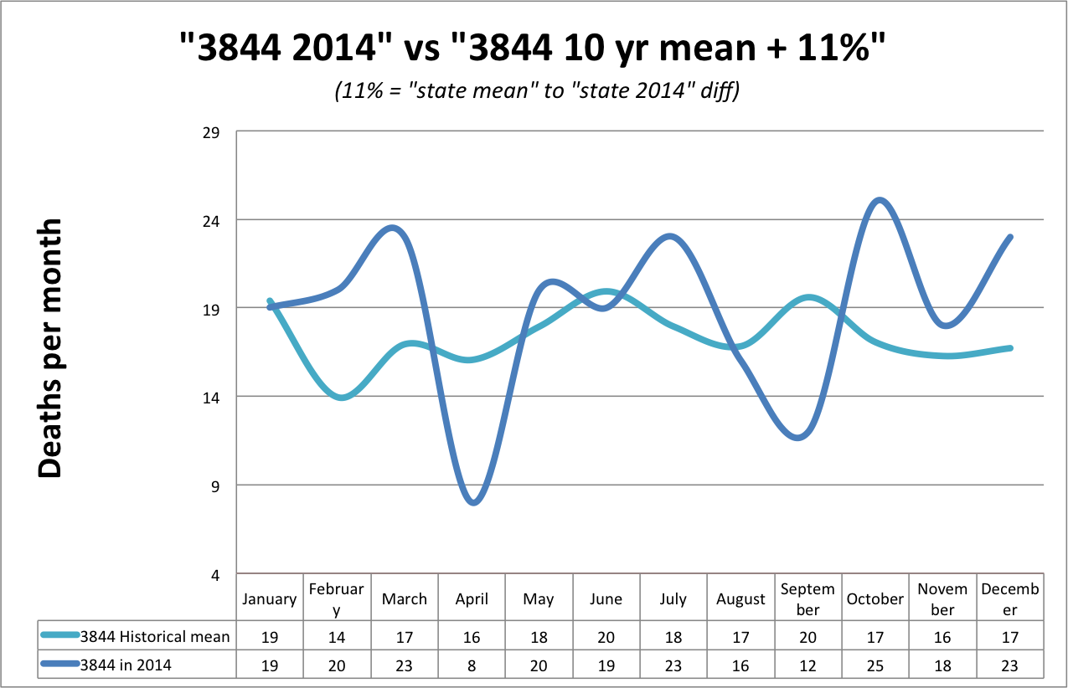

*Figure 3-3844 Traralgon deaths*

3844:- Town predominately downwind.

Blanketed, unwarned, unconcerned & considered safe.

Immediate harvesting impact and again in winter. (Traralgon)

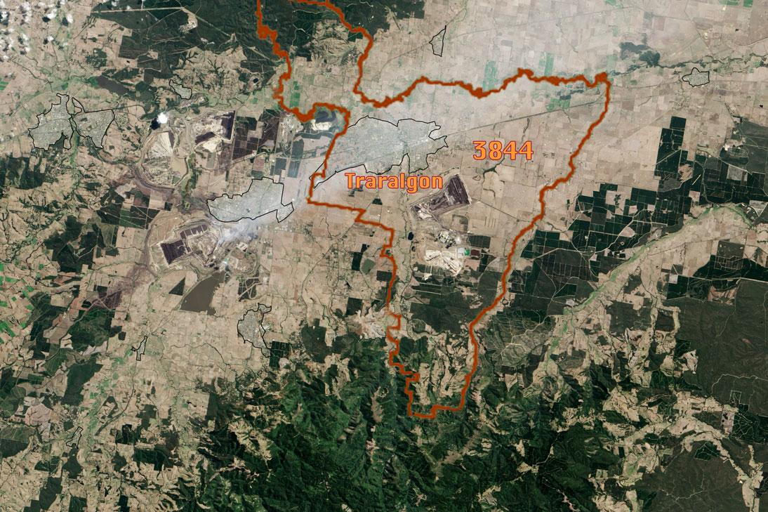

*Figure 4*

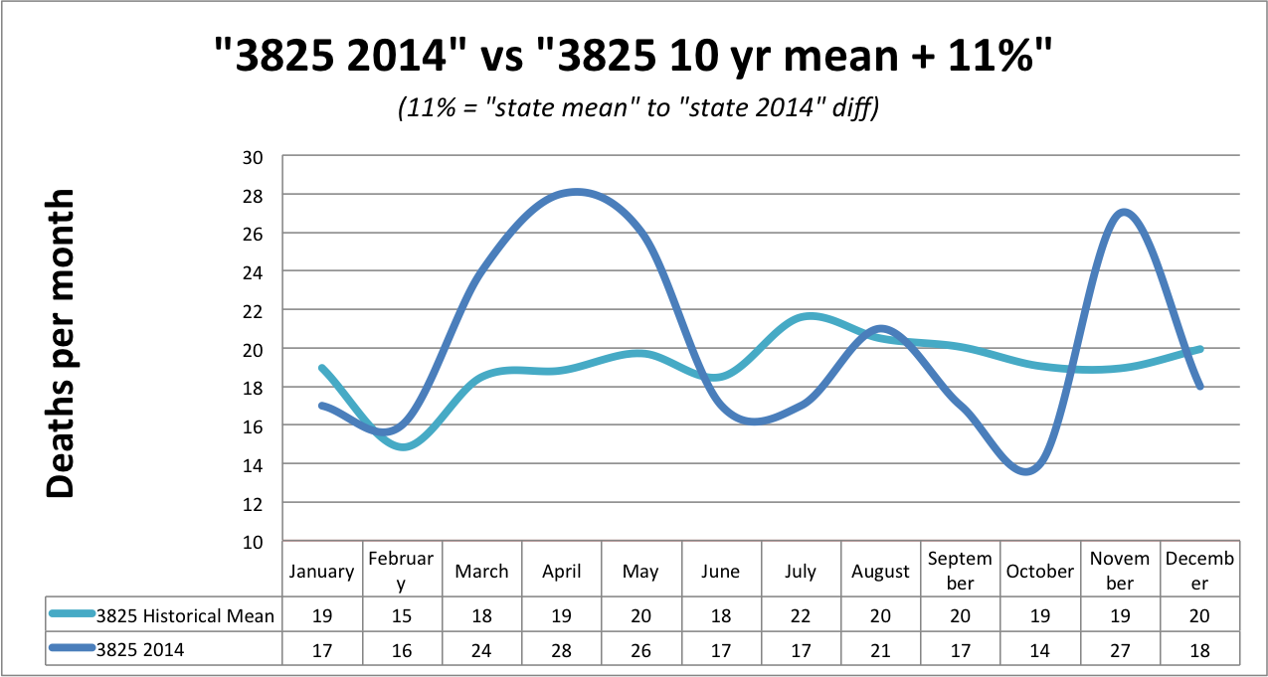

*Figure 5*

3825:- Town located in geographic basin that captures heavy gasses. Immersed, unwarned, unconcerned & considered safe.

immediate prolonged rise in death of vulnerable residents. (Moe)

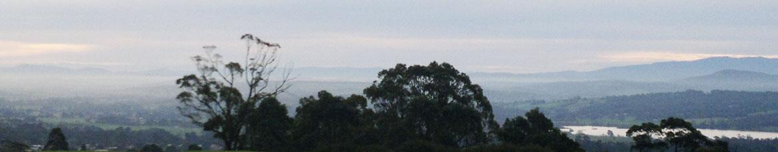

*Figure 6 heavy material sitting in Moe Basin*

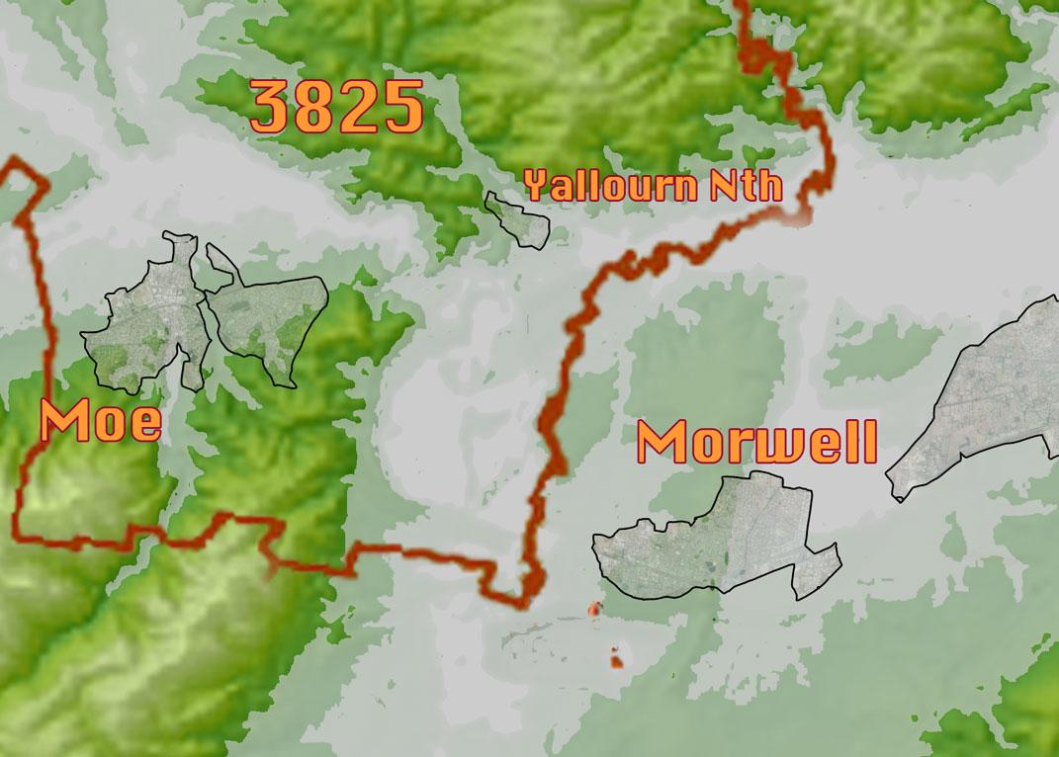

*Figure 7- 3825 geography, basin mouth + low point where Strzelecki Range & Great Divide meet.*

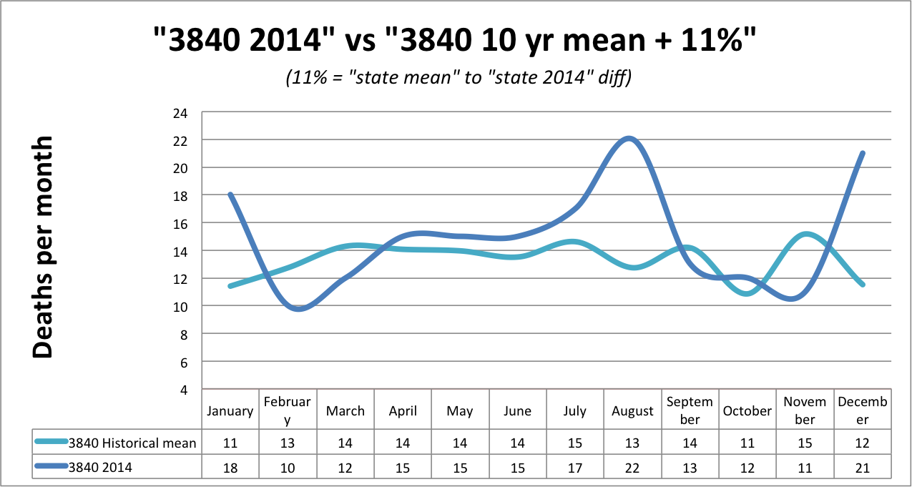

*Figure 8- 3840-Morwell deaths*

3840:- Town immediately adjacent to source.

Concerned, health efforts focused, 60% evacuated.

long term damage to vulnerable, harvesting from record heat wave in January then again in July and August with the onset of winter. (Morwell)

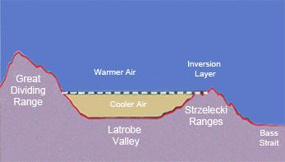

*Figure 9 – Gippsland inversion layer diagram*

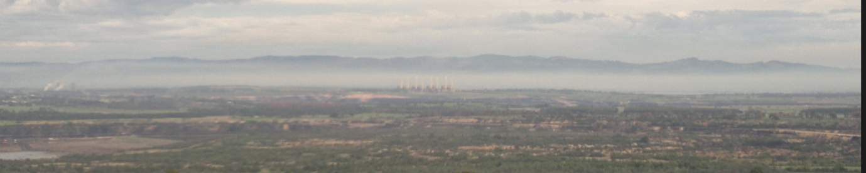

*Figure 10 – inversion layer over Morwell*

1. We ask the Inquiry to see if it can obtain data about causes of death (which we are not able to obtain because it is only available to registered medical researchers) specifically to discover if the higher than expected mortality rates are associated with the various toxins produced by the coal mine fire.

Conclusion

Analysis of the mortality data for the 10 year period 2004-2014 clearly shows a pattern in the Latrobe Valley during 2014 which needs to be recognised and investigated.

The initial analysis based on the 5 year period from 2009 to 2014 had only the data for the first 6 months of the 2014 year to compare with the 5 year period, and the 2 statistical interpretations, one by Professor Barnett and one by the University of Melbourne, are both based on these ranges. Barnett extrapolated that 10+ deaths could be attributed to the mine fire with some probability and the Melbourne University study, commissioned by the then health minister was unable to state statistically that none of the deaths could be attributed to the mine fire.

Since then the deaths have continue to increase and the figures have worsened.

We commissioned BDM to supply a broader range of statistics covering 10 years, the 12 months of 2014, and the whole of state deaths for trend comparisons.

We would respectfully suggest that the inquiry look at the 10 year range and examine the data from the whole 18 months since the mine fire rather than what has been used in the initial series of data analyses.

VOTV submission to Hazelwood Mine Fire Inquiry re Terms of reference 7.

Short, medium and long term measures to improve the health of the Latrobe Valley communities having regard to any health impacts identified by the Board as being associated with the Hazelwood Coal Mine Fire;

1. Voices of the Valley have always maintained that the imperative has been to conduct an immediate health snapshot of the Latrobe Valley population; to proactively search out what the current health status is in order to determine how best to maintain and improve the health of the population, rather than to do statistical assessments on corpses until a causal relationship can be shown with the mine fire.
2. At the beginning of the Hazelwood Mine Fire in 2014, members of Voices of the Valley began hearing stories of people being ill, of pets suffering and dying, and later, of higher than usual numbers of deaths for the time of the year. VotV began documenting these comments from the first public meeting, ran another health survey online and then again at the second public meeting in Kernot hall. When these matters were raised with Health authorities they did not seem to be taken seriously. Eventually the Government promised a long-term Health study as a panacea, but it seemed to be very slow getting off the ground.
3. Questionnaires about symptoms experienced were distributed and collected at each major event Voices of the Valley ran since the mine fire and the results were collated and analysed. Headaches, nose-bleeds, confusion and difficulty breathing were predominant, but most symptoms tended to be dismissed by health authorities as transitory or undiagnosed pre-existing conditions. However, the stories were sufficiently widespread and similar so that members of Voices of the Valley thought there were questions to be raised. Responses to surveys on 2 March 2014(meeting), 5-17 March 2014(on-line), and 24 March 204 (second meeting) about location and symptoms were collated and presented to the first Inquiry by Ron Ipsen on behalf of Voices of the Valley. They showed the same symptoms were being experienced in Morwell, Traralgon and Moe, with reported symptoms as far as Glengarry and Warragul.

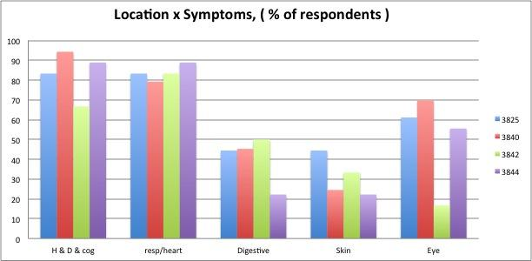

*Figure 1*

VotV began to correlate the data over time, recording increased reporting of different symptoms.

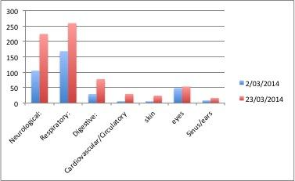

Figure 2(a) Symptoms reported (grouped)

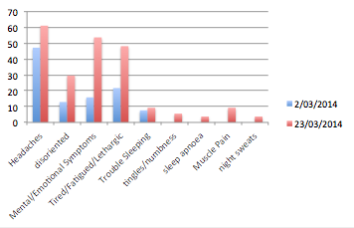

Figure 2 (b) eg- Neurological sub group

1. Following the release of the Hazelwood Mine Fire Inquiry Report, a Community Forum was held and another health survey was undertaken. The results of this indicated that while respiratory complaints had reduced somewhat, more than half the respondents indicated they had been suffering stress, anxiety and depression since the fire. At that time, the local office of Relationships Australia, Victoria, offered counselling, but were forced to withdraw the offer for lack of funding. In 2015, they again offered counselling. Voices of the Valley has no information about whether this offer has been taken up. Figure 3 shows the symptoms people reported at the time.

Because of the “pre-existing undiagnosed condition” rationale that was prevalent in health circles at the time , VotV began asking that question on the surveys to determine its relevance.

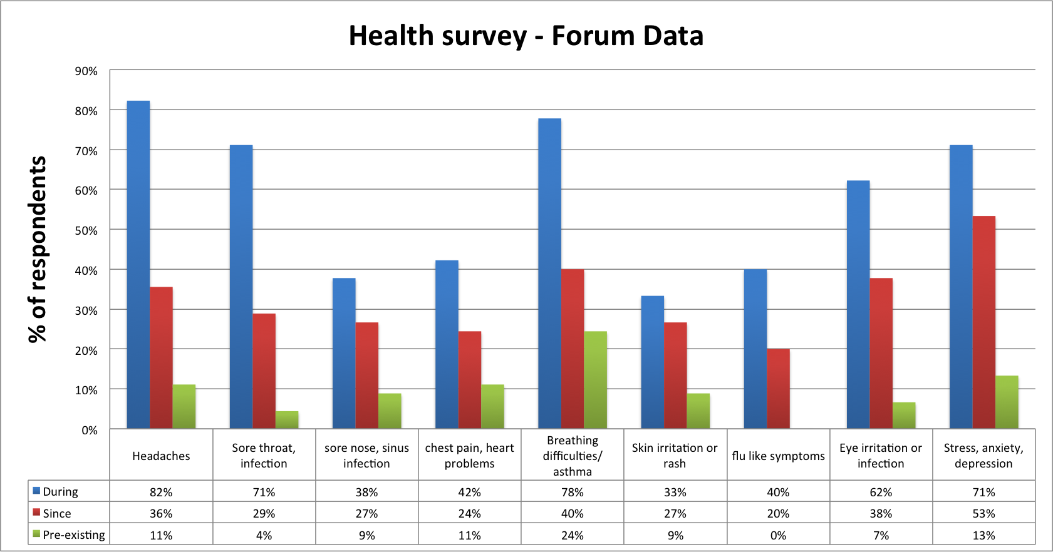

Figure 3

1. A fifth survey was carried out on the weekend of 25/26 July 2015. 220 people were asked to complete surveys. A broad analysis of the responses is presented in the following figures.

Figure 4

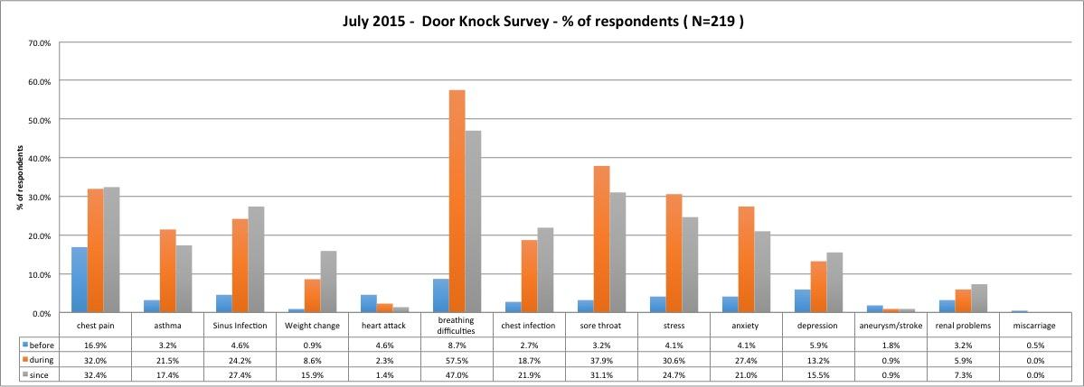

The results of the more recent surveys show that in most categories, symptoms have not abated as the then health department expected they would. Instead data indicates the opposite, including an increase in self reported psychological and emotional struggles.

1. The surveys Voices of the Valley have carried out have been of people who have attended events, filled out online questionnaires or have been approached in a door-knock of particular areas. All results are in terms of percentage of respondents in the particular survey, not percentage of population and are comparable only within the scope of the studies.

We do not claim that they are based on a representative sample, but the responses are self reported and indicative of the concerns that people are expressing, and they raise significant questions that must be investigated. These concerns and experiences are not restricted to residents of Morwell, but occur across all the major communities of the Latrobe Valley. The range of the mine fire smoke plume can be clearly seen in the satellite image below.

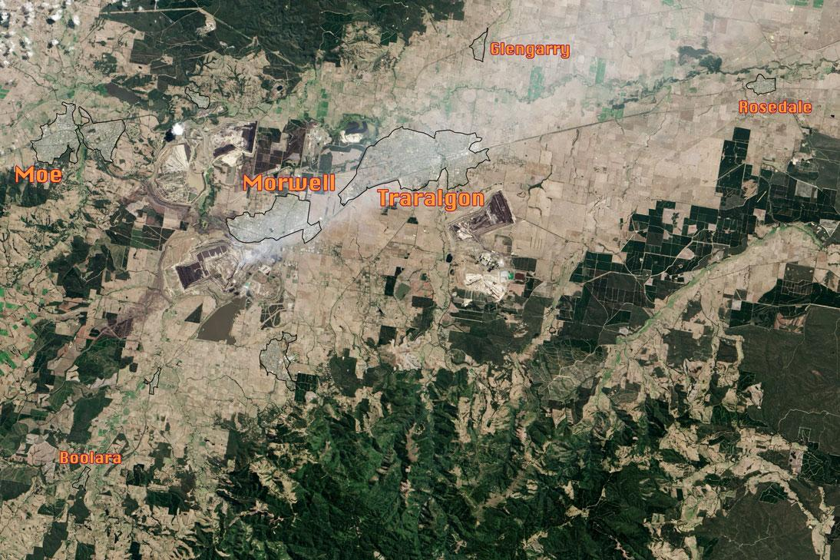

Figure 5

1. In October, 2014, members of Voices of the Valley started to work on designing a ‘health audit’ questionnaire which would comprehensively cover all the possible health consequences of exposure to toxic smoke, VOCs and Pm2.5 and other potential toxic effects of the mine fire. Details of the questionnaire and its basis can be found in the submission from Deearne Nicholson. We did not proceed with this audit for two reasons: firstly, our resources were limited to a small number of volunteers; secondly, the contract for a long term health study was announced, and we expected that the health study would begin with such an audit.
2. VotV continues to be approached by individuals who have experienced significant loss of health since the mine fire and are finding difficulty getting any help. Some report ongoing stress and anxiety in themselves and /or their children while others are reporting serious physical conditions that they fear may be attributable to the fire. On VotV’s Facebook page (public) there have been posts about illnesses in pets, as well.
3. Professor Campbell’s evidence to the first Inquiry drew attention to the likelihood of the kinds of experiences and symptoms VotV has been documenting.
4. Further questions we want the HMFI to ask are:
   1. Is there a program for screening volunteer fire fighters who fought the fire in the mine? Are there records of where the thousands of volunteers came from? Recently, a Gippsland volunteer firefighter was diagnosed with a form of cancer which his doctor believes is related the toxic elements of the mine fire and the firefighter has called for others who were working with him in the mine to seek immediate medical testing.
   2. Is there a program for screening professional firefighters who fought the fire in the mine? We would expect this is more likely as an occupational health and safety matter. If there is such a program, these fire fighters could be a population where emerging health issues might become apparent.
   3. Is there a program for screening mineworkers and others working close to the mine fire?
   4. Is there a program for screening people who lived and /or worked in Morwell, Traralgon and Moe during the period of the mine fire?
5. If there are no screening programs in place as yet, we ask the Inquiry to make a recommendation that one be set up using the expertise of specialists in environmental medicine and to advise who should be responsible for it.
6. We ask the Inquiry to make a recommendation for specific professional education for doctors to alert them to investigate symptoms which may be related to the toxins produced by the mine fire, bearing in mind that a number of doctors are new to the area, may not be aware of the specific health issues associated with coal mining and an industrial coal fire. This is especially important in light of the repeated statements of the previous Chief Health Officer for Victoria Rosemary Lester that she did not expect to see long term health effects from the mine fire.
7. The establishment of the Mine Fire Health Clinic for people who are concerned with their health following the mine fire was welcomed, but the experiences of how it works have been less positive. Appointments must be made through Latrobe Community Health in a rather laborious process, and the clinic consists of a single nurse who does a standard check and cannot refer people to a specialist or for tests. All the nurse can do is advise people to go to a GP.
8. What the people of the Latrobe Valley need are specialists with expertise in environmental medicine to check for conditions that may emerge from living through a toxic event. Medical services need to provide for tests and scanning to be done in the Latrobe Valley. There is data of particulates and volatile organic compounds released during the fire in EPA records. These should be used to inform a screening process to discover their effects. There is a pressing need for specialists in the Valley to avoid the current slow climb up current waiting lists. As reported to Wendy Farmer (President VotV) one family has a six month wait to see a specialist paediatrician while another resident is waiting for seven weeks to see a heart specialist despite having had a heart attack.
9. Bearing in mind the history of James Hardie Industries and compensation for asbestos related illnesses, we ask the Inquiry to make a recommendation for provision for people who suffer related health conditions that may emerge at a later date.
10. Two recent reports have drawn attention to the disadvantaged status of Morwell in particular. The VCOSS report *One Year On* notes some decline in health services since the mine fire along with increased demand, especially with respect to mental health services (p9-10). The just released report, *Dropping off the Edge,* published by Jesuit Social Services and Catholic Social Services Australia in July 2015, categorises Morwell as one of the most disadvantaged areas in the state. For this reason, many residents could not afford to evacuate and neither could they afford the air purifiers that made a considerable difference to those able to afford them. The out of date and inappropriate face masks which were distributed did not stop the carbon monoxide, pm2.5s or the NO2 or SO2 (nox and sox) and other toxic substances that was being inhaled day and night.
11. VotV supports the idea of a Health Conservation Zone for the Latrobe Valley, outlined as a matter for further consideration in the Report of the Hazelwood Mine Fire Inquiry.

18. Air monitoring must take into consideration the geography of the area and install monitors in order to monitor the air no matter which direction the winds blows in order to provide more accurate data. Had this been in place, it is unlikely that the short term solution of ‘evacuating’ groups of children and the elderly to the heavily impacted areas of Moe or Traralgon would have taken place.

Figure 6 Monitors needed to cover wind directions and geological architecture.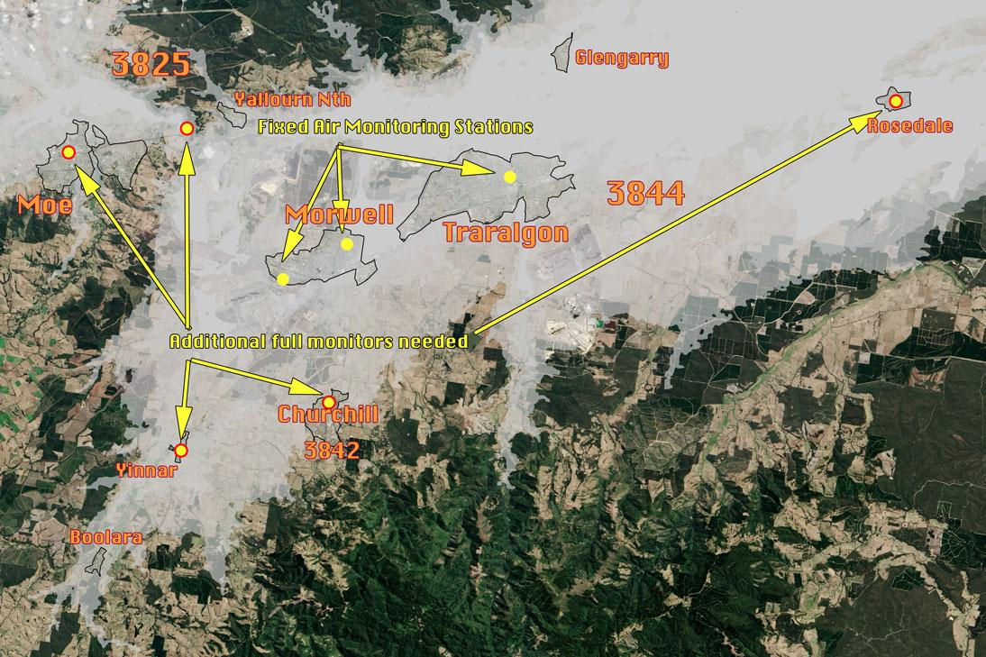

Conclusion:

The impact of exposure to a prolonged HazMat event on the health of residents in the Latrobe Valley seems to be both serious and ongoing. Symptoms have not dissipated as hoped, rather there are already indications that damage to many major bodily systems has occurred and continues to occur along with attendant rise in those self reporting anxiety, stress and depression.

Mental Health services require bolstering and the waiting times to see specialists is unacceptable. The creation of a Health Conservation Area and a Health Advocate for the Latrobe Valley as recommended in the report handed down after the first Mine Fire Inquiry is highly desirable.