**Hazelwood Coal Mine Fire Inquiry**

Page 1

Hazelwood Coal Mine Fire Inquiry

Submission from the Victorian Government – Anglesea Coal Mine, July 2015

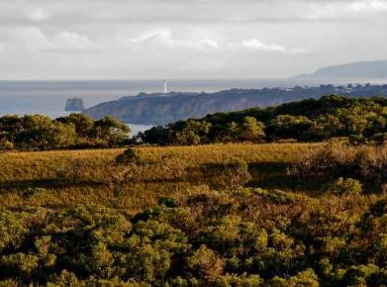

# Submission from the Victorian Government – Anglesea Coal Mine

July 2015

Authorised and published by the Victorian Government, 1 Treasury Place, Melbourne.

*Accessibility*

If you would like to receive this publication in an accessible format, please telephone 9651 5111 or email [advertising@dpc.vic.gov.au.](mailto:advertising@dpc.vic.gov.au)

© State of Victoria 2015



This work is licensed under a [Creative Commons Attribution 3.0 Australia licence.](http://creativecommons.org/licenses/by/3.0/au/) You are free to re-use the work under that licence, on the condition that you credit the State of Victoria as author. The licence does not apply to any images, photographs or branding, including the Victorian Coat of Arms and the Victorian Government logo.

To view a copy of this licence, visit [creativecommons.org/licenses/by/3.0/au](http://creativecommons.org/licenses/by/3.0/au/).

# Table of contents

1. Glossary 4
2. Introduction 6

Hazelwood Coal Mine Fire Inquiry 2014 6

Reopened Hazelwood Coal Mine Fire Inquiry 6

Victorian Government Submission – Anglesea Coal Mine 6

1. Management of the Anglesea Heath 8

The Anglesea Coal Mine 8

Coal Mine Emergency Management Taskforce - Surf Coast 9

Anglesea Heath 9

Management of the Heath 10

Fire Management for the Heath 11

Prevention 13

Preparedness 16

Response 20

Recovery 21

1. Fire responses within the Anglesea Coal Mine and Anglesea Power

Station 22

Alcoa Anglesea CFA PIP 22

Next Steps 23

# Glossary

Common terms used throughout this Submission include:

|  |  |
| --- | --- |
| Alcoa | Alcoa of Australia Limited |
| Alcoa Anglesea Coordination Committee | The whole of Victorian Government Committee established to respond to the Anglesea mine closure |
| Alcoa Anglesea Pre- Incident Plan | Alcoa Anglesea Pre-Incident Plan, April 2015 |
| Anglesea Local Emergency Planning Factors | Anglesea Local Emergency Planning Factors 2012-2013 |
| Anglesea Coal Mine | The open cut coal mine at Anglesea |
| Anglesea Local Response Plan – Bushfires | Anglesea Local Response Plan – Bushfires, February 2015 |
| Anglesea Heath Management Plan | The Anglesea Heath Management Plan (2002) |
| Anglesea Power Station | The power station adjoining the Anglesea Coal Mine |
| Barwon Otway Bushfire Risk Landscape | The Barwon Otway Bushfire Risk Landscape is in the south west of Victoria, extending north from Skipton, south to Cape Otway, east to Queenscliff and west to Port Campbell. The landscape includes the City of Greater Geelong, the Borough of Queenscliff, Colac Otway Shire, Corangamite Shire and Surf Coast Shire (containing Anglesea town, Anglesea Coal Mine and the Heath) |
| Barwon Otway Plan | Strategic Bushfire Management Plan – Barwon Otway Bushfires Risk Landscape 2014 |
| Barwon South West Region | The Barwon South Western region covers south western Victoria and is bounded by Lara to the east and the border of South Australia to the west |
| Barwon South West Response Plan | Barwon South West Region 2014/15 Bushfire Readiness and Response Plan |
| Barwon South West Region FOP | Fire Operations Plan Barwon South West Region 2014/15 – 2016/17 |
| Board of Inquiry | The Board of Inquiry into the Hazelwood Coal Mine Fire, comprising the Honourable Bernard Teague AO (Chair), Professor John Catford and Mrs Anita Roper |
| Alcoa Anglesea CFA PIP | Alcoa Anglesea County Fire Authority Operational Pre-Incident Plan, ANGL0027 |
| Chief Officer | The individual designated, under the *Emergency Services Act 2013*, as having overall control of the response activities in relation to a fire |
| Code of Practice for Bushfire Management | Code of Practice for Bushfire Management on Public Land (2012) |
| Cooperative Land Management Agreement | The Cooperative Land Management Agreement (2000) between Alcoa and the former Department of Natural Resources and Environment (now Department of Environment, Land, Water and Planning) for the management of Anglesea Heath |
| ESTA | Emergency Services Telecommunications Authority |

|  |  |
| --- | --- |
| HAZMAT | Hazardous materials |
| Heath | Anglesea Heath that adjoins the Great Otway National Park |
| Hazelwood Coal Mine Fire | The fire at the Hazelwood Coal Mine in February and March 2014 |
| Latrobe Valley coal mines | The Loy Yang, Hazelwood and Yallourn coal mines in the Latrobe Valley |
| Management Agreement 2013 | Management Agreement 2013 between the Secretary to the Department of Environment and Primary Industries and Parks Victoria, which sets out the arrangements for the management of the parks and reserves estate in Victoria and the delivery of land management services necessary to implement the objectives of Victoria’s land legislation |
| PHOENIX Rapidfire | Bushfire simulation software developed by the University of Melbourne and the Bushfire Co-operative Research Centre, together with the former Department of Environment and Primary Industries (now the Department of Environment, Land, Water and Planning) |
| Register | Register of the National Estate |
| Surf Coast Taskforce | Coal Mine Emergency Management Taskforce - Surf Coast, established to examine preparedness for the 2014/15 and 2015/16 summer seasons for the Anglesea Coal Mine |
| This Submission | The Government’s Submission to the Hazelwood Coal Mine Fire Inquiry, titled *Submission from the Victorian Government – Anglesea Coal Mine July 2015* |
| Township Protection Plan | Township Protection Plan, November 2011 |
| 2014 Inquiry Report | Hazelwood Coal Mine Fire Inquiry Report 2014 |

The following acronyms are used throughout this Submission:

|  |  |
| --- | --- |
| CFA | Country Fire Authority |
| CFL Act | *Conservation, Forests and Lands Act 1987* (Vic) |
| DEDJTR | Department of Economic Development, Jobs Resources and Transport |
| DELWP | Department of Environment, Land, Water and Planning |
| DEPI | Former Department of Environment and Primary Industries |
| EMC | Emergency Management Commissioner |
| EMV | Emergency Management Victoria |
| EPA | Environment Protection Authority |
| FOP | Fire Operations Plan |
| Forests Act | *Forests Act 1958* (Vic) |
| M(AA) Act | *Mines (Aluminium Agreement) Act 1961* (Vic) |
| National Parks Act | *National Parks Act 1975* (Vic) |
| NRE | Former Department of Natural Resources and Environment |
| TOR | Terms of Reference for the Hazelwood Coal Mine Fire Inquiry |
| VWA | Victorian WorkCover Authority |

# Introduction

## Hazelwood Coal Mine Fire Inquiry 2014

* 1. In February and March 2014, a fire burned in the Hazelwood Coal Mine. The fire required significant resources to bring it under control, and impacted on local communities, particularly in the town of Morwell.
  2. An independent inquiry into the circumstances of the Hazelwood Coal Mine Fire was held in 2014. The Board of Inquiry conducted a thorough investigation into the Hazelwood Coal Mine Fire, which included community consultations, public submissions and 14 days of public hearings.
  3. The 2014 Inquiry Report was tabled in the Victorian Parliament on 2 September 2014.
  4. The Victorian Government has committed to implementing the 2014 Inquiry Report Recommendations and Affirmations, with $30 million announced in the 2015/16 Victorian Budget to fulfil this commitment.1
  5. The Hazelwood Mine Fire Inquiry Implementation Monitor has been appointed to monitor and report on the implementation of the 2014 Inquiry Report by the Victorian Government and the Hazelwood Coal Mine operator, GDF Suez, annually for three years.

## Reopened Hazelwood Coal Mine Fire Inquiry

* 1. On 26 May 2015, The Honourable Lily D’Ambrosio MP, Minister for Energy and Resources, and The Honourable Jill Hennessy MP, Minister for Health, announced the reopening of the Hazelwood Mine Fire Inquiry.
  2. On 26 May 2015, the Governor in Council established the Hazelwood Coal Mine Fire Board of Inquiry, chaired by the Honourable Bernard Teague AO, with Professor John Catford and Mrs Anita Roper as Board Members.
  3. The Board of Inquiry will inquire into, and report on, concerns in respect of an increase in deaths following the Hazelwood Coal Mine Fire, options for rehabilitation of the Latrobe Valley coal mines and options to minimise the risk of fire at the Anglesea Coal Mine for the 2015/16 summer season.

## Victorian Government Submission – Anglesea Coal Mine

* 1. The Victorian Government welcomes the opportunity to assist the Board of Inquiry to inquire into, and report on, options for Alcoa to minimise the risk of fire at the Anglesea Coal Mine for the 2015/16 summer season. This Submission has been prepared on behalf of all departments and relevant agencies of the Victorian Government.
  2. The Victorian Government intends to make further submissions to the Board of Inquiry in respect of the TOR.
  3. This Submission responds to relevant matters for inquiry set out in the Order in Council, Term of Reference 11, which appointed the Inquiry in respect of the Anglesea Coal Mine, to inquire into and report on:

1 Victorian Budget 15 – 16, Service Delivery Budget Paper No. 3, pages 12 to 15.

‘Sustainable, practical and effective options that could be undertaken by the mine operator to decrease the risk of fire arising from or impacting the Anglesea Mine for the 2015/2016 summer season, noting the impending closure of the mine on 31 August 2015.’2

* 1. This Submission sets out:

 a high level overview of the Victorian Government’s response to the closure of the Anglesea Coal Mine and Anglesea Power Station on 31 August 2015

 the arrangements for management of the Heath, focusing on the management of the risk of bushfires

 the management of the Great Otway National Park, to address the risk of bushfire and protect the community of Anglesea, and the greater region, from the negative impacts of bushfires

 a broad context of fire risk management in the Barwon South West Region, demonstrating the prevention, preparedness, response and recovery roles.

2 Order In Council Appointment of the a Board of Inquiry into the Hazelwood Coal Mine Fire dated 26 May 2015.

# Management of the Anglesea Heath

## The Anglesea Coal Mine

* 1. On 22 November 1961, the State of Victoria and Alcoa entered into a 50 year agreement supporting the development of the Point Henry aluminium smelter and the operation of the power station and associated coal mine at Anglesea. In 2011, Alcoa exercised its right to extend the lease for a further 50 years.
  2. Alcoa’s mine lease area covers 7,145 hectares of land and includes the mine site, the power station and approximately 6,495 hectares of the Heath. This is shown below at **Map 1**.

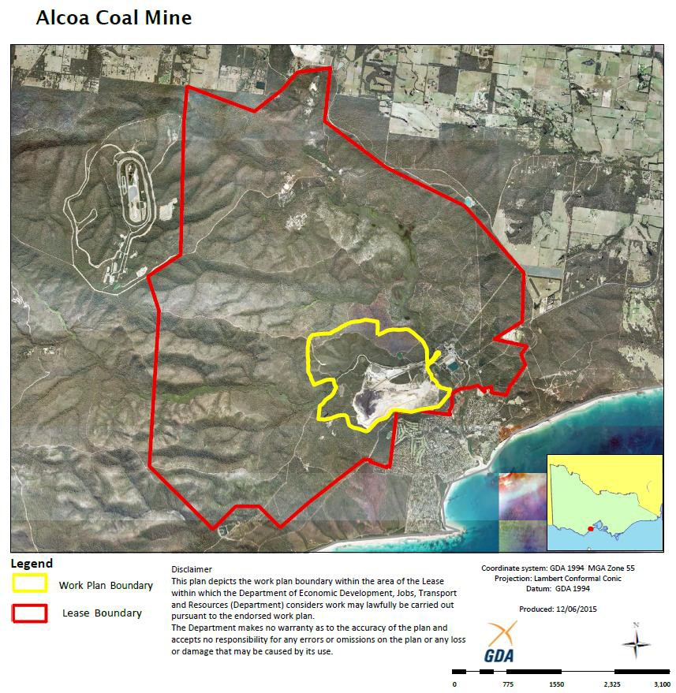

### Map 1: Map of the Anglesea Coal Mine work plan and lease boundary area June 2015

* 1. On 12 May 2015, Alcoa announced that it would permanently close the Anglesea Coal Mine and Anglesea Power Station on 31 August 2015.
  2. The Victorian Government has a coordinated response to the closure of the Anglesea Coal Mine and Anglesea Power Station through the Alcoa Anglesea Coordination Committee, which was established when Alcoa announced the closure. The Alcoa Anglesea Coordination

Committee is chaired by the Deputy Secretary of Energy and Resources in DEDJTR, with membership from across Victorian Government agencies and departments that have a role in the closure or post closure requirements.

* 1. The Alcoa Anglesea Coordination Committee provides a single contact point to assist Alcoa plan for the closure of the Anglesea Coal Mine and Anglesea Power Station and the Victorian Government’s response. Alcoa’s plans for the closure, rehabilitation of the site and all other regulatory and administrative requirements will be overseen by government departments and agencies. This includes DEDJTR, which regulates the rehabilitation of the Anglesea Coal Mine, the EPA which regulates the decommissioning and rehabilitation of the Anglesea Power Station and any ongoing water discharges from the site in respect of environmental issues, and DELWP in regards to land, fire and water matters. Through the assistance of Regional Development Victoria, the Victorian Government is committed to providing support to workers during this difficult time.
  2. Alcoa has committed to working with the Victorian Government to develop and implement plans to rehabilitate the Anglesea Coal Mine and Anglesea Power Station. Alcoa will provide its proposed timeline for closure and post closure activities to the Alcoa Anglesea Coordination Committee in July 2015, for consideration and consultation with the Victorian Government. The rehabilitation of the Anglesea Coal Mine and Anglesea Power Station is expected to take a number of years to complete and the community will be consulted on the closure and rehabilitation of the site.

## Coal Mine Emergency Management Taskforce - Surf Coast

* 1. As part of the implementation of the 2014 Inquiry Report, the Surf Coast Taskforce was established to examine fire preparedness for the 2014/15 and 2015/16 summer seasons for the Anglesea Coal Mine and support improved capability and interoperability between the coal mine industry, government agencies and community.
  2. The Surf Coast Taskforce is chaired by the EMC. Its membership includes CFA, EMV, DELWP, DEDJTR, VWA, EPA, the Surf Coast Shire Council, Alcoa and others as appropriate.
  3. The Surf Coast Taskforce commenced on 14 November 2014. It has held four meetings/workshops and encouraged Alcoa and the Latrobe Valley Mines to work together to learn from the lessons arising out of the Hazelwood Coal Mine Fire.
  4. With the announcement by Alcoa of the closure of the Anglesea Coal Mine and Anglesea Power Station, the Surf Coast Taskforce focus is on maintaining a safe site for the 2015/16 summer season.

## Anglesea Heath

* 1. The Heath lies to the north and west of the town of Anglesea within DELWP’s Barwon South West Region and is adjacent to the Great Otway National Park. The Heath is represented on **Map 1** as the land within the Lease Boundary, excluding the land within the work plan boundary.
  2. The Heath contains a high diversity of flora and fauna, including nine plant species considered rare or vulnerable in Victoria, and 16 plant species with disjunct populations. The Heath was assessed by the Australian Heritage Commission in 1992 as having the richest and most diverse vegetation community recorded in Victoria.
  3. The Victorian Government has committed to incorporating the Heath into the Great Otway National Park.3 This is subject to discussions with Alcoa and will also require legislative amendments to the M(AA) Act and the National Parks Act.

## Management of the Heath

* 1. A Cooperative Land Management Agreement was signed on 8 November 2000 by the Secretary of the former NRE4 and Alcoa, to allow the Secretary and Alcoa to manage the Heath for conservation purposes.5
  2. The Cooperative Land Management Agreement provides for the protection and preservation of the natural environment, including indigenous flora and fauna, and features of scenic, archaeological, geological, historic or other scientific interest.6
  3. The Cooperative Land Management Agreement was entered into pursuant to s. 69 of CFL Act.7
  4. The Anglesea Heath Management Plan8 was developed to guide the strategic and ‘day-to- day’ management of the Heath in accordance with the overarching conservation objectives of the Cooperative Land Management Agreement. It was prepared by the Secretary of the former NRE, Parks Victoria and Alcoa, with input from stakeholders including Anglesea Aireys Inlet Society for the Protection of Flora and Fauna, Geelong Environment Council, Deakin University and the Surf Coast Shire.
  5. The primary focus of the management regime is to manage the Heath for its various conservation values in a manner that is consistent with the surrounding Great Otway National Park. This includes managing it for fire risk.
  6. The Anglesea Heath Management Plan contains seven key management areas:  biodiversity conservation

 protection of natural values  impact management

 cultural resource management

 recreation and tourism management  interpretation and information

 community participation and involvement.

* 1. Each key management area contains sub-plans, that focus on the management of specific elements of the Heath and its recreational use. Sub-plan D.5.4 focuses on fire management, and the actions associated with this key area are detailed below.9

3 *Our Environment, Our Future*, Victorian Labour Party Election Commitments 2014.

4 Now the Secretary to DELWP, being the body corporate created by s.6 of the CFL Act.

5 Agreement between the Secretary of the Department of NRE and Alcoa of Australia Limited (2000), land for conversation shown on the Plan in Schedule B.

6 Ibid, paragraph 2.

7 Alcoa are treated as the landowner of the Heath for the purpose of the Cooperative Land Management

Agreement, stemming from the nature of the leasehold right Alcoa has over the Heath pursuant to the M(AA) Act.

8 [http://parkweb.vic.gov.au/__data/assets/pdf_file/0005/313277/plan-Anglesea-Heath.pdf.](http://parkweb.vic.gov.au/__data/assets/pdf_file/0005/313277/plan-Anglesea-Heath.pdf)

9 Anglesea Heath Management Plan November 2002, page 33.

### Anglesea Heath Management Plan, Sub-Plan, D.5.4 Fire Management “Actions – Major actions to be undertaken for this key area are to:

 provide interpretative material regarding fire safety and management  prohibit open fires and fuel stoves in Anglesea Heath

 patrol sites of highest visitor use, particularly in periods of high fire danger

 enforce fire regulations and restrictions on the use of fire within Anglesea Heath  use, where possible, the following least disturbance strategies for wildfire

suppression in Anglesea Heath (in accordance with the Code of Practice for

Bushfire Management):

* fireline construction using hand crews
* air attack to drop fire retardant, water and foam
* back burning from existing roads and tracks
* using existing roads and tracks or topographic features as control lines
* where possible avoid the use of bulldozers within the heritage area
* where possible, avoid the use of bulldozers in areas infected with Cinnamon Fungus

undertake washdowns and other available measures to prevent the introduction and/or spread of pest plants and Cinnamon Fungus during prescribed burning activities

close and revegetate any new control lines after fire in accordance with the Code of Practice for Bushfire Management

develop Anglesea area ecological burn strategy.”

## Fire Management for the Heath

* 1. The Heath is, and will continue to be managed for the 2015/16 summer season, by DELWP and Parks Victoria as though it forms part of the adjoining Great Otway National Park. This approach is a practical response to the physical proximity of the Heath to the national park and means that the bushfire management at the Heath will continue to be consistent with arrangements for the national park. These arrangements include those documented in the Management Agreement 2013 between DELWP and Parks Victoria,10 the Great Otway National Parks Management Plan, the Anglesea Heath Management Plan and the Barwon Otway Plan.
  2. DELWP’s fire management role in relation to relevant public land stems from the Forests Act. The Forests Act provides that the Secretary to DEWLP (acting in its body corporate capacity) must carry out proper and sufficient work for the planned prevention of fire in State forests, national parks and protected public land.
  3. The Heath forms land regulated by the M(AA) Act. It is not State forest, national park, or protected public land for the purposes of the Forests Act. However, on the basis of the

10 DELWP, along with Parks Victoria, manage more than seven million hectares of public land across Victoria, carrying out fire prevention activities on this land to help reduce the impacts of bushfires to communities and the environment.

Cooperative Land Management Agreement, for practical purposes it is managed by DELWP and Parks Victoria. The management of the Heath is fully integrated with the broader bushfire management program in DELWP’s Barwon South West Region

* 1. Bushfire management planning for public land in Victoria occurs at State, regional and local levels, as seen in **Figure 1.**

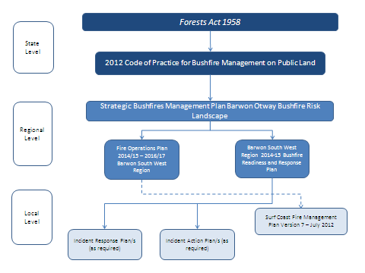

### Figure 1: Bushfire management planning for public land in Victoria at the State, regional and local level

* 1. A series of regional level plans are in place to address bushfire management in DELWP’s Barwon South West Region, including:

 a strategic bushfire management plan (for the) Barwon Otway Bushfire Risk Landscape

 Barwon South West Readiness and Response Plan (which is updated annually)  Fire Operations Plan Barwon South West Region (which is updated annually).

* 1. These plans inform local level planning and resource allocation within DELWP’s Barwon South West Region, and guide DELWP and Parks Victoria, as the managers of relevant public land, in undertaking coordinated prevention, fuel management, preparedness, and response and recovery actions on relevant public land to reduce bushfire risk and promote ecosystem resilience.

*Barwon Otway Plan*

* 1. For strategic bushfire management planning purposes, Victoria is broken up into seven bushfire risk landscapes. Strategic bushfire management plans are developed for each bushfire risk landscape to guide implementation of bushfire mitigation strategies.
  2. A ‘bushfire risk landscape’ is an area where bushfire behaviour is sufficiently common to treat the area as a whole; such as the types of places bushfires can start, the terrain and vegetation that they could spread in and the types of impacts that could occur. The risk

landscape that encompasses the Heath is the Barwon Otway Bushfire Risk Landscape, which is wholly located within DELWP’s Barwon South West Region.

* 1. The Barwon Otway Bushfire Risk Landscape covers 1,065,300 hectares, which is five per cent of the State’s area.11 Of this, 4.6 per cent of the landscape is public land managed by DELWP (48,500 hectares) and 13.5 per cent is public land managed by Parks Victoria (143,900 hectares).12
  2. The Barwon Otway Plan outlines the fuel management strategy, and other actions that will be undertaken by DELWP and Parks Victoria to minimise the impact of major bushfires on people, property, infrastructure and economic activity within the region. The Barwon Otway Plan guides DELWP and Parks Victoria on the coordinated implementation of works to comply with the Code of Practice for Bushfire Management, which is the State’s key governing document for bushfire management on public land in Victoria.
  3. The Barwon Otway Plan aims to reduce the impact of bushfires on communities (such as Anglesea, Aireys Inlet and Lorne), infrastructure and high-value ecosystem areas. This is achieved by managing fuel loads to reduce fire spread and intensity. Strategic fire management planning involves conducting detailed likelihood and consequence risk assessments across the landscape. These risk assessments are used to target locations where fuel management activities will contribute to mitigating the spread and intensity of fires. Fuel management activities are conducted:

 in areas where bushfires are likely to start, to prevent or limit ignition

 along the paths that bushfires are likely to spread, to reduce their rate of spread, intensity and long-distance spotting potential

 close to high-priority assets, to reduce the intensity and short-distance spotting potential of bushfires.

* 1. DELWP’s Otway’s District, with the support of Parks Victoria and a strong relationship with the CFA, leads the delivery of fire management programs within the Barwon South West Region. The management of fire risk extends to strategies and activities across the emergency management spectrum, from prevention, preparedness and fuel management to response and recovery.

### Prevention

* 1. Preventing fires from igniting and spreading on public land lowers the risk of fires impacting on communities and the environment. DELWP and Parks Victoria carry out numerous activities to prevent fires from igniting on public land.
  2. DELWP and Parks Victoria engage with communities to educate people on fire risk and promote shared responsibility and risk management.
  3. Officers from DELWP and Parks Victoria also patrol campsites on severe fire weather days, and on days leading up to severe fire weather conditions. These officers inspect campsites to ensure compliance with relevant regulations and issue fines for non-compliance, enforce total fire ban days, and engage with campers about fire danger.

11 Strategic Bushfire Management Plan – Barwon Otway Bushfires Risk Landscape 2014, page 10.

*Fuel Management*

* 1. Managing fuel loads on public land is an important part of DELWP and Parks Victoria’s fire prevention activities.
  2. The likelihood of a fire igniting and spreading is impacted by a range of factors, including the terrain and vegetation within a landscape. Fuel management of the landscape reduces the amount of vegetation a fire could consume and includes planned burning and mechanical fuel reduction activities, such as slashing and mowing, to remove undergrowth and tree canopies.
  3. DELWP and Parks Victoria undertake a range of fuel management activities to reduce fuel loads, including decreasing the quantity of leaf litter, twigs, bark and undergrowth. This is carried out by planned burning and mechanical methods, such as mulching, applying herbicide, mowing and slashing.
  4. Planned burning, the deliberate introduction of fire into the landscape to reduce the fuel load, is an effective method to manage fuels in large areas of public lands. It is the main mechanism used by DELWP and Parks Victoria to reduce bushfire risk under the Barwon Otway Plan. Planned burns also play a role in ecological management and forest regeneration. Although planned burning cannot eliminate the risk of bushfires, it reduces fuel loads and can increase the effectiveness of fire suppression activities, which decreases the likelihood of fires igniting and spreading.
  5. Approximately 180,000 hectares, or 17 per cent of the total landscape, of the Barwon Otway Risk Landscape is treatable by planned burning, comprising 42 per cent of public land and 10 per cent of private land.13 The remaining land is not treatable by planned burning because the vegetation cannot readily be treated by fire under controlled conditions (such as wet forest), or the land is sensitive to fire, is physically too difficult to burn or is occupied by infrastructure or private homes.
  6. In the past 10 years, 11.3 per cent of the public land and 0.1 per cent of the private land has been burnt through planned burning in the Barwon Otway bushfire risk landscape. The planned burning targets for 2015/16 have been set at 9,000 hectares for the Barwon Otway Bushfire Risk Landscape, which is approximately five per cent of public land.
  7. Implementation of the Barwon Otway Plan has significantly reduced the risk of bushfires to communities in the region. Fuel management activities on public land have reduced the risk to Anglesea by 79 per cent.14 As seen in **Figure 2**, the modelled residual risk of bushfires to communities is between 50 per cent and 65 per cent in 2015.15
  8. Strategic fire management modelling indicates that planned burning and fuel reduction activities have significantly reduced the residual risk faced by the communities in the region since the Ash Wednesday bushfires of 1983 burnt through 41,000 hectares in the Otway Ranges and resulted in the loss of three lives and 782 buildings.

13 Ibid, page 28.

14 Ibid, page 31.

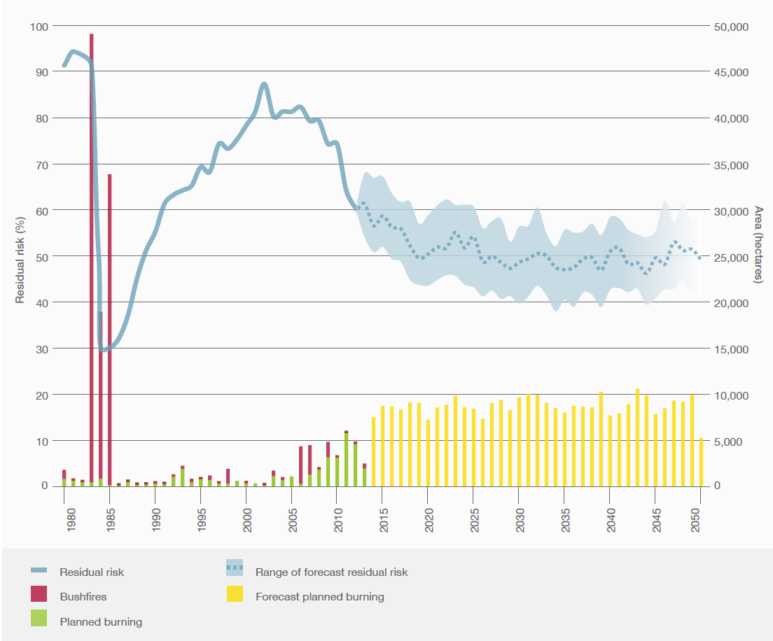

### Figure 2: Residual risk, 1980 – 2050 (Barwon Otway Plan, p 31)

*Fire Operations - Barwon South West Region*

* 1. Specific fuel reduction activities are regulated by a FOP, a regional plan updated annually, which details the fuel reduction activities to be completed for the following three years. The current Barwon South West Region FOP will regulate fuel reduction activities for 2014/15 to 2016/17.
  2. FOPs are produced by each bushfire risk landscape region. They outline where DELWP and Parks Victoria intend to carry out fuel reduction activities over the next three years, weather and conditions permitting.
  3. The Barwon South West Region FOP details the fire prevention and preparedness works to be delivered in this region for the period 2014/15 to 2016/17.
  4. The Barwon South West Region FOP is prepared by DELWP, and shaped by feedback and knowledge from local communities and key stakeholders such as the CFA, local councils, forest managers and flora and fauna specialists, as well as key industries.
  5. The Barwon South West Region FOP identifies three types of fuel reduction activities, which have been and will continue to be undertaken over the three-year cycle:

 **planned burns:** controlled application of fire during periods of lower fire risk to achieve one of three main purposes – fuel reduction, ecological management and forest regeneration

 **works program:** activities required to support the planned burning program, such as the maintenance and construction of fire control lines, fuel breaks, fire infrastructure and other fuel management activities

 **strategic fuel breaks:** establishing and maintaining a network of strategic fuel breaks, which are strips of land where vegetation has been modified to reduce the amount of fuel available to burn during bushfires.

* 1. The planned burning schedule for the Surf Coast Shire (which includes the Heath) for the next three years and some of the response resources in the region are set out in **Map 2**.

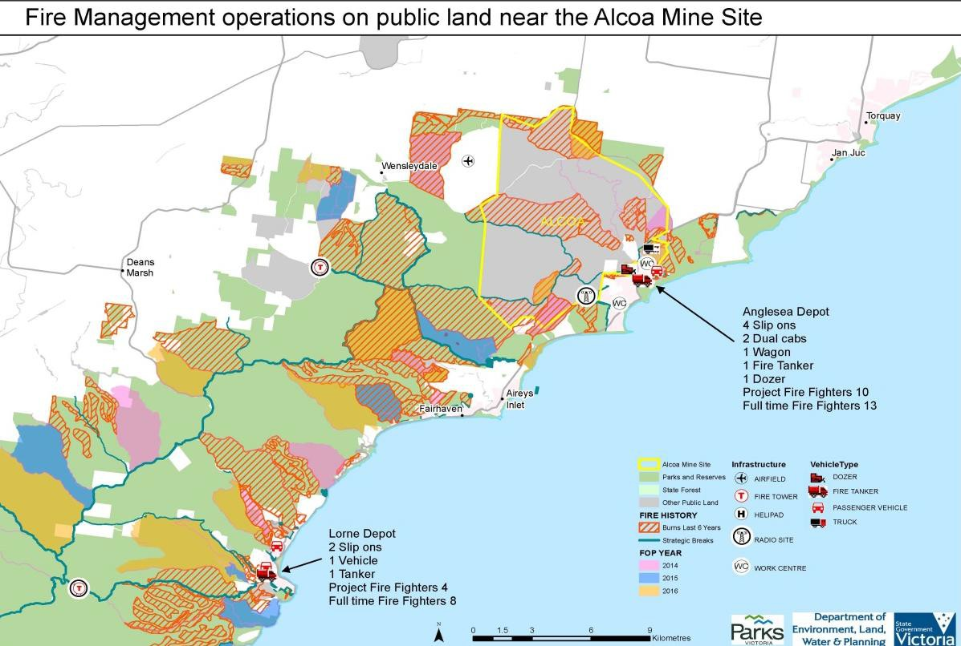

### Map 2: Map of the planned burning schedule for the Surf Coast Shire (Note: schedule is not static and may change as a result of bushfire risk analysis)

* 1. In 2014/15, one planned burn of 232 hectares was completed within the Heath. It must be noted that the FOP is not a static document and may change as a result of bushfire risk analysis.

### Preparedness

* 1. Preparedness activities play an important role in managing emergencies. Preparedness activities, including scenario planning, ensure response activities can occur quickly, efficiently and effectively in response to emerging threats.
  2. As outlined in the Code of Practice for Bushfire Management, DELWP through its preparedness activities and risk analysis aims to achieve the following outcomes:

 effective and appropriate allocation of staff capabilities and resources for bushfire management

 effective and appropriate allocation of non-staff capabilities (including equipment, plant and vehicles) and resources for bushfire management

 improved interoperability with other fire and emergency management agencies.

* 1. These outcomes are achieved through the following strategies:

 developing and maintaining staff capabilities, resources and readiness for bushfire response according to existing and forecast bushfire risk

 developing and maintaining non-staff capabilities, resources and readiness for bushfire response according to existing and forecast bushfire risk

 developing and implementing robust and functional fire danger and risk analysis products and systems, which describe existing and forecast bushfire risk across Victoria at daily, weekly and seasonal levels

 developing strategies and joint partnership arrangements that assist interagency interoperability.

*PHOENIX Rapidfire*

* 1. PHOENIX Rapidfire bushfire simulation software was developed by the University of Melbourne and the Bushfire Co-operative Research Centre, together with the former DEPI (now DELWP).
  2. PHOENIX Rapidfire has enhanced Victoria’s preparedness and response to bushfires. It allows DELWP to simulate the spread, behaviour and intensity of bushfire by predicting how bushfires will spread from a range of ignition points based on facts such as vegetation, weather and terrain. Comparisons between PHOENIX Rapidfire simulations and actual past events show that the software reasonably accurately calculates bushfire spread and intensity.
  3. PHOENIX Rapidfire simulations are based on worst-case bushfire weather, where the Forest Fire Danger Index ratings are extreme and catastrophic. These ratings are based on dryness (rainfall and evaporation), wind speed, temperature and humidity, and mirror the weather that Victoria experienced during the Ash Wednesday and Black Saturday bushfires.
  4. DELWP has undertaken PHOENIX Rapidfire modelling for bushfires affecting the Heath and Anglesea Coal Mine. These simulations, shown in **Figure 3**, demonstrate that residual risk to the Anglesea Coal Mine and Anglesea Power Station was significantly reduced after the Ash Wednesday bushfire. Between 1983 and the late 2000s the residual risk increased significantly. Since 2008 a targeted planned burn program has been implemented around the Anglesea Coal Mine and Anglesea Power Station resulting in a significant reduction in bushfire risk.
  5. The decrease in residual risk to the Anglesea Coal Mine from 2008 onwards reflects a reduction in the total number of modelled fires impacting on the mine, as a result of the targeted planned burn program.
  6. **Figure 3** uses a single weather scenario for all bushfire simulations, which has been designed to represent a typical ‘worst case scenario’ fire day in Victoria. This restricts modelling to analysis of extreme, single-day bushfires (historically, the fires causing the greatest losses of life and property in Victoria).

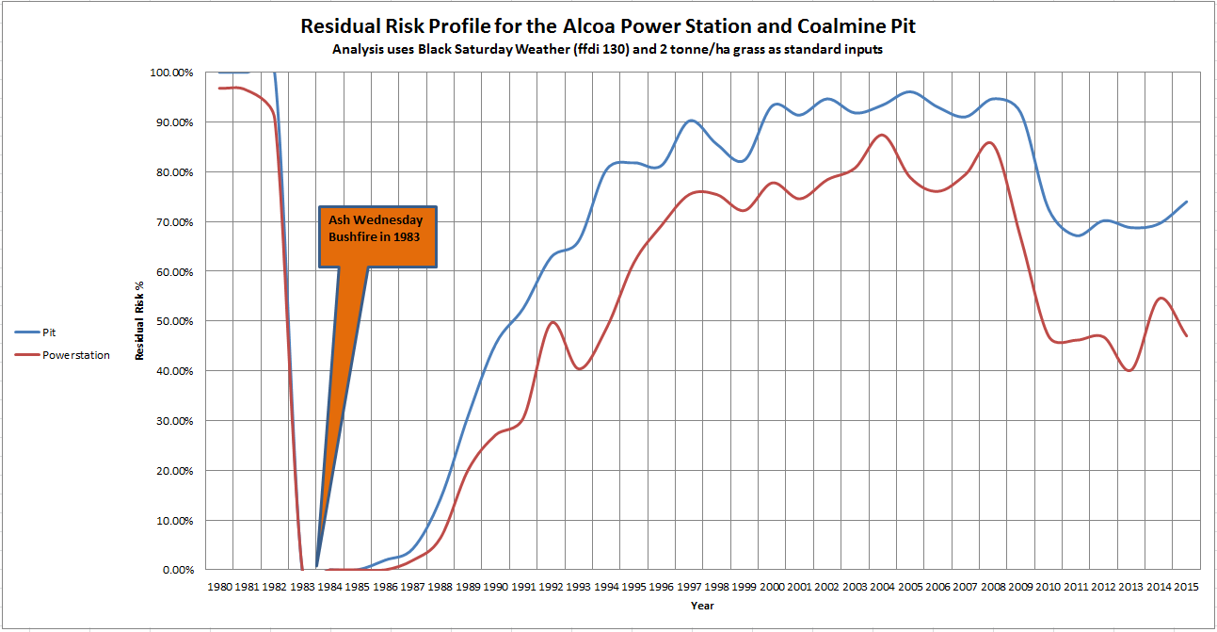

### Figure 3: Residual risk profile (Barwon Otway Plan, p 13)

*Fire Lookouts*

* 1. DELWP and Parks Victoria’s preparedness for bushfire risk in the Barwon South West Region is increased through the use of manned fire lookout towers and air observer flights on high fire danger days during the summer season. These observation points allow for quick identification of recent bushfire ignitions, and expeditious response activities to occur.
  2. There are eight fire lookouts located in the Barwon South West Region. These are listed below:

|  |  |
| --- | --- |
| Otway District | Far South West District |
| Peters Hill (Anglesea) Crowes (Gellibrand) Mt Crowley (Lorne) | Corndale (Casterton) Chetwynd (Casterton) Balrock (Dartmoor) Annya (Heywood)  Mt Clay (Heywood) |

* 1. Fire lookouts are equipped with radios, telephones, high powered binoculars and map tables, with sight bearings for major features marked out. The lookout at Peters Hill overlooks the Heath, with additional coverage from the Mount Cowley fire lookout and the CFA tower at Mount Duneed.

*Resourcing for the Barwon South West Region*

* 1. The Barwon South West Response Plan also outlines the resources, both personnel and equipment, that will be available for fire response in the Barwon South West Region for the 2015/16 summer season. Should an incident within the region be of such a magnitude as to escalate coordination to the State level, additional resources will be made available for response activities.
  2. DELWP and Parks Victoria employ a permanent firefighting workforce. During summer seasons this workforce is supplemented with an annual recruitment of Project Fire Fighters. There will be 80 seasonal firefighters recruited by DELWP for the Barwon South West Region for the 2015/16 summer season. This recruitment is detailed below.

|  |  |  |  |  |
| --- | --- | --- | --- | --- |
| **Location** | **October – May (34 Weeks)** | **November – April (26 Weeks)** | **January – March (18 Weeks)** | **Total** |
| **Far South West District** | 5 | 14 | 26 | **45** |
| **Otway District** | 7 | 10 | 18 | **35** |
| **Region totals** | **12** | **24** | **44** | **80** |

* 1. Parks Victoria is finalising its seasonal recruitment plan for the 2015/16 summer season. Recruitment is anticipated to match recruitment for the 2014/15 summer season, when 10 seasonal staff were employed to assist with patrolling and fire response on the Heath.
  2. Equipment resources that are available for response activities in the Barwon South West Region for the 2015/16 summer season include:

|  |  |  |  |  |  |
| --- | --- | --- | --- | --- | --- |
| **Equipment** | | **Statewide** | **Barwon South West Region** | | |
| **Otway District\*** | **Far South West District\*\*** | **Total** |
| Aircraft | Helitack | 10 | 1 | - | **1** |
| Firebird | 15 | 1 | - | **1** |
| Bombers | 16 | 2 | 4 | **6** |
| Others | 7 | 1 | - | **1** |
| Total | 48 | 5 | 1 | **6** |
| Tankers (slip ons) | |  | 31 | 33 | **64** |
| Vehicles (4WDs) | |  | 49 | 49 | **98** |
| Dozers | |  | 7 | 6 | **13** |
| Trailers | |  | 15 | 10 | **25** |
| Airbases | |  | 3 (Colac) | 6 | **9** |

* Otway District covers Anglesea, Apollo Bay, Colac, Forest, Gellibrand, Lorne and Port Campbell.

** Far South West District covers Casterton, Dartmoor, Hamilton, Heywood, Macarthur, Nelson, Portland and Warrnambool.

### Response

* 1. DELWP, Parks Victoria and the CFA undertake extensive response activities during bushfires. Response activities include any action aimed at suppressing an ignited fire, such as water or foam dropping via a helicopter or fixed-wing aircraft and direct or indirect attack by ground personnel.
  2. Across the State, as in the Barwon South West Region, response to fires is in accordance with the State strategic control priorities as follows:

 protection and preservation of life is paramount

 issuing of community information and community warnings

 protection of critical infrastructure and community assets supporting community resilience

 protection of residential property

 protection of assets supporting individual livelihoods and economic production  protection of environmental and conservation assets.16

* 1. The Barwon South West Region produces an annual Barwon South West Response Plan, which defines the readiness, initial attack and firefighting procedures, to be adopted by DELWP and Parks Victoria in the Barwon South West Fire Region for each upcoming bushfire season.
  2. The Barwon South West Response Plan allows for effective, efficient and consistent response activities across each locality within the region. DELWP and Parks Victoria officers are trained to the same standard in their fire response roles. This allows for resources throughout the region to be drawn on for fires that require prolonged response actions.
  3. The Barwon South West Response Plan mandates readiness arrangements, such as standby Incident Control Centres and aviation capability during days and periods of elevated forest and grass fire danger index. This aims to ensure that initial attacks of emerging fires can be swift and targeted to minimise the spread of fires.

*Responding to Fires Affecting Anglesea Heath*

* 1. Management of a fire affecting the Heath will be coordinated from the Geelong Incident Control Centre, in accordance with the Command and Control arrangements for the Barwon South West Region.17 The CFA and DELWP operations will be integrated for any fire affecting the Heath.17
  2. Initial attack fire response on the Heath will be coordinated under the Barwon South West Response Plan until such a time as an Incident Action Plan is put in place by the Chief Fire Officer.

16 State Emergency Response Plan, Part 3: Emergency Management Manual Victoria at *3.2.2 State strategic control priorities* (page 3-2).

17 Barwon South West DELWP/CFA Local Mutual Aid Plan 2014/2015 Fire Season.

* 1. The Barwon South West Response Plan provides guidance on the tactics that may be suitable for fire suppression of a fire in a sensitive area, such as the Heath. These tactics include: fireline construction using helicopter rappel crews; hover exit crews or ground hand crews; air attack using water bombing; fire retardant or foam; backburning from existing tracks; fireline construction using bulldozers; flattening or slashing vegetation using rollers or slashers; and wet firefighting using pumps and hoses with water and/or foam.
  2. An Incident Action Plan outlines the strategic, operational and tactical actions to be undertaken during a fire response.

### Recovery

* 1. Recovery programs and activities play several important roles following bushfires, including regenerating ecological environments and mitigation against future fires.
  2. Recovery planning for the Barwon South West Region incorporates recovery planning for the Heath. Recovery plans are developed through the Regional Emergency Management Team and the Surf Coast Shire Municipal Emergency Management Planning Committee.

# Fire responses within the Anglesea Coal Mine and Anglesea Power Station

* 1. The CFA has developed specific plans for responding to fires within the Anglesea Coal Mine and Anglesea Power Station and for the protection of the Anglesea community. These plans are in addition to the integrated approach between DELWP and CFA for fires occurring in the Heath.
  2. The CFA plans exist on multiple levels and include:

 Anglesea Local Response Plan – Bushfires, developed to assist operational planning and for use by brigades and at Incident Control Centres

 Township Protection Plan, developed to provides community members with information to assist them in making decisions about bushfire threats

 Anglesea Local Emergency Planning Factors  Alcoa Anglesea CFA PIP.

## Alcoa Anglesea CFA PIP

* 1. The Alcoa Anglesea CFA PIP is the primary document for the purposes of responding to a fire at both the Anglesea Coal Mine and the Anglesea Power Station. It contains pre-planning information relevant to wildfires, open cut coal fire, structure fires, HAZMAT and rescue events. The Alcoa Anglesea CFA PIP also provides guidance to CFA commanders and personnel on operational considerations for responding to such events.
  2. The CFA co-operates with DELWP and Parks Victoria in respect of the Alcoa Anglesea CFA PIP. Triple zero callouts at the Anglesea Coal Mine and Anglesea Power Station trigger an automatic response of CFA firefighting resources. Pursuant to the Alcoa Anglesea CFA PIP and arrangements between CFA and the ESTA, emergency events at the Anglesea Coal Mine or Anglesea Power Station can trigger at a minimum a three brigade response of multiple appliances drawn from Anglesea, Torquay and Bellbrae.
  3. The Alcoa Anglesea CFA PIP details:

 CFA and Alcoa resources available in the vicinity of the Anglesea Coal Mine, which the CFA can draw upon for fire suppression activities

 known hazards

 the location of hydrants and open water points

 access routes and designated staging areas to ensure that initial attack can be coordinated swiftly and effectively.

* 1. The CFA resources detailed in the Alcoa Anglesea CFA PIP, specifically in relation to non- structural open cut coalmine fires, include:

two tankers from Anglesea one rumper from Anglesea



two additional tankers from Torquay and Bellbrae.

* 1. For a Level 2 Response, additional resources can be requested which include:  five additional tankers from neighbouring locations within CFA District 7

tanker strike teams from the district, region or State pumper strike teams from the district, region or State Corio Heavy Hazmat (atmospheric monitoring capability) five thermal imaging cameras, located across the District bulk water tanker



CFA Health Support Team.

* 1. Other resources available include:

CFA aerial appliances



DELWP (tankers, slip-ons, incident management) Geelong Ladder Platform (42M Bronto)

Corio Teleboom (17M Ladder) aircraft

helitanks – water bombers on request and subject to availability.

* 1. In the event of structure fires, HAZMAT and rescue events, additional specialised appliances are also drawn from Belmont, Geelong and its surrounding suburbs, and the South Barwon State Emergency Service. This can include Heavy HAZMAT equipment from Corio.

## Next Steps

* 1. The CFA and Alcoa are currently in discussions to update the Alcoa Anglesea CFA PIP to take account of the closures of the Anglesea Coal Mine and Anglesea Power Station. These discussions have included consideration of access, security, radio communications, training and safety at the site after 31 August 2015.
  2. The CFA and Alcoa are meeting on 3 August 2015 to consider what amendments to the Alcoa Anglesea CFA PIP may be required due to the closure of the Anglesea Mine.

