**From:** [David Harden](mailto:DHarden@ntsv.com.au)

**To:** [Hazelwood Info Shared Mailbox](mailto:info@hazelwoodinquiry.vic.gov.au)

**Subject:** Hazelwood Mine Fire Inquiry - GLaWAC Written Submission

**Date:** Wednesday, 2 September 2015 4:15:18 PM

**Attachments:** 2015 09 02 Hazelwood Mine Fire Inquiry - GLaWAC Written Submission ToR 8 9 and 10.pdf

Dear Board of Inquiry

Please find attached written submission from the Gunaikurnai Land and Waters Aboriginal Corporation RNTBC addressing Terms of Reference 8,9 and 10.

Kind regards

**David Harden Lawyer**

**Native Title Services Victoria**

12-14 Leveson Street (PO Box 431) North Melbourne VIC 3051

| **Toll Free**: 1800 791 779 | | **f**: (03) 9326 4075

Website: [www.ntsv.com.au](http://www.ntsv.com.au/)



###### Find us on Facebook

I acknowledge the Traditional Owners of the land I work on as the first people of this country.

**CONFIDENTIALITY AND PRIVILEGE NOTICE**

This email and any attachments may contain confidential information and may be subject to legal professional privilege. If this email has been sent to you in error, confidentiality and privilege is not waived, and any use or disclosure of the information therein is prohibited. If you have received this email in error, please notify the sender by reply email, delete it from your system and destroy any copies**.** If this is a private communication, it does not represent the views of Native Title Services Victoria Ltd.

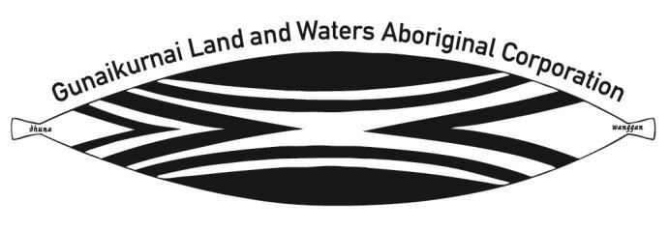

Hazelwood Mine Fire Inquiry PO Box 24

Flinders Lane VIC 8009

*Electronic submission*

2 September 2015

Dear Board of Inquiry

Gunaikurnai Land and Waters Aboriginal Corporation RNTBC submission to the Hazelwood Mine Fire Inquiry

1. Thank you for the opportunity to make a submission on Terms of Reference 8, 9 and 10 of the re-opened Hazelwood Mine Fire Inquiry (the Inquiry) relating to rehabilitation options for the three Latrobe Valley Mines.
2. The Gunaikurnai Land and Waters Aboriginal Corporation RNTBC (GLaWAC) is the Registered Native Title Body Corporate holding Native Title Rights and Interests in trust on behalf of the Gunaikurnai People pursuant to the *Native Title Act 1993* (Cth)(the NTA).
3. We, as Gunaikurnai People, were recognised as the traditional owners over much of our Country in 2010 following a Federal Court Determination and Recognition and Settlement Agreement with the State of Victoria. This area includes the entire Latrobe Valley coal industry region the subject of the inquiry. GLaWAC is also a Registered Aboriginal Party (RAP) over this area with cultural heritage rights and responsibilities under the *Aboriginal Heritage Act 2006* (Vic)(the AHA).

Our rights, interests and responsibilities

1. In the Federal Court Determination in 2010, our native title rights and interests were recognised. These include the important rights:
   1. to have access to or enter and remain on the land and waters;
   2. to use and enjoy the land and waters;
   3. to take the resources of the land and waters for the purpose of satisfying personal, domestic or communal needs;
   4. to protect and maintain places and areas on the land and waters which are of importance according to Gunaikurnai traditional laws and customs; and
   5. include the right to undertake the following activities on our Country:
      1. camping;
      2. engaging in cultural activities;
      3. engaging in rituals and ceremonies;
      4. holding meetings and gatherings; and
      5. teaching and learning about the physical, spiritual and cultural attributes of places and areas of importance.

Gunaikurnai Land and Waters Aboriginal Corporation RNTBC (ICN 4768) **|** ABN 43 709 397 769

193-197 Macleod Street Bairnsdale Victoria 3875 **|** PO Box 1699 Bairnsdale Victoria 3875

**T** 03 5152 5100 **| F** 03 5152 1666 **| E** [admin@glawac.com.au](mailto:admin@glawac.com.au)

1. As recognised native title holders, the Gunaikurnai People are afforded negotiation rights with companies over certain activities occurring on Country under the NTA. For other activities, we have different procedural rights under the NTA, such as those afforded to an ordinary titleholder.
2. At the same time that the Gunaikurnai People were recognised in the Federal Court, a negotiated settlement package was reached with the Victorian government under the *Traditional Owner Settlement Act 2010* (Vic). This settlement was the first of its kind in Victoria and included:
   1. Recognition of Traditional Owner rights over all public lands within the boundary of our Federal Court Determination;
   2. A grant of Aboriginal Title over 10 areas of land totalling approximately 46,000 hectares;
   3. Joint management arrangements over those 10 areas of land;
   4. Funding for GLaWAC.
   5. Rights to access Crown land for traditional purposes such as hunting, fishing, gathering and camping;
   6. Employment with Parks Victoria;
   7. Assistance to set up a natural resource management contracting business; and
   8. Various cultural strengthening commitments surrounding the recognition of the Gunaikurnai as native title holders and Traditional Owners of the land within the Federal Court Determination area.
3. As a RAP under the AHA, we have statutory rights and responsibilities to protect our cultural heritage including registered aboriginal places and sites that are significant to our people, on both public and private land.

Cultural Values of the Latrobe Valley

1. As Gunaikurnai, we see our land (Wurruk), waters (Yarnda), air (Watpootjan) and every living thing as one. All things come from Wurruk, Yarnda and Watpootjan and they are the spiritual life-giving resources, providing us with resources and forming the basis of our cultural practices. We have a cultural responsibility to ensure that all of it is looked after.
2. The Gunaikurnai People are comprised of five clan groups; the Brayakaulung, the Brabralung, the Krauatungalung, the Tatungalung, and the Brataualung. The land of the Latrobe Valley mine sites is Brayakaulung Country.
3. The damage that has occurred to our Country through mining development in the Latrobe Valley is unquestionable. Wurruk, Yarnda and Watpootjan have all been greatly affected by mining. One example is the diversion and damming of major waterways around the open cut brown coal mines. This impacts directly on our creation story; of Borun the pelican, who traversed our Country from the mountains in the north to the place called Tarra Warackel in the south (now known as Port Albert). Borun followed the river systems across our Country and created songlines and storylines as he went.

Gunaikurnai Land and Waters Aboriginal Corporation RNTBC (ICN 4768) **|** ABN 43 709 397 769

193-197 Macleod Street Bairnsdale Victoria 3875 **|** PO Box 1699 Bairnsdale Victoria 3875

**T** 03 5152 5100 **| F** 03 5152 1666 **| E** [admin@glawac.com.au](mailto:admin@glawac.com.au)

1. Most of the damage to Country occurred prior to the appreciation of discriminatory practices that had occurred against Aboriginal people, prior to the *Racial Discrimination Act 1975* (Cth), the *Mabo* decision in the High Court and the enactment of the NTA. As a result, the Gunaikurnai people had no say and received no compensation for this extensive damage to Country.
2. GLaWAC makes this submission on behalf of the Gunaikurnai People to ensure that when it comes to rehabilitating the three mine sites in the Latrobe Valley, the Gunaikurnai People will have an active role and all major stakeholders explore the many opportunities in this process which align with the aspirations of the Gunaikurnai People.

Aspirations of the Gunaikurnai People

1. Recently, GLaWAC launched our Gunaikurnai Whole-of-Country Plan which sets out the vision and aspirations of the Gunaikurnai people not only in relation to Wurruk, Yarnda, and Watpootjan but for the physical, mental and economic wellbeing of our mob. I attach the Gunaikurnai Whole-of-Country Plan to this submission. I direct the Board of Inquiry to the following goals outlined within the Plan which GLaWAC believes are relevant to the process of rehabilitating the three major mine sites of the Latrobe Valley:
   1. Goal 1: To have a strong, healthy and happy mob (pages 16-17);
   2. Goal 2: To heal our Country (pages 18-19);
   3. Goal 3: To protect and practice our culture (pages 20-21);
   4. Goal 4: To be respected as the Traditional Owners of our Country (pages 22-23);
   5. Goal 5: To have the right to use, manage and control our Country (pages 24-25);
   6. Goal 6: To be economically independent (pages 26-27); and
   7. Goal 7: To have a strong focus on learning (pages 28-29).
2. Once again, I thank the Board of Inquiry for the opportunity to make this submission, to express the cultural values of the Latrobe Valley and outline the aspirations of our people. Should you have any questions about this submission, please do not hesitate to contact me on (03) 5152 5100.

Yours faithfully



Aunty Beryl Booth Interim Chairperson

Gunaikurnai Land and Waters Aboriginal Corporation RNTBC

Gunaikurnai Land and Waters Aboriginal Corporation RNTBC (ICN 4768) **|** ABN 43 709 397 769

193-197 Macleod Street Bairnsdale Victoria 3875 **|** PO Box 1699 Bairnsdale Victoria 3875

**T** 03 5152 5100 **| F** 03 5152 1666 **| E** [admin@glawac.com.au](mailto:admin@glawac.com.au)

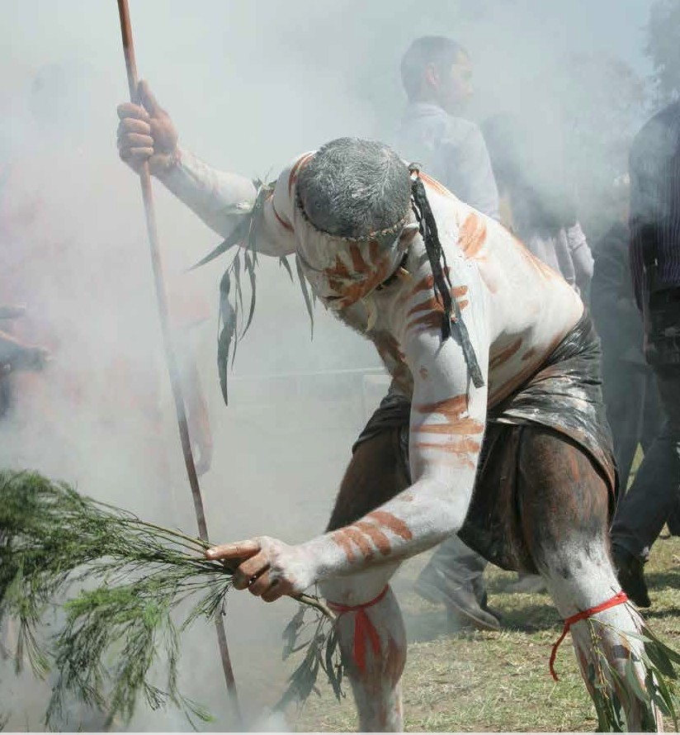

unaikct,nai

Whole-of-Gountr-t flan



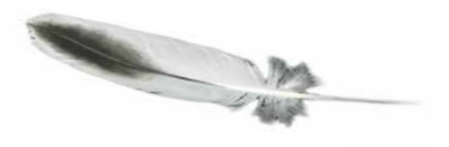

Acknowledgements

This Whole-of-Country Plan has drawn heavily from the aspirations that our mob have expressed over many years. We have worked hard to be faithful to all of the work that was done before, and bring it into the new context in which we are now operating. We are now embarking on a fresh push to implement the things that our mob has cared about for a long time.

Building on all of this previous work, the Plan has been strengthened by discussions with the mob at a range of meetings held across our Country. Particular thanks go to the Gunaikurnai Elders Council, our Traditional Owner Land Management Board and our young people who are working on Country. Their contributions at the Country Planning workshops have brought a multi-generational perspective to our aspirations, and have put us on a strong footing for the future.

This Whole-of-Country Plan was developed by Gunaikurnai Land and Waters Aboriginal Corporation, with the assistance of Native Title Services Victoria.

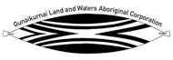 

This project is supported by the East Gippsland and West Gippsland Catchment Management Authorities through funding from the Australian Government’s National Landcare Programme

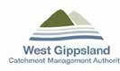  

PO Box 1699

Bairnsdale, Victoria 3875

Telephone (03) 5152 5100

© Copyright Gunaikurnai Land and Waters Aboriginal Corporation

July 2015

No part may be reproduced by except in accordance with provisions in the Copyright Act 1968 or with written permission from

Gunaikurnai Land and Waters Aboriginal Corporation

Images courtesy of: Gunaikurnai Land and Waters Aboriginal Corporation, Tourism Victoria Cover Photo: Alfie Hudson performs a smoking ceremony at the Gunaikurnai Native Title determination. Image by Todd Condie

This publication is also available electronically on the Gunaikurnai Land and Waters Aboriginal Corporation websit[e - www.glawac.com.au](http://www.glawac.com.au/)

2



Message from the chair

Our Native Title determination in 2010 was an historic moment. After many years of hard work by a great many people, we finally achieved legal recognition of our connection to Country and our rights as Traditional Owners. The determination, along with the Traditional Owner settlement agreements that we entered into on the same day, have provided us with a strong base of rights and benefits from which we can build.

This Whole-of-Country Plan has been developed by our mob, for our mob. It aims to bring together and add to the discussions that Gunaikurnai people have had over the past two decades during our fight for Native Title, and paints a picture of how we are now going to move forward.

Now is the right time to take stock. We have established an effective corporation that is getting stronger every day. We have financial and capital assets and we have skilled people.

We are also preparing to conclude our Native Title settlement with the State by negotiating for natural resource rights and procedural rights over land use activities – another important step in cutting our dependence on government and building our capacity to support our own mob.

This Plan will help us make the most of the benefits we have already secured through Native Title. There are new opportunities to grasp and partnerships to establish. The perspectives and values we hold for Country will be reflected and supported in joint management, with our management role now on equal footing with the State.

This plan will ensure the interests of our mob are put first, by guiding the activities of Gunaikurnai Land and Waters Aboriginal Corporation and the Traditional Owner Land Management Board. But it remains a starting point and is not set in stone. The plan has been developed with the best information and input that we have available. There are more discussions to be had as we continue to build in more knowledge, perspectives and priorities from the mob. This plan is about talking with each other about the future, on our path to truly becoming ‘one mob’.

We commend the tireless work of all Gunaikurnai who have contributed over the years in our long fight for recognition – those who continue in their efforts to strengthen the mob and those who have sadly passed away. Your legacy has set the foundations for a strong and prosperous future for Gunaikurnai, and this Whole-of- Country plan is the next step in that process.



Robert Critch

Chairperson, Gunaikurnai Land and Waters Aboriginal Corporation

April 2015

##### 3

Five clans

**Brayakaulung** people around the current site of Sale. Providence Ponds, Avon and Latrobe Rivers; west of Lake Wellington to Mounts Baw Baw and Howitt.



**Brabralung** people in Central Gippsland. Mitchell, Nicholson, and Tambo Rivers; south to about Bairnsdale and Bruthen.

**Krauatungalung** people near the Snowy River. Cape Everard (Point Hicks) to Lakes Entrance; on Cann, Brodribb, Buchan, and Snowy Rivers; inland to about Black Mountain.

**Tatungalung** people near Lakes En

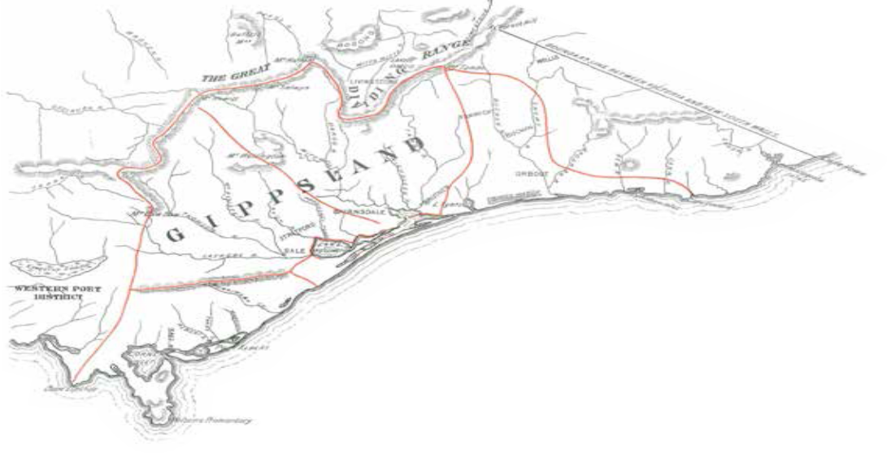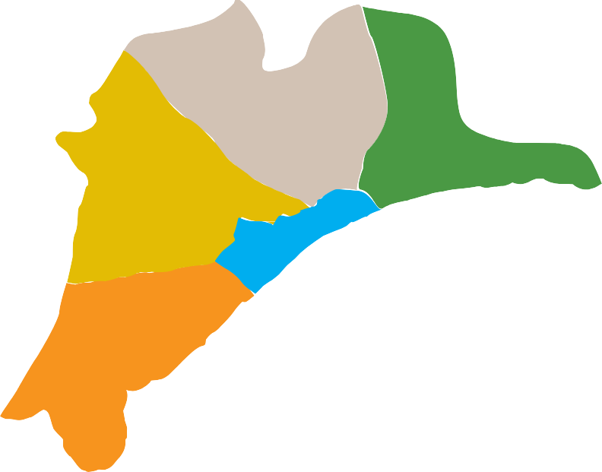

**Brataualung** people in South Gippsland. From Cape Liptrap and Tarwin Meadows east to the mouth of Merriman Creek; inland to near Mirboo; at Port Albert and Wilsons Promontory.

4

trance on the coast. Along Ninety Mile Beach and about Lakes Victoria and Wellington from Lakes Entrance southwest to mouth of Merriman Creek; also

on Raymond Island in Lake King.



Contents

Vision 6

Our creation story 7

Our Country` 8

Our story 10

Strategic framework 16

Our Aboriginal Title lands 30

Other areas of interest 52

Implementing the Plan 60

Measuring progress 64

A commitment to planning 66

##### 5

# Vision

We are Gunaikurnai, the First People of our Country. We have survived for tens of thousands of years, often against great adversity. We have looked after our Country and passed on our stories and traditions through countless generations. We continue to survive and thrive, maintaining connection to our Country and to our ancestors.

The future we see is one where Gunaikurnai stands proud and strong, where our people have strong connections to their culture and Country, where our businesses and relationships are base on solid foundations and where we are self-sufficient and highly respected. In our future, our mob is united – the five clans of Gunaikurnai working together to support each other.

To help us work towards our vision, we have seven strategic goals:

### D

###### A strong, healthy, happy mob

###### Healthy Country

#### G

BRATAUALUNG U N

BRAYAKAULUNG A

#### I

#### K

BRABRALUNG TATUNGALUNG

###### Respect as Traditional Owners of our Country

###### The right to use, manage and control our resources

###### Protecting

###### and practicing our culture

#### U R N A I

##### GLaWAC

KRAUATUNGALUNG

###### A strong focus on learning

###### Economic independence

Vision diagram by Aunty Faye Voss

##### 6



# Our creation story

The story of our creation starts with Borun, the pelican, who traversed our Country from the mountains in the north to the place called Tarra Warackel in the south.

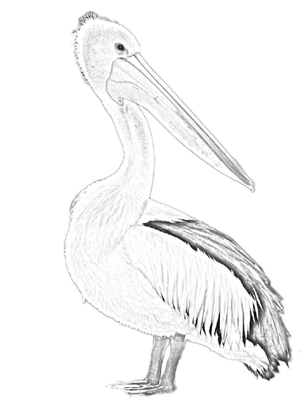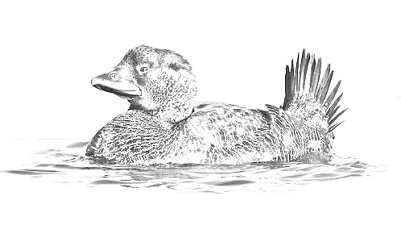

As Borun travelled down the mountains, he could hear a constant tapping sound, but he couldn’t identify the sound or where it was coming from. Tap tap tap. He traversed the cliffs and mountains and forged

his way through the forests. Tap tap tap. He followed the river systems across our Country and created songlines and storylines as he went. Tap tap tap.

He walked on alone and when he got down into the deeper inlets near Tarra Warackel (now known as Port Albert) he put down his canoe and, much to his surprise, there was a woman in it. She was Tuk, the musk duck.

Borun was very happy to see Tuk, and they married and became the mother and father of the five clans, the creators of Gunaikurnai.

The creation story is about the origin of our people. It helps to explain the bonds we have to our Country and reminds us that our ancestors are still watching over the landscape today.

It is important for us to be able to walk in their footsteps and follow their journeys from

thousands of years ago – it is a powerful, spiritual aspect to our cultural heritage, and fundamental to our recognition and respect. We are guided by the spirits of our ancestors when we walk through this Country.

##### 7

# Our Country`

We are recognised as Traditional Owners over approximately 1.33 million hectares in Gippsland – extending from west Gippsland near Warragul, east to the Snowy River, and north to the Great Dividing Range, and including 200 metres of offshore sea territory. We also have interests and ancestral and historical connections to other places beyond this recognised area. As Gunaikurnai, we see our land (Wurruk), waters (Yarnda), air (Watpootjan) and every living thing as one. All things come from Wurruk, Yarnda and Watpootjan and they are the spiritual life-giving resources, providing us with resources and forming the basis of our cultural practices. We have a cultural responsibility to ensure that all of it is looked after.

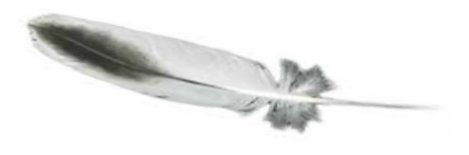

Our Country is diverse and fertile. It includes the southern slopes of Victoria’s alpine ranges and the grassy plains that sit at their feet. Our lakes and coastal lagoons form the largest navigable network of inland waterways in Australia and are host to internationally significant wetlands. We have isolated beaches and temperate forests, and the spectacular granite landscapes of Wilsons

Promontory. Our Sea Country is equally important, with a huge diversity of marine life that supports rich tourism and fishing industries.

There are around 250,000 people who live in Gippsland, including 3,000 Gunaikurnai. The population of this area is expected to increase by 20% in the next decade, largely through migration and people living longer. These demographic changes are likely to lead to increased demand for jobs as well as aged and health care services.

8

The economy of our region is largely driven by energy, particularly offshore gas and oil, and brown coal, as well as a strong agriculture sector underpinned by the high rainfall and fertile soils. Tourism is also a major industry, accounting for nearly $900 million in revenue annually and nearly 10% of regional employment. The rich natural resource base provides a number of other opportunities for business development in the region, including new industries such as carbon sequestration.

Our Country possesses a rich Aboriginal culture. Our heritage is strong across our landscape, and Aboriginal cultural sites and artefacts can be found along our songlines, and trade routes, mountain ridges and waterways. They remind us about the ways of our ancestors and show our close and continuing connection to Country. Some of these sites have been recorded, however many have

not yet been found and protected. Our spiritual connection is something that cannot be seen, but nevertheless exists strongly in the places we walk and in the paths of our ancestors.

We are also facing a number of challenges in our efforts to heal and manage our Country. Despite being so rich in natural, cultural and economic values, our Country has been drastically altered since European colonisation, in particular by the introduction of industrial agriculture.

Some remnants of forest are now isolated by a web of farmland and urban settlements, and in many places the environmental systems are not healthy.



The loss of native vegetation and the use of European cropping methods has led to an increase in the water table and in turn increased the salinity levels of the land. Run-off from fertilisers is causing algal blooms in our lakes. The decrease in habitat from agricultural production and urban expansion is affecting native animal populations, including endangered species such as the Eastern Bristlebird, Diamond Python and Stuttering Frog, all of which are unique to our region.

Climate change poses a further threat to our Country with decreasing rainfall and an increase in temperatures threatening the health of our rivers and land. Our towns and bush will come under threat from increased bushfire events, and the flooding of coastal environments and towns such as Lakes Entrance will have a major impact on cultural and natural values as well as the tourism industries.

*Falls Creek*

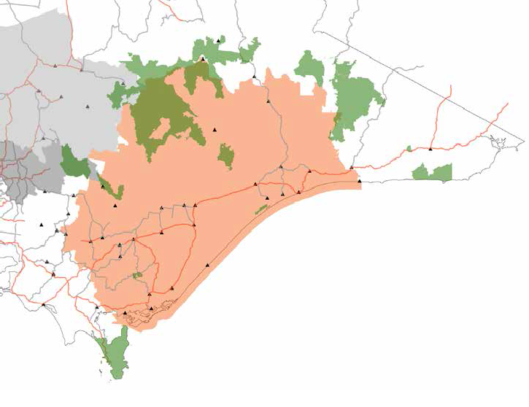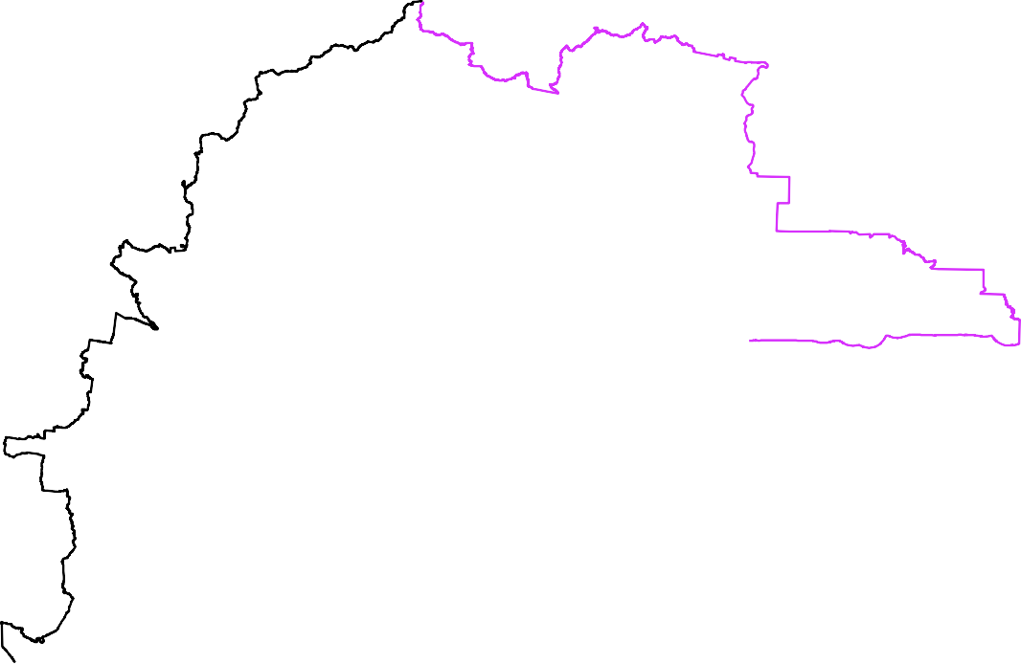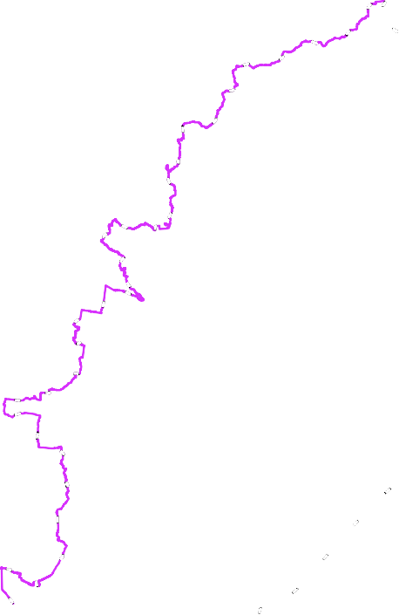

*Bonnie DoonMansfield Alexandra*

*Eildon*

*Jamieson*

*Hotham Heights*

*Omeo*

*Mount Buller Alpine Village*

*Swifts Creek*

*Marysville*

*Dargo*

*Cann River*

*Bruthen*

*Orbost*

*Powelltown*

*Noojee*

*Baw Baw Alpine Village*

*Bairnsdale PaynesvilleMetung*

*Nowa Nowa*

*Marlo*

*Neerim South*

*Bunyi Drouin*

*p*

*Erica*

*HeyfieldMaffra*

*Stratford*

*Sale*

*Rosedale*

*Lakes Entrance*

*Warragul Moe*

*Morwell*

*Poowong*

*TrafalgarChurchill*

*Seaspray*

**Legend**

*Korumburra*

*Inverloch*

*Foster*

*Yarram Port Albert*

*Port Welshpool*

Gunaikurnai Country of Interest Gunaikurnai Appointed RAP Taungurung Appointed RAP Wurundjeri Appointed RAP National Parks

RAP - Registered Aboriginal Party

Note: Country of Interest includes all land that Gunaikurnai have connection to and traditional responsibility for, irrespective of whether exclusive rights have been recognised through the *Native Title Act 1993* or *Traditional Owner Settlement Act 2010 (Vic)*.

##### 9

# Our story

## Our ancient past

For many thousands of years Gunaikurnai have lived in the valleys, on the fertile plains and up in the mountains of our traditional Country. Our Country was created by the spirits – the ancestors who link us to the land and bestow on us identity, rights and responsibilities. They defined our relationship with the land – how it should be used, how to move through it safely and how to care for it. In return, Country provided physical and spiritual nourishment for our people, with plentiful food, medicine, water and natural resources for survival.

Gunaikurnai were regularly on the move. Canoes made from a single piece of river red gum bark or stringybark softened over a fire and bent into shape with an axe and tied at the ends were used to travel the waterways, lakes and ocean. The movement

of tribes was dictated by the knowledge of where food, water and other resources could be found at particular times of the year. Little was carried on these seasonal migrations, with food being

collected and eaten at camps and shelters that were constructed at sites along travel routes. Stringybark rope was used to tie branches and bark together for shelter and possum skins were used at night for extra warmth. Woven baskets were used to carry items.

Each of the five clans of Gunaikurnai was entrusted to care for their own land. They were owners by customary right and had responsibility for looking after sacred places. They knew where their land started and finished based on the acts of our great ancestors. Our land was rigorously defended. Tribes

to the west feared our warriors who had a reputation for being fierce in battle. We had clear rules of engagement, with boomerangs and shields used at the outset of combat followed by the use of clubs.

Fighting would generally stop once blood was drawn, although in some instances Gunaikurnai would use raiding parties to attack without warning, seeking the death of their enemies.

Tribal customs dictated that there was no single leader – everyone was equal. Young people respected and obeyed their Elders, who provided advice and guidance to the community and passed on cultural knowledge and practices. Respect has always been, and continues to be, an important part of our culture. When disputes or problems occurred, our Elders would sit down and discuss them for as long as it took. Everyone would have a chance to voice their opinions, before a course of action was determined that was in the best interests of the community as a whole.

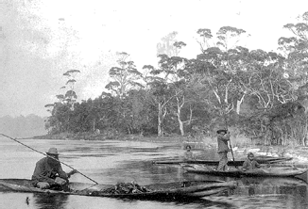

We held corroborees where clans would gather together over a number of days for trade and initiation rites, a central part of the transition from childhood to adulthood. Young men and women would move through a number of initiation stages, demonstrating their knowledge and understanding to successfully complete their initiation. Boys were trained to be expert hunters – using boomerangs and spears. They learnt the use of paddle canoes and were trained in combat and defence. Girls were trained by their mothers in selecting and preparing edible plants, and in fishing and cooking.

##### 10



Kangaroo was the main source of meat but possum was also widely eaten. Wombats, emus, koalas, echidnas, goannas and frogs were also eaten,

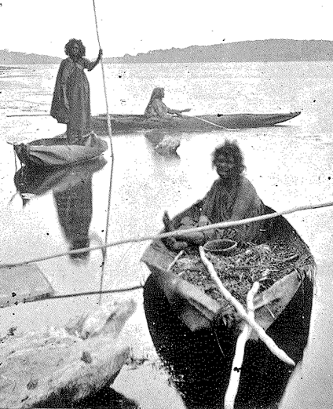

along with ducks, swans, gulls, pelicans, spoonbills, cormorants and sea eagles. Fish included flounder and flat mullet, along with snapper, garfish, perch, bream, flathead, mussels and abalone. They were caught with hooks made from bone and line made from the bark of the Yowan or caught in nets of stringy bark. Fish were wrapped in stringy paperbark and steamed under hot coals.

The Bogong Moth was an annual delicacy – a major food source in the cooler months, eaten cooked whole or as a paste. All of the clans would assemble in the mountains at Omeo and feast on Bogong Moth.

Many different plants were used for food and medicines, and to produce baskets, nets and tools. The underground tubers of water ribbons are still a popular food. Silver banksia flowers were soaked in wooden bowls to make a sweet drink. Pigface was eaten for the salt – leaves eaten as greens and the fleshy fruit was an accompaniment to fatty meats like echidna.

The bush also provided all of the remedies and tools needed by our ancestors. Tea tree would treat cuts, bruises and sprains. Old man weed and river mint were for chest and breathing problems,

poultices were made of wattlebark. Milk thistle was an anaesthetic. If other treatments failed, a *mulla mulung* was called for spiritual remedies. The hard wood of the wattle blackwood was prized for spear throwers and shields, while its bark was heated and soaked in water for bathing rheumatic joints and the inner fibres woven into fishing lines.

##### 11

## Our recent past

Our traditional way of life was interrupted by the settlement of Europeans. The mountains, swamps and dense forests of our Country initially formed a natural barrier to the expansion of settlement but from the 1840s pastoralists began to encroach on our Country. Much of the forested land was cleared to make way for agriculture, leaving small and often disconnected patches of forest.

At first, our ancestors thought the settlers were ‘mrarts’, or returned spirits. But the dispossession and violence that followed soon made it clear that the pastoralists were not in harmony with the earth. Squatters depleted our food sources and drew too much from the water reserves. We were pushed from our land and placed in missions. No longer able to care for Country as we had done for thousands of years, our Country became sick.

To protect our mob and our Country, Gunaikurnai began attacking outstations as part of a guerrilla campaign. But our spears were no match for the Europeans’ guns. In retaliation for the attacks and as part of a broader campaign to dispossess Aboriginal people from our land, a number of massacres

were committed by the settlers, including the 1843 massacre by Angus McMillan at Warrigal Creek and the killing of 100 to 150 Brataualung by settlers in 1845 after the spearing of the pastoralist, Ronald Macalister.

Along with introduced diseases, the massacres drastically reduced the Aboriginal population and by 1850 it was estimated that 90% of Gunaikurnai had died. The fear created by these massacres, and the increasing pace of settlement throughout Gippsland, reduced our territory to small enclaves

within a sea of European farms. Government policy in the 1860s resulted in our people being moved to mission stations such as Ramahyuck and Lake Tyers, to be educated in European traditions and religions. Families were broken up in the process, traditional practices were not permitted to be continued in most cases and by the early 1900s much of our language had been lost.

Believing that Victorian Aboriginal people were dying out, the Aborigines Protection Board took over the management of Lake Tyers in 1908. Over the next decade, reserves all around Victoria were closed which resulted in people from Coranderrk,

Ebenezer and Lake Condah also being moved to Lake Tyers. A change of government policy in the 1950s subsequently forced many families to move into towns in a bid to assimilate and gain employment, which was met with great resistance from the non- Aboriginal population.

In 1965, after years of petitioning, the mission was declared a permanent 4,000 acre reserve, which was finally handed over to the newly formed Lake Tyers Aboriginal Trust. This was the first successful Aboriginal Land Rights claim in Australia’s history.

##### 12

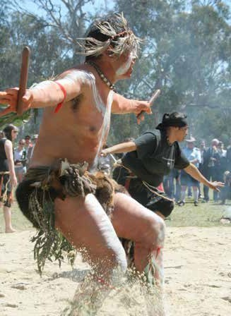

The 1990s saw Gunaikurnai Elders begin the long and difficult fight for Native Title recognition and the securing of our rights for future generations. Nearly two decades later, on 22 October 2010, the Federal Court recognised that the Gunaikurnai holds Native Title over much of Gippsland. On the same day, the State of Victoria entered into the first Recognition and Settlement Agreement with the Gunaikurnai under new state legislation, the *Traditional Owner Settlement Act 2010* (Vic).

This was a proud and emotional day for our people. To finally have our rights and connection to Country formally recognised, and to have our unique and continuing culture acknowledged, meant a great deal to our people. It has given us a legitimate voice. We are considered key stakeholders on

our traditional land and we can engage with government as equals.

The non-exclusive rights and interests recognised in our consent determination by the Federal Court of Australia include:

ø rights of access and use

ø the right to take resources for personal, domestic or communal needs

ø the right to protect and maintain places of importance

ø the right to camp

ø the right to engage in cultural activities, meetings, rituals and ceremonies

ø the right to teach about places of importance

ø the right to take water for domestic and ordinary use.

Alongside the consent determination and as part of our negotiated settlement package under the *Traditional Owner Settlement Act 2010* (Vic), the Gunaikurnai entered into an Indigenous Land Use

Agreement and a number of other agreements with the State of Victoria. These agreements build on our rights as Traditional Owners and include:

ø the recognition of Traditional Owner rights over all public land within the external boundary of the consent determination

ø a grant of Aboriginal Title over 10 areas of land totalling approximately 46,000 hectares

ø joint management arrangements over those 10 areas of land

ø $12 million in funding, of which $10 million is to be placed in trust and the interest used to help fund the operations of the corporation

ø rights to access Crown land for traditional purposes such as hunting, fishing, gathering and camping

ø employment with Parks Victoria

ø assistance to set up a natural resource management contracting business

ø various cultural strengthening commitments surrounding recognition of the Gunaikurnai as Native Title holders and Traditional Owners of the land within the consent determination.

Gunaikurnai Land and Waters Aboriginal Corporation (GLaWAC) was established to further the aspirations of Gunaikurnai Traditional Owners and Native Title holders from the Brataualung, Brayakaulung, Brabralung, Krauatungalung and Tatungalung family clans, through implementation of the Native Title Consent Determination and Traditional Owner Settlement agreements.

##### 13

## Looking to the future

With our strong and living culture, legal recognition of our land and natural resource rights, and a growing, stable corporation, we are now in a position to move forward. While there is much to do, we have built the foundations to heal wounds from the past and rebuild our heritage, culture

and people. This plan provides the Whole-of- Country and mob perspective on what we want for the future. It has been built from the words and aspirations that Gunaikurnai have shared over the last two decades. It outlines our overall goals for Country and will guide all that we do.

Informed by this plan, we will soon begin negotiating a Natural Resources Agreement (NRA) with the State. The NRA will include our aspirations relating to use of and access to natural resources, how we wish to participate in the management

of our Country and include agreed strategies to help deliver on our aspirations. This is a critical agreement for us as the health of our lands, waters and biodiversity will be a key factor in our ability to

practice our traditional ceremonies and customs and develop economically as a community.

We will also consider negotiating a Land Use Activity Agreement to secure decision-making rights in relation to land use activities carried out on public land, such as:

ø the issuing of leases, licences, permits

ø exploration and mining licences and other works approvals for a range of earth resources activities, including approvals for pipelines

ø activities of a public land manager such as clearing of land, construction of works, planned burning of land, revegetation of land

ø approval of a timber release plan and various other plans

ø the sale or other disposal of public land.

Under the guidance of the Board of Directors and Elders Council, GLaWAC represents all Gunaikurnai people and their aspirations for Native Title, cultural heritage, land, water and natural resource

management. With a membership of more than 600 Traditional Owners, all with established links to one of our 25 apical ancestors, GLaWAC already has a strong community base. However, there are many more Gunaikurnai citizens who have not yet become members who GLaWAC will also seek to engage and support in the business of our mob.

The corporation will continue to grow and increase its influence across our Country, building its capacity to address disadvantage while creating many and varied opportunities for Gunaikurnai people. In particular,

GLaWAC will build on its successful enterprises in firewood and natural resource management

contracting and create new opportunities for our mob to showcase their skills and talents.

There are of course challenges to overcome. The incomes of Aboriginal people are far below the Victorian average and our unemployment levels are often two to four times above the average. Our Country is also facing many threats, such as from climate and land use change. Access to and

management of our Country will provide us with the means to improve our livelihoods. Joint management in particular will give us the opportunity to pass our traditions on to the younger generations and to use our knowledge of Country to help manage these threats, in partnership with all levels of government as well as with the local community.

This is our first Country Plan and it is a living document. Over time, as our circumstances change and our goals are realised, we will review and improve it to ensure it remains relevant to the needs and wishes of our mob. In providing leadership

to our mob, GLaWAC will continue to engage all Gunaikurnai in conversations about the future.

##### 14

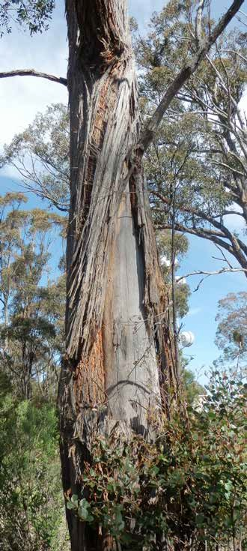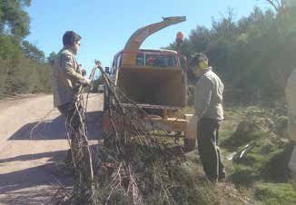

Mother Earth

The rolling plains the desert sands Our deep garden valleys Throughout the land.

Beauty unfolds as far as the eye can see The Rainbow Serpent

Gives to the Aborigine.

Custodians we must be forever more, To pass on our tradition

And respect our law. Elders have taught us

Since time began, we must take care Of our sacred land.

If we turn our backs and walk away We could lose it all one day.

No more will we be free to roam, No more this great land

Will be our home.

*Aunty Margaret, 1998 ©*

##### 15

# Strategic framework

This strategic framework sets the foundation for how our mob is going to move forward, to manage Country and participate in society. It contains principles that will be used to guide our decision-making and seven goal areas that together paint a picture of the future we want.

## Whole-of-Country principles

We have cultural obligations

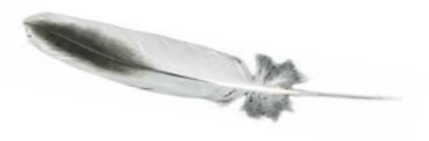

It is our inherent responsibility to look after Country

– to heal the damage of the past and protect it for future generations.

Everything is connected

All of our Country is linked. There is no separation between our landscapes, waterways, coasts and oceans, and natural and cultural resources. All are linked and bound to our people, law and custom.

Every bit matters

We understand the need to prioritise limited resources to where important values are under threat, but every part of our Country remains important to us.

Our values exist even when you can’t see them – whether they are under water, deep inside caves, covered with vegetation, they are still important to us.

Don’t wait until it has gone

When you lose a site, it’s gone forever. We need to act now to prevent any further loss of environmental or cultural values.

Look at what was there before

When we are healing and restoring degraded landscapes, we should try to put back the plants and animals that used to be there.

Sustainable use

Our approach to managing Country is to balance resource use with conservation – they are all part of the same.

Take only what you need – leave some for others.

Seek collective benefits

We use our resources for the benefit of our mob rather than seek individual gain.

We have the right to be on our Country Traditional Owners should not be restricted in

accessing our traditional Country. At the same time,

we should have the right to restrict access to others who disrespect and damage our sensitive areas.

Our traditional knowledge is valuable

Our traditional practices and approaches sustained the land for thousands of years. Our Country should be managed in harmony with our traditional ways.

We need to take the time to understand what natural and cultural heritage exists out on Country. It can’t be managed properly if we don’t know what is there.

16



## GOAL 1: To have a strong, healthy and happy mob

The well-being of our mob is our top priority. More than just physical health and security, it is about being respected, having stable employment and housing, and maintaining a strong spiritual

connection with our Country and our ancestors. We can be healthy if our Country is looked after, and we can be strong if our living culture is thriving.

We have lived through colonisation and decades of dispossession and discrimination, and we are still dealing with the impacts of these injustices. Health and housing services don’t yet meet our needs and our employment rates are among the lowest in the region. Although it has improved in recent years, racism remains an ongoing issue that our mob continues to face.

We are making great strides in overcoming these colonial legacies by setting up new enterprises to employ our own people, and building partnerships to address a range of challenges. We still have some way to go however to ensure our Elders

are properly looked after and that we are being true to traditional laws and customs. We want all

Gunaikurnai to be comfortable and proud, to be free from worry and live fulfilled lives, both individually and together as a mob.

To achieve these objectives, we must begin by doing the following:

ø Hold regular cultural festivals, clan gatherings and ancestor reunions at our gathering places on Country

ø Promote cultural camps for families to sort out their business

ø Establish good communication processes to keep our five clan groups engaged and actively participating in the business of our mob

ø Identify the housing needs for our mob and work with the Gippsland and East Gippsland Aboriginal Co-operative and the Aboriginal Housing Board to make sure services are appropriate

ø Establish a Gunaikurnai cemetery and funeral fund

ø Talk with health and social service providers to ensure they are meeting the needs of

Gunaikurnai and investigate the feasibility of a gold card for health services

ø Establish programs to support our mob to identify job opportunities, including

information sessions to help jobseekers find out what job they want and how to get it

This goal means that:

ø We have a shared vision for our future, and we are working towards the same goals

ø Our Elders are respected and cared for

ø Our younger generations have opportunities in all aspects of life, helping to build their confidence and improve their health and wellbeing

ø The cultural, spiritual and physical needs of our people are met

ø Our mob regularly gets together to celebrate our culture

ø Continue to support the storybook process and capture stories about what is being done on Country, and share these experiences

ø Support our mob to stay in work by placing Aboriginal mentors in organisations

ø Work with our Elders Council and others to identify the needs of our Elders and develop actions to make sure they are supported and cared for.

Success measures

We will know we are achieving our goal when health indicators and housing rates improve and our mob are participating in gatherings.

##### 17

## GOAL 2: To heal our Country

Our Country is the land, the rivers and the ocean, the people and the stories, the past and the future. All of it is connected. All of it is important to us.

This goal means that:

ø Our skills and knowledge in managing Country are recognised, actively sought and respected

ø We are treated as an equal partner in land and sea management

ø Our people are working on Country in all areas of natural and cultural resource management

ø There are enough ranger positions to properly manage our Country, including water and Sea Country

ø We are empowered to make and enforce the laws of our land

ø All Gunaikurnai Country is managed according to our Traditional laws and customs

Country heals us and connects us to our ancestors, our culture and history. We are sustained by our Country – through the water, food, medicines and materials that it provides us. As they have in the past, the resources of our Country will be the basis for our success in the modern economy.

We have been managing and using the natural resources on our land and in our waters for many thousands of years, and we are responsible for keeping them in good condition. Our mob cannot be healthy when our Country is sick, and in many places it is

sick. Since white settlement, our Country has been changed and exploited. For two hundred years, people have been taking too much from the land, rivers and oceans and using it in a way that is unsustainable.

We now have to reverse the impacts of these actions by contributing the skills and knowledge we have acquired over thousands of years.

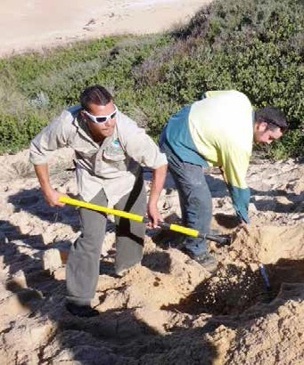

To safeguard what is valued on Country we must deal with issues like erosion, pests and pollution. We want to be actively managing the water, fire,

wildlife and biodiversity on our Country, and helping others to also do this in a culturally appropriate way. We must have the resources and authority to play this role on behalf of the rest of the community.

##### 18



To achieve these objectives, we must begin by doing the following:

ø Increase training opportunities for Gunaikurnai in traditional and modern natural resource management practices through partnerships and scholarships

ø Undertake research about past management practices to document what is known of traditional land management techniques

ø Work with government to negotiate more appropriate authority for enforcing the laws of our land, through the accreditation of Gunaikurnai Rangers as cultural inspectors under the *Aboriginal Heritage Act 2006* (Vic) and the broadening of their role to include issuing permits and doing inspections

ø Through joint management planning:

* identify where it makes cultural and environmental sense to change park boundaries
* secure an increase in the number of Gunaikurnai Ranger positions to better manage the breadth of Aboriginal Title Lands.
* build capacity and evidence for the next phase of handbacks of Aboriginal Title land
* consider opportunities for large scale wildlife and cultural corridors across Gunaikurnai Country and use this to secure additional funding for joint management

ø Procure a boat to support on-ground work along the lakes network and off the coast

ø Research and develop a sea ranger program

ø Develop strategies and protocols for water, fire, emergency management and revegetation, and work with other land management agencies and providers to ensure their work on our Country is culturally appropriate

ø Work with key government agency partners to review their policies and procedures to ensure Gunaikurnai Traditional Owners are appropriately included. This could involve developing partnership agreements that include:

* agreements about how to work with Gunaikurnai
* protocols for contacting Gunaikurnai before planning gets underway
* employment of Gunaikurnai in agencies as Indigenous Liaison Officers

ø Work with government and other businesses to establish preferential contracting for natural resource management works on Gunaikurnai Country

ø Develop a ‘mob intelligence network’ to communicate on-ground information back to GLaWAC to inform future plans and programs for managing Country.

Success measures

We will know we are achieving our goal when we can see the health of our Country improving, we are being involved in land management decisions and we have more of our mob working on Country.

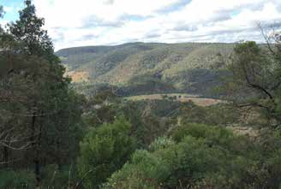

##### 19

## GOAL 3: To protect and practice our culture

We have one of the oldest cultures in the world and that culture has been passed on through many generations. Our culture is embedded in our Country, which is vital to our identity. Our stories

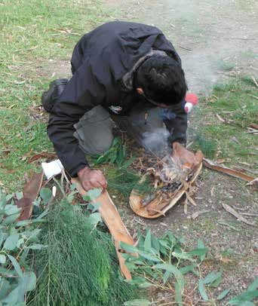

This goal means that:

ø We are actively maintaining our strong spiritual connection to Country

ø We are passing on our customs and traditions across generations through song, dance and story, being on Country and our dreaming

ø Our sacred sites are identified and protected and our cultural objects are returned

ø The remains of our ancestors are returned to Country

ø We have a keeping place for each clan

ø Our real language is restored and preserved

and songlines link us to our ancestors, who travelled across the Country practicing the customs that

make us Gunaikurnai. They moved throughout the landscape to harvest and protect natural resources, to seek refuge from the seasons, and to trade and mix with neighbouring groups.

While the artefacts spread across our Country provide evidence and insights into the way our people lived, our culture is also about philosophies and principles – the traditional rules that inform how women’s and men’s business is practiced, how decisions are made and disputes resolved, and how traditions are passed on through dance and song.

In our culture, having a proper burial is vital. We are slowly getting our ancestral remains returned but

it is a slow process. Our Elders say that we’ll never heal ourselves until our old people are in the ground on their own Country. There are also many cultural artefacts and significant places that are yet to be recorded. We need to keep filling in the gaps of our cultural heritage so that we can continue to learn about ourselves and strengthen our identity. This

is especially important for the younger generations who risk disengaging with Gunaikurnai culture if our knowledge is lost with the passing of our Elders.

We need to ensure that our young people know what it means to be a blackfella on our Country, to be part of a living culture. They should feel like they belong to a proud and strong mob. We also need

to share our stories with the broader community

so they better understand our ways and our values, and start to understand that protecting our culture doesn’t mean taking away their rights.

##### 20



To achieve these objectives, we can begin by doing the following:

ø Establish keeping places for each clan

ø Reinvigorate the Bataluk Cultural Trail and link it to the keeping places

ø Create a central database where we can store our cultural and traditional knowledge

ø Develop a cultural heritage strategy

ø Create a Gunaikurnai Cultural Heritage Advisory Council

ø Build memorials on all massacre sites (including Millie Creek, Butcher’s Ridge and Butcher’s Creek)

ø Install more interpretation materials, including installing signs and developing an app, so the wider community can appreciate Gunaikurnai history

ø Develop a communication strategy and fact sheets that capture the positive stories about protection of cultural sites

ø Work with the Victorian Farmers Federation to dispel myths about what it means to have cultural sites on farmland

ø Working through the Federation of Victorian Traditional Owner Corporations (the Federation), review the effectiveness of existing traditional owner settlement agreements and provide feedback to government

ø Work with the Federation to ensure the protocols for the repatriation of ancestors are in place, appropriate and resourced

ø Realign tracks away from culturally sensitive areas

ø Talk with government about options for giving us responsibility for collecting and maintaining records of our own cultural sites

ø Undertake mapping and surveying to find our sites and document our songlines

ø Address loopholes in current Cultural Heritage Management Plan requirements.

Success measures

We will know we are achieving our goal when our sites and artefacts are no longer being damaged, our ancestors are returned to Country and we have more ceremonies and cultural events being performed.

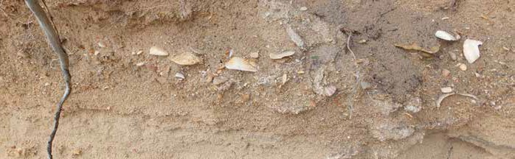

##### 21

## GOAL 4: To be respected as the Traditional

## Owners of our Country

Since colonisation, successive governments and others have tried to deny the right of Aboriginal people to practice our law and culture and maintain our connection to our land and waters. Despite

This goal means that:

ø We are recognised and respected as equal by all levels of government and by the broader community

ø Our ancient past is acknowledged, shared and respected

ø Government policies appropriately reflect our rights and interests

ø Our corporation is strong and effective, and recognised as the peak body representing the interests of Gunaikurnai people

this, we have maintained this connection and have kept our cultural practices alive. Recognition and strengthening of our culture can help to heal the wounds of the past, enable us to feel proud of

our rich heritage and promote reconciliation and respect.

Our Native Title determination and the recognition by both State and Federal governments that we

are the Traditional Owners of our Country, was a turning point for us. It was a proud moment, but it was only the beginning. Now we need to make that symbolic recognition a reality, and embed words of respect into the way we work together. We need

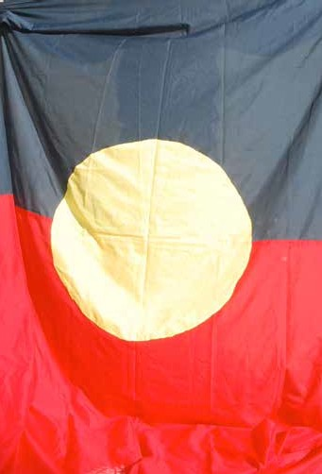

to address the racism that still exists in society, and turn around the trends of disadvantage that exist because of our difficult history.

We want a strong and productive relationship with government and other partners, for the benefit

of our mob and the broader community. We want to be genuinely engaged in a meaningful and respectful way, as Gunaikurnai people – able to negotiate on equal terms to establish our rightful place in the broader Gippsland community. We will continue to work towards this through strong regional partnerships and by building a greater presence across our Country.

##### 22



To achieve these objectives, we must begin by doing the following:

ø Increase the presence and accessibility of GLaWAC by increasing the number of offices across Country

ø Define and formalise processes for gathering informed consent so that all Gunaikurnai can participate appropriately in business that affects them

ø Review the place names across Gippsland with an eye to cultural sensitivity, including removal of the name McMillan from public use

ø Work with the Shires, VicRoads and relevant State Government departments to ensure that correct spelling and placement of Gunaikurnai names on Country

ø Install signs at key entry and exit routes recognising Gunaikurnai Country

ø Seek agreements and Memorandums of Understanding with key government agencies to formalise effective relationships

ø Provide better information to the mob about their rights and interests as Traditional Owners with a Native Title determination and settlement

ø Develop fact sheets to provide useful information to Gunaikurnai Traditional Owners about other agencies

ø Complete the oral history project of the Gunaikurnai journey and share it with agencies, community groups and schools

ø Clarify protocols for assigning and undertaking ceremonial tasks, including Welcomes to Country and smoking ceremonies

ø Work with local media to share Gunaikurnai stories, key messages and protocols for approaching Traditional Owners to do ceremonies.

Success measures

We will know we are achieving our goal when our Welcome to Country and other ceremonial services are in demand, we have partnership agreements with all of our key stakeholders and we have GLaWAC offices across our Country.

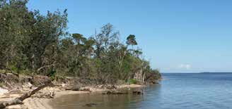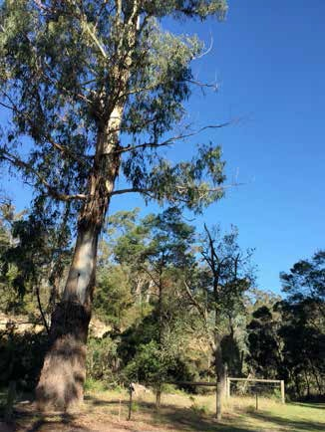

##### 23

## GOAL 5: To have the right to use, manage and control our Country

If we are to achieve our goals and work to improve the lives of our mob, we must have clearly defined legal rights that reflect our standing as the First Peoples of this Country. We were a sovereign people at the time of European settlement and did not cede any of our rights over our traditional land and waters, or our natural and cultural resources. We have the right to be on our Country and make decisions about the things that affect us.

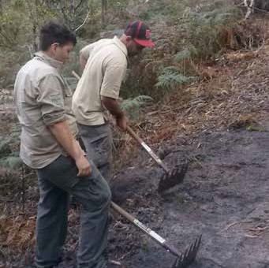

This goal means that:

ø All public land is handed back as Aboriginal Title, and managed to deliver on the rights and interests of Gunaikurnai

ø We have access to resources for commercial, cultural and ceremonial purposes, and we determine what is sustainable and appropriate

ø We have unrestricted access to all of our Country and the right to restrict the access of others to our culturally significant sites

ø We are fairly compensated for the resources that others take from Gunaikurnai Country, including minerals, timber and water

ø We control who accesses and uses our traditional knowledge, including cultural copyright.

Some of our fundamental rights have been enshrined in the United Nations Declaration on the Rights of Indigenous People. Even though this declaration has been endorsed by the Australian Government, however, there is a long way to go before many of the articles are fully understood or enacted. Our Commonwealth Native Title

determination and State Government Recognition and Settlement Agreement have also provided us with some of these rights such as the hand back of certain lands under Aboriginal Title.

We are now working towards negotiating further rights to better access and use our natural resources, to have formal roles in the governance of our land, waters and natural resources, and to influence land use activities that are carried out on public land. As part of these processes, we must secure for our mob our rights to use water for cultural and economic purposes and to obtain

natural resource assets from which we can build our future. The other ongoing challenge for us is to fully and effectively apply the rights that we do have for the benefit of our mob.

##### 24



To achieve these objectives, we must begin by doing the following:

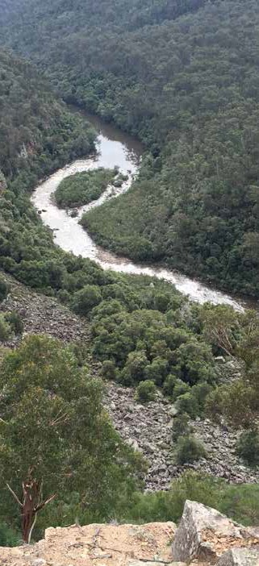

ø Secure the return of our cultural, genealogical and intellectual property from all agencies and organisations that hold on to it.

ø Clarify copyright rules and protocols for cultural knowledge and ensure they can be applied by all Gunaikurnai.

ø Upskill our mob to take on the full suite of land management responsibilities – from onground to upper management, recognising that it will take time to build our capability to fully exert our rights over Aboriginal Title and other land.

ø Use ‘The Knob’ as a case study and learning ground for future management arrangements

ø Explore what can be undertaken with Wyndarra, Boole Poole, Kurnai Park and the Ramahyuck Keeping Place to get management of these significant places back with Gunaikurnai and ensure cultural protection, employment and proper ownership

ø Work with the Gippsland and East

Gippsland Aboriginal Co-operative to look at opportunities for cultural land titles including Boole Poole burial site, Wyndarra, Ramahyuck cemetery, Kurnai Park (where the lease is up for renewal).

Success measures

We will know we are achieving our goal as our Aboriginal Title land estate grows, we have built up enterprises based on natural resource use, and have clear cultural copyright protocols in place.

##### 25

## GOAL 6: To be economically independent

We have many competitive advantages that will help us to build up a strong asset and skill base and secure our future. Our connection to and knowledge of Country puts us in a unique position in the natural resource management sector and we have already made great progress in building up our capabilities in a range of natural resource management roles. We are the custodians of our ancient culture and are passionate about sharing our stories and perspectives through tourism

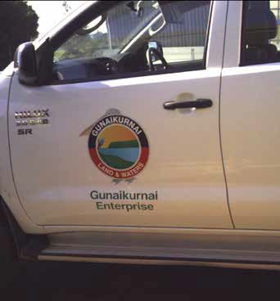

This goal means that:

ø GLaWAC is sustainable into the future

ø All Gunaikurnai people have access to secure employment

ø Our natural and cultural resources are a secure source of revenue for our mob

ø Government policy supports our economic development

ø We have diverse, successful and ethical enterprises providing jobs and income to our mob

ø We are taking advantage of emerging market opportunities

enterprises. We want to continue to provide cultural awareness training, cultural heritage management planning and other services to local organisations and government agencies.

There are, however, hurdles to overcome before we can establish a sustainable economic base and maximise our potential. Job security in the region is low, and even when training opportunities are available there is rarely secure employment at the end of it. Cultural differences can also make it

challenging for our young people in employment to feel comfortable in their workplace.

In the short term, we need to continue to strengthen the Corporation and build its capital base to be the foundation of our economic growth. GLaWAC seeks to become a major employer of Gunaikurnai while also creating more supportive and secure opportunities for Gunaikurnai to work

with other organisations. Once our mob, individually and collectively, has financial security, we will

be able to improve our circumstances and break the cycle of dependence that was created by our colonisation.

##### 26



To achieve these objectives, we must begin by doing the following:

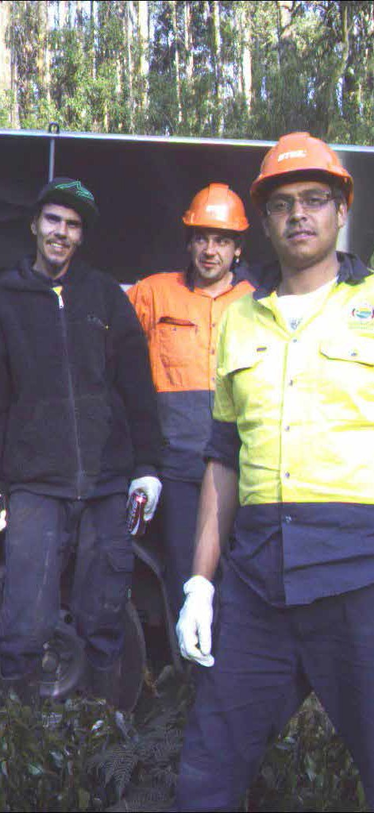

ø Develop an employment strategy to provide better opportunities for all Gunaikurnai

ø Investigate and pursue new business opportunities that use our unique strengths, including bushfood and native fauna

farming enterprises, seed collection, nursery management and carbon farming

ø Build up Gunaikurnai tourism and cultural awareness enterprises across our Country

ø Continue to strengthen our natural resource management business

ø Establish a Gunaikurnai green waste facility

ø Identify job opportunities and support the skills training that is required for Gunaikurnai to pursue those job opportunities

ø Investigate tax exemptions, first option licences and other legal mechanisms that could support the development of successful Traditional Owner enterprises

ø Use the Natural Resources Agreement negotiation process to seek agreement that Government procurement and projects

will preferentially choose Gunaikurnai as employees through the GLaWAC employment process, and provide GLaWAC with the first option to deliver works on Gunaikurnai Country

ø Research what other Traditional Owner groups are doing regarding building employment opportunities and developing emerging market opportunities.

Success measures

We will know we are achieving our goal as we build diverse enterprises providing income to the corporation and the mob, and employment of Gunaikurnai people increases.

##### 27

## GOAL 7: To have a strong focus on learning

Our mob is fortunate to have had many great leaders and people willing to protect and practice

This means that:

ø We, as Gunaikurnai, are actively sharing our culture and knowledge with our mob and the wider community

ø The broader community understands and respects our culture and journey, and partners with us to care for Country

ø Our people are building the professional skills and qualifications needed to work on Country, and take up employment opportunities

ø Gunaikurnai leaders are identified and supported to reach their potential

ø Our ancient past and culture is embedded in the school curriculum

ø GLaWAC collects, owns and manages our own cultural knowledge and information, with

a dedicated research arm and database of cultural practices

our culture during the difficult period post-European settlement. Our culture is intact and evolving, and we are strengthening it with every passing year.

When fires burn our Country, we record and learn from what is revealed under the vegetation. We are recording our oral history and sharing our traditional ecological knowledge. We have an Elders Council who share their wisdom and guide the activities

of our Corporation. We get together to talk about our aspirations when we fight for our rights, and through this plan we are describing for ourselves and others the road we are taking to a better future.

The current education system does not cater for the needs of our mob – our young people need to be taught the right things in the right way. We need to look beyond the current mainstream

curriculum to make sure they are also being taught cultural knowledge. There is little Aboriginal cultural education in schools and this is a problem not only for Gunaikurnai kids who are missing the opportunity to understand their culture in context,

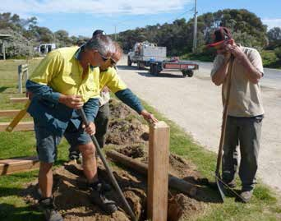

but also for the broader community. Unless cultural awareness begins early in the education system,

we cannot hope to bridge the gap in understanding and build more respectful and equal relationships

in the community. It is important that it is taught by the appropriate person – it is disrespectful for non- Gunaikurnai people to be teaching our culture.

Learning is the key to our advancement. We need to keep building our knowledge base, remember and record the stories and the old ways and share

them with the mob. We also need to be more active in the formal education sector, providing our young ones with better opportunities to learn and advance in any career path they want.

##### 28



To achieve these objectives, we must begin by doing the following:

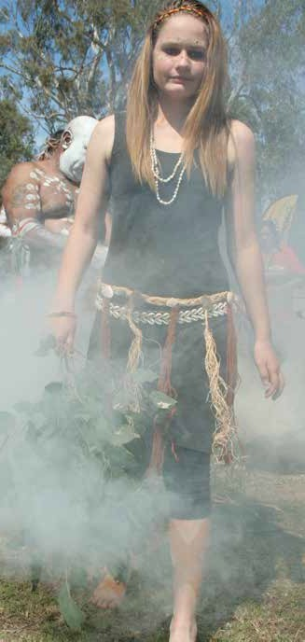

ø Investigate the use of different media platforms to teach Gunaikurnai history and reach a broad audience

ø Run cultural camps to provide opportunities for our kids to connect with their Country and learn about their culture

ø Advocate for the appropriate inclusion of Gunaikurnai perspectives and culture in the school curriculum

ø Foster opportunities for training and employment with partners

ø Provide scholarships to young Gunaikurnai

ø Market GLaWAC as an organisation that can deliver cultural education and learning programs for different levels within the education system

ø Develop protocols for cultural awareness training in schools

ø Develop a leadership and mentoring program for young Gunaikurnai

ø Establish a research arm of GLaWAC.

Success measures

We will know we are achieving our goal when we see more young Gunaikurnai finishing school going on to secure employment, and our culture and stories are being taught.

##### 29

Our Aboriginal Title land

## About joint management

The Gunaikurnai people’s strong and continuing connection with Country was legally recognised in October 2010. As part of the package of agreements in the Traditional Owner Recognition and Settlement Agreement, Gunaikurnai were granted Aboriginal Title over 10 national parks and reserves.

Aboriginal Title is the grant of crown land to Traditional Owners for the sole purpose of joint management, and recognises Aboriginal peoples’ deep understanding of land, water and biodiversity. Joint management of this land is a partnership between Gunaikurnai Traditional Owners and the State, allowing both to bring their knowledge and skills to the management of protected areas.

Gunaikurnai’s 10 national parks and reserves under Aboriginal Title are vital to contemporary Aboriginal culture and an important part of the cultural identity of Gunaikurnai Traditional Owners.

The joint management is overseen by a Traditional Owner Land Management Board (TOLMB) comprised of a majority of our Traditional

Owners, along with representatives of the broader community.

Gunaikurnai and Parks Victoria Rangers are collectively responsible for the on-ground management of these parks and reserves.

The long-term aspiration of the Gunaikurnai, as shared by the TOLMB, is to progress through joint management to full management of all Aboriginal Title land, generating a range of cultural and economic benefits for Traditional Owners and delivering important outcomes for the broader community. It is recognised that there is a long way to go before this aspiration can be realised, but steps can be taken now to build the capacity, experience and evidence base to work towards a full transfer of responsibility to Gunaikurnai in the future.

This joint management model is a new way of managing the land, and an exciting opportunity for us to have real influence over what happens on our Country.

The following section outlines the Gunaikurnai perspectives and aspirations for the joint management of our Aboriginal Title land. It is a starting point for collaboration with Parks Victoria and other land and water management partners.

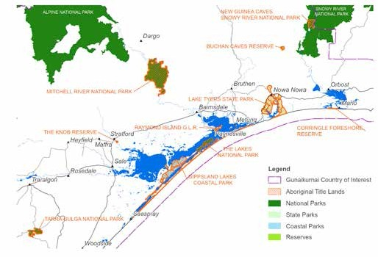

##### 30



## Principles for joint management

In addition to our overarching principles for managing Gunaikurnai Country, we have specific principles that are relevant to the implementation of our joint management arrangements.

Consider the landscape context

The value of our jointly managed parks and reserves is embedded in the surrounding landscape – we need to look beyond the park boundaries to manage them properly.

Protect the best

Resources will be prioritised to manage areas of significant cultural value that are at high risk of damage.

Openness to change

Joint management is a new way of managing the multiple values in our Aboriginal Title land, and all partners will need to be open to new approaches to managing the land.

Cultural respect

Joint management is a partnership and all parties must be respectful of one another’s values, perspectives and culture.

Respect for Elders

Our Elders are the custodians of knowledge and representatives of the mob, and must be appropriately consulted throughout joint management.

Shared benefits

Gunaikurnai should receive a fair share of profits from tourism and resource extraction activities on Aboriginal Title land.

All joint management work contracts should be offered preferentially to Gunaikurnai Rangers and enterprises.

Gunaikurnai should have the right to operate commercial business enterprises on Aboriginal Title land.

Equal partnerships

Gunaikurnai should be involved at all levels of joint management as equal decision-makers – our

views, ideas and priorities should count in planning, resource allocation and implementation.

Gunaikurnai Rangers should have equal authority as other rangers, particularly in compliance roles.

Appropriate resourcing

Adequate funding should be guaranteed for the management of Aboriginal Title land, including enough ranger positions to do the job.

##### 31

## Tarra-Bulga National Park

#### Brataualung Country

ø 2,015 hectares, situated approximately 200km east of Melbourne in the eastern part of the Strzelecki Ranges.

ø Tall open forests of giant Mountain Ash with cool temperate pockets featuring fern gullies and ancient Myrtle Beech trees.

ø One third of the park is in a Special Water Catchment Area. Originally two separate reserved areas, it was consolidated into a single park in 1986.

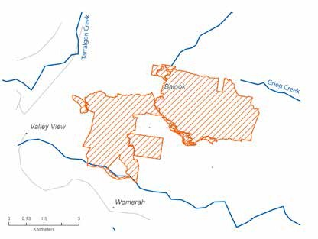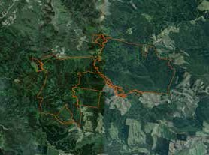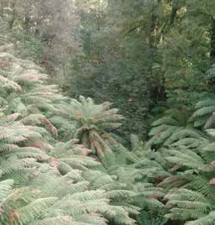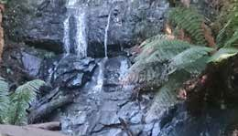

##### 32



Values

Tarra-Bulga National Park is a stronghold of virgin bushland in an otherwise cleared landscape. It is one of the last refuges of natural forest in the area and home to mountain ash trees, lyrebirds and wallabies, as well as a number of species that have now largely disappeared from the rest of the region. The significant remnants of old growth forest are characteristic of a time when only Gunaikurnai were present on the land, and is therefore an important reminder to us of what our Country was like in the time of our ancestors.

Although there is much work to be done to fully understand the cultural values within the park, we know it sits in a significant part of our cultural

landscape – on our creation storyline, where Borun travelled carrying his canoe from the mountains to the sea. The park also used to link our Country from the mountains to the sea at Wilsons Promotory,

and was part of a natural corridor that allowed our wildlife to flourish.

Much of the land surrounding Tarra-Bulga National Park has been heavily logged, and remains under threat from the encroachment of land clearing.

The cleared hills are visible from inside the park. A buffer of forest around the park is needed to protect its unique features and minimise the impact of pests and other threats.

The park also faces threats from inside. As one of the more accessible parks, it is popular with visitors and heavily used by many people. As there is limited infrastructure in the park, walking and camping occurs anywhere, causing erosion and damage to plants and cultural sites. The heavy traffic of logging trucks passing through the park also puts strain

on the roads, and the resulting erosion is the main source of pollution of the waterways.

Management approach

Our priority for this park is to protect what is left and ensure it is in good condition. To do this, we need to think about the landscape context, and look at opportunities beyond the park boundaries

– in particular through our rights in surrounding Native Title areas and through partnerships with other landowners. We will look into its value as a landscape corridor, connecting down to Wilsons Promontory. The lack of Aboriginal heritage records also makes this park a priority for cultural surveys.

Our management priorities for this area include:

ø Preventing the park from being cut off by logging

ø Maintaining roads and tourist infrastructure to minimise the impact of heavy traffic

ø Reclassification and management of the unreserved areas in the middle of the park

ø Ensuring the visitor centre actively promotes Gunaikurnai cultural values and involves Gunaikurnai people in the design of displays and audio-visual material

ø Focused cultural mapping.

##### 33

## The Knob Reserve

#### Brayakaulung Country

ø 59 hectares, located 3km south-east of Stratford, on the Avon River

ø Primarily used by the local community for recreation, including horseriding

Values

The Knob Reserve was traditionally a common ground for the five clans of the Gunaikurnai. Aboriginal people would travel for days to join great meetings where they would feast, share information, trade goods and practice corroborees and other cultural ceremonies. Evidence of these

gatherings can be seen in the rich range of artefacts found in the Reserve – scar trees, grinding grooves and, unusually, wooden artefacts like spears and paddles.

On the bluff high above the bend in the Dooyeedang (Avon River), axe heads were sharpened on the sandstone grinding stones. The deep grooves

which can still be seen today are a reminder of the ancestors who have visited this place for centuries. The bluff provided an ideal vantage point from which to look out for fish, animals or other people. Down by the river, people fished for eels, bream, flathead and prawns, which were an important part of the food supply. As well as being a source

of food, Dooyeedang was a major transport route for the Gunaikurnai people. Bark canoes were used for fishing and travelling up and down the river between the mountains and the lakes. Cultural heritage sites in this small area are extensive, and there are many that are not yet recorded.

Around the turn of the century, this area was used for less happy meetings. After our old people

were forced by law to live in missions, they came to this traditional gathering place in secret and in fear to meet with their relatives. In recognition of its significance to Gunaikurnai people, The Knob Reserve was chosen as the place where our 2010 Native Title determination was signed.

Today, The Knob Reserve lies near the town of Stratford, and is used by the local community as a sports and recreation reserve. It has barbecue facilities, walking paths, an oval and a pony club that make it a popular local spot. This intensive use is degrading the site and, along with erosion caused by the Avon River, is threatening cultural artefacts. There are different views in the local

community about how freely accessible the Reserve should be, and whether the current usage rates are sustainable.

Management approach

Because of the high concentration of artefacts in the Reserve and surrounding areas, our primary aim is to manage the impact of users of The Knob Reserve in

a way that protects our cultural heritage values and doesn’t cause harm. As a small and highly significant site, it is a place where Gunaikurnai could feasibly take over sole management responsibilities in the near future.

##### 34



Our management priorities for this area include:

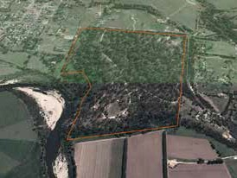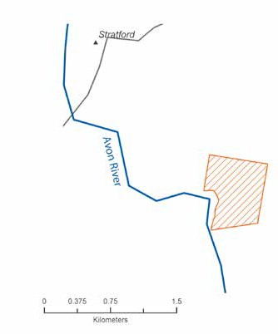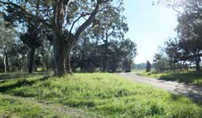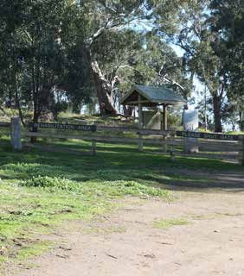

ø Extending the Aboriginal Title boundary to include sections of the river bank that have a high concentration of important cultural sites

ø Revegetating the sand dune system to get the river flowing properly and cleanly again

ø Undertaking careful fire management in a way that is sensitive to cultural values – fuel management rather than burns and doing slashing rather than using earth breaks

ø Undertaking more cultural surveys, which is particularly important in such a populated area where there is a high risk to damage of sites

ø Recognising the need for formal agreements with users of The Knob Reserve, look at ways to ensure their use does not cause harm to the land or resources

ø Educating the local community about the sites and culturally appropriate use of them.

##### 35

## Gippsland Lakes Coastal Park

#### Tatungalung Country

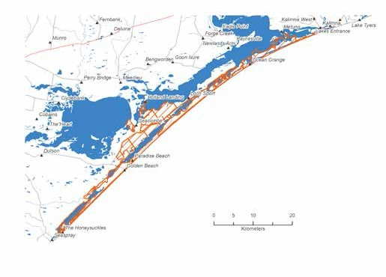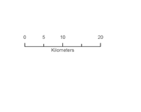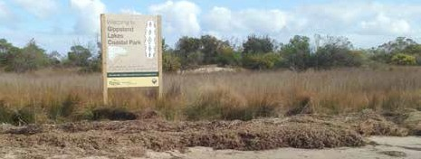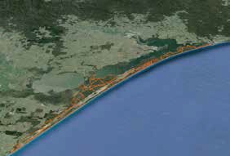

ø 17,610 hectares, stretching along 90km of coastline from Seaspray to Lakes Entrance

ø Home to internationally significant lakes, wetlands and marine and terrestrial environments

ø Includes Lake Reeve, Bunga Arm and Boole Poole Peninsula

##### 36



Values

The Gippsland Lakes Coastal Park is part of the Gippsland Lakes system, which has traditionally been a major food source for our people. Its resource abundance and diversity encouraged our ancestors to spend a lot of time in this area - fishing, camping, hunting and collecting natural resources.

Our people have a deep, longstanding connection with this area. The towns of Lakes Entrance, Metung and Paynesville were developed on our old people’s camping grounds. Evidence of our use and occupation is visible in the many midden sites,

artefact scatters and scar trees found within the park. There are many burial grounds in this area, around Boole Poole for example, and there are a number of massacre sites which are terrible but important parts of our past. The waterways and lakes system were our transport network – our ancestors would use bark canoes to move from one spot to another. They would also travel into the open ocean from this area, harvesting a range of marine resources and moving up and down the coast.

The area is under threat from development and unrestricted recreation. Many of our cultural heritage sites are being destroyed by people camping and fishing in inappropriate places, and from the construction of roads and houses. The vast lagoon network makes travel to sites difficult and our limited resources and authority mean we are hamstrung in our desires to protect our sites.

Management approach

Our focus in this coastal dune network is to protect our significant cultural heritage through direct protection works and sustainable visitor management. This includes the artefacts and remains that are submerged under the waterways

behind the dunes, which are not currently protected under the coastal park banner.

Our management priorities for this area include:

ø Looking at options for realigning park boundaries to include the waterways behind the dunes and extend out to the low tide mark

ø Educating park users about significant places and culturally sensitive park use

ø Ensuring all commercial tour operators and other non-Gunaikurnai people working in the park undertake cultural awareness training, run by Gunaikurnai people

ø Regular monitoring and compliance of park users

ø Establishment of a sea ranger program, including boats for monitoring and compliance

ø Restoration of middens and other significant sites

ø Building more boardwalks to protect the dunes from erosion and preserve cultural sites.

The story of Legend Rock

Legend Rock, lying in the shallow waters of Bancroft Bay, is an important part of Gunaikurnai mythology.

One day, three fishermen caught many fish in their nets but didn’t share their catch with the mob. The women, who were guardians of the social law, turned them into stone as punishment for their greed.

Legend Rock holds great spiritual value to the Gunaikurnai people and the story serves as a reminder of the laws of the land, and gathering and sharing.

There were originally three rocks in the formation, but unfortunately two were destroyed in the 1960s during road construction. An intervention saved the final rock, which is now protected

under the *Heritage Act 1995 (Vic)*.

##### 37

## The Lakes National Park

#### Tatungalung Country

ø 2,390 hectares at the eastern end of Loch Sport, fringed by Lake Victoria and Lake Reeve

ø Mainly low-lying woodland and coastal health

ø Consists of Sperm Whale Head Peninsula, Rotamah and Little Rotamah Islands

Values

Nestled alongside the Gippsland Lakes Coastal Park, The Lakes National Park is recognised as

an internationally significant wetland, playing an important role in providing habitat for migratory bird species. The marsh and wetland between the park and the coast are also very significant. Rich in wildlife, they are home to several of our totem species as well as a number of rare and endangered species.

The Lakes is a hotspot of cultural sites. There are shell middens all along the sand dunes, Aboriginal human remains (where people were wrapped in bark and buried upright in hollowed out possum holes), and

a possible massacre site. Our ancestors travelled up between Pelican Bay and Sperm Whale Head, across the land and waters, and over the islands.

The area is recovering from recent fires and is in reasonably good condition. There have, however, been a number of unexplained bird and fish deaths in the area. Erosion is fairly widespread, which can be useful in exposing artefacts for identification, but places them under greater threat of damage.

Gunaikurnai burial sites along the coast are vulnerable to rising waters caused by climate change. A high concentration of cultural sites was unearthed along access roads when the pipeline was built revealing new information and an opportunity to focus effort on cultural mapping in this area.

Management approach

As part of the connected lakes and dunes system, we think about management of this park in conjunction with the surrounding Gippsland Lakes Coastal Park. Our focus is on protecting and better understanding the cultural heritage and natural values of the area. As many of our important sites are in the unstable dunes we need to be proactive in protecting the vulnerable areas.

Our management priorities for this area include:

ø Limiting further development and undertaking stabilisation works to protect the sensitive dunes

ø Looking at realigning the boundary of the park or management area to include cultural sites along the coast and out to sea

ø Strengthening our understanding of the area – researching and telling storylines and undertaking surveys

ø Research that looks into wildlife deaths in the area.

##### 38

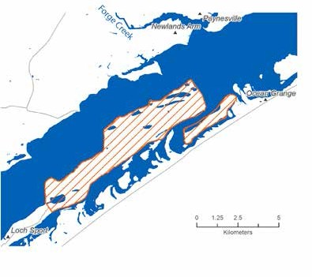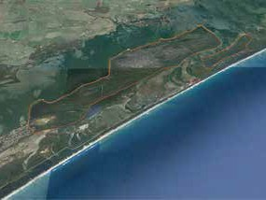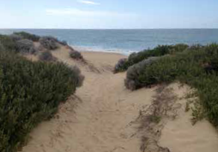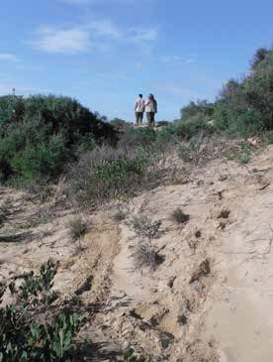

##### 39

## Gippsland Lakes Reserve on Raymond Island

#### Tatungalung Country

ø 248 hectares on Raymond Island, just to the east of Paynesville

ø Disconnected pockets of bush among a low density settlement

Values

Gippsland Lakes Reserve on Raymond Island comprises some disconnected pockets of bushland and stretches of coastline that have abundant native plants and animals. Raymond Island is not a densely populated area, but it does get busy during peak tourist seasons.

Gunaikurnai lived and camped on this Island, which they called *Gragin,* for thousands of years. It was particularly important for collecting swan eggs,

and evidence of scar trees, burial sites and artefact scatters have been found in the area. It is in a strategic location in the lagoon system, providing a line of sight to many of the other important places on the water. Our old people would have used this place to keep an eye on what was going on in the surrounding area.

Though a popular tourist destination, there is not a lot of damage caused by the periodic influx of people. There are some problems with disease in the koala population, and over-browsing by koalas

has caused some stress to the manna gums. But the bushland remnants and cultural sites are in largely good condition. Without their own watercraft, however, rangers managing the Gippsland Lakes Reserve must rely on the ferry for access.

Management approach

Because of the existing extent of bushland, we have the opportunity to keep Gippsland Lakes Reserve in good condition without too much work.

Reconnecting and restoring the parcels of remnant bushland will increase their resilience for the future, and it will be important to maintain the current low- impact approach to tourism and occupation.

Our management priorities for this area include:

ø Looking into the possibility of establishing an Indigenous Protected Area to help maintain the Reserve’s good condition

ø Looking into buying strategic parcels of

land to reconnect and bring back the forest, investigating opportunities with the Indigenous Land Corporation and other funding mechanisms

ø Formally identifying and protecting burial sites

ø Renaming the streets with Gunaikurnai names and sharing information about our traditional past, to balance the settler perspective of history

ø Undertaking more cultural surveys to get a better picture of what happened there.

##### 40

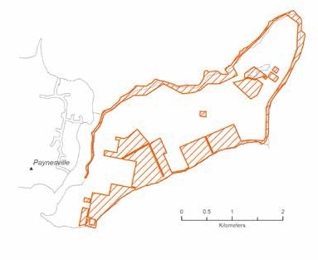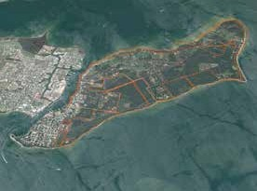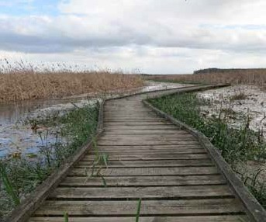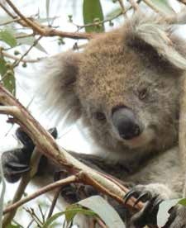

##### 41

## Lake Tyers State Park

#### Krauatungalung Country

ø 8,500 hectares extending from Lake Tyers Beach to Mount Nowa Nowa, surrounding Lake Tyers mission

ø Tall eucalypt forests and sandy beaches

ø Legislated as a State Park in 2013

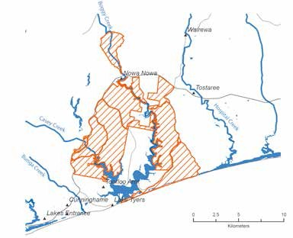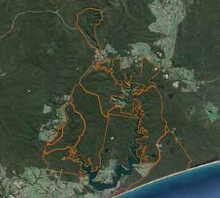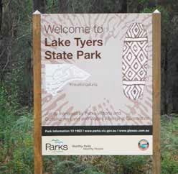

How Bung Yarnda was formed

Narkabungdha, the sea, was tired from playing with fish, rushing over rocks and rolling up and back on the sand. He searched the coast for somewhere to

rest. At last he found a quiet place with tall gum trees for shade and soft earth to lie on. Narkabungdha

lay down to sleep. He wriggled down into the soft sand, turning his body this way and that until he was comfortable. This place became Bung Yarnda (Lake Tyers), a place where Narkabungdha still rests among the trees.

##### 42



Values

Bung Yarnda (Lake Tyers) was an important meeting place for Gunaikurnai groups throughout the area.

It was a neutral place that was rich in food and materials. It is the place our mob lived when we were forcibly removed from our homelands by European settlers. The catchment area surrounding the Lake Tyers mission is also very significant to us. Our ancestors often passed through this bushland to get to and from Bung Yarnda, as we continue to do today.

The catchment area is where a lot of our mob lived, camped and fished. It is an abundant place, providing us with food all year round. And it is a beautiful place

– you can see why the old fellas went there. As home to our ancestors, there are many recorded sites – scar trees, artefact scatters, birthing places and burial sites. Burnt Bridge Reserve is a popular gathering place and ochre site. The cultural sites continue all

the way along the coast to Corringle.

Because it is so fertile and accessible, the area is under a lot of pressure from visitors. People camp on the foreshore, destroying artefacts and the bush. When we use boulders to block access to sensitive areas, they are moved by four-wheel drivers. This culture of public access getting right of way over cultural heritage values is one of our primary concerns in this area. Managing the catchment area itself is important for protecting the water which flows into the lake.

Management approach

The Lake Tyers State Park is a clear example of where the meaning and value of an important place can’t be divorced from its neighbouring areas. Our management of values in this area can be more efficient and effective if we work in this broader landscape context.

Our focus for managing this area is on reducing the threats to our cultural heritage and the environment by managing inappropriate use, and

also encouraging appropriate use. It is an area that can be used sustainably and shared by all, but needs to be done in a sensitive and measured way.

Our management priorities for this area include:

ø Reducing public access points to the river

ø Undertaking compliance activities in the park to protect significant and vulnerable sites

ø Planning and developing sustainable use areas, including building playgrounds in the park

ø Working with authorities to help manage for sustainable fisheries

ø Clarifying resource extraction rights (including firewood) for Traditional Owners

ø Developing an agreement for the protection and management of the many significant areas that lie just outside the area.

Lake Tyers mission

By the 1850s, the Aboriginal population had significantly declined. Missions were established where the remaining Aboriginal people would be located and be Christianised. After rejecting Mitchell River because of its cold winter, Lake Tyers was chosen for its reliable supply of food and water. The mission was both good and bad for Gunaikurnai people.

For some, Lake Tyers was home – a place where people were born and grew up. Where family were buried and where connection to Country could be maintained without persecution.

Others felt hemmed in by the rules and rigid protocols of the governing agencies, the severity of which varied depending on the government of the day.

Lake Tyers was one of the last remaining missions, where Aboriginal people were sent from across Victoria when other missions were closed. In 1970, Lake Tyers was the first transfer of crown land back to Aboriginal people.

##### 43

## Corringle Foreshore Reserve

#### Krauatungalung Country

ø 159 hectares at the mouth of the Snowy River, just west of Marlo

ø Coastal tea-tree vegetation

Values

Corringle Foreshore Reserve is a fairly natural camping and recreation area. The old people used to go camping and fishing here. It was a plentiful

food source for the mob and a place of connection – connecting the ocean to the rivers, connecting along the coastline to Lake Tyers. And it was an important meeting place for families. This is the place where our people came when they were displaced from

the mission, and a place where people who lived off-Country would come to re-connect to the traditional land. It was a safe place.

Evidence of our use and occupation can be seen in the many large middens, canoe trees and an earth oven at Lake Corringle. Many Gunaikurnai continue to use the area today for camping, fishing, hunting and gathering natural resources.

Since Gunaikurnai people have been working here under the joint management arrangements,

Corringle is the best it’s ever been. We have a good understanding of the Reserve and take great care in its management, making sure that facilities are well maintained.

Management approach

Corringle is a realistic prospect for sole management in the short term. Gunaikurnai Rangers are skilled

in all of the jobs that are required to manage this place, and we feel a strong ownership over the area. By taking over management of this area, we would not only be developing the skills and evidence we need to transition to sole management of Aboriginal Title land in the long term, but also the revenue generated from tourism activities could be used to strengthen our joint management capacity.

Our management priorities for this area include:

ø Making arrangements for Gunaikurnai Rangers and NRM staff to do all of the management roles, including maintenance, interpretations, cleaning and bookings

ø Increasing the number of rangers working on the ground

ø Putting in place an evaluation to determine the effectiveness of this arrangement and build

the case for the transfer of full management responsibility

ø Looking at creating/reserving certain campsites for use only by Gunaikurnai.

##### 44

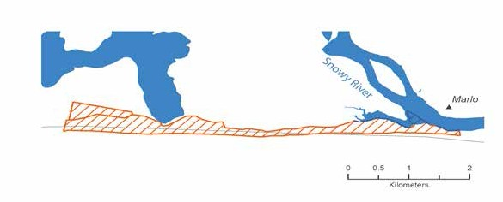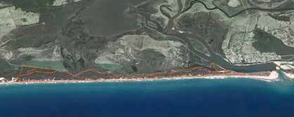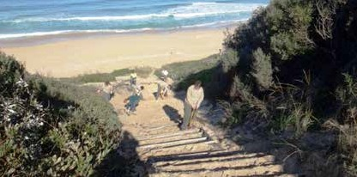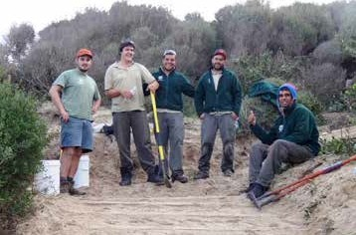

##### 45

## Mitchell River National Park

#### Brabrablung Country

ø 14,250 hectares, situated 25km northwest of Bairnsdale

ø Rainforest gullies, rugged cliffs, open forest and remote river gorges

ø Special conservation values, with several significant and threatened species and communities

Values

Mitchell River National Park has a rich cultural history that tells of tribal conflict, ceremonies, food gathering, community life and local spirits.

It is rocky country that has rugged gorges and 100 metre sheer drops. Some of these, such as The Bluff, provide 360 degree views that were good lookout points for our ancestors, used for safety and defence. Mitchell River is Victoria’s largest remaining wild and free flowing river.

Mitchell River was a major stop-off point for our old people travelling from the high country to the lowlands. It was at one point going to be the site of the mission, but it was found to be too cold in

winter so Lake Tyers was chosen instead. There are important places throughout this park – Angusvale was a good source of food, medicine and materials, and Billy Goat Bend had reliable water. Deadcock Den is important to Gunaikurnai men. There are caves throughout the area that were shelter places and burial grounds where human remains have been found.

While much of the bushland is in good condition, some areas are deteriorating – where the forest is not healthy and you can see a lot of erosion and damage from floods. There is four-wheel drive access in many spots, a lot of walking tracks throughout the park and natural clearings that are used for camping. While this infrastructure is

good for managing park visitors, the park users are damaging artefacts and exacerbating erosion.

Management approach

The park needs to be carefully managed to minimise the impact of public activities, protect significant sites and rehabilitate eroded areas.

Our management priorities for this area include:

ø Restricting where camping can occur to protect significant cultural sites

ø Restricting four-wheel drive access to sensitive areas

ø Ensuring that Gunaikurnai are consulted on any new walking tracks or roads that are being built, to make sure cultural values are protected

ø Giving Gunaikurnai first preference for all future and renegotiated tourism operations in the National Park.

##### 46

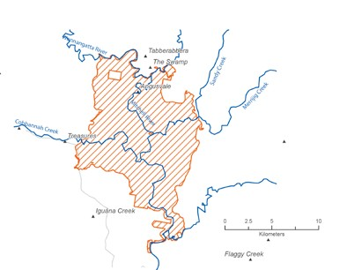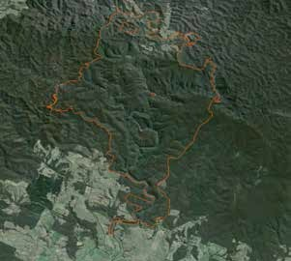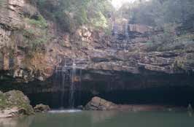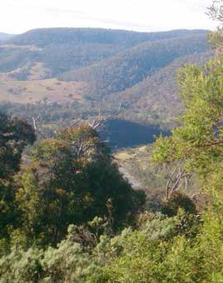

##### 47

The Den of Nargun

The Den of Nargun, a cave behind a waterfall of the Mitchell River, is a place of great cultural significance to the Gunaikurnai people, especially women.

Stories were told around campfires about how the Nargun – a large female creature who lived in the cave – would abduct children who wandered off on their own. The Nargun could not be harmed with boomerang or spears. These stories not only kept children close to camp, but also ensured people stayed away from the sacred cave.

The Den of Nargun is a special place for women

and may have been used for women’s initiation and learning ceremonies.

## Buchan Caves Reserve

#### Krauatungalung Country

ø 232 hectares near the township of Buchan

ø Honeycomb of caves full of spectactular limestone formations

Values

Buchan Caves were traditionally an important meeting place for our people. The area connects to the high country and was a place of refuge during the seasonal migrations to and from the mountains, where our mob would go to chase the Bogong Moth and other food sources. Although Gunaikurnai people did not traditionally venture very deep into the limestone caves, there is evidence going back more than 18,000 years of the important role they played in the lives of our old people, including burials in the caves and ceremonial rings all through the Buchan area.

Some of the artefacts and cultural materials are very rare, such as artwork done in animal fat. There is also evidence of fishing and camping, as well as a significant massacre site.

In a highly modified landscape, the Buchan Caves are popular with tourists and there are several commercial tourism enterprises operating in the area.

Management approach

As traditional owners of the Country and custodians of the ancient knowledge of this place, Gunaikurnai are well placed to provide unique tourism experiences around Buchan Caves. This area is also a good opportunity for joint managers to share responsibility for administration and management of the reserve.

Our management priorities for this area include:

ø Establishing cultural businesses and enterprises around tourism and education

ø Ensuring that all non-Gunaikurnai working in the Buchan caves area undertake cultural awareness training

ø Taking a more active role in the administration of visitation and receiving commensurate income from camping and other fees.

##### 48

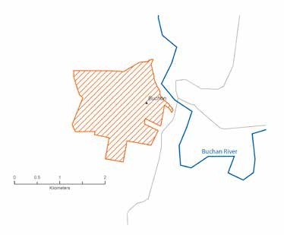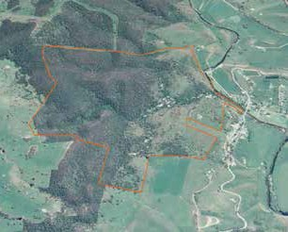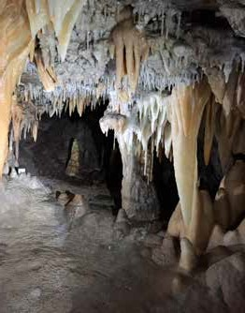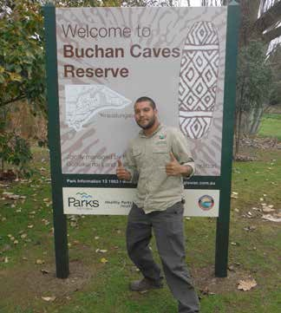

##### 49

## New Guinea Cave II (within Snowy River National Park)

#### Krauatungalung Country

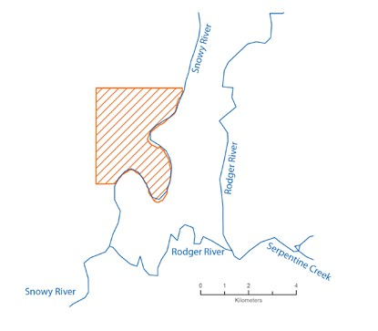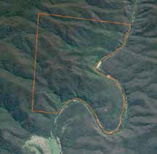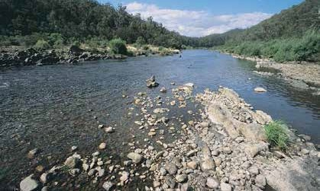

ø 1194 hectares on the Snowy River, about 20km northeast of Buchan

ø Limestone cave and rock shelter

##### 50



Values

New Guinea Cave II is a rare cultural site and one

of the oldest inhabited caves in the world. Set deep in the Snowy River National Park, the steep terrain makes it difficult to access, especially during the wetter months when the clay soils make the roads impassable. Our old people used to camp in this refuge on their way to and from the high country, when they followed food and temperate weather

in their seasonal migrations. There was always a good supply of water from the Snowy River and an

abundant source of food and other natural materials. Prone to seasonal flooding, when water came into the caves, our ancestors would move up on to the shelf and paint the walls using their fingers.

Because of the good supply and quality of rocks,

the area was an important stone tool manufacturing and repair site, where thousands of artefacts are well documented in the archaeological records.

New Guinea Cave II has one of the few examples of rock art in Victoria, with engravings dated at over 21,000 years old. These are listed on the Register

of the National Estate and proclaimed under the Archaeological and Aboriginal Relics Preservation Act. Human remains, believed to be a victim of a massacre that took place in 1840, have been found in the cave.

People like the idea of visiting this interesting and challenging place, but this is causing significant damage to the site – through erosion of the roads

and the theft of cultural artefacts. There are instances where visitors have cut padlocks to get in to the cave, but its remoteness makes it difficult to patrol the area and prevent this kind of vandalism. The caves are

also threatened by the flooding and wildfires that are common in that part of the Country.

Management approach

Our key objective for New Guinea Cave II is to protect the important cultural values that exist there. It is fragile and not a place that should be developed for tourism. The overarching strategy for the cave should therefore be to prevent public access and make it accessible for Aboriginal cultural use only.

We want a more active role in managing the area, given its very high cultural significance. It may also be a good prospect in the short term as a trial for sole management by Gunaikurnai.

Our management priorities for this area include:

ø Preventing public access and establishing an effective enforcement regime

ø Clean up and removal of debris from past floods

ø Putting strategies in place that minimise damage from future floods and wildfire

ø Looking at options for sole management of New Guinea Cave II, including adequate resourcing.

##### 51

# Other areas of interest

## Wilsons Promontory complex

#### Brataualung Country

Values

Corner Inlet Marine and Coastal Park

ø 28,500 hectares in the crook of Wilsons Promontory

Corner Inlet Marine National Park

ø ‘No-take area’ protecting sheltered mudflats, channels and seagrass meadows

Nooramunga Marine and Coastal Park and Marine and Wildlife Park

ø 30,170 hectares

ø An intricate network of waterways and islands with shallow marine waters, isolated granite islands, intertidal mudflats and sand barrier islands

Shallow Inlet Marine and Coastal Park

ø 2,377 hectares nestled between Waratah Bay and the peaks of Wilsons Promontory

ø Large tidal bay with salt marsh terraces, woodlands and mudflats

Wilsons Promontory Marine National Park,

Marine Park and Marine Reserve

ø Largest protected area in Victoria’s marine national park system

ø Shallow and deep reefs, rocky shores, sandy beaches, underwater granite cliffs and seagrass communities. Habitat for a huge diversity of marine plants and animals as well as shorebirds and fur seals

Wilsons Promontory National Park

ø 50,500 hectares – the largest coastal wilderness area in Victoria

ø Designated biosphere reserve, recognised for its lush rainforests, unspoilt beaches and abundant wildlife

As recently as 10,000 years ago, Victoria was connected to Tasmania by a land bridge, with sea levels estimated to be 50 metres lower than they are today. At this time, the marine parks and reserves around Wilsons Promontory were terrestrial habitats, inhabited by our ancestors.

Gunaikurnai who lived around Yiruk were protected from invasions by a spirit called Loӓn, also known

as Kŭlŭngrŭk, who lived in a cave and had a huge spear. Cultural places and objects in the area show evidence of our old people living there and using the natural resources from at least 6,500 years ago. They would have hunted and gathered seasonally abundant food, including terrestrial and aquatic animals, fruits, yams and eggs. As the sea level increased and the low plains became submerged, our ancestors would have used bark canoes to travel around the area and harvest fish.

Today, the area is made up of a complex of terrestrial and marine protected areas that encircle the imposing Wilsons Promontory and series of islands off the coast of Port Albert. These reserves

recognise the exceptional natural and cultural values that exist in the area; features that have helped to make them popular tourist destinations. Though in largely good condition, these areas do face a range of threats.

Although they are very different environments, the land and marine environments are interconnected. Some plants and animals rely on both onshore and offshore areas for different life cycle stages and

the marine parks and reserves are susceptible to influences from land, making the focus of many programs reducing erosion and nutrient runoff. Managing the landscape as a system and considering the connections between these systems is a core principle in our approach to managing Country.

##### 52

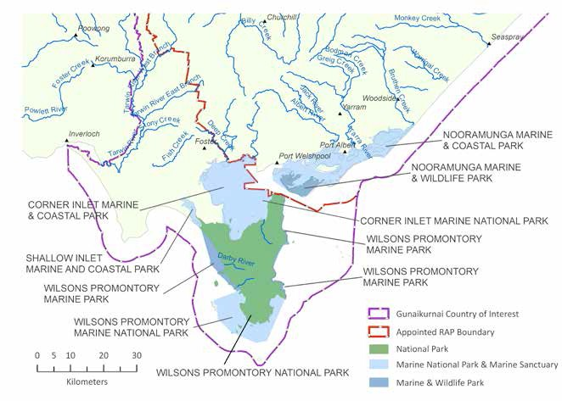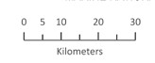

Opportunities

The natural and cultural significance of the Wilsons Promontory complex of terrestrial and marine parks and reserves make it a very valuable place. There

is already a strong tourism sector, with particularly high visitation to Wilsons Promontory National

Park. Commercial opportunities around eco-tourism and sustainable joint ventures are emerging as government shifts its policies around use of national parks. While predominantly based on natural

values, there is scope to strengthen the cultural component of these activities. Investigations into carbon sequestration potential of seagrass beds may also highlight some new and innovative commercial options for the area.

These important places also present an opportunity for strengthening Gunaikurnai culture, both through the protection of cultural heritage sites and artefacts, and opportunities to access and use the area for cultural purposes. They could be used as a canvas

for investigating and practicing traditional ecological knowledge, looking at ways to sustainably and holistically manage connected land and water systems.

The land and sea parks are currently managed individually. We want to look at alternative models for managing these protected areas that could improve natural and cultural management outcomes while providing benefits to Gunaikurnai people.

##### 53

One option might be to establish this network of parks as a multi-tenure Indigenous Protected Area (IPA). IPAs can be land and/or sea country that are voluntarily declared by the Traditional Owners as protected areas, and recognised as a formal part of Australia’s National Reserve System. The IPA

approach provides a framework for coordinating the management of cultural and natural values across tenures and across management agencies.

This approach would help ensure management of the parks and reserves became more aligned with traditional approaches, to better integrate

cultural values into the natural values management approach. It could be a means to forge stronger partnerships between delivery agencies and help to embed a cross-tenure approach to managing this inherently linked system.

Establishing an IPA would not be without its challenges. Ensuring strong and clear governance systems would be critical to ensure all partners are clear on their roles and responsibilities. It would also be necessary to ensure all managers had the appropriate capacity to meet both the terrestrial and marine management requirements.

The following things would need to be investigated to assess the feasibility of this approach:

ø The legislative basis for establishing an IPA would need to be considered, in particular the most appropriate tenure arrangements.

Most IPAs are established on Aboriginal-owned land, and this could be an option following

the granting of Aboriginal Title of this area

to Gunaikurnai. Alternatively, a voluntary IPA could be declared over the existing legislated tenures. This would mean that management of the IPA would also need to meet all existing obligations for each of the reserved areas

ø A review of existing catchment and water programs would help to identify synergies and differences between management objectives and approaches in each of these areas, and begin to identify overarching goals

ø The development of partnership arrangements and memorandums of understanding with both public and private land managers, would help to ensure all parties are committed to common goals

ø Benefit sharing arrangements would need to be considered, potentially in the context of Native Title settlement negotiations.

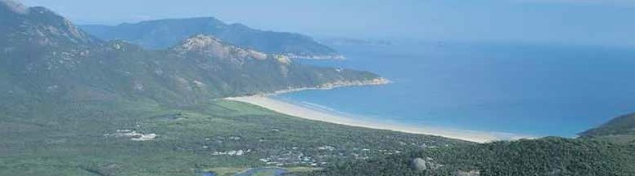

##### 54



## Sea Country

#### Brataualung, Krauatungalung and Tatungalung Country

Values

Gunaikurnai people have occupied, used and managed coastal land and sea environments for many thousands of years. These include those areas that were dry land before the current sea level stabilised about 5,000 years ago. Our relationship with these cultural landscapes continues, even where the evidence of our previous occupation now lies beneath the ocean.

We see no distinction between the land and the sea. It is all a part of our Country. But our connection to the coastal and marine parts of our Country is rarely recognised, so we now need to be explicit about its significance to us.

Coastal areas were among the most densely populated parts of our Country. Rich in both terrestrial and marine food sources, they provided good places

for our old people to live, camp and hunt, and the launching place for expeditions out to sea to gather seafood. Our ancestors would travel to islands in bark canoes and harvest fish and coastal species at levels that did not disrupt the natural balance.

We are still heavily dependent on our Sea Country and its resources. A major challenge for us is the lack of access to and equality in use of marine resources, not just for cultural purposes but for commercial uses as well. Our people have always used fish and other products that were harvested from the oceans as items to trade. Although the terms of trade have significantly changed in the past 200 years, our fundamental need still exists. But without commercial rights to fisheries resources, this need cannot be met.

Opportunities

Stronger involvement in the management of sea country can open up opportunities for improving economic outcomes for our mob, while better protecting our cultural heritage and improving environmental outcomes.

With a longstanding connection to managing the coast and sea, we can provide valuable perspectives to the coastal management programs.

Some of our joint management parks and reserves are adjacent to important coastal and marine areas, which need to be included holistically in the joint management program. We want to look at options to broaden our joint management areas to include

the adjacent marine environments, as well as identify future wholly marine joint management areas, such as the Ninety Mile Beach Marine National Park and the marine parks around Wilsons Promontory.

In addition, we need stronger involvement in the protection of coastal and inundated cultural values within and beyond our Aboriginal Title areas.

Reclaiming our rights to use our sea as a resource is fundamental to recognising our ongoing connection with sea country. This should include access to fisheries anywhere for cultural purposes, which we would manage according to sustainability principles, and rights to harvesting of sea resources for commercial purposes.

To strengthen our rights and role in sea country management and use, we need to:

ø Look into extending management boundaries of Aboriginal Title land to include adjacent coastal values

ø Undertake research into the feasibility and location of new marine parks, including

cultural parks where our submerged values can be better protected

ø Establish a sea-ranger program and build up the skills of our mob in managing sea country

ø Negotiate with government for the allocation of commercial fishing licences to Gunaikurnai people.

##### 55

## Greater Alpine National Parks

#### Brabralung, Brataualung, Brayakaulung and Krauatungalung Country

Values

The southern slopes of Victoria’s alpine ranges are a vast cultural landscape. They are where our creation story began and where our ancestors travelled for trade, for gatherings and to track seasonal food sources. The forests are rich in cultural artefacts

and sacred sites, many of which were uncovered following the 2003 alpine bushfires. The surveys that were done after these fires when the land was cleared have helped us to tell the story of our ancestors’ occupation of the high country, and

demonstrate how far and wide our people travelled.

Our old people would come to the high country during the summer, following spur lines and heading up into the mountains as the food sources lower down finished. They would move through the landscape – harvesting food resources without exhausting them, and caring for the Country along the way, using firestick management at the right time so that it didn’t damage the food source. They followed the Bogong Moth paths as well as many other food sources, sustaining themselves by eating little by little as they went on their journey. They looked for the right sorts of stones as they travelled, to make tools.

The designated national parks in the high country are the sites of some of Victoria’s most spectacular reserves, with largely intact natural landscapes

and diverse plants and animals. Connections between these parks are relatively strong, making it logical to take a whole-of-landscape approach to management. In recognition of this, Parks Victoria

has developed a draft Greater Alpine National Parks Management Plan, covering the full suite of parks across the alpine ranges. It is within this landscape context that we see a future role for Gunaikurnai.

Opportunities

The generally good condition of this suite of alpine parks forms the basis of several opportunities

for sustainable economic development. As the headwaters of many of Victoria’s water catchments, their value in providing good quality water supplies is significant. Visitation of many of these parks is high, providing a strong basis for tourism-related industries. Carbon production through forest restoration and fire management may also prove to be applicable in these areas.

Protecting the extensive cultural and natural values across this large area is a big job and one that is fundamental to our role as custodians of the land. We have cultural obligations to make sure it is cared for. As we build our capability and experience in joint management, and work over time towards increasing our Aboriginal Title landholdings, these alpine parks have potential to be brought under joint management regimes. This would not only support our ongoing connection with this Country, but also enable us to ensure they are looked

after and provide employment opportunities for Gunaikurnai people.

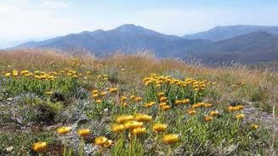

##### 56



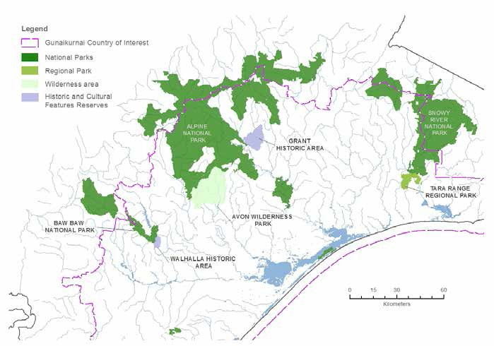

Working towards joint management of the alpine park estate is a long term goal. Steps that could help us work towards this goal could include:

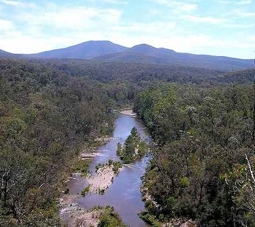

ø Building our experience of joint management and drawing together the evidence for an expansion of the Aboriginal Title estate

ø Further investigations into the alpine parks to determine priorities for incrementally building them into the Aboriginal Title estate

ø Collaborating with other Traditional Owner groups to develop collective approaches and goals for management of alpine parks, recognising that landscape features and not

park boundaries dictate the natural systems.

##### 57

## Far East

#### Krauatungalung Country

Values

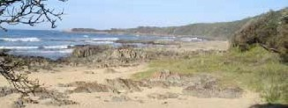

The eastern portion of our Country is home to a rich tapestry of Gunaikurnai cultural and historical

values. It was largely a transitory landscape, through which our ancestors would travel to take advantage of different food sources available at different times of the year. This seasonal migration – from the high country to the coast and back – has left an indelible mark on our Far East Country, with a wide variety of cultural sites providing the physical evidence of our ongoing connection to these land and seascapes.

Many of our old travelling and trade routes through this country followed the freshwater river systems and ridgelines, with others following what are now major road networks, especially through the high country.

The Princes Highway that runs through the Far East and into the rest of Gunaikurnai Country follows our songlines – the walking routes of our old people.

Along their migrations, our ancestors would camp on river banks and coasts at places like Bemm River, Cabbage Tree Creek and Pearl Point. They would harvest abalone, mussels and periwinkles, using tea tree bushes to catch shrimp and travelling as far as

five miles out to sea in bark canoes to access the best fishing grounds. The women would collect swan eggs and materials for medicine, and banksia pods would be used to carry sacred fire from place to place. Many areas in this region, such as Bullock Island, remain popular places for our families to visit.

The Far East area is rich with significant sites. Cape Conran was very special place - a rich source of food and a place where people would camp for long periods. It has many middens and burial sites, although not all have been recorded. The Yeerung River is named for the Gunaikurnai male totem.

Marlo, at the mouth of the Snowy River, was an important source of ochre for our ceremonies - *Marloo* means white clay. The remote area around Mueller River was a place for tribal business, where people would be exiled in punishment for

breaking our customary laws. These places are very important to us.

After European settlement, our families moved through these landscapes following available work

– taking on seasonal jobs such as bean picking, or more stable employment in the timber industry.

They camped on the outskirts of timber towns

like Cann River and Club Terrace. As the industries declined and work became scarce, Gunaikurnai families moved back towards the bigger towns, settling in places like Orbost and Newmerella. These were important meeting places, where people began to move into more permanent housing.

The land and seascapes of the Far East are significant for Gunaikurnai people, and looking after them is an important part of meeting our responsibilities as caretakers of Country.

58



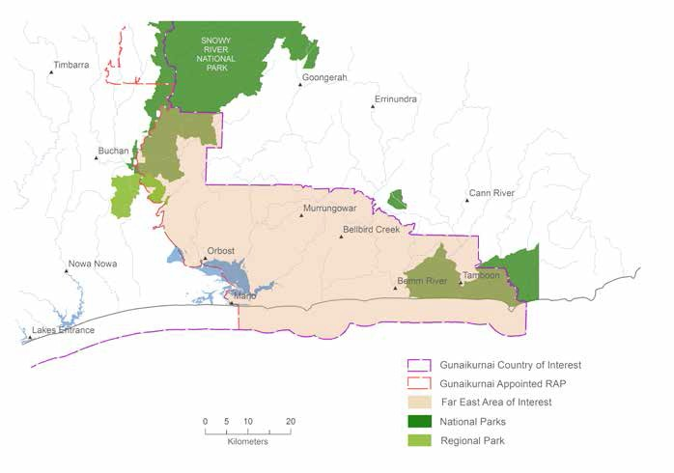

Opportunities

Although outside of our current Native Title determination area, we have never lost our close connection with the Far East of our Country. It is a priority for us to secure formal recognition of

Gunaikurnai traditional ownership of this area; and given its high cultural significance and sensitivity, we will also be seeking joint management of the Cape Conran Coastal Park. Consistent with our aspirations to be involved in the management of our sea Country, we will explore joint managament opportunities for important parts of the marine environment, such as the Beware Reef Marine Protected Area.

The timber industry has historically been a major industry in this region. Although greatly reduced since its heyday, the Victorian Government continues to undertake significant timber harvesting activity on our Country. We want to work with VicForests to support our economic development

in this area, through NRM contracting and timber salvage enterprises.

To fulfil our role as traditional custodians of this Country, and maintain our strong cultural and physical connections, we also need to:

ø Undertake comprehensive cultural mapping to identify high value sites, and ensure they are adequately protected

ø Install signage along the eastern boundary of our country at the major entry points

ø Establish an interpretation centre and keeping place for Krauatungalung cultural heritage.

##### 59

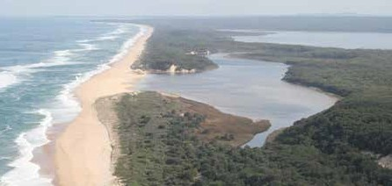

# Implementing the Plan

## Principles for implementation

There is much to do to implement our Whole-of-Country Plan. In addition to our overarching principles for managing Gunaikurnai Country, we have principles that will guide the way that we work towards achieving our goals.

Inclusiveness

All Gunaikurnai should have the opportunity to participate in working towards our collective goals.

Good communication

The mob must be kept informed in a consistent and transparent way throughout the implementation of the Whole-of-Country Plan.

Fair division of benefits

Benefits and opportunities arising from the implementation of the Whole-of-Country Plan should be shared fairly across the five clans.

Partnerships and collaboration

We will partner with others to complement and strengthen our existing skills and achieve mutual goals, working in a spirit of cooperation.

Coordination

Wherever possible, activities and consultations should be coordinated to ensure maximum value from our limited time and resources.

The best available solutions

We are not frozen in time. We will use both our traditional approaches and contemporary tools to sustainably manage our natural resources.

Respectful consultation

We expect government and other groups to engage with us in a timely, appropriate and respectful manner on matters that affect our rights and interests.

Continuous improvement

We will continue to assess our progress and improve our approaches to get the best outcomes for our mob.

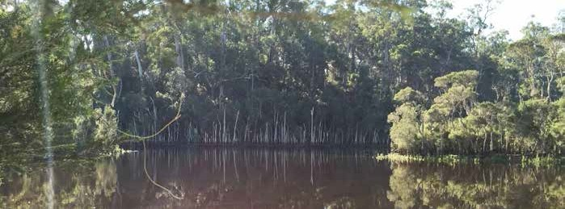

##### 60



## Mechanisms

This Whole-of-Country Plan describes the future that we are working towards and the steps we need to take to improve the lives of Gunaikurnai people. Achieving our vision will be a long-term effort and will require sustained efforts by our mob and our partners.

We don’t yet have all the answers, nor do we currently have the resources to do everything that we have described in this plan, but we are in a strong position to make a start. We have put some important things in place that mean we can start taking action, and there are many new opportunities to pursue that will help us implement this plan.

Building wealth and capacity

Securing employment and economic independence is a priority for our mob. We want everyone to be able to provide for themselves and their families, and stand with pride in the community.

ø GLaWAC is building a range of enterprises to provide a sustainable income source for the Corporation and employment for Gunaikurnai people. Current services include firewood production, natural resource management contracting and cultural heritage services, and this will expand over time as our corporation grows

ø The ongoing effort to expand our rights to natural resources will help GLaWAC to

establish new enterprises and employment opportunities for our people. As the corporation’s revenues increase it also will be increasingly able to provide more programs and services to the mob

ø We can do more to help facilitate employment of our people in other businesses and organisations in the region – by building strategic partnerships with government, non- government organisations and industry and ensuring our people have the right skills and support to take advantage of opportunities

ø We will focus on training and skills development for our mob, with pathways to real and secure jobs.

GLaWAC programs and services

As outlined in its constitution, the primary role of GLaWAC is to advance the well-being, education, cultural, social and economic independence

and social inclusion of Gunaikurnai people. As highlighted in this Country Plan, many of the mobs’ goals and objectives relate directly to this mission, and so it is the intent of GLaWAC to be able to increasingly provide a range of programs and services to Gunaikurnai people to make progress in these areas. Initially, GLaWAC will seek to:

ø Establish a range of community support programs to help our people in their times of need, including funeral and scholarship funds

ø Provide places and host events to practice, share and strengthen our culture into the future; and opportunities to pass on our traditions to future generations

ø Establish language programs

ø As our businesses grow, provide more opportunities for Gunaikurnai to work for their own mob

ø Continue to raise awareness among the broader community about our mob and our priorities, through community education programs, information materials and increased signage.

##### 61

Legal recognition

Our Native Title determination and Traditional Owner Recognition and Settlement Agreement have provided us with a strong legal basis upon which to secure real benefits for our mob. In particular:

ø A number of different statutes give GLaWAC legal authority over Native Title and cultural heritage matters on behalf of the mob. These allow us to influence what happens on our Country, generate revenue streams that will be critical to delivering on our development goals and continue to maintain our strong and ongoing connection with our Country

ø Our Recognition and Settlement Agreement included funding for economic development and cultural strengthening opportunities. We will use this seed money wisely, to progress our most urgent goals and establish sustainable enterprises that will continue to provide for

our mob into the future. The funding has also enabled us to develop the capacity of GLaWAC and its services, which we will continue to expand in order to employ more Gunaikurnai people

ø Through our Traditional Owner Land Management Agreement, we have been granted Aboriginal Title over 10 parks and reserves, which we are managing jointly with the Victorian Government. The specific rights and responsibilities of joint management partners are still being finalised. Nevertheless, we expect that these new arrangements will support Gunaikurnai enterprise development in these parks and reserves, as well as increased employment of Gunaikurnai people in land management and governance roles

ø Through our upcoming negotiations with the Victorian Government we will work to secure further rights to better access and use our natural resources, to have formal roles in the governance of our land, waters and natural resources, and to influence land use activities that are carried out on public land.

Advocacy and influencing policy and planning

By clearly articulating our priorities, our Whole-of-

Country Plan provides us with a strong platform to engage with government on issues that are important to us, such as commercial use rights and resource rents for our people. The Country Plan also supports more equitable representation and participation in the development and implementation of the government’s key regional

plans. As government policies and plans increasingly reflect and support our vision and goals, we expect to be more heavily involved in the investment programs that implement them.

ø We are a member of the Federation of Victorian Traditional Owner Corporations, the peak body for Traditional Owners in Victoria. We will work with this alliance on issues of state and federal significance, to use our collective voices to continue to advocate for greater cultural and economic rights to water resources. We will seek legal rights to carbon on our Aboriginal title land so that we can generate and trade carbon credits as part of our mix of land management strategies. We will also be seeking greater access and use rights to other resources such as timber and fisheries

ø At a regional level, we will work directly with government and other partners to influence plans and programs and ensure that our aspirations are properly considered in the decisions that affect us. We will seek more equitable representation and participation

in the development and implementation

of Regional Catchment Strategies, Regional Growth Plans and public land management plans

ø Through the Traditional Owner Land Management Board, we will influence the planning and operational decisions of our Aboriginal Title land, and seek to extend that influence to other public land on our Country.

##### 62



Joint management

Our Aboriginal Title land is a cornerstone of our development agenda, strengthening our rights to connect with our traditional land and providing a basis for leveraging economic outcomes sought in the Country Plan. In particular:

ø We have a strong governance role in the Traditional Owner Land Management Board (TOLMB), on which we have a majority of the membership including the chairperson

position. Responsible for the strategic oversight of our joint management areas, the TOLMB provides us with a genuine opportunity to determine how these areas should be managed in order to protect what is important to Gunaikurnai

ø This Whole-of-Country Plan provides the direction for joint management planning by outlining our objectives, principles and priorities for public land management, and

putting each area into the right cultural context with our creation story and cultural landscape

ø By expanding our joint management ranger teams and accessing skills development opportunities through Parks Victoria, we are providing increasing employment opportunities for our young people

ø Joint management will also encourage greater sharing of knowledge and experience between Gunaikurnai and Parks Victoria Rangers, improving the capacity of both while helping us to move closer to our goal of managing our Aboriginal Title land by ourselves in future.

Partnerships

This Whole-of-Country Plan provides a platform for strengthening existing relationships and developing new partnerships. By identifying opportunities

and shared goals, we can work with the range of partners to achieve mutual benefit.

ø We are already working closely with land, sea and natural resource managers at all levels

of government. Through joint management and other partnerships, we are increasingly involved in decisions and actions on our

Country. We want to expand these partnerships and forge new ones with the stakeholders who have delegated responsibility for managing our traditional Country

ø We will develop new relationships with the private sector, in tourism and forestry for example, so that we can leverage off each other’s strengths to improve both financial return and land management outcomes

ø There are many non-government organisations who are working on our Country, and who are interested in partnering with us. We will seek out these groups and look for opportunities where our skills, knowledge and perspectives can complement each other’s goals

ø There are several Aboriginal service providers in our region who provide critical functions in our community, such as the Gippsland and East Gippsland Aboriginal Co-operative and Local

Indigenous Networks – securing housing, health, employment and other services. We need to ensure that we do not duplicate the important work of these organisations, rather complement them and ensure that together we are providing the most appropriate services to our mob.

Our Whole-of-Country Plan puts us in a strong position to talk with local and regional funding bodies to seek direct support for the implementation of our aspirations.

##### 63

# Measuring progress

## A framework for monitoring and evaluation

Our Whole-of-Country Plan describes a better future for our People, and outlines pathways to achieving the life we deserve as Traditional Owners. What is in the plan is ambitious and necessary, and to implement it will take time and commitment. We must be responsible to ourselves and be able to collaborate effectively with our partners.

This monitoring and evaluation framework will help us keep track of how we are progressing towards our vision and goals over this time. By periodically measuring our key indicators, we will be able to determine the impact of our actions and programs, and adjust our approaches accordingly.

These indicators are designed to give us a snapshot of our goals – they are not comprehensive, but rather a manageable sub-set that will allow us to tell our story and flag any issues. What we consider to be indicators of success will need to be tested and strengthened through an ongoing conversation with the mob.

Much of the information required to answer our key evaluation questions is already collected by a range of organisations. We will strengthen and formalise our relationships with these organisations to access this information and use it guide our work. Where possible, we will make sure our indicators are aligned with those in our other plans and reporting frameworks, and ensure that our indicators are included in their local, regional and state program assessments.

As we learn from our evaluations, and as our circumstances and aspirations evolve, we will update our Whole-of-Country Plan. At the same time, we will revisit and, if necessary, revise our evaluation framework to make sure it is helping us to effectively tell the stories we need to tell.

|  |  |  |  |  |
| --- | --- | --- | --- | --- |
| Goal | Key evaluation question | Indicator | Data source | Timing |
| To have a strong, happy and healthy mob | Is the health of our mob improving? | Health service statistics  Life expectancy of Gunaikurnai people | GEGAC  Ramahyuck Close the Gap | 5 years  5 years |
| Are basic services meeting our needs? | Housing rates | Aboriginal Housing Service | 5 years |
| Is our mob becoming more unified? | Attendance at gatherings | GLaWAC | Annual |

|  |  |  |  |  |
| --- | --- | --- | --- | --- |
| To heal our Country | Is the health of our Country improving? | Index of Stream Condition | Department of Environment, Land, Water and Planning | 5 years |
| Are we being involved | Gunaikurnai participation | GLaWAC | Annual |
| in land management | on relevant Boards |  |  |
| decisions? | Number of times we are | GLaWAC | Annual |
| consulted on NRM issues |
| Are more of our mob working on Country? | Number of GLaWAC NRM staff and cultural rangers | GLaWAC | Annual |

##### 64



|  |  |  |  |  |
| --- | --- | --- | --- | --- |
| Goal | Key evaluation question | Indicator | Data source | Timing |
| To protect and | Is our cultural heritage | Number of cultural sites | Aboriginal Affairs | 2 years |
| practice our | being protected? | recorded | Victoria |  |
| culture | Number of cultural objects | GLaWAC | 2 years |
| returned |  |  |
| Number of ancestral remains | GLaWAC | 2 years |
| repatriated |
| Are we actively practicing our culture? | Number of ceremonies and cultural events held | GLaWAC | Annual |
| Do we have systems in place to make sure our traditional knowledge is being passed on? | Completion of protocols and guidelines | GLaWAC | 2 years |

|  |  |  |  |  |
| --- | --- | --- | --- | --- |
| To be respected as the Traditional Owners of our Country | Are people approaching us as the Traditional Owners | Number of Memorandums of Understanding  Number of ceremonies we are employed to undertake (eg Welcomes to Country) | GLaWAC GLaWAC | Annual Annual |
| Is our Corporation growing and effectively representing our mob? | Number of GLaWAC employees Number of GLaWAC offices | GLaWAC GLaWAC | Annual Annual |

|  |  |  |  |  |
| --- | --- | --- | --- | --- |
| To have the right to use, manage and control our Country | Do we have appropriate rights over our land? | Are of Aboriginal Title land | Department of 5 years Environment, Land,  Water and Planning | |
| Are we being sustained by our natural resources? | Number of natural resource enterprises  Number of commercial resource use agreements | GLaWAC  GLaWAC | Annual  Annual |

|  |  |  |  |  |
| --- | --- | --- | --- | --- |
| To be economically independent | Do more of our mob have stable jobs? | Employment rates | Australian Bureau of Statistics | 5 years |
| Are our enterprises providing secure income? | Number of GLaWAC enterprises | GLaWAC | Annual |

|  |  |  |  |  |
| --- | --- | --- | --- | --- |
| To have a strong focus on learning | Are we actively sharing knowledge with our mob and the broader community? | Number of knowledge-sharing events, activties or publications | GLaWAC | Annual |
| Are our young people finishing school? | School completion rates | Department of Education and Training | 5 years |

##### 65

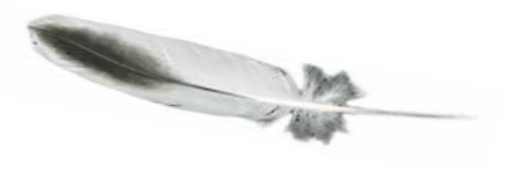

# A commitment to planning

## Developing the Whole-of-Country Plan

The Gunaikurnai Whole-of-Country Plan was developed in 2013-2014 by the GLaWAC Board, through funding from the East and West Gippsland Catchment Management Authorities. The original project aim was to translate the aspirations of Gunaikurnai Traditional Owners into a holistic framework that links cultural heritage, natural resource management, economic development and community wellbeing.

The country planning project objectives were to:

5.

1.

2.

3.

Bring the Gunaikurnai community together

build an agreed direction and purpose, with community ownership and commitment to act

Optimise remaining Native Title Settlement negotiations (Land Use Activity Agreement, Natural Resources Agreement and any future claims) by defining clear goals and priorities

Prepare Gunaikurnai Traditional Owners for implementing agreements that will include new and expanded roles in the management of traditional land and natural and cultural resources

Strengthen the capacity of the Gunaikurnai Land and Waters Aboriginal Corporation to facilitate future strategic community and corporation planning activities

6.

7.

8.

4.

9.

Provide the strategic basis for Joint

Management Planning

Empower the younger generation to shape the future and own their vision, preparing them for working on Country and for meeting their cultural obligations

Establish a strong basis for Gunaikurnai to engage with and influence policy and planning, and for government agencies to

better incorporate Gunaikurnai values and knowledge into NRM plans and policies

Establish a strategic basis for developing partnerships to manage Country and explore new business opportunities

Provide a platform for leveraging resources to manage Country and improve community wellbeing.

Stage 1 – Setting a strong foundation

The GLaWAC Board oversaw the design of the country planning project and established effective governance and reporting arrangements that ensured the Whole-of-Country Plan would be clearly owned and managed by Gunaikurnai for Gunaikurnai. The mob was kept informed about the project through the GLaWAC newsletter.

Existing information, research and planning was gathered to ensure that this Country Plan was built on the vast work that has been done by Gunaikurnai people over the years. In particular, the plan relied heavily on the aspirations work that was developed through our Native Title process.

66



Stage 2 – Distilling our aspirations

The Gunaikurnai’s Statement of Aspirations — a key input into this plan — is based on aspirations identified and discussed at the following meetings:

ø Full group meeting in Sale on 2 and 3 November 2005

ø Further clarified by the Instructing Committee in Melbourne on 7 April 2006

ø Incorporation workshops in Melbourne on 10 March and 18 May 2006

ø Full group meeting in Sale

on 9 and 10 September 2006

ø Governing Committee meeting in Sale on 20 July 2007

ø Elders Camp at Cape Conran on 20 to 22 August 2007

ø Aspirations workshop in Lakes Entrance on 20 September 2007

ø Aspirations workshop in Melbourne on 10 October 2007

ø Aspirations workshop in Orbost on 26 February 2008

ø Aspirations workshop in Lake Tyers on 27 February 2008

ø Aspirations workshop in Bairnsdale on 4 March 2008

ø Aspirations workshop in Morwell on 5 March 2008

ø Governing Committee meeting in Bairnsdale on 14 March 2008

ø Governing Committee aspirations workshop in Melbourne on 17 July 2008

ø Governing Committee meeting in Melbourne on 18 July 2008

Building on the previous work, the GLaWAC Board, Elder’s Council and some of the ranger staff met over two days in April 2014 to clarify our goals for Country and look at the key areas that we want

to work on into the future. This resulted in our strategic framework, with the seven goals that form the core of this Country Plan.

The draft framework was published in the GLaWAC newsletter and the mob was provided an opportunity to have input. It was also discussed at an Elders’ Council meeting and three community meetings that were held in Bairnsdale, Traralgon

and Melbourne. The final framework was approved by the GLaWAC Board and formed the basis of the next stage.

Stage 3 – Developing the plan

A second workshop was held in August 2014 with the GLaWAC Board, members of the Traditional Owner Land Management Board and GLaWAC’s NRM staff and Joint Management Rangers. At

this meeting, we looked at actions and strategies that would help us to achieve our goals. We also examined each of our 10 Aboriginal Title land areas and talked about what we want to achieve through the joint management arrangements.

All of the information gathered through the process was drawn into a draft Whole-of-Country Plan, which was approved by the GLaWAC Board in

February 2015. This is now our plan, and the starting point for our mob to move forward on achieving our vision for Gunaikurnai Country.

##### 67

