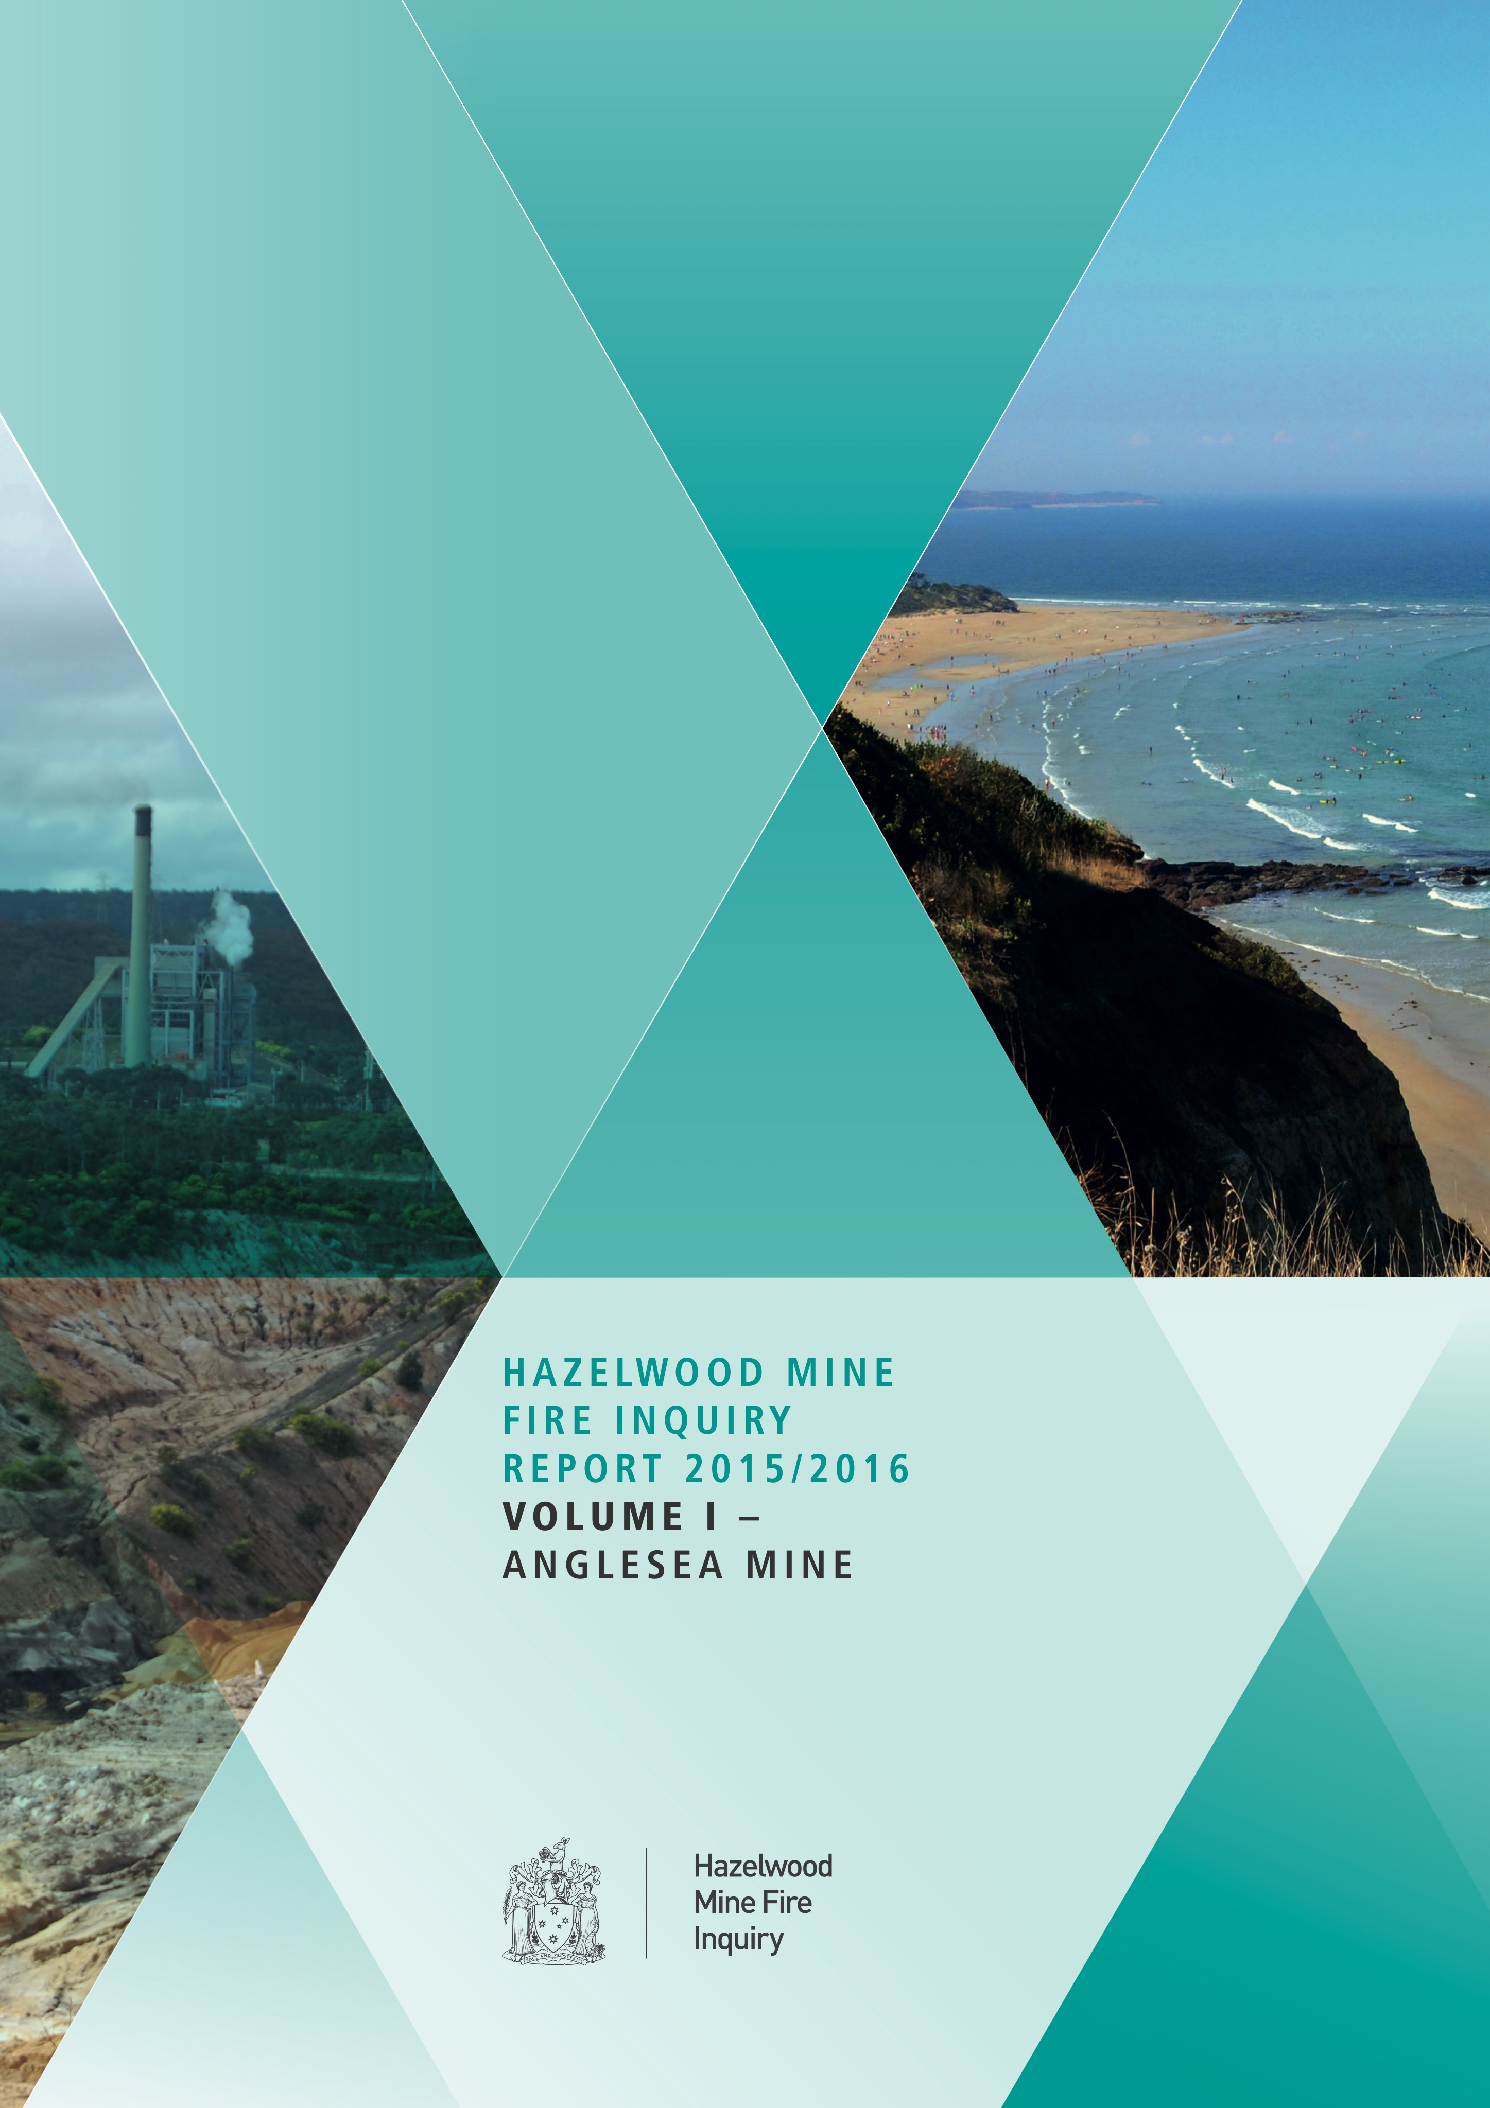

Cover images from Alcoa of Australia Limited and dreamstime.com

ISBN 978-0-9944194-0-8



HAZELWOOD MINE FIRE INQUIRY REPORT

2015/2016 VOLUME 1 – ANGLESEA MINE

THE HON. BERNARD TEAGUE AO – CHAIRPERSON

PROF. JOHN CATFORD – BOARD MEMBER

MRS ANITA ROPER – BOARD MEMBER

ORDERED TO BE PRINTED

VICTORIAN GOVERNMENT

PRINTER

2015

PP no 80, Session 2014 –2015

Image source *Roderic Incoll*

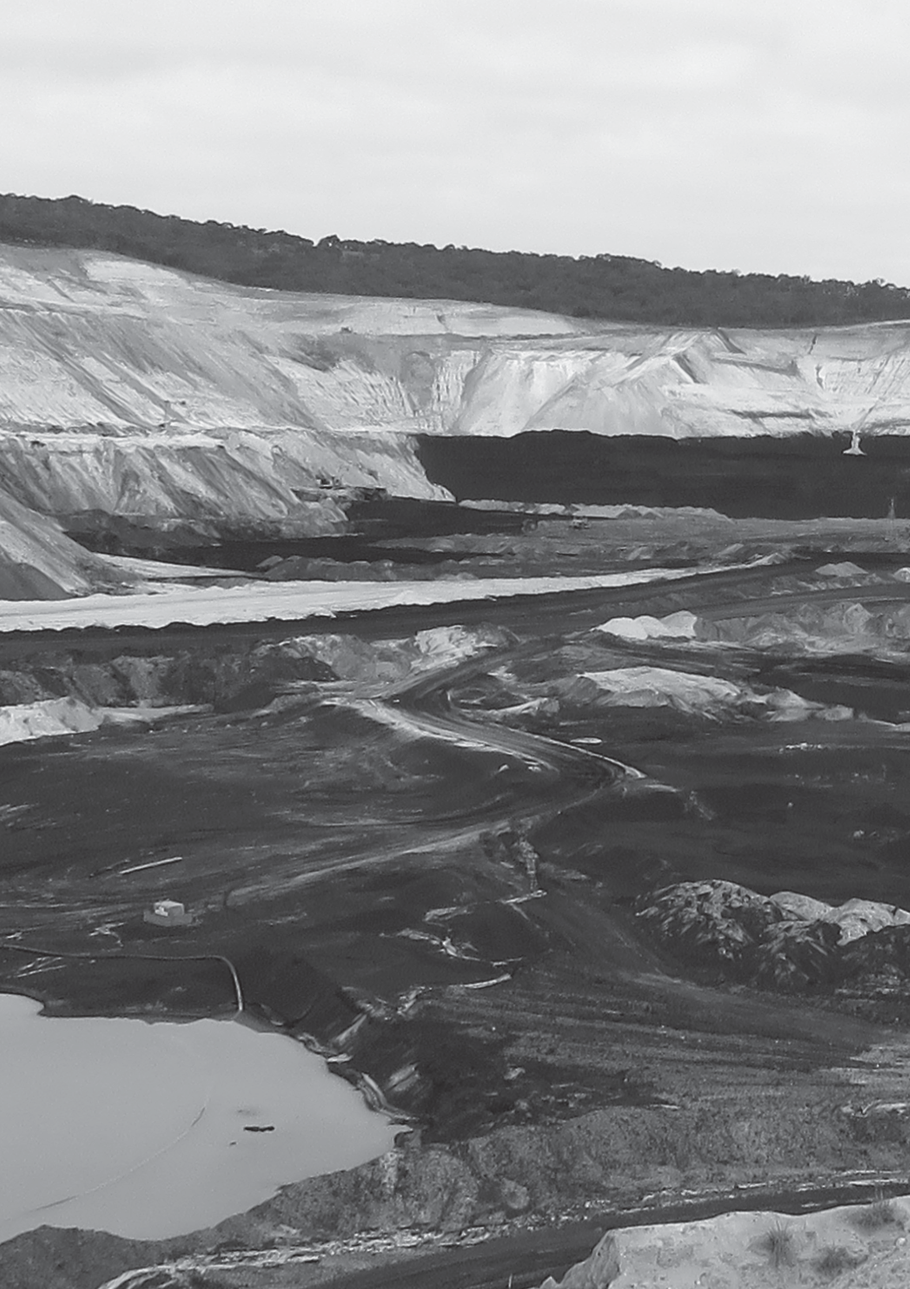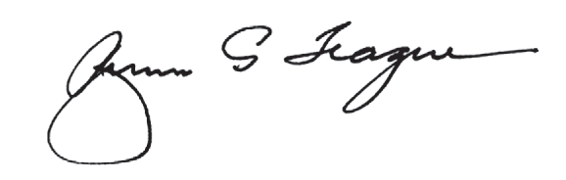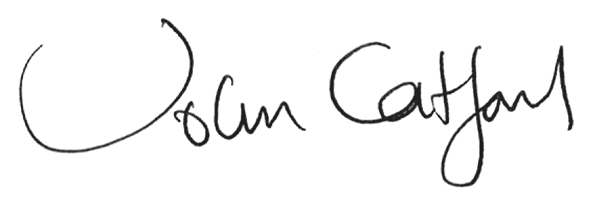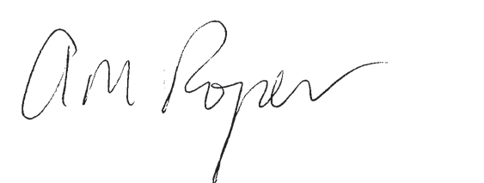

Letter of Transmission

Letter of transmission

The Honourable Linda Dessau AM

Governor of Victoria Government House Melbourne VIC 3004

31 august 2015

Your Excellency

In accordance with the terms of reference dated 26 May 2015, we have the honour of presenting

to you the first volume of the report of the 2015/2016 Hazelwood Mine Fire Inquiry.

This volume addresses paragraph 11 of the Terms of Reference relating to decreasing fire risks at the Anglesea coal mine. It includes background information about the Anglesea coal mine

and fires in the area, and details of the fire mitigation plans that the mine operator has undertaken, or proposes to undertake.

The Board affirms the mine operator’s actions announced or underway, and makes a recommendation

that the mine operator publish two reports on its website to inform the community of its completion

of commitments.

Undertaking this work has been a privilege and we would like to thank the people of Anglesea

for their hospitality and generosity. We also appreciate the contribution of the community, industry and government agencies to the Inquiry’s conclusion and recommendation.

Yours sincerely

The Hon. Bernard Teague AO

Prof. John Catford

Mrs Anita Roper

3



Hazelwood Mine Fire Inquiry Report 2015/2016 Volume 1

**Victoria Government Gazette**

No. S 123 Tuesday 26 May 2015

By Authority of Victorian Government Printer

**Inquiries Act 2014**

APPOINTMENT OF A BOARD OF INQUIRY INTO THE HAZELWOOD COAL MINE FIRE

Order in Council

The Governor in Council, on the recommendation of the Premier under section 53(1) of the

**Inquiries Act 2014**, appoints:

the Honourable Bernard George Teague AO; Professor John Charles Catford; and

Mrs Anita Michele Roper

to constitute a Board of Inquiry to inquire into and report on the terms of reference specified in paragraphs 6 to 11 of this Order.

The Honourable Bernard George Teague AO is appointed as Chairperson of the Inquiry. This Order comes into effect on the date it is published in the Government Gazette.

**BACKGROUND**

1.

In early February 2014 a fire ignited which, on or about 9 February 2014, took hold in the

Hazelwood Coal Mine.

The Hazelwood Coal Mine Fire impacted the Latrobe Valley communities.

In March 2014, a Board of Inquiry was established to inquire into and report on the following specified matters:

2.

3.

1.

The origin and circumstances of the fire, including how it spread into the Hazelwood

Coal Mine.

The adequacy and effectiveness of the measures taken by or on behalf of the owner, operator and licensee of the Hazelwood Coal Mine to prevent the outbreak of a fire, and to be prepared to respond to an outbreak of a fire including mitigating its spread and severity, in the Hazelwood Coal Mine, including whether the owner, operator and licensee of the Hazelwood Coal Mine, or any person or entity acting on behalf of any *of them:*

2.

i.

implemented the recommendations arising from reviews of previous events;

*and*

in the opinion of the Board, breached or did not comply with the requirements of (or under) any relevant statute or regulation, including any notification or directive given under such statute or regulation and any code of practice, management plan or similar scheme, developed and/or implemented due to such requirements.

ii.

3.

The adequacy and effectiveness of the application and administration of relevant regulatory regimes in relation to the risk of, and response to, fire at the Hazelwood Coal Mine.

The adequacy and effectiveness of the response to the Hazelwood Coal Mine Fire by:

4.

i.

ii. iii.

the owner, operator and licensee of the Hazelwood Coal Mine;

the emergency services; and

other relevant government agencies, including environmental and public health officials,

and in particular, the measures taken in respect of the health and well-being of the

*affected communities by:*

4

SPECIAL



Gazette Notice

*2*

*S 123*

*26* May 2015

Victoria Government Gazette

iv.

informing the affected communities of the Hazelwood Coal Mine Fire and about its known effects and risks; and

responding to those effects on, and risks to, the affected communities.

v.

5.

Any other matter reasonably incidental to the matters specified in paragraphs 1 to 4.

4.

5.

That Inquiry’s report was tabled in the Victorian Parliament on 2 September 2014.

Since that report was tabled, further concerns have been raised about the potential health impacts of the fire on the Latrobe Valley communities and future options for rehabilitating Victorian mines in the Latrobe Valley.

**TERMS OF REFERENCE**

You are required to inquire into and report on the following terms of reference:

6.

Whether the Hazelwood Coal Mine Fire contributed to an increase in deaths, having regard to any relevant evidence for the period 2009 to 2014;

Short, medium and long term measures to improve the health of the Latrobe Valley communities having regard to any health impacts identified by the Board as being associated with the Hazelwood Coal Mine Fire;

Short, medium and long term options to rehabilitate:

7.

8.

(a)

land on which work has been, is being or may lawfully be done in accordance with a Work Plan approved for the Hazelwood Mine, the Yallourn Mine, and the Loy Yang Mine; and

land in relation to which an application for variation of the Work Plan is under consideration for the Hazelwood Mine, the Yallourn Mine, or the Loy Yang Mine;

(b)

9.

For each rehabilitation option identified under paragraph 8:

(a)

whether, and to what extent, the option would decrease the risk of a fire that could impact the mine and if so, the cost of the option relative to the cost of other fire prevention measures;

whether, and to what extent, the option would affect the stability of the mine;

whether, and to what extent, the option would create a stable landform and minimise long term environmental degradation;

whether, and to what extent, the option would ensure that progressive rehabilitation is carried out as required under the **Mineral Resources (Sustainable Development) Act 1990**;

the estimated timeframe for implementing the option;

the option’s viability, any associated limitations and its estimated cost;

the impact of the option on any current rehabilitation plans for each mine;

whether, and to what extent, the option would impact the future beneficial use of land

areas impacted by the mines; and

whether the option is otherwise sustainable, practicable and effective;

(b)

(c)

(d)

(e)

(f) (g) (h)

(i)

10.

Having regard to the rehabilitation liability assessments that have been or will be reported in

2015 by the operators of each of the Hazelwood Mine, the Yallourn Mine, and the Loy Yang Mine, as required by the **Mineral Resources (Sustainable Development) Act 1990**, and to the outcome of the Rehabilitation Bond Review Project:

(a)

(b)

whether the rehabilitation liability assessments referred to above are adequate;

whether the current rehabilitation bond system, being one of the measures to provide for progressive rehabilitation by end of mine life as required under the **Mineral Resources (Sustainable Development) Act 1990**, is, or is likely to be, effective for the Hazelwood Mine, the Yallourn Mine, and the Loy Yang Mine; and

5

Hazelwood Mine Fire Inquiry Report 2015/2016 Volume 1

Victoria Government Gazette

*S 123*

*26* May *2015*

*3*

(c)

any practical, sustainable, efficient and effective alternative mechanisms to ensure rehabilitation of the mines as required by the **Mineral Resources (Sustainable Development) Act 1990**;

11.

Sustainable, practical and effective options that could be undertaken by the mine operator to decrease the risk of fire arising from or impacting the Anglesea Mine for the 2015/2016 summer season, noting the impending closure of the mine on 31 August 2015; and

Any other matter that is reasonably incidental to those set out in paragraphs 6 to 10.

12.

**REPORTING DATES**

You must report your findings and any recommendations to the Governor as soon as possible, and not later than:

(a)

31 August 2015, in respect of the Anglesea mine Term of Reference in paragraph 11 of this

Order, and any reasonably incidental matters;

2 December 2015, in respect of the Health Terms of Reference, and any reasonably incidental matters; and

15 March 2016, in respect of the Mine Terms of Reference, and any reasonably incidental matters.

(b)

(c)

**CONDUCTING THE INQUIRY**

13.

You may:

(a)

conduct your inquiry as you consider appropriate, subject to the requirements of procedural fairness, including by adopting any informal and flexible procedures to: engage with the relevant local communities; ascertain the relevant facts as directly and effectively as possible; and avoid unnecessary cost or delay;

have regard to any research, past inquiries, reports and evaluations that may inform your inquiry and avoid unnecessary duplication;

have regard to any documents, things or evidence received by, and any matters submitted to, the Board of Inquiry referred to in paragraph 3 as if those documents, things or evidence had been received by you, or those matters had been submitted to you, as the case may be, for the purposes of your inquiry and any report or reports under this Order;

consult with the relevant local communities; and

consult with and engage experts (including Australian legal practitioners) as necessary to provide relevant advice and assistance.

(b)

(c)

(d)

(e)

14.

You must conduct your inquiry in accordance with this Order, the **Inquiries Act 2014**, and all other relevant laws.

It is anticipated that in conducting your inquiry you will, to the extent you think it appropriate, work co-operatively with, and seek not to prejudice, any ongoing response or recovery activities or investigations into the Hazelwood Coal Mine Fire.

The powers of the Board of Inquiry, at the discretion of the Chairperson may, at any time, be exercised by one or more Inquiry members.

15.

16.

**BUDGET**

17.

You may incur expenses and financial obligations to be met from the Consolidated Fund up to $3.378 million in conducting this Inquiry.

**DEFINITIONS**

18.

In this Order:

***Anglesea Mine*** means the land the subject of the Mines Aluminium Agreement (Agreement 6829) as in force from time to time, which was ratified by the **Mines (Aluminium Agreement) Act 1961**;

6

Gazette Notice

4

S 123

26 May 2015

Victoria Government Gazette

***Hazelwood Coal Mine Fire*** means the fire that took hold in the Hazelwood Mine on or about

9 February 2014;

***Hazelwood Mine*** means the land the subject of Mining Licence Number 5004, as in force from time to time;

***Health Terms of Reference*** means the terms of reference in paragraphs 6 and 7 of this Order;

***Loy Yang Mine*** means the land the subject of Mining Licence Number 5189, as in force from time to time;

***Mine Terms of Reference*** means the terms of reference in paragraphs 8, 9 and 10 of this

Order;

***Rehabilitation Bond Review Project*** means the current review into rehabilitation bonds and the methodology by which they are calculated, as referred to at page 1612, lines 7–8 of the transcript of the Hazelwood Mine Fire Inquiry dated 10 June 2014;

***Work Plan*** means a work plan approved under the **Mineral Resources (Sustainable Development) Act 1990** or endorsed pursuant to clause 21A of the Agreement set out in Schedule 1 to the **Mines (Aluminium Agreement) Act 1961**, as amended by the Amendment Agreement set out in Schedule 2 to that Act, as the case may be;

***Yallourn Mine*** means the land the subject of Mining Licence Number 5003, as in force from time to time.

Dated 26 May 2015

Responsible Minister:

THE HON DANIEL ANDREWS MP Premier

YVETTE CARISBROOKE Clerk of the Executive Council

7

**PART 2 BACKGROUND INFORMATION**

About Anglesea

The Anglesea mine

Differences between the Anglesea mine

and the Hazelwood mine

Fires affecting Anglesea

Fires affecting the Anglesea mine

Hazelwood Mine Fire Inquiry Report 2015/2016 Volume 1

CONTENTS

**10**

**GUIDE TO READING THIS REPORT**

**11**

12

13

**PART 1 INTRODUCTION TO THE INQUIRY**

Establishment of the Inquiry

The Board’s approach

**15**

16

17

19

21

23

**25**

26

26

27

27

**PART 3 REGULATORY FRAMEWORK**

Mining regulation in Victoria

Specific legislation governing the Anglesea mine

Occupational Health and Safety

Coal Mine Emergency Taskforce

**28**

**PART 4 FIRE RISK MANAGEMENT DURING OPERATION OF THE ANGLESEA MINE**

Anglesea Emergency Plan

Management of Hot Coal and Coal fires Country Fire Authority Pre-incident Plan Other Alcoa policies and practices

29

30

30

30

**31**

**PART 5 FIRE RISK MANAGEMENT AFTER SHUTDOWN**

**OF THE ANGLESEA MINE**

Alcoa’s overburden strategy

Onsite firefighting equipment and water supply Mine site personnel and accountabilities Updating fire-related documents

Agency involvement in the mine’s shutdown

Final mine closure and rehabilitation

32

36

37

38

38

39

8

**40**

**PART 6 CONCLUSION, AFFIRMATIONS**

**AND RECOMMENDATION**

The Anglesea and Hazelwood mines

Risk of fire arising from or impacting on the Anglesea mine

Alcoa’s strategy for minimising the risk of fire after

31 August 2015

Work in progress

The Board’s conclusion Affirmations Recommendation

41

41

42

43

45

46

46

**47**

49

50

51

**APPENDICES**

Appendix A: Inquiry personnel

Appendix B: Public submissions

Appendix C: Witnesses appearing at the Anglesea

public hearings

Appendix D: exhibits tendered at the anglesea public hearings

52

53

Appendix E: Exhibit 3B – Close up photograph of mining area

dated 2015

Appendix F: Exhibit 11 – Alcoa’s response to recommendations

54

**64**

65

65

66

**SHORTENED FORMS, GLOSSARY AND BIBLIOGRAPHY**

Shortened forms Glossary Bibliography

9



Hazelwood Mine Fire Inquiry Report 2015/2016 Volume 1

GUIDe to reaDInG tHIS rePort

This report constitutes the Board of Inquiry’s response to paragraph 11 of the Hazelwood Mine Fire Inquiry’s Terms of Reference. Paragraph 11 requires the Board to inquire into, and report on sustainable, practical and effective options that could be undertaken by Alcoa of Australia Limited (Alcoa) to decrease the risk of fire arising from or impacting the Anglesea mine for the 2015/2016 summer season, noting the impending closure of the mine on 31 August 2015.

The report takes into account information provided at community consultations, through public

submissions, witness statements and expert reports, and at public hearings held in Anglesea on

30 and 31 July 2015 and in Melbourne on 6 August 2015.

In this report, the term ‘State’ is used broadly to refer to the Victorian Government, the Victorian public service, and public entities such as emergency management Victoria, the Country fire authority, and the Victorian WorkCover Authority (also known as WorkSafe Victoria). Paragraph 11 of the Terms of Reference is limited to options that could be undertaken by Alcoa. The Board has not been directed

to inquire into or report on the adequacy or effectiveness of measures carried out or proposed to be undertaken by the State. However, the response of the State is relevant to this report in so far as the State has a role in monitoring and enforcing regulatory compliance by Alcoa, and actions taken by the State impact on the overall risk profile of fire arising from or impacting the Anglesea mine.

**Part 1** of the report provides an overview of the Inquiry.

**Part 2** of the report contains important background information relevant to the Anglesea mine,

including key facts regarding the town of Anglesea and surrounding geography, and the history of fires in the mine and the Anglesea area.

**Part 3** provides an overview of the regulatory framework relevant to the prevention and mitigation

of fire risk at the Anglesea mine.

**Part 4** of the report examines the measures taken by Alcoa to prevent and mitigate the risk of fire

at the Anglesea mine site during the operation of the mine and power station.

**Part 5** describes the plan that Alcoa is developing and implementing for the shutdown of the

mine and power station on 31 August 2015. This plan includes actions taken by Alcoa since

the announcement on 12 may 2015 that the mine and power station were shutting down,

as well as actions that will be taken after 31 August 2015 until the mine’s closure plan is finalised.

the main components of the shutdown plan include an overburden strategy to deal with most of the exposed coal in the mine, the maintenance of onsite firefighting equipment and water supply after 31 august 2015, the onsite presence of mine personnel and contracted staff,

and the updating of fire-mitigation documents relating to the Anglesea mine.

**Part 6** of the report sets out the Board’s conclusion, affirmations and recommendation, including

an assessment of the adequacy of measures adopted by Alcoa to plan for the 2015/2016 fire season and further options for consideration. In summary, the Board concludes that Alcoa has either implemented, or is in the process of implementing, a range of fire minimisation strategies that are sustainable, practical and effective. These strategies, when fully implemented, should reduce the risk of fire at the Anglesea mine so far as is reasonably practicable.

10