**From:** [Jane and Danny Caffrey](mailto:janolbran@netspace.net.au)

**To:** [Hazelwood Info Shared Mailbox](mailto:info@hazelwoodinquiry.vic.gov.au)

**Subject:** Submission from Jane Caffrey

**Date:** Wednesday, 12 August 2015 9:11:42 PM

As a resident of Traralgon, I have been aware of the problem of the ongoing dangers of the open cut mine expansion for a long time.

I am keen to see a proper rehabilitation effort that renders the mine safe and allows for the use of the land for productive purposes into the future.

My suggestion for the rehabilitation of the Hazelwood Mine is to adopt a plan similar to the Butchart Gardens on Vancouver Island Canada.

This is now a beautiful landscape of sunken gardens of different themes, Roses, Japanese, Mediterranean with fountains, ponds and waterscapes.

It also includes concert stages and lawns and a Giant Greenhouse.

It provides wondrous examples of tourist focussed activities such as tours, restaurants, cafes, seed and gift stores and so on.

It could be adapted to our situation on a grand scale and build on the history of the coal extraction business, but blending with the future transition to sustainable businesses and green energy production. It could be a beacon example of a transition in progress.

Some website links are below.

<https://en.wikipedia.org/wiki/Butchart_Gardens>

The Butchart Gardens - Brentwood Bay, British Columbia … Butchart Gardens Tour - Victoria Sightseeing Tours

Thanks you for accepting my suggestion Jane Caffrey

8/13/2015 Butchart Gardens - Wikipedia , the free encyclopedia

**Butchart Gardens**

From Wikipedia, the free encyclopedia

The **Butchart Gardens** is a group of floral display gardens in Brentwood Bay, British Columbia, Canada, located near Victoria on Vancouver Island. The gardens receive close to a million visitors each year. The gardens have been designated a National Historic Site of Canada due to . their international renown _ [l]

Coordinates : 48 °33'55"N 123°28'10"W

Sunken Garden .

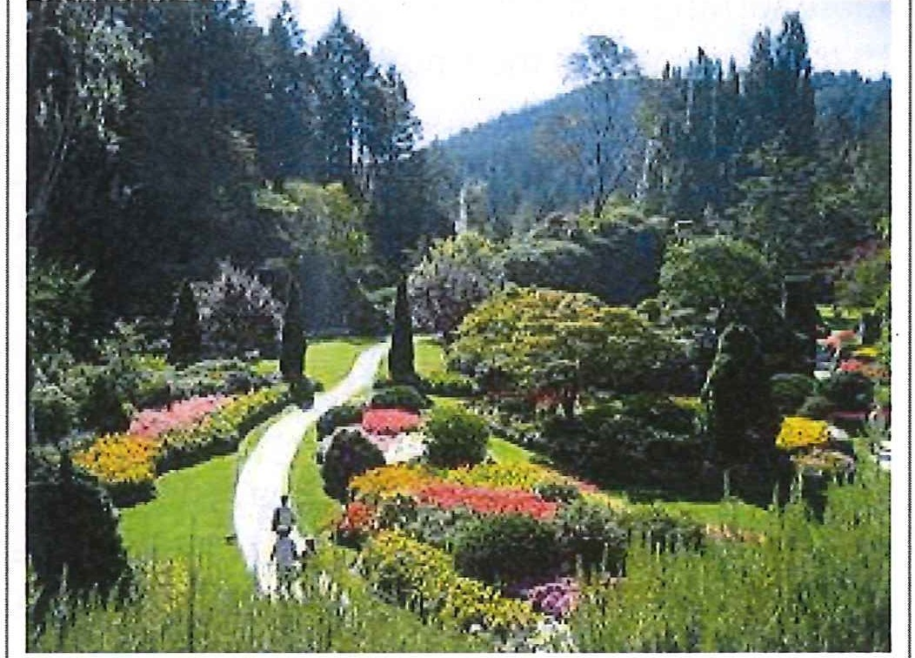

**Butchart Gardens**

**Contents**

* 1 Hist01y
* 2 Collections
  + 2. 1 Birds
  + 2.2 Statuary
* 3 Entertainment
* 4 Gallery
* 5 References
* 6 External links

# History

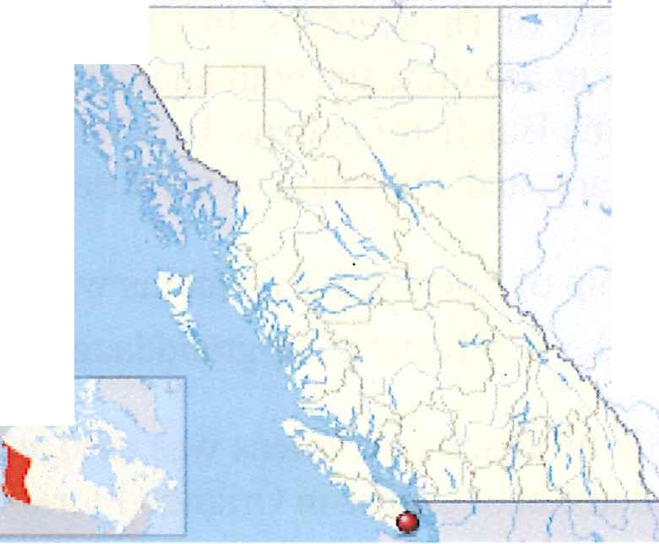

. *n 'll*

· ·-" ......

..

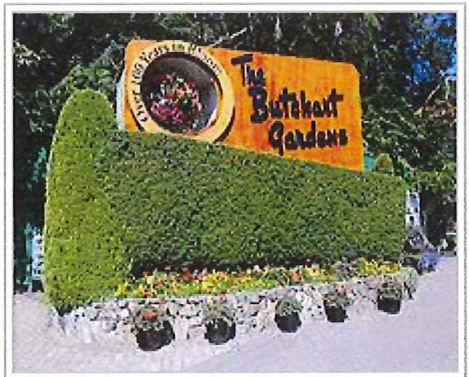**Robert Pim Butchart** (1856- 1943)

began

**. Type Location**

Botanical

Brentwood Bay near Victoria, British Columbia

Entrance to the Butchart Gardens

--- - -

manufacturing Portland cement in 1888 near his

**Coordina tes** 48°33'55"N 123°28'10"W

**Website** Butchart Gardens

([http://www.](http://www/) butchartgardens .com/)

**i National Historic Site of Canada i**

**Official** Butchart Gardens National Historic

birthplace of Owen Sound, Ontario, Canada. He and

**name**

Site of Canada

his wife **Jennie Butchart** (1866- 1950) came to the west coast of Canada because of rich limestone deposits necessaiy for cement production.

**Designated** 2004

In 1904, they established their home near his quarry on Tod Inlet at the base of the Saanich Peninsula on Vancouver Island . [21

https://en.wikipedia.org/wiki/Butchart_Gardens 1/5

8/13/2015 Butchart Gardens - Wikipedia , the free encyclopedia

In 1907, 65 year old garden designer Isaburo Kishida of Yokohama came to Victoria, at the request of his son, to build a tea garden for Esquimalt Gorge Park. This garden was wildly popular and a place to be seen. Several prominent citizens, Jennie Butchart among them, commissioned Japanese gardens from Kishida for their estates. He returned to Japan in 1912.

In 1909, when the limestone quarry was exhausted , Jennie set about turning it into the Sunken Garden, which was completed in 1921. They named their home 11 Benvenuto 11 ("welcome" in Italian), and began to receive visitors to their gardens. In 1926, they replaced their tennis courts with an Italian garden and in 1929 they replaced their kitchen vegetable garden with a large rose garden to the design of Butler Sturtevant of Seattle. Samuel Maclure, who was consultant to the Butchart Gardens, reflected the aesthetic of the English Arts and Crafts Movement.

In 1939, the Butcharts gave the Gardens to their grandson Ian Ross (1918- 1997) on his 21st birthday. Ross was involved in the

operation and promotion of the gardens until his death 58 years later.

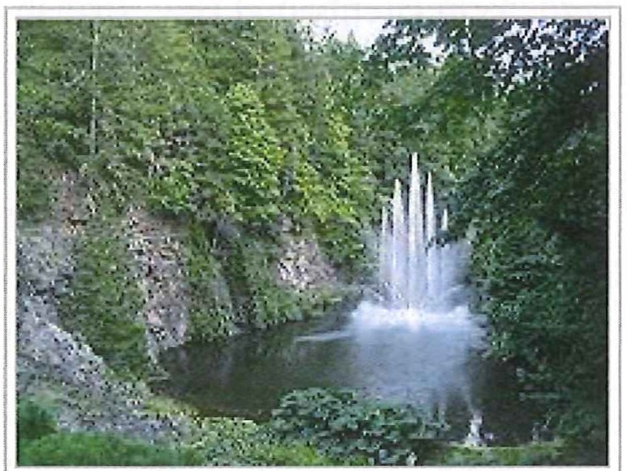

The Ross Fountain

In 1953, miles of underground wiring was laid to provide night illumination, to mark the 50th anniversary of The Gardens. In 1964, the ever-changing Ross Fountain was installed in the lower reservoir to celebrate the 60th anniversary . In 1994, the Canadian Heraldic Authority granted a coat of arms to the Butchart Gardens. In 2004, two 30-foot (9. 1 m) totem poles were installed to mark the l OOth anniversary , and The Gardens were designated as a national historic site.

Ownership of The Gardens remains within the Butchart family; the owner and managing director since 2001 is the Butcharts' great-granddaughter Robin-Lee Clarke. [3]

In 1982 the Butchart Gardens was used as the inspiration for the gardens at the Canadian pavilion opened at Epcot Centre in Orlando Florida.

In December, 2009 the Children's Pavilion and the Rose Carousel were opened . The menagerie includes thirty animals ranging from bears, to horses, to ostriches, to zebras and mirrors the world from which The Gardens draws its visitors . The designs were hand picked by the owner, in consultation with an artist from North Carolina. The carvings were done by some of the few remaining carvers of carousel

art. Each animal is carved from basswood and took many months to complete. There are also two chariots able to accommodate disabled persons.

**Collections**

## Birds

While Mrs. Butchart collected plants, Mr. Butchart collected ornamental birds from all over the world, having a parrot in the house, ducks in the Star Pond and peacocks on the front lawn. He built several elaborate birdhouses for the gardens and trained pigeons on the site of the present-day Begonia Bower.

## Statuary

Several bronze statues are displayed in the gardens.

https://en.wikipedia.org/wiki/Butchart_Gardens *215*

8/13/2015

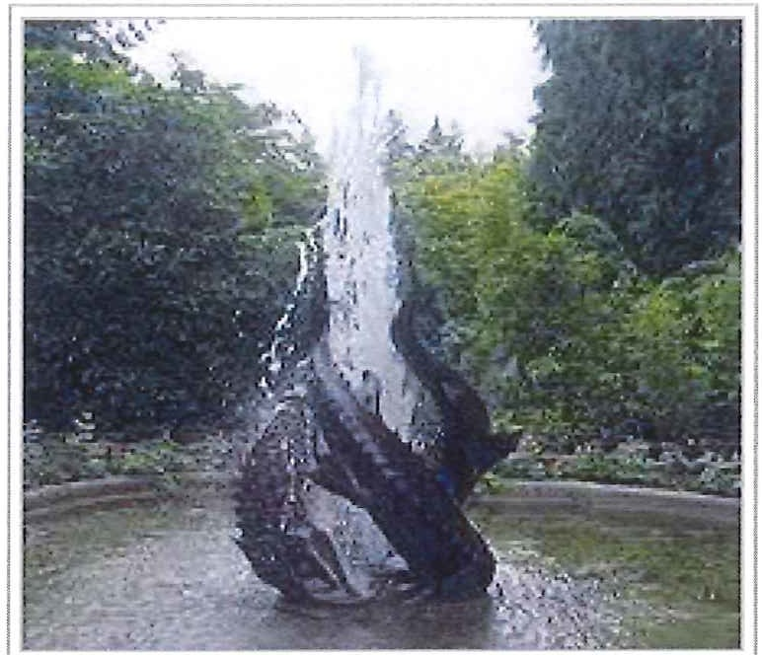

Sturgeon fountain

Butchart Gardens - Wikipedia, the free encyclopedia

One, of a wild boar, purchased on a Mediterranean trip in 1973, was cast in Florence, a replica of a 1620 bronze cast by Pietro Tacca. It is called "Tacca" in honor of the sculptor and, just as the original's, its snout is shiny from the many visitors rubbing it for luck.

Another, nearby in front of the residence, of a donkey and foal is by Sirio Tofanari. A fountain statue of three sturgeon, also by Tofanari, is installed near the Japanese garden.

In 1993, "Circle of Doves", which Ann-Lee Ross gave her husband Ian in 1991 to commemorate their 50th wedding anniversary, was installed in front of the begonia bower.

In the summer of 2008, The Gardens introduced the Jennie B, an electrically driven 12-passenger boat, which plies the local coastlines in the summer giving visitors an appreciation of the waterside history plus coastal aquatic plants and animals.

On December 1, 2009, the Children's Pavilion and Rose Carousel were opened to the public . The Rose Carousel, crafted by Brass Ring Entertainment of Sun Valley, California is the only carousel on Vancouver Island. The menagerie includes thirty animals ranging from bears, to horses, to ostriches, to zebras, to cats and mirrors the world from which The Gardens draws its visitors. The designs were hand picked by Robin Clarke, The Gardens' owner and great grand daughter of Jennie Butchait, in consultation with an artist from North Carolina. The carvings were done by some of the few remaining carvers of carousel art. Each animal is carved from basswood and took many months to complete. There are also two chariots able to accommodate disabled persons .

The Rose Carousel is housed within the 700 sq m (7,534 sq ft) Children's Pavilion, which has a dome with a 23 m (75 ft) clear span, a full-fronted glass fac;,ade and a roof planted with native plant species. The pavilion also has an event room for such things as children's birthday parties.

# Entertainment

In the early days, weekly symphony concerts were hosted by Mr and Mrs. Butchart. These were often held for guests of the family, but later attracted a larger audience. More recently, in the Summer Season (July and August) and during the Winter Holiday Season they provide a wide range of local entertainment, from Jazz to classical music. Also, The Weeds, a band made up of staff members from The Gardens, sometimes plays during the Summer Season. In 1977, Ian Ross's son Christopher ( 1944- 2000) introduced firework shows accompanied by show tunes on summer Saturday evenings. During the Winter, lights and seasonal decorations adorn the gardens along with an ice-skating rink in the Waterwheel Square.

# Gallery

https://en.wikipedia .org/wiki/Butchart_Gardens 3/5

8/13/2015 Butchart Gardens - Wikipedia, the free encyclopedia

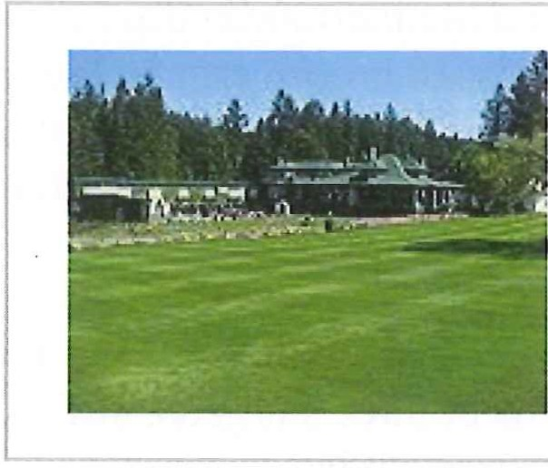 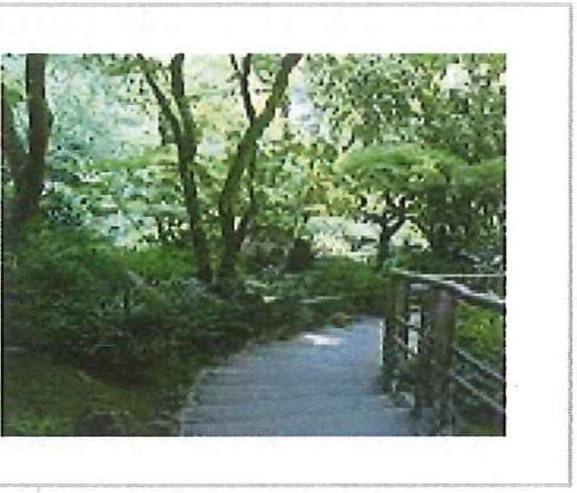 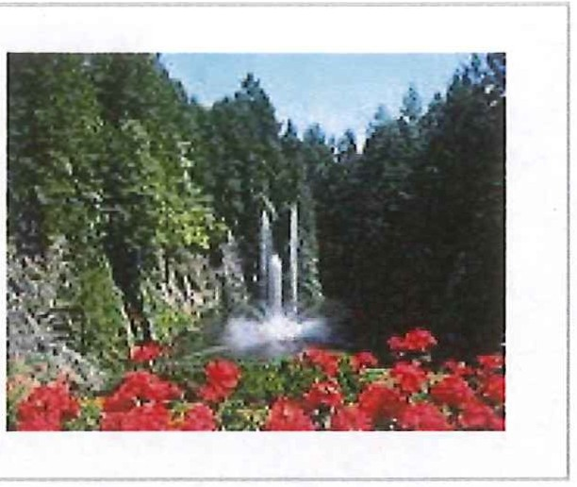

The former residence beyond the Italian Garden .

Japanese Garden Ross Fountain

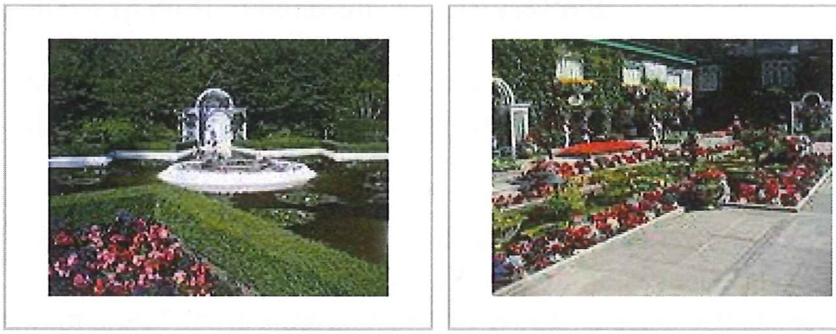

Star Pond Italian Garden

# References

l . Butchart G;rrdens (http://www.historicplaces .ca/en/rep-reg/place -lieu. aspx?id=782 l&pid=O) . *Canadian Register of Historic Places .* Retrieved 24 October 2011 .

1. Smith, Rollin (1998). *The Aeolian pipe organ and its music.* Richmond VA USA: The Organ Historical Society. p. 363. ISBN 0-913499-16-1.
2. Koch, Jessica (2008-01-30) . "Generosity blooms at Butchart Gardens" . *Saanich News :* A34.

# External links

* The Butchart Gardens ([http://www](http://www/) .butchartgardens .com/)

- official website

* Butchart Gardens photo gallery

Wikimedia Commons has media related to *Butclwrt*

*Ga1'£le11s.*

(http://www.photoree. com/collections/gallery/1463146/1)

* Flower Photos of Butchart Gardens (http://www.brainfuel. tv/flowers-i-saw-at-butchart-gardens­ vancouver-island/)
* Butchart Gardens - a Gardens Guide review

([http://www](http://www/) .gardenvisit.com/garden/butchart_gardens)

* Butchart Gardens - Victoria BC attraction ([http://www](http://www/).gazebo­ victoria .com/butchart_gardens .html)

Retrieved from "https://en .wikiped ia.org/w/index .php?title=Butchart_ Gardens&oldid=641546082"

Categories: Gardens in Canada I Estate gardens in Canada I Greater Victoria

I Parks in British Columbia I National Historic Sites in British Columbia I Quarries in Canada

I Japanese gardens in Canada

https://en.wikipedia .orgMtiki/Butchart_Gardens *415*

8/13/2015 Butchart Gardens - Wikipedia, the free encyclopedia

* This page was last modified on 8 January 2015, at 07:48 .
* Text is available under the Creative Commons Attribution-ShareAlike License; additional terms may apply . By using this site, you agree to the Terms of Use and Privacy Policy . Wikipedia® is a registered trademark of the Wikimedia Foundation, Inc., a non-profit organization .

https://en.wikipedia .org/wiki/Butchart_Gardens 5/5



8/13/2015 The Butchart Gardens - Brentwood Bay, British Columbia - Tourist Attraction, Tours & Sightseeing I Facebook

Email or Phone Password

!kristen.stock31@gmail.co1! -------

O Keep me logged in Forgot your password?

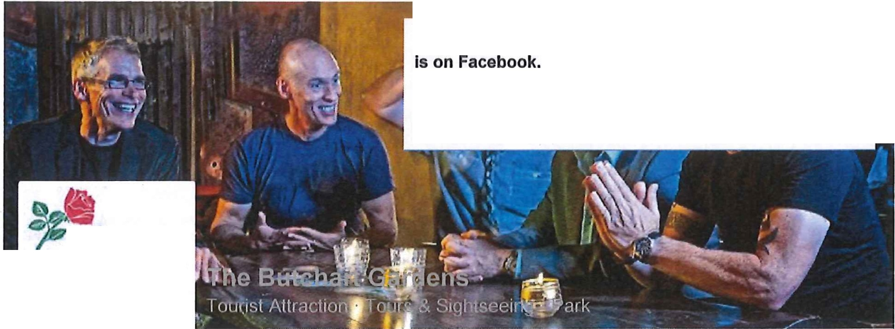

The Butchart Gardens

To connect with The Butchart Gardens, sign up for Facebook today.

I Sign Up 1 1 Log In I

**Butchan.t**

**(iallde11s.**

•Ol'tK IOO YEAkS IN 0100>1•

**The**

PEOPLE

...

Tlmellne About Photos Videos More •

-::9The The Butchart Gardens

]!;ftllo.\f

S, B hrs ·

27,687 likes

77,471 visits

Find out what's in the Butchart Summer Festival lineup for the week starting Thursday!

ABOUT

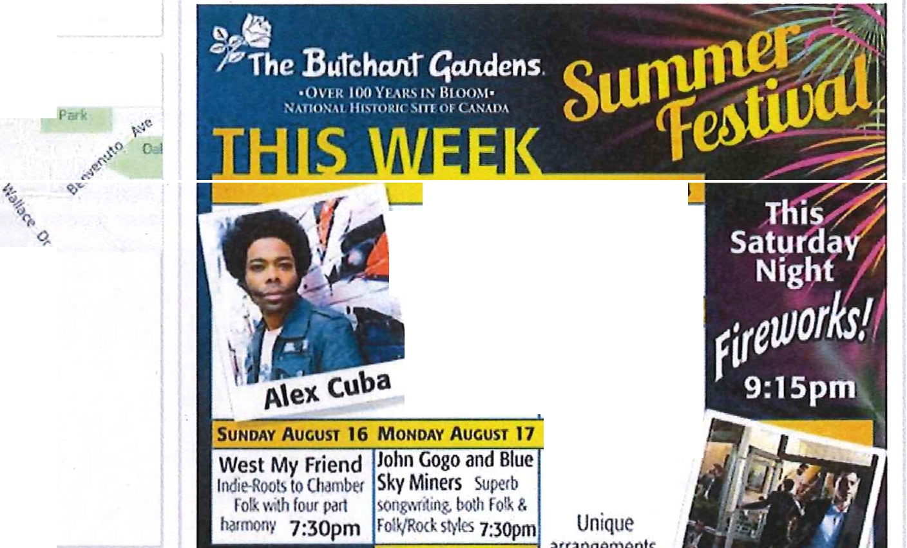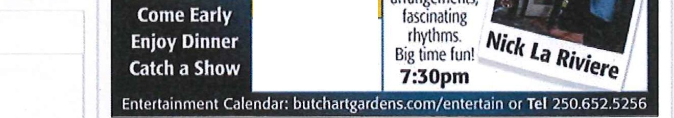

THURSDAY Bachand

FRIDAY AUGUST 14

Qristina & Quinn

AUGUST 13 Taking the Cetic Music

- The soulol 1',1>ild by l!orm 7:3opm

uba, Grammy SATURDAY AuGusr 15

& Juno award Uncle Wiggly's Hot

winner Shoes Blues Band

7:30pm Bumin' up the Blue$!

6:15pm

WEDNESDAY

AUGUST 19

TUESDAY AUGUST 18

The Commodores ClcJssic Big Band 1vl1h danmg on sLJge

7:30pm

800 Benvenuto Ave

Brentwood Bay, British Columbia

+1 250-652-4422

Open

Today 9:00AM • 10:00PM

[http://www .butchartga rdens.com/](http://www.butchartgardens.com/) lmpressum

VIDEOS

Like Comment Share

Adam Zelazo, KeemU Ardhawa, Lynda Cameron and 4 others like this.

124 4

1 share

-::9The The Butchart Gardens

14

B,l'dwlr

Yesterday at 11:05am ·

38

PHOTOS

Read the Flower and Garden Report for the week of August 6 - 12, 2015.

6

https:/lwww .facebook .com/butchartgardens

1/12

8/13/2015 The Butchart Gardens - Brentwood Bay, British Columbia - Tourist Attraction, Tours & Sightseeing I Facebook

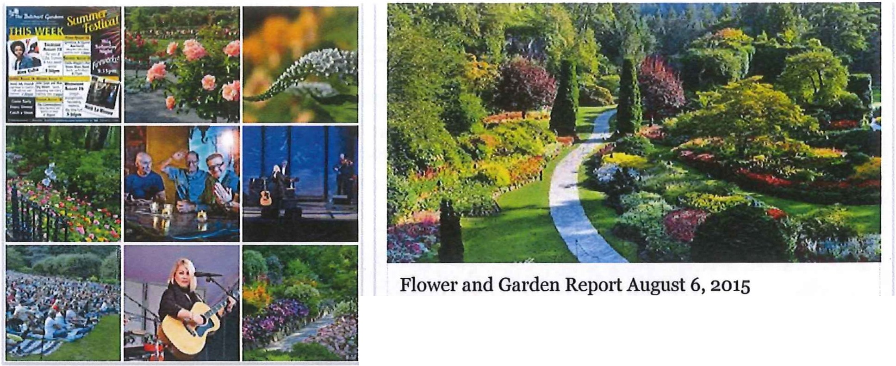

The Butchart Gardens is one of the wortd's premier show gardens , and a designated National Historic Site of Canada. Itwas founded by the Butcharts In the early 1900s.

BUTCHARTGARDENS.COM

APPS

Like Comment Share

lnstagram feed

Carole Perez, Lupita Morales, Grazyna Burchart and 246 others like this.

Most Recent

31 shares



VISITOR POSTS

YouTube

TrlpAdvlsor Reviews

View 2 more comments

Lie Torres DD

Yesterday at 11:47am

Jeremy Caselllnl The Harp Twins need to do a video there . 10 hrs

n.. The Butchart Gardens added 3 new photos.

B,Tcl,a.,T

!! August 1O at 8:30am ·

Flowers are blooming everywhere as we reach the height of summer! Share your summer flower garden photos below.

Soledad Andrea Peiia Sepulveda Yesterday at 2:25pm

aprecio la elaboraci6n de esta pagina, algun dla ire a conocer,les ... See More

Like · Comment · Share

Cecelia Rodman August 9 at 5:28pm

The most beautiful gardens Ihave ever been in. Like · Comment ·Share

lk..

Alex Wright

It] August 9 al2:15pm

Way over priced for what you get and you gelwake around for an hour... See More

Like ·Comment · Share

REVIEWS

4.7 4 .7 of 5 stars • 3.7k reviews

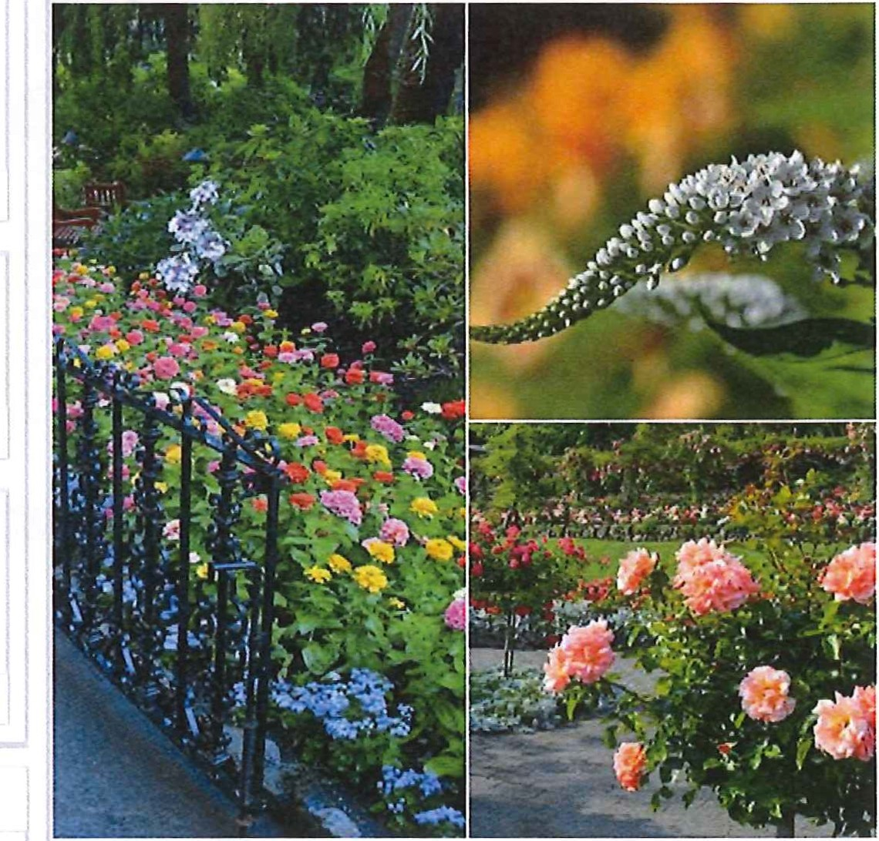

Like Comment

Chris Alder - Iloved visiting Victoria . I also loved visiting The Butchart Gardens. This Is a must see If you are ever In the area....

See More

October 2, 2014 ·21 Reviews ·

7 3

https:/lwww .facebook .com/butchartgardens

Marisla de Kramer, Rose Yasothom , Tredelina Pltplt and 597 others like this.

89 shares

View 17 more comments

•• . Gina Tudor Stunning cant wait for summer here In NewZealand.

•J August 10 at 12:37pm

Most Recent

2/12