**APPENDICES**

92

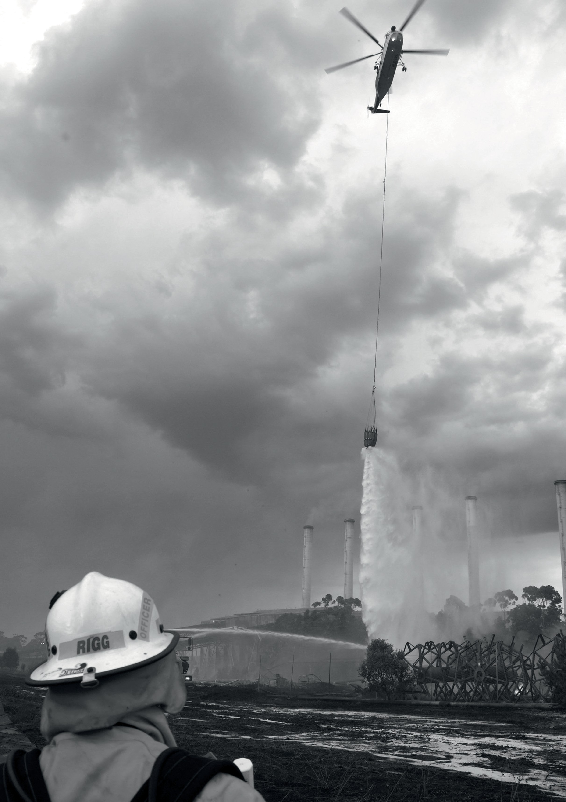

Image source *Keith Pakenham, CFA Pix*



**Hazelwood Mine Fire Inquiry Report 2015/2016 VOLUME II – Investigations into 2009–2014 deaths**

APPENDICES

**APPENDIX A: INQUIRY**

**PERSONNEL**

**NAME**

BLACKMAN, Joel

**ROLE**

Paralegal Support

HORSFIELD, Sam

Editor

JACKSON, Candice

Business and Paralegal Support

KELLY, Monica

Health Lead

MITTEN, Spencer

Communications Manager

NICHOLLS, Cassie

Senior Policy Officer

PIERIS, Gregory

Legal Advisor

RADOJKOVIC, Andrew

Technical Officer – Mines

ROZEN, Peter

Counsel Assisting

RYAN, Genelle

Head of Secretariat

SEAH, Shyuan

Project Officer – Mines

SHANN, Ruth

Counsel Assisting

STANSEN, Justine

Principal Legal Advisor

STOCK, Kristen

Business Support

WELLINGTON, Bethany

Legal Advisor

94



**Appendices**

**APPENDIX B: PUBLIC SUBMISSIONS**

**ORGANISATIONS**

Asbestos Council of Victoria

Australian Medical Students’ Association

Climate and Health Alliance

Doctors for the Environment

Environment Victoria

Healthy Futures

Monash University

Public Health Association Australia

Quit Coal Collective

Voices of the Valley

**INDIVIDUALS**

BROWELL, Julia

CLISSOLD, Kiery-Anne

DOIG, Tom

FARMER, Wendy

FITZGERALD, Grace

HAMILTON, Christine

NICHOLSON, Deearn

ROBINSON, Marianne

YACANO, Peter

95



**Hazelwood Mine Fire Inquiry Report 2015/2016 VOLUME II – Investigations into 2009–2014 deaths**

**APPENDIX C: WITNESSES APPEARING AT THE PUBLIC HEARINGS**

**TITLE**

Prof

**NAME**

ABRAMSON, Michael

**ROLE**

Professor of Clinical Epidemiology and Deputy Head of the Department of Epidemiology and Preventive Medicine, School of Public Health and Preventive Medicine at Monash University

Prof

ARMSTRONG AM,

Bruce

Medical practitioner, public health physician and epidemiologist from the School of Public Health, University of Sydney

Assoc Prof

BARNETT, Adrian

Statistician from the Institute of Health and Biomedical Innovation and School of Public Health, Queensland University of Technology

Ms

CRISTINE, Linda

Director, Inquiry Response Team, Department of Health and Human Services

Dr

FLANDER, Louisa

Senior Research Fellow, Centre for Epidemiology and Biostatistics, Melbourne School of Population and Global Health, University of Melbourne

Prof

GORDON, Ian

Director of the Statistical Consulting Centre and Professor of Statistics in the School of Mathematics and Statistics at the University of Melbourne

Mr

IPSEN, Ron

Latrobe Valley resident, Voices of the Valley member

Dr

JOHNSTON, Fay

Public health physician and environmental epidemiologist, University of Tasmania

Dr

LESTER, Rosemary

Former Chief Health Officer, Department of Health and Human Services

Dr

McCLOUD, Philip

Director and Principal Statistician, McCloud Consulting Group

Prof

McNEIL AM, John

Professor and Head of the Department of Epidemiology and Preventive Medicine at Monash University

Ms

SIMS, Dawn

Enterprise Data and Intelligence Consultant, Victorian Registry of Births, Deaths and Marriages

96



**Appendices**

**APPENDIX D: EXHIBITS TENDERED AT 2015 PUBLIC HEARINGS**

**EXHIBIT**

Exhibit 1A

**TITLE**

Extract from submission filed by Voices of the Valley dated 10 August 2015

Exhibit 1B

Extract from submission filed by Voices of the Valley dated 10 August 2015

Exhibit 1C

Extract from submission filed by Voices of the Valley dated 10 August 2015

Exhibit 2

Witness statement of Ms Dawn Alvine Sims, undated

Exhibit 3

Witness statement of Ms Linda Cristine dated 18 August 2015

Exhibit 4

Supplementary witness statement of Ms Linda Cristine dated 31 August 2015

Exhibit 5

Letter from Victorian Government Solicitor’s Office to Hazelwood Mine Fire Inquiry dated 28 August 2015

Exhibit 6

Witness statement of Professor Michael Abramson, undated

Exhibit 7

Bundle of correspondence tendered by Mr Richard Attiwill QC

Exhibit 8

Copies of correspondence between the Department of Health and Human Services and University of Melbourne

Exhibit 9

Draft ‘Review of “Analysis of death data during the Morwell mine fire,” A. Barnett, working paper, unpublished (2014, Queensland University of Technology) and “An updated analysis of death data during the Morwell mine fire,” A. Barnett, working paper, unpublished (2015, Queensland University of Technology)’ report dated 13 March 2015 (2:30pm)

Exhibit 10

Draft ‘Review of “Analysis of death data during the Morwell mine fire,” A. Barnett, working paper, unpublished (2014, Queensland University of technology) and “An updated analysis of death data during the Morwell mine fire,” A. Barnett, working paper, unpublished (2015, Queensland University of technology)’ report 8 April 2015 (11.28am)

Exhibit 11

Report of Professor John McNeil AM and letter of instructions dated 18 August 2015

Exhibit 12

Copies of correspondence between the Department of Health and Human Services and University of Melbourne

Exhibit 13

Bundle of draft ‘Age-standardised mortality and cause of death in the Latrobe Valley

at the time of (and five years prior to) the Hazelwood coalmine fire in Morwell, Victoria)’ reports dated 22 May 2015; 30 May 2015 and 31 May 2015

Exhibit 14

Witness statement of Dr Rosemary Lester dated 24 August 2015

Exhibit 15

Supplementary witness statement of Dr Rosemary Lester dated 26 August 2015

Exhibit 16

Copies of correspondence between the Department of Health and Human Services and University, of Melbourne

Exhibit 17

Draft ‘Review of Birth Deaths & Marriages Victoria (BDMV) mortality data for the Latrobe Valley and the time of the Hazelwood coal mine fire in Morwell’ report dated 19 September 2014

Exhibit 18

Draft ‘Review of Birth Deaths & Marriages Victoria (BDMV) mortality data for the Latrobe Valley and the time of the Hazelwood coal mine fire in Morwell’ report dated 23 September 2014 (11.36am)

Exhibit 19

Draft ‘Review of Birth Deaths & Marriages Victoria (BDMV) mortality data for the Latrobe Valley and the time of the Hazelwood coal mine fire in Morwell’ report dated 23 September 2014 (1.30pm)

Exhibit 20

Draft ‘Review of Birth Deaths & Marriages Victoria (BDMV) mortality data for the Latrobe Valley and the time of the Hazelwood coal mine fire in Morwell’ report dated 26 September 2014 (4.30pm)

Exhibit 21

Report of Dr Louisa Flander dated 16 September 2014 ‘Review of Birth Deaths

& Marriages Victoria (BDMV) mortality data for the Latrobe Valley and the time of the Hazelwood coal mine fire in Morwell’

97



**Hazelwood Mine Fire Inquiry Report 2015/2016 VOLUME II – Investigations into 2009–2014 deaths**

**EXHIBIT**

Exhibit 22

**TITLE**

Report of Dr Louisa Flander dated 28 April 2015 ‘Review of “Analysis of death data during the Morwell mine fire,” A. Barnett, working paper, unpublished (2014,

Queensland University of technology) and “An updated analysis of death data during the Morwell mine fire,” A. Barnett, working paper, unpublished (2015, Queensland University of technology)’

Exhibit 23

Report of Dr Louisa Flander dated 4 June 2015 ‘Age-standardised mortality and cause of death in the Latrobe Valley at the time of (and five years prior to) the Hazelwood coalmine fire in Morwell, Victoria)’

Exhibit 24

Curriculum Vitae of Dr Louisa Flander

Exhibit 25

Curriculum Vitae of Associate Professor Adrian Barnett

Exhibit 26

Report of Associate Professor Adrian Barnett dated September 2014 ‘Analysis of death data during the Morwell mine fire’

Exhibit 27

Report of Associate Professor Adrian Barnett dated December 2014 ‘An updated analysis of death data during the Morwell mine fire’

Exhibit 28

Expert report of Professor Bruce Armstrong ‘Expert assessment and advice regarding mortality information as it relates to the Hazelwood Mine Fire Inquiry Terms of Reference – Final report’

Exhibit 29

Report of Professor Ian Gordon dated 11 August 2015 ‘Commentary on the Hazelwood mine fire and possible contribution to deaths’

Exhibit 30

Joint expert report of Professor Bruce Armstrong, Associate Professor Adrian Barnett, Dr Louisa Flander and Professor Ian Gordon dated 31 August 2015

Exhibit 31

Bundle of emails – Professor Adrian Barnett

Exhibit 32

Report of Dr Jonathon Burdon undated

Exhibit 33

Determination by Coroner Hawkins dated 11 November 2014

Exhibit 34

Letter from Coroner to the Board of Inquiry dated 15 July 2015 and 22 July 2015

Exhibit 35

Letter from Victorian Government Solicitor’s Office to Hazelwood Mine Fire Inquiry dated 9 July 2015 Morwell deaths enquiry 2015

Exhibit 36

Minutes – Hazelwood Study Steering Contract Committee dated 24 June 2015

Exhibit 37

Bundle of Reports

Exhibit 38

Email chain between the Victorian Registry of Births, Deaths and Marriages and the Department of Health

Exhibit 39

Receipt from the Victorian Registry of Births, Deaths and Marriages for Voices of the Valley dated 12 December 2014

Exhibit 40

Bundle of correspondence between the Board, the parties and the experts

Exhibit 41

Victorian Registry of Births, Deaths and Marriages data extracted 8 October 2015

Exhibit 42

Report of Associate Professor Adrian Barnett, ‘Analysis of daily death data during the Hazelwood mine fire dated September 2015’

Exhibit 43

Report of Associate Professor Adrian Barnett, ‘Analysis of daily death data during the Hazelwood mine fire dated 25 September 2015’

Exhibit 44

Report of Associate Professor Adrian Barnett, ‘Analysis of daily death data during the Hazelwood mine fire dated 9 October 2015’

Exhibit 45

Email Dr Fay Johnston to Professor John Catford dated 13 October 2015, 1.11pm

Exhibit 45A

Email Justine Stansen to all parties dated 18.10.15 at 11:50am, email Justine Stansen to all parties 18.10.15 at 11:52am and email Justine Stansen to all parties dated

18.10.15 at 11:55am

98



**Appendices**

**EXHIBIT**

Exhibit 46

**TITLE**

Report Dr Fay Johnston dated 18 October 2015 and email Dr Fay Johnston to Justine Stansen dated 18 October 2015 at 9:50pm, email Justine Stansen to experts dated

19 October 2015 at 10:09am and email Justine Stansen to Emily Heffernan dated 19 October 2015 at 10:11am

Exhibit 46A

Email Justine Stansen to all parties dated 19 October 2015 enclosing joint expert report dated 19 October 2015

Exhibit 47

Curriculum Vitae of Dr Fay Johnston

Exhibit 48

Email Dr Louisa Flander to Justine Stansen dated 13 October 2015, 3.27pm

Exhibit 49

Report of Professor Ian Gordon dated 14 October 2015

Exhibit 50

Letters from Dr Philip McCloud to King & Wood Mallesons dated 13 and 14 October 2015

Exhibit 51

Curriculum Vitae of Dr Philip McCloud

Exhibit 52

Correspondence from King & Wood Mallesons to Dr Philip McCloud (various dates)

Exhibit 53

Summary of total recorded deaths by postcode of usual place of residence in eight postcode areas in the period 9 February—25 March in the years 2009—2015 as per Births, Deaths and Marriages (BD&M) mortality data received from the Board on 8 October 2015

Exhibit 54

Summary of daily deaths recorded by postcode of usual place of residence in four postcode areas in the period 9 February—26 March 2014 as per Births, Deaths and Marriages (BD&M) mortality data received from the Board on 8 October 2015

Exhibit 55

Map prepared by King & Wood Mallesons overlaying Commonwealth Scientific and Industrial Research Organisation Mine Fire air pollution modelling with postcode boundaries determined in reference to Australian Statistical Geography Standard

Exhibit 56

Map prepared by King & Wood Mallesons overlaying Commonwealth Scientific and Industrial Research Organisation Mine Fire air pollution modelling with postcode boundaries determined in reference to municipal suburb boundaries

Exhibit 57

Joint Expert report of Professor Bruce Armstrong AM, Professor Ian Gordon, Associate Professor Adrian Barnett, Dr Louisa Flander, Dr Philip McCloud and Dr Fay Johnston dated 19.10.15

Exhibit 58

Table produced by Dr Philip McCloud on 19 October 2015

Exhibit 59

Further Supplementary Statement of Dr Rosemary Lester dated 28 September 2015; letter from Perry Maddocks Trollope to the Inquiry dated 28 September 2015

and two letters from the Inquiry to Perry Maddocks Trollope dated 18 September 2015 and 29 September 2015

Exhibit 60

Report of Associate Professor Adrian Barnett, ‘Analysis of daily death data during the Hazelwood mine fire’ dated 7 October 2015

Exhibit 61

Atkinson R, Kang S, Anderson H, Mills I, & Walton, H, 2014 ‘Epidemiological time

series studies of PM and daily mortality and hospital admissions: a systematic review

2.5

and meta-analysis’, *Thorax*

99



**Hazelwood Mine Fire Inquiry Report 2015/2016 VOLUME II – Investigations into 2009–2014 deaths**

**APPENDIX E: TENDERED AT 2014 HEARINGS**

**EXHIBIT**

Exhibit 35

**TITLE**

Statement of Simon Ellis, 2 June 2015

Exhibit 48

Expert report of Professor Donald Campbell, 28 May 2014

100