

**PART ONE**

**INTRODUCTION**

**TO**

**THE**

**INQUIRY**

13

THE BOARD

On 26 May 2015, the Governor in Council established the Hazelwood Mine Fire Board of Inquiry and appointed the following Board members:

BERNARD TEAGUE, CHAIRPERSON

Justice Bernard Teague AO was a Supreme Court Judge from 1987 to 2008. During this period he also chaired the Adult Parole Board and the Victorian Forensic Leave Panel, and was a Council member at the Institute of Forensic Mental Health. Prior to his appointment to the Supreme Court, Justice Teague

was a solicitor specialising in defamation and other civil law.

Justice Teague was Chair of the 2009 Victorian Bushfires Royal Commission and Chair of the 2014 Hazelwood Mine Fire Inquiry.

**Hazelwood Mine Fire Inquiry Report 2015/2016 Volume 3**

PART 1 INTRODUCTION TO THE INQUIRY

The 2014 Hazelwood Mine Fire Inquiry was held from February to September 2014. On 26 May 2015,  
The Honourable Lily D’Ambrosio MP, Minister for Energy and Resources, and The Honourable Jill Hennessy MP, Minister for Health, announced the re-opening of the Inquiry. The purpose of the re-opened Inquiry is to investigate and report on whether the 2014 Hazelwood mine fire contributed to an increase

in deaths; measures to improve the health of the Latrobe Valley; rehabilitation options for Latrobe Valley coal mines; and minimising fire risks at the Anglesea coal mine for the 2015/2016 summer season.

TERMS OF REFERENCE

This report addresses paragraph 7 of the Hazelwood Mine Fire Board of Inquiry’s Terms of Reference (Term of Reference 7). Under Term of Reference 7, the Board is to inquire into, and report on, and make any recommendations that it considers appropriate in relation to short, medium and long-term measures to improve the health of the Latrobe Valley communities, having regard to any health impacts identified by  
the Board as being associated with the Hazelwood Coal Mine Fire.

The Board of the 2014 Inquiry determined that the health effects of the Hazelwood mine fire on Latrobe Valley communities were significant and diverse.1 People with pre-existing illness or poor health generally, and people from socially disadvantaged backgrounds, were particularly susceptible to adverse health effects from the fire. The 2014 Board of Inquiry considered that it was important to have an understanding of the overall health of the Latrobe Valley in order to fully appreciate adverse health effects caused by the fire.2 The 2014 Board concluded that the ‘fire added further insult to an already vulnerable community.’3

The Board considers that the purpose and intent of its 2015 Inquiry into Term of Reference 7 is to examine both the health effects that are likely to be attributable to the Hazelwood mine fire, and the health of the Latrobe Valley region more generally—these matters are inextricably linked. The Board has also inquired into measures to improve the health of particularly vulnerable groups within the Latrobe Valley community. The Board is of the view that had the health of Latrobe Valley communities been more robust at the time the mine fire started, there would have been less adverse impacts on the community’s health as a result of the fire.

‘Short, medium and long-term measures’ are not further specified in Term of Reference 7. The Board has determined that, for the purposes of this report, short-term means up to two years; medium-term means between two and five years; and long-term means more than five years.

**ESTABLISHMENT OF THE INQUIRY**

14

**Part One Introduction to the Inquiry**

JOHN CATFORD, BOARD MEMBER

Professor Emeritus John Catford is a registered medical practitioner and the Executive Director, Academic and Medical, of the Epworth HealthCare Group.

Professor Catford has been a Professor of public health for 30 years and has held senior academic and health service management positions in Australia and the United Kingdom, and with the World Health Organization. In 2008, Professor Catford led the establishment of the School of Medicine at Deakin University in Geelong. He was appointed Vice President and Deputy Vice Chancellor of Deakin University in 2011.

Professor Catford was a Board member of the 2014 Hazelwood Mine Fire Inquiry.

ANITA ROPER, BOARD MEMBER

Mrs Anita Roper is an experienced Director with a strong background in sustainability. Her career spans the public and private sectors. She has over 30 years’ experience in senior management roles working  
with business, government, communities and multi-lateral agencies in Australia and internationally. She is currently a Director of Yarra Valley Water, a Board member of the Fitzroy Football Club and a member of the Victorian Public Sector Commission Advisory Board.

Mrs Roper’s previous roles include Chief Executive Officer at Sustainability Victoria and Global Director  
of Sustainability with Alcoa (New York). She has also previously served as a non-executive Director of Pacific-Hydro and as Chair of the Board’s Health, Safety, Sustainability and People Committee; as a member of AngloGold Ashanti’s Global Panel on Sustainability; and as a Board member of the Women’s Network for a Sustainable Future (New York).

HAZELWOOD MINE FIRE INQUIRY SECRETARIAT

The Hazelwood Mine Fire Inquiry Secretariat was established to support the Board of Inquiry. Ms Genelle Ryan headed the Secretariat. Members of the Secretariat are listed in Appendix A. The Board thanks them for their dedication and commitment to this Inquiry. The Board also thanks K&L Gates for contributing their legal expertise.

COUNSEL ASSISTING

Counsel Assisting, Mr Peter Rozen and Ms Ruth Shann, provided the Board with legal advice and guidance throughout the Inquiry. The Board thanks Mr Rozen and Ms Shann for their assistance.

**THE BOARD’S APPROACH**

The Board recognised that, in order to effectively conduct this Inquiry, genuine engagement with the Latrobe Valley community was required. The Board emphasised transparency and accessibility throughout the Inquiry and endeavoured to hear and understand the concerns of the Latrobe Valley community relevant to Term of Reference 7.

Given the forward-looking nature of Term of Reference 7, the Board took a new approach by convening Health Improvement Forums, rather than conducting formal public hearings.4

The Board’s overall approach to its inquiry in relation to Term of Reference 7 was:

•

•

•

•

•

•

•

•

Communicating with the public through its website and other media.

Obtaining expert opinions on health improvement measures for the Latrobe Valley. Holding informal discussions with key health agencies and bodies.

Holding informal discussions with community members. Undertaking public community consultations in the Latrobe Valley. Commissioning research and conducting other investigations.

Holding Health Improvement Forums in the Latrobe Valley.

Inviting public submissions both before and after conducting Health Improvement Forums.

15

**Hazelwood Mine Fire Inquiry Report 2015/2016 Volume 3**

COMMUNICATIONS

A website [(http://hazelwoodinquiry.vic.gov.au/)](http://hazelwoodinquiry.vic.gov.au/)) was established for the 2014 Hazelwood Mine Fire Inquiry.

This website was updated when the Inquiry was re-opened, and has since been continuously updated to provide information to the Latrobe Valley and broader Victorian community about the Board, Terms of Reference, public submissions, community consultations, public hearings and documents relevant to public forums, including expert reports.

To generate community attendance at consultations, hearings and Health Improvement Forums, and to maximise the number of written submissions received, the Inquiry was promoted through local newspaper and radio advertisements, brochures, posters, mail drops and broader media.

Members of the public were able to contact the Inquiry by phone (1300 556 034) and by email (info@hazelwoodinquiry.vic.gov.au) for the duration of the Inquiry.

PUBLIC SUBMISSIONS

The Board invited the public to make submissions on the matters relevant to Term of Reference 7 until 10 August 2015. The Board received 61 written submissions from individuals and organisations. Board members read and considered all written submissions.

After the Health Improvement Forums were held, the Board invited the public to make additional submissions relevant to the matters discussed in each of the forums. The Board received eight additional submissions, all of which were read and considered by the Board.

The organisations and individuals who made submissions are listed at Appendix B. The Board thanks all who made written submissions.

INDEPENDENT EXPERTS

Taking into account the complexity of the issues to be considered under Term of Reference 7, the Board engaged a number of independent experts to provide information and advice regarding health improvements in the Latrobe Valley.

Professor Donald Campbell and Professor David Clarke prepared a report for the Board titled *Improving the health of the people of the Latrobe Valley*. Professor Campbell is Professor of Medicine, School

of Clinical Sciences at Monash University and Program Director, General Medicine, Monash Health. Professor Clarke is Professor of Psychological Medicine, Department of Psychiatry, Monash University, and Medical Director of the Mental Health Program at Monash Health.

Professor Evelyne de Leeuw and Associate Professor Marilyn Wise prepared a report for the Board titled *Population health development in the Latrobe Valley*. Professor de Leeuw is the Director of Glocal Health Consultants, Editor-in-Chief of *Health Promotion International*, and the Director, Centre for Health Equity Training, Research and Evaluation, University of New South Wales. Associate Professor Wise is Associate Professor, Centre for Primary Health Care and Equity, University of New South Wales.

The Board thanks the experts for their reports.

COMMUNITY CONSULTATIONS

On 17 and 18 August 2015, the Board held four community consultation sessions in Morwell, Moe and Traralgon. Sixty-four people attended the consultations, including representatives from the local

community, local industry and the State. Professor Campbell, Professor Clarke and Professor de Leeuw also attended the community consultations.

At the consultations, the Board provided an overview of the Inquiry and invited participants to discuss the challenges to achieving good health in the Latrobe Valley. Questions posed to participants included:

Question 1:

The 2014 Hazelwood Mine Fire Inquiry Report identified that the effects of the mine fire were more significant in the Latrobe Valley because of underlying poor health in the Valley. What are the health challenges in the Latrobe Valley?

16

**Part One Introduction to the Inquiry**

Question 2:

With regard to health services in the Latrobe Valley: What’s working well? What’s not working so well?

What are the potential solutions to the health issues in the Latrobe Valley? What would help to strengthen health services in the Latrobe Valley? What more could be done to improve the health of the whole population of the Latrobe Valley?

What do you think about the Latrobe Valley being designated a special area for health improvement, perhaps to be called a ‘Health Conservation Zone’? What do you think about the idea of the Latrobe Valley having a special ‘Health Advocate’ who can be

a champion—a voice—for the needs of local people?

Question 3:

Question 4:

The consultations enabled many voices to be heard and a broad range of issues to be raised. The Board considered the comments and ideas contributed by participants.5 Many of the issues raised in the consultations informed the development of themes that were subsequently explored in the Health Improvement Forums.

The Board thanks the community members who attended the community consultations and provided the Board with invaluable insights and information.

HEALTH IMPROVEMENT FORUMS

The Board held a series of public Health Improvement Forums over five days in Traralgon—on 28–30 September 2015, 13 October 2015 and 19 October 2015. The aim of the Health Improvement Forums was to bring together diverse experts from across the community to discuss the best ways to improve the health and wellbeing of people in the Latrobe Valley, and to build consensus, where possible, about how best to move forward.

The Board heard from 70 panellists to discuss the possible short, medium and long-term measures required to improve particular health issues. The Board selected panellists based on their expertise and experience relevant to different areas of health. Panel members included representatives from the Latrobe Valley community, industry, state and local governments, state and local health agencies, and medical practitioners. Professor Campbell, Professor Clarke, Professor de Leeuw and Associate Professor Wise also participated in the Health Improvement Forums.

These forums considered themes commonly raised in public submissions and in community consultations. The Health Improvement Forums comprised 13 expert panels:

•

**Chronic Disease Management:** helping people with serious ongoing health conditions to manage their illness well and prevent further complications—focusing on cardiovascular ailments, cancers, diabetes, and respiratory disease.

**Health Behaviours:** enabling healthy lifestyles through education, sport, health policies and encouraging healthy choices—focusing on smoking, nutrition, and physical activity.

**Mental Health:** responding to mental health issues such as anxiety and depression, drug and alcohol use, and by promoting mental wellbeing.

**Early Detection and High Risk Screening:** detecting signs of chronic disease early to prevent further progression—focusing on raised blood pressure, sugar and cholesterol, and lung conditions.

**Health Workforce:** recruiting and retaining suitable professionals to work locally—focusing on doctors, nurses, allied health, and other health professionals.

**Children and Youth:** giving children and young people the best chance in life through health services, schools, and early childhood and youth services.

**Healthy Workplaces:** strengthening work environments and cultures to create healthy and productive places to work.

**Healthy Environments:** creating physical and built environments that protect and promote health (for example, air and water quality; public and private spaces).

•

•

•

•

•

•

•

17

**Hazelwood Mine Fire Inquiry Report 2015/2016 Volume 3**

•

**Social Disadvantage:** reducing the impact of social disadvantage on health—focusing on access to health services, and health promotion opportunities.

**Aboriginal Health:** responding to the needs of Aboriginal communities as they relate to health services, and health and wellbeing.

**Community Engagement and Communication:** engaging and empowering the broader community to create and promote positive health futures for the Latrobe Valley.

**Health Conservation Zone and Health Advocate:** investing in and implementing innovative action in the health sector.

**Governance, Leadership and Sustainability:** considering the best ways to move forward in the short, medium and long-term.

•

•

•

•

The Board provided questions to each panel in advance of their Health Improvement Forum. Expert panels on the first 11 themes were asked to consider the following questions as they related specifically to their panel topic:

1. What are the strategies for action that should be taken within the next two years having regard to:
   1. Whether there is evidence to suggest the improvement is effective
   2. What the likely costs and benefits of the improvement are
   3. What enablers and barriers to successfully implementing the improvements presently exist
   4. How can any barriers be overcome?
2. What are the future areas for health improvement over the medium and longer-term having regard to:
   1. Whether there is evidence to suggest the improvement is effective
   2. What the likely costs and benefits of the improvement are
   3. What enablers and barriers to successfully implementing the improvements presently exist
   4. How can any barriers can be overcome?
3. What are the promising areas for health improvement that require further investigation and/or testing having regard to:
   1. Whether there is evidence to suggest the further investigation and/or testing is likely to be effective
   2. What the likely costs and benefits of the further investigation and/or testing are
   3. What enablers and barriers to successfully implementing the improvements currently exist
   4. How can any barriers be overcome?
4. How would you rank or prioritise the actions that should be taken:
   1. Within the next two years
   2. In the medium and longer-term?

The Health Conservation Zone and Health Advocate panel was asked to consider the following questions:

1. How can leadership and action for health in the Latrobe Valley be improved having regard to:
   1. Whether the Latrobe Valley should be designated a special area for action and investments to improve health (perhaps called a ‘Health Conservation Zone’)
   2. Whether the Latrobe Valley should have a special ‘Health Advocate’ who acts as a champion for the needs of local communities?
2. How should any such measures be implemented and maintained having regard to the need to ensure the sustainability and effectiveness of the measure?

The Governance, Leadership and Sustainability panel was asked to consider the following question:

1. Having regard to panel feedback sessions on 28–30 September 2015 and 13 October 2015, what is the best way forward to ensure that the health of people in the Latrobe Valley improves in the short, medium and long-term?

18

**Part One Introduction to the Inquiry**

These questions were then considered in roundtable discussions with panellists and community members. Community members were invited to listen, ask questions and provide feedback to panel members. The panel then presented their views to the Board in an expert panel feedback session. Panel presentations and discussions were transcribed and are available on the Inquiry’s website.6

The use of Health Improvement Forums departs from the Inquiry’s usual approach of holding public hearings. The Board considered that Term of Reference 7 did not lend itself to public hearings, as there was no evidence that required testing using a formal inquisitorial hearing process. The Board considers that the Health Improvement Forums yielded a richer source of information and resulted in a greater degree of consensus because they provided an opportunity for discussion. The Board heard from many panellists and community members that the Health Improvement Forums were a positive step in modelling community engagement and inclusion. A number of panels made commitments to progress health improvement initiatives irrespective of the Board’s findings and recommendations in this report. The Board affirms those commitments.

The Board thanks the panellists and the community members who attended the Health Improvement Forums for their insights and opinions, and for their valuable contribution and commitment to health improvements in the Latrobe Valley.

19

**Hazelwood Mine Fire Inquiry Report 2015/2016 Volume 3**

20

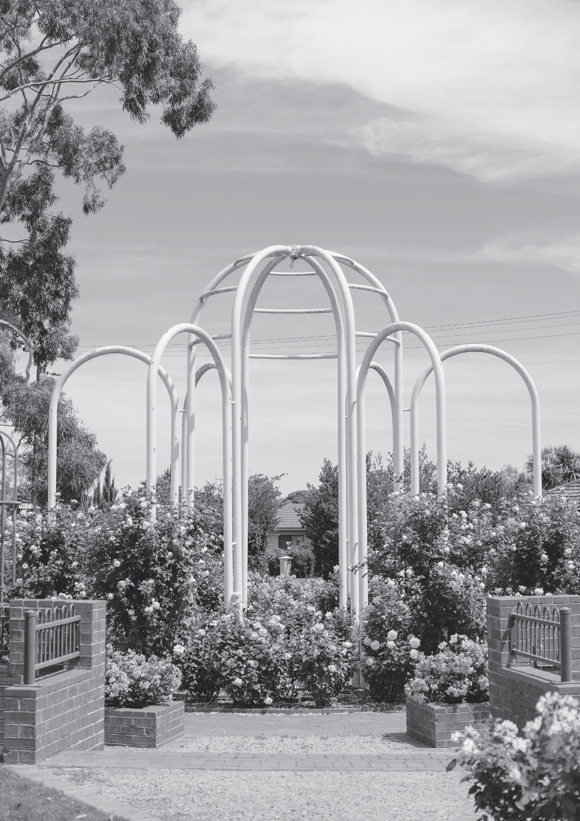



**PART TWO**

**BACKGROUND TO HEALTH**

**IMPROVEMENTS**

21

**Hazelwood Mine Fire Inquiry Report 2015/2016 Volume 3**

PART 2 BACKGROUND TO HEALTH IMPROVEMENTS

Under Term of Reference 7, the Board is tasked with considering short, medium and long-term measures to improve the health of Latrobe Valley communities, having regard to any health impacts identified by the Board as being associated with the Hazelwood mine fire. Term of Reference 12 requires the Board

to consider any matters that are reasonably incidental to the Terms of Reference of this Inquiry, including Term of Reference 7.

During the 2014 Hazelwood Mine Fire Inquiry, the Board recognised a need to understand the general health of people in the Latrobe Valley prior to the Hazelwood mine fire, in order to appreciate the health effects of the mine fire.1 In the 2014 Hazelwood Mine Fire Inquiry, the Board stated that:

There is a strong case for the health of the population of the Latrobe Valley to be substantially improved. Based on current health status information, this was justified before the Hazelwood mine fire and is even more necessary after it.2

This Part provides a general overview of the health of Latrobe Valley communities and canvasses the broad areas relevant to health improvements that will be considered in detail in this report.

**2.1 THE HEALTH OF COMMUNITIES IN THE LATROBE VALLEY**

The 2014 Hazelwood Mine Fire Inquiry found that the Latrobe Valley, and in particular Morwell, has a poorer health profile compared to other local government areas in Victoria and the average for the State.3 This means that amongst communities of the Latrobe Valley, more years of life will be lost on average than in other Victorian communities as a direct result of conditions such as cancer, diabetes, mental disorders, cardiovascular disease, asthma and injuries.4 In the 2014 Hazelwood Mine Fire Inquiry Report, the Board states:

…the population of the Latrobe Valley already has significant health challenges and does not enjoy the levels of health and social wellbeing of most other Victorians. Latrobe Valley is also socially and economically disadvantaged relative to the rest of Victoria, which further exacerbates health conditions.5

The 2014 Hazelwood Mine Fire Inquiry considered the results of investigations into the burden of disease in Victoria.6

**Figure 1. Disability adjusted life year, males, Gippsland region, 1996**7

22

Macintosh HD:Users:station10:Desktop:Lines.jpg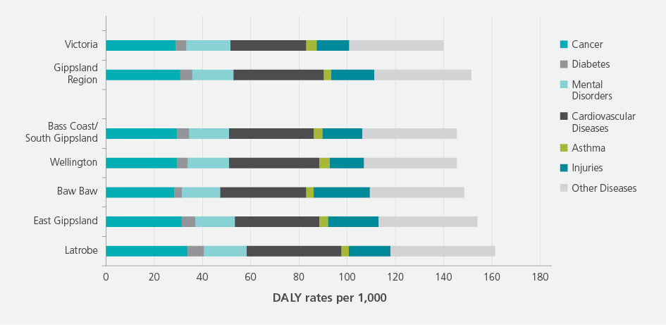



**Part Two Background to Health Improvements**

Figure 1 above shows the years of healthy life lost for males in the Gippsland region (referred to as disability adjusted life year or DALY) for six key health conditions: cancer, diabetes, mental disorders, cardiovascular diseases, asthma, injuries, and other diseases. Figure 2 below shows the years of healthy life lost for females. These figures demonstrate that men and women in the Gippsland region lose more years to disease than the average Victorian. Men and women in the Latrobe Valley also have the greatest number of years lost to disease of any area in Gippsland.

**Figure 2. Disability adjusted life year, females, Gippsland region, 1996**8

More recent data further demonstrates the stark differences in health that exist between populations of the Latrobe Valley and the rest of Victoria. In its submission to the Board during the re-opened Inquiry, VicHealth includes collated health-related information that compares health indicators in the Latrobe Valley to the Victorian average.9 This information is presented in Table 1 below.

**Table 1. Selected indicators of health – Latrobe Valley compared to the Victorian average**10

**Indicator**

Proportion of population that reports high or very high psychological distress (2011)

**Latrobe**

13.7%

**Victoria**

11.1%

Proportion of population with depression and/or anxiety (2011)

24.1%

19.9%

Family violence incident reports per 1,000 population (2013–2014)

27.7

11.3

Percentage of adults over 18 years who are overweight or obese (2011–2012)

60.6%

49.8%

Percentage of smokers (2011–2012)

19.8%

15.7%

Proportion of population at short-term risk of alcohol-related harm: risky or high risk (2011–2012)

52.6%

45.3%

Proportion of population at long term risk of alcohol-related harm: risky or high risk (2011–2012)

4.8%

3.3%

Clients of drug and alcohol services per 1,000 population (2011–2012)

12.2

5.8

* Note that the most recent estimate of daily smoking rates in Victoria is 12.6%, reflecting the continuing decrease in the smoking rates at the population level. Daily smoking rates are likely to have also decreased in the Latrobe Valley, although a significant gap in smoking rates is likely to persist.

In its submission to the re-opened Inquiry, the Victorian branch of the Heart Foundation draws attention to the high levels of heart disease in the Latrobe Valley compared to the Victorian average. This

information (presented in Table 2) is based on hospital admissions and out-of-hospital cardiac arrest   
for the period 2007–2008 to 2012–2013.11

23

Macintosh HD:Users:station10:Desktop:Lines.jpgMacintosh HD:Users:station10:Desktop:Lines.jpg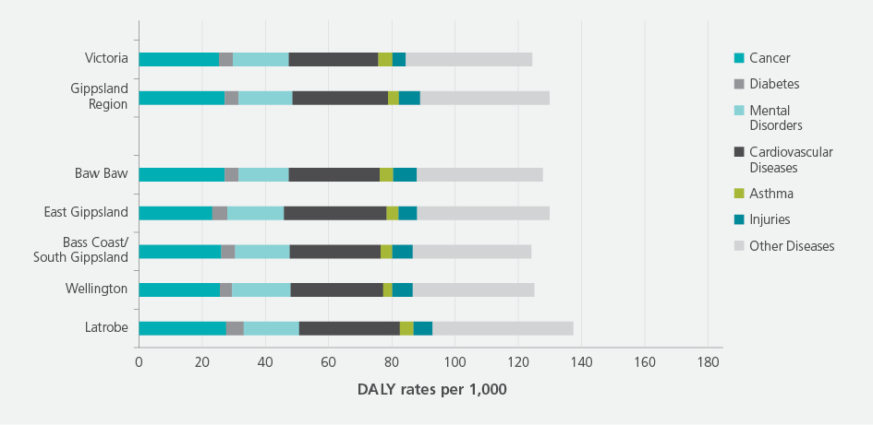



**Hazelwood Mine Fire Inquiry Report 2015/2016 Volume 3**

**Table 2. Hospital admissions and out-of-hospital cardiac arrest for the City of Latrobe (2007–2008 to 2012–2013) compared to the Victorian average**12

**Indicator**

Heart attack per 10,000 population

**Latrobe**

27.5

**Victoria**

23

Unstable angina per 10,000 population

18.0

13

Heart failure per 10,000 population

28.6

24

Cardiac arrest per 10,000 population

9.9

7

In addition, Diabetes Victoria in its submission to the re-opened Inquiry, noted that the Latrobe Valley overall has high diabetes prevalence, with 6.6 per cent of the population affected (the average national rate is 5.3 per cent). Morwell is classified as a ‘very high’ diabetes prevalence area, with 7.8 per cent of the population of Morwell directly affected by diabetes.13

Given this significant disease burden, it is not surprising that men and women in the Latrobe Valley have, on average, a lower life expectancy than their counterparts in neighbouring Gippsland shires (as demonstrated by Figure 3 and 4) and in the rest of Victoria.

**Figure 3. Life expectancy, females, Gippsland 2007**14

**Figure 4. Life expectancy, males, Gippsland 2007**15

24

Macintosh HD:Users:station10:Desktop:Lines.jpgMacintosh HD:Users:station10:Desktop:Lines.jpgMacintosh HD:Users:station10:Desktop:Lines.jpg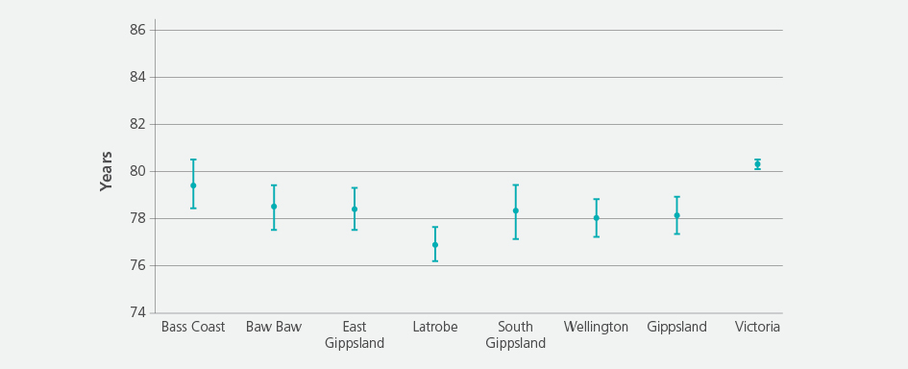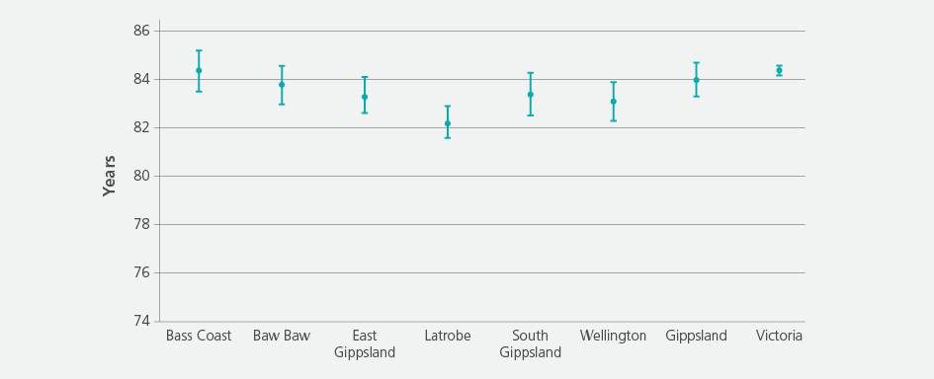



**Part Two Background to Health Improvements**

The table below shows that, on average, males in the Latrobe Valley die 3.4 years earlier than men in Victoria overall. On average, females in the Latrobe Valley die 2.2 years earlier than women in Victoria overall. These differences in health status are significant.

**Table 3. Life expectancy, Latrobe Valley compared to the Victorian average**16

**Indicator**

Life expectancy – Female Life expectancy – Male

**Latrobe**

82.2 years

76.9 years

**Victoria**

84.4 years

80.3 years

Recent research also shows that the socioeconomic disadvantage that exacerbates health problems in the Latrobe Valley is getting worse. Morwell is now amongst the most disadvantaged local government areas in Australia, with Moe and Churchill also disadvantaged relative to many other communities in Australia.17 Further information about health inequities confronting the Latrobe Valley is provided in Part 6 of this report.

**2.2 HEALTH IMPACTS ASSOCIATED WITH THE HAZELWOOD MINE FIRE** The 2014 Hazelwood Mine Fire Inquiry considered in detail the health impacts experienced by Latrobe Valley communities during, and in the immediate aftermath of, the Hazelwood mine fire. During the 2014 Inquiry, members of the Latrobe Valley community, and in particular residents of Morwell, reported suffering

distressing adverse health effects from the mine fire, including sore and stinging eyes, headaches and blood noses. The majority of these symptoms resolved when smoke and ash from the mine fire dissipated, however some residents reported continuing symptoms. In addition to these symptoms, a small number of residents reported developing new health conditions.18

Professor Donald Campbell, Professor of Medicine, School of Clinical Sciences at Monash University and Program Director, General Medicine, Monash Health, advised the Board during the 2014 Inquiry that the probable cause of these adverse health impacts was the smoke and ash produced by the mine fire.19

Professor Campbell identified specific components of smoke and ash from the mine fire and indicated the potential short and long-term effects of exposure to those components. In particular, he noted the presence of

carbon monoxide, ozone and particulate matter (PM) in the smoke and ash.20 PM2.5 is fine particulate matter

that is found in smoke and haze and has the potential to cause adverse health effects.21

Professor Campbell advised that there are a number of vulnerable groups in the community who are particularly susceptible to adverse health effects from smoke and ash, namely those with pre-existing cardiovascular and respiratory conditions, pregnant women and unborn children, children and the elderly.22 People with pre-existing health conditions, including asthma, chronic obstructive pulmonary disease, ischaemic heart disease and congestive heart failure, are at increased risk of adverse health

impacts from exposure to PM , carbon monoxide and ozone.23 Also at increased risk are smokers, who

2.5

generally have compromised lung function, and people undertaking vigorous activity.24 Research has shown that individuals with chronic obstructive pulmonary disease have an increased risk of requiring

emergency care after exposure to elevated levels of PM .25 Unborn children are particularly susceptible to

2.5

high doses of carbon monoxide, which can lead to low birth weight, premature birth and foetal death.26

During the 2014 Inquiry, Professor Campbell also advised the Board that potential adverse health effects for people with pre-existing cardiovascular and respiratory disease range from exacerbation of their condition, hospital admission, stroke, heart attack, and in severe cases, death.27 People with pre- existing cardiovascular and respiratory conditions are particularly susceptible to potential adverse long-

term health effects when exposed to ozone, PM and larger particles. In particular, they are susceptible

2.5

to an aggravation or progression of their underlying condition, an increased risk of lung cancer, and potential effects on coagulation, which could result in an increased risk of arrhythmias, morbidity, hospital admissions, psychosocial effects, and death.28

Professor Campbell further advised the Board that there is a risk that the general population could

develop health problems in the medium to long-term from exposure to PM and ozone, including but not

2.5

limited to the development of respiratory conditions, effects on cardiac conduction, increased risk

of heart attack, stroke and lung cancer, long-term cognitive decline, psychosocial effects and death.29

25

Macintosh HD:Users:station10:Desktop:Lines.jpg

**Hazelwood Mine Fire Inquiry Report 2015/2016 Volume 3**

In a submission to the Board, Doctors for the Environment Australia refer to findings of the United States Environmental Protection Agency on particulate matter and health.30 The Agency’s website states:

Numerous scientific studies have linked particle pollution exposure to a variety of problems, including:

•

•

•

•

•

•

premature death in people with heart or lung disease nonfatal heart attacks

irregular heartbeat aggravated asthma decreased lung function

increased respiratory symptoms, such as irritation of the airways, coughing or difficulty breathing.31

During the re-opened Inquiry, the Board received submissions from a number of Latrobe Valley residents and service providers that describe ongoing health issues since the Hazelwood mine fire.32

In her submission to the Board, Dr Joanna McCubbin, a paediatrician and environmental medicine teacher based in Sale, states that health is a major concern for Latrobe Valley residents following the mine fire. Dr McCubbin has heard from parents in the Latrobe Valley that they are concerned that their children are not as healthy as they were prior to the mine fire. In particular, parents are reporting an increase in asthma, stomach aches and behavioural concerns amongst their children. She states in her submission that ‘[t]heir concerns are not unreasonable, since the evidence suggests that fine particulates are implicated in inflammation, which may cause both lung irritation but also brain inflammation leading to cognitive and behavioural effects as well as mental health issues.’33

In its submission to the Board, the Victorian Council of Social Service (VCOSS) indicates that it has consulted with members of the Latrobe Valley community and community sector organisations since the mine fire, and has heard a number of concerns about the potential long-term impacts on health, the availability of healthcare and whether the health impacts of the mine fire are being adequately monitored.34 The VCOSS submission also notes that mental health organisations have advised VCOSS that ‘there were significant ongoing, emerging and new mental health issues as a result of the mine fire.’35

Voices of the Valley undertook a ‘door knock survey’ in the Latrobe Valley at the commencement of the Hazelwood mine fire, during the mine fire, and in July 2015. Results of this survey were provided to the Board, and a summary of the health concerns identified is presented in Figure 5.

**Figure 5. Summary of door knock survey undertaken by Voices of the Valley, July 2015**36

26

Macintosh HD:Users:station10:Desktop:Lines.jpg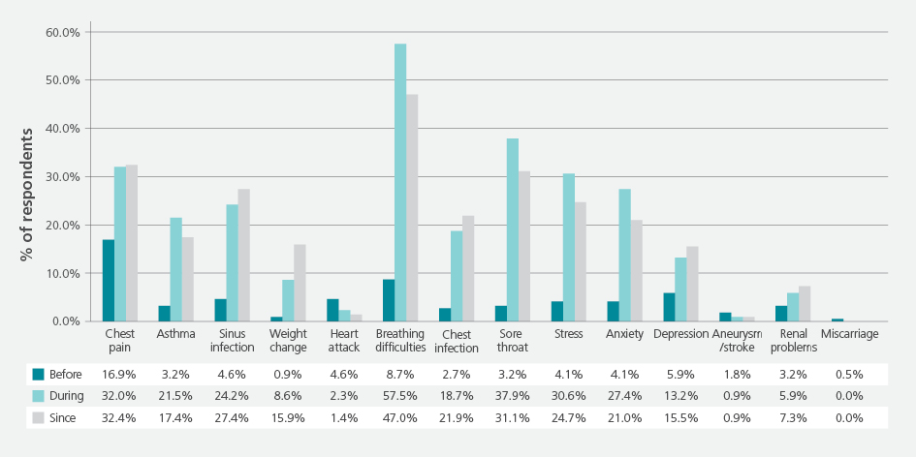

**Part Two Background to Health Improvements**

Voices of the Valley submits that whilst this information is not based on a representative sample, the responses are nonetheless ‘indicative of the concerns that people are expressing’ in the Latrobe Valley community.37

DID THE MINE FIRE CONTRIBUTE TO AN INCREASE IN DEATHS?

Pursuant to this Inquiry’s Term of Reference 6, the Board considered whether the Hazelwood mine fire contributed to an increase in deaths in the Latrobe Valley. On 2 December 2015, the Board delivered its report relevant to this term of reference to the Governor of Victoria. The Board’s key findings were:

* It is likely that there was an increase in deaths in the Latrobe Valley between February and June 2014 when compared with the same period during 2009–2013.
* It is likely that the Hazelwood mine fire contributed to some of the increase in deaths in the Latrobe Valley in 2014.38

During its inquiry relevant to Term of Reference 6, the Board heard from Professor Bruce Armstrong, medical practitioner, public health physician and epidemiologist from the School of Public Health, University of Sydney, and Associate Professor Adrian Barnett, a statistician from the Institute of Health and Biomedical Innovation and School of Public Health, Queensland University of Technology. These experts told the Board that the dominant health impacts of the mine fire were likely to be respiratory and cardiovascular disease.

Professor Armstrong informed the Board that ‘any emission from the fire is potentially inhalable and can cause illness and death.’39 In relation to particulate matter, Professor Armstrong noted that smaller

particulate matter such as PM is able to persist in the lung longer than larger particulate matter, and can

2.5

have effects on the functional level of the lung and on the heart.40 Professor Armstrong further stated that the dominant effect of air pollution on health is cardiovascular rather than respiratory.41

Associate Professor Barnett referred to reports published by the American Heart Association and World Health Organization, which describe the relationship between particulate matter pollution and death and morbidity, and demonstrate that there is very strong evidence that the short and long-term effects of air pollution include stroke, increased risk of death, and increased risk of emergency hospital admissions for cardiovascular and respiratory disease.42

27

**Hazelwood Mine Fire Inquiry Report 2015/2016 Volume 3**

**2.3 2014 INQUIRY HEALTH IMPROVEMENT RECOMMENDATIONS** Discussing the impacts of the mine fire on community health in the 2014 Hazelwood Mine Fire Inquiry, the Board noted:

these impacts have further compromised the poorer health and wellbeing of communities such that some residents feel more distrustful of government agencies and services than they previously did. Special attention and targeted action is required to change this and provide hope for current and future generations.43

The Board further stated:

[s]ystem-wide improvements are also needed, such as strengthening community capacity and resilience, tackling the social determinants of health, and providing hope and optimism for the community.44

The Board made three suggestions in relation to addressing the potential health impacts of the Hazelwood mine fire — implementing a long-term health study; creating a designated health zone; and appointing a Health Advocate for the Latrobe Valley.

HAZELWOOD MINE FIRE HEALTH STUDY

There is some uncertainty about the long-term physical and mental health impacts of a coal mine fire that burnt for 45 days, particularly on a community with an already poorer health status. Given this context,

in the 2014 Hazelwood Mine Fire Inquiry, the Board affirmed the decision of the Department of Health (as it was then known) to establish a long-term health study to consider the continued impact of the mine fire on the Latrobe Valley community. The Board also recommended that the study cover a period of at least 20 years in order to ensure that it captures the long legacy of some potential pollutants and their

health impacts on young children as they grow.45 The Board emphasised that taking action towards health improvements for the Latrobe Valley community should not be contingent on the findings of this study:

studies are all very well, but they must be linked to sustained efforts to improve health outcomes for the region… Action protocols should be developed to ensure that any findings from the study are quickly implemented to minimise the health consequences for both individuals and communities.46

The Hazelwood Mine Fire Health Study was commissioned on 30 October 2014. The study is being undertaken by a number of researchers working collaboratively, including researchers from Monash University, Federation University Australia, the University of Tasmania and the CSIRO.47 The Health Study is considered further in Part 3 of this report.

DESIGNATED HEALTH ZONE

The purpose of a designated health zone would be to significantly improve the health of the Latrobe Valley community by coordinating and integrating health services with health responses that address the broader social and economic determinants of health. In the 2014 Hazelwood Mine Fire Inquiry Report, the Board stated:

[o]ne way of providing a focal point for the coordination and integration of health services is to nominate the Latrobe Valley as a priority area for action across the health continuum…The Victorian Government could require and encourage all relevant agencies and organisations to collaborate to protect and improve the health of the people of the Latrobe Valley…The Victorian Government could provide additional funding and other resources to enable this, together with legislative and regulatory measures where necessary.48

28

**Part Two Background to Health Improvements**

The Board indicated that the development of an integrated health plan for the Latrobe Valley could focus on the prevention and management of chronic diseases and the creation of supportive environments for health. In order for this plan to work, the following should be considered:

•

•

•

•

•

•

•

•

•

health promotion/prevention (e.g. *Healthy Together* program) acute and subacute hospital care (public and private) rehabilitation, hospital in the home, aged care

Aboriginal health, women’s and men’s health, health of minorities mental health

alcohol and drug services

general practice, community health services, community agencies tertiary universities, the regional medical school

local government health services.49

HEALTH ADVOCATE

In the 2014 Hazelwood Mine Fire Inquiry Report, the Board stated:

[a] noticeable feature of the Hazelwood mine fire was a lack of health leadership at the local level. The Board found no examples of health professionals who took on the role of enabler, mediator and advocate for the health of the community. Rather this was left to local community members or officers of Melbourne-based government agencies, who inevitably were at some disadvantage.

This was a significant deficiency, as many community members expressed a lack of trust in Melbourne-based government officials, based on prior experience over several decades.50

The Board of the 2014 Inquiry proposed that a Health Advocate be appointed for the Latrobe Valley in order to provide ‘advice, mediation and advocacy on health-related matters’ for the community.51 The Board noted that the Health Advocate role would not replace or compete with the roles of the Chief Health Officer or Health Services Commissioner.52 The role of the Health Advocate would need to include:

•

•

•

•

•

•

leadership

monitoring and assessing the health of the public policy, planning and program development communication, collaboration and partnering foundational clinical competencies

professional practice.53

Further consideration is given to the concepts of a designated health zone and a Health Advocate in Part 8 of this report.

29

**Hazelwood Mine Fire Inquiry Report 2015/2016 Volume 3**

**2.4 FRAMEWORK FOR CONSIDERING HEALTH IMPROVEMENTS**

As discussed in Part 1 of this report, the Board adopted a different approach to investigating the short, medium and long-term measures that could be implemented to improve the health of the Latrobe Valley. This approach included obtaining information and opinions from community members, representatives of key peak health bodies, medical practitioners, health professionals, academics in the area of public health, and government representatives. A variety of methods were used, including calling for public submissions, holding formal and informal consultations, commissioning research, and convening

Health Improvement Forums.

As noted in Part 1, the Board has considered 13 health areas:

•

•

•

•

•

•

•

•

•

•

•

•

•

chronic disease management health behaviours

mental health

early detection and high risk screening health workforce

children and youth healthy workplaces healthy environments social disadvantage Aboriginal health

community engagement and communication Health Conservation Zone and Health Advocate

governance, leadership and sustainability.

The Board considers that the ideas and comments contributed by those who participated in one or more of the Inquiry’s processes can be grouped into five main themes:

1. Health improvements that could be achieved by **strengthening health services** in the Latrobe Valley.
2. Health improvements that could be achieved by **promoting healthy living** more broadly in everyday settings.
3. The need to **reduce health inequities**, that is, to reduce measurable differences in the Latrobe Valley’s health status that ‘…are considered to be unfair, unjust, and avoidable’.54
4. The need to strengthen community engagement and communicate the assets of the Latrobe Valley, by **building pride of place** and creating a positive health future in the Latrobe Valley.
5. Issues relating to **strengthening leadership and sustainability** in the Latrobe Valley, including consideration of a designated health zone and a health advocate.

These five themes are discussed in Parts 4 through 8 of this report.

30