

**PART SIX**

**REDUCING HEA LTH INEQUITIES**

79

**Hazelwood Mine Fire Inquiry Report 2015/2016 Volume 3**

PART 6 REDUCING HEALTH INEQUITIES

This Part considers how social disadvantage impacts on the health of Latrobe Valley communities, and the potential measures to improve health equity and therefore health outcomes in the Latrobe Valley. Given that Aboriginal people experience significant overall health inequities and a life expectancy of some 10 years less than non-Aboriginal people,1 this Part has a particular focus on the health and wellbeing of Aboriginal people in the Latrobe Valley.

This Part was informed by the community through consultations and written submissions, and by two Health Improvement Forums convened to consider social disadvantage and Aboriginal health.

The members of the expert panel on social disadvantage were Ms Sally Richmond from the Department of Health and Human Services (DHHS); Ms Kellie Horton from the Victorian Health Promotion Foundation (VicHealth); Ms Mary Sayers from the Victorian Council of Social Service (VCOSS); Mr Steve Tong from the Latrobe City Council; Professor Evelyne de Leeuw, Director of Glocal Health Consultants, Editor-in- Chief of *Health Promotion International,* and the Director, Centre for Health Equity Training, Research and Evaluation, University of New South Wales; and Ms Jayne Gallo from the EW Tipping Foundation.

An informal consultation with Latrobe Valley Aboriginal community members was held at Ramahyuck Aboriginal Health Service in Morwell on 18 August 2015. Subsequently, a Health Improvement Forum on Aboriginal health was held in Morwell. This forum was conducted less formally than other Health Improvement Forums. Rather than being led by an expert panel, community members were invited to share their views directly with the Board. In adopting a more informal approach, the Board aimed to promote open and frank discussion amongst community members.

In attendance at the Health Improvement Forum on Aboriginal health were representatives from Ramahyuck District Aboriginal Corporation; the Victorian Aboriginal Community Controlled Health Organisation (VACCHO); the Victorian Aboriginal Legal Service; and DHHS. A representative of VACCHO made an oral presentation to the Board that was subsequently provided to the Board as a written submission on behalf of VACCHO. Other members of the Latrobe Valley Aboriginal community participated in the Aboriginal health panel and the informal consultation on the basis that their contributions were anonymous. For this reason, these community members have not been named.

**6.1 SOCIAL DISADVANTAGE AND HEALTH**

The social conditions that impact on health are often referred to as the ‘social determinants of health’.2 The World Health Organization defines social determinants of health as:

The conditions in which people are born, grow, live, work and age. These circumstances are shaped by the distribution of money, power and resources at global, national and local levels. The social determinants of health are mostly responsible for health inequities—the unfair and avoidable differences in health status seen within and between countries.3

The Board heard that social disadvantage is an underlying determinant of health and health inequity, and  
is closely linked to an individual’s health outcomes.4 In their expert report to the Board, Professor Evelyne de Leeuw, Director of Glocal Health Consultants, Editor-in-Chief of *Health Promotion International,* and the Director, Centre for Health Equity Training, Research and Evaluation, University of New South Wales, and Associate Professor Marilyn Wise, Centre for Primary Health Care and Equity at the University of New South Wales, discuss the relationship between social determinants and health inequities, and the way in which health equity can be achieved by addressing social disadvantage.5

The Board was advised that health inequities exist within the Latrobe Valley and between the Latrobe Valley and other parts of Victoria, and that these inequities contribute to the poor health of the Latrobe Valley.6

80

dental services,

**Part Six Reducing Health Inequities**

UNDERSTANDING SOCIAL DISADVANTAGE IN THE LATROBE VALLEY

The 2014 Hazelwood Mine Fire Inquiry Report outlines the greater social and economic challenges confronting the Latrobe Valley relative to other areas of Victoria.7 During the re-opened Inquiry, a number of submissions commented on the socioeconomic circumstances of the Latrobe Valley and the connection of these circumstances with poorer health outcomes.8

In its submission to the Board, VicHealth states that:

the Latrobe Valley area has higher levels of socioeconomic disadvantage compared to the Victorian average. Morwell has recently been identified as one of the most socioeconomically disadvantaged postcodes in Victoria, and has been consistently reported among the most disadvantaged populations in previous research.9

The expert panel on social disadvantage told the Board that the ‘pathways to poverty and disadvantage are very complex and solutions are not simple’ and that Morwell in particular, ‘has a pattern of deep and entrenched and persistent disadvantage.’10 The panel also noted that disadvantage in the Latrobe Valley community can be inter-generational (experienced across generations).11

In its written submission, VicHealth identifies some of the key indicators of disadvantage within the Latrobe Valley region (see below Table 5).12 VicHealth notes that these indicators may have worsened since the mine fire.13

**Table 5. Key indicators of disadvantage**14

Unemployment rate (2015)

6.9%

(12.5% in Morwell)

6%

Medium weekly household income (2011)

$942

$1,216

Percentage of population who did not complete year 12 (2011)

62.4%

43.7%

Percentage of population with higher education qualification (2011)

24.8%

45.7%

Food insecurity (2011)

7.2%

4.6%

Total criminal offences per 1,000 population (2013/14)

138.5

74.9

In its submission to the Board, Victorian Council of Social Service states that:

[s]ignificant service gaps in public housing, drug and alcohol services,

accommodation for people with mental health issues, youth services, child protection, and other areas prevent [the Latrobe Valley] from addressing the causes and impacts of disadvantage.15

In their expert report to the Board, Professor de Leeuw and Associate Professor Wise state that ‘[t]he social and economic disadvantages experienced by the residents of the Latrobe Valley are strongly, positively associated with poor health and premature death.’16 Figure 7 demonstrates that the lower a person’s household income, the higher the likelihood that they will have a chronic disease.

81

**Indicator Latrobe Victoria**

Macintosh HD:Users:station10:Desktop:Lines.jpg

**Hazelwood Mine Fire Inquiry Report 2015/2016 Volume 3**

**Figure 7. Social gradient for four disease groups presented by Rebecca Vassarotti (2013)**17

CHANGING SOCIAL DISADVANTAGE

In their report, Professor de Leeuw and Associate Professor Wise state that the social determinants  
of health are amenable to change, and they point to research demonstrating the interrelation between policies that strive to:

•

•

•

•

•

•

Give every child the best start in life

Enable all children, young people and adults, to maximise their capabilities and have control over their lives Create fair employment and good work for all

Ensure a healthy standard of living for all

Create and develop healthy and sustainable places and communities Strengthen the role and impact of ill-health prevention.18

In its submission, VicHealth refers to a framework it has developed, titled *Fair Foundations: The VicHealth framework for health equity,* to guide policy and practice to promote health equity (see Figure 8). The framework promotes understanding of the social determinants of health and offers ‘entry points for action’.19 The framework recognises four levels of influence that impact on health outcomes, such as life- expectancy, and mortality and morbidity rates.20 These are:

•

Socioeconomic, political and cultural contexts: the influence of governance and policy, and the dominant societal norms and values that can influence daily living conditions.

Social position: key markers of social position include education, occupational status, income, gender, race/ethnicity, Aboriginality and disability.

Daily living conditions: these impact on an individual’s material circumstances, psychosocial control and social connections, and either protect or damage their health.

Individual health-related factors: people’s health-related knowledge, attitudes and behaviours.21

•

•

•

82

Macintosh HD:Users:station10:Desktop:Lines.jpg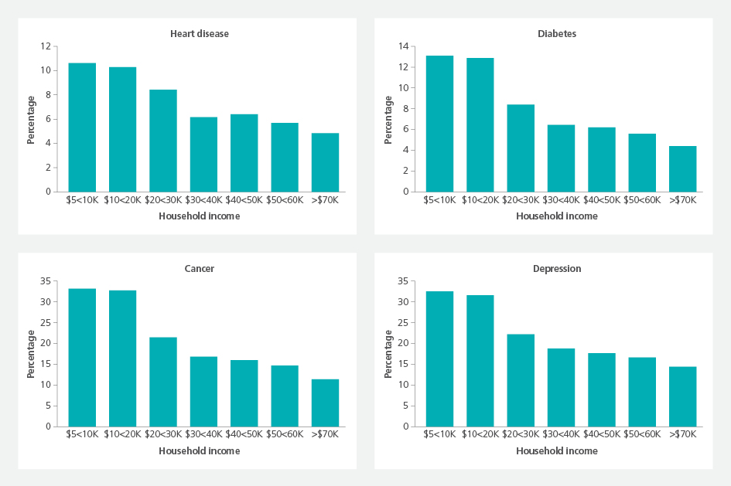

**Part Six Reducing Health Inequities**

Figure 8 below illustrates the influence of these factors on health and wellbeing outcomes.

**Figure 8. Fair Foundations: The VicHealth framework for health equity adapted from Fair Foundations** 22

**SOCIAL POSITION**

* **Education • Occupation • Income • Race/ethnicity**
  + **Gender • Aboriginality • Disability • Sexuality**

83

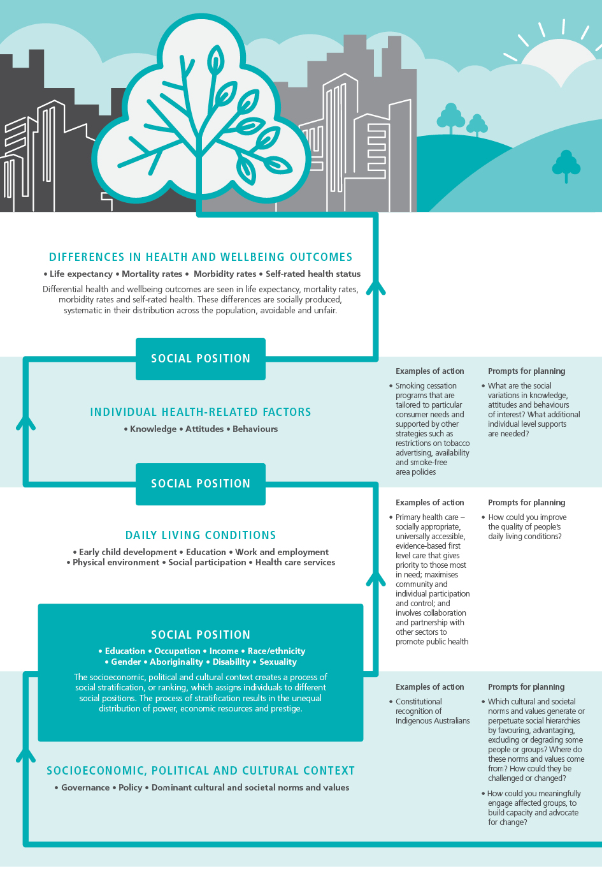Macintosh HD:Users:station10:Desktop:Lines.jpg

**Hazelwood Mine Fire Inquiry Report 2015/2016 Volume 3**

JOINT RESPONSIBILITIES AND RESOURCING

In their expert report to the Board, Professor de Leeuw and Associate Professor Wise also point to evidence indicating that, in addition to the benefits to people’s health and wellbeing, taking action to improve the social determinants of health equity can have significant financial benefits.23 At a national level, the projected cost savings include:

•

•

•

•

•

170,000 extra Australians could enter the workforce, generating $8 billion in extra earnings annual savings of $4 billion in welfare support payments

60,000 fewer admissions to hospital annually, resulting in annual savings of $2.3 billion

5.5 million fewer Medicare services annually, resulting in annual savings of $273 million

5.3 million fewer Pharmaceutical Benefits Scheme (PBS) scripts being filled annually, resulting in annual savings of $184.5 million.24

International evidence also demonstrates the significant cost of health inequities, and therefore the potential savings if health inequities are addressed. A review of 25 European countries found that health inequity accounted for up to 20 per cent of total healthcare costs.25

The expert panel on social disadvantage noted that there have been recent funding cuts in relation to emergency relief, financial counselling, child and family services, and the *Youth Connections* program, which provided intensive case management to disengaged young people to assist them to get back

to education or work.26 This program had a 93 per cent success rate.27 The Board heard that the loss of funding is felt acutely, as reduced resourcing for services puts additional pressures on disadvantaged community members who utilise these services.28

The factors that impact on health equity are often outside the immediate control of the local community, and mitigating social disadvantage is an endeavour shared by Commonwealth, state and local governments.29 Further discussion about health funding and governance structures, and the interplay between stakeholders, can be found in Part 8.

**6.2 ADDRESSING THE SOCIAL DETERMINANTS OF HEALTH EQUITY**

A consistent message that the Board heard was that measures to improve social disadvantage need consistent and long-term effort, and increased resourcing.30 The Board also heard that focusing only on the disadvantage confronting the Latrobe Valley is disempowering, and that measures to improve health must also be positive and build on the assets of the Latrobe Valley.31

EDUCATION

The Board heard that access to education was a significant issue for the Latrobe Valley community. The expert panel on social disadvantage described several factors that are currently limiting the community’s access to education, including: reductions in funding for education; changes to the vocational education and training sector; and challenges with getting transport to and from education centres.32 The expert panel on children and youth also advised that children in the Latrobe Valley often start school developmentally behind their peers, when measured according to the Australian Early Development Index.33

Ms Sally Richmond from DHHS, highlighted a number of recent State announcements about additional investment in schools, including opening a new primary school in Morwell.34 The Department of Education has also published its vision for Victoria as the ‘Education State’, with funding announced to support the education of children in out-of-home-care and to re-engage students who drop out of school and training.35

Ms Richmond told the Board that the *Roadmap for Reform: Strong Families, Safe Children* policy presents an opportunity to influence the way family and childrens services are delivered and to improve outcomes for those most disadvantaged.36 The Roadmap will set out ‘how the Victorian child and family service system can be improved to help prevent neglect and abuse, intervene early, keep more families together through crises, and secure better futures for children who cannot live at home.’ The first stage of the *Roadmap for Reform* is due to be implemented in December 2015.37

84

**Part Six Reducing Health Inequities**

The panel also reflected on the *Children and Youth Area Partnership*, which runs in Gippsland.38 The Partnership looks at new ways of working at the local level, in particular by joining up local and state- wide services to more effectively support vulnerable children, young people and their families. It adopts a collaborative model of governance and involves representatives from the State, Commonwealth and local governments, the community sector and the broader community.39 The Partnership’s initial priority was to focus on assisting children living in out-of-home care, however it now also focuses on early intervention.40

In the short-term, the panel suggested that the additional funding made available in the current State budget can assist children who need additional help at school.41 The Board also heard that future programs to strengthen the health of children in the Latrobe Valley could build on the work of the existing *Children and Youth Area Partnership*.42

EMPLOYMENT

Mr Steve Tong from Latrobe City Council and a member of the expert panel on social disadvantage told the Board that significant job losses occurred in the Latrobe Valley following privatisation of the Latrobe Valley mines. Participants at the Health Improvement Forums told the Board that before the Latrobe Valley mines were privatised, there were significant job and apprenticeship opportunities for all members of the community, including those with disabilities and vulnerabilities.43

The Board heard that lack of job security is a concern for many in the Latrobe Valley.44 The expert panel on healthy environments also advised that economic transition is anticipated in the coming decades, and that there is a need to plan for transition of industry and skills.45 Mr Tong described employment as part of the ‘building blocks of a good life’ and indicated that unless more jobs are created in the Latrobe Valley, social disadvantage will continue.46

The expert panel noted that processes for accessing training have changed over time and become less acessible.47 Mr Tong told the Board that many training courses and opportunities have become ‘extremely fragmented and difficult, almost nigh-on impossible for people from disadvantaged backgrounds to access.’48

Members of the expert panel on healthy workplaces suggested that consideration should be given to how new industries and employment opportunities can be generated in the Latrobe Valley using existing assets. The panel suggested that initial additional resourcing is needed to promote new industry and employment in the short-term, alongside longer-term planning for the Latrobe Valley’s future.49

Ms Mary Sayers from the Victorian Council of Social Service (VCOSS) suggested that supporting social enterprise could provide pathways to the attainment of new skills for Latrobe Valley residents, in turn leading to greater employment opportunities.50

ACCESS TO HEALTH SERVICES

The expert panel on social disadvantage advised that vulnerable people in the community can have difficulty accessing health services, and that current methods for engagement with vulnerable communities may be ineffective.51 One example provided was the Hazelwood Mine Fire Health Study, with the panel raising concerns that it may not be reaching those most vulnerable in the community.52 The Health Study is discussed in Part 3 of this report.

In the medium to long-term, the expert panel on social disadvantage considered the need for a ‘universal service guarantee’ – ‘everyone in the Latrobe Valley gets a minimum level of service’ – that is monitored to ensure it is being achieved.53 It was noted that access to a minimum standard of service would assist to achieve ‘proportionate universalism’, whereby additional services are available to those with greater need.54 In their report, Professor de Leeuw and Associate Professor Wise describe the concept of ‘proportionate universalism’ by reference to the work of Professor Sir Michael Marmot who states ‘we need not only to deal with poverty but to examine the whole distribution. Hence the need for universalist policies with effort proportionate to need, what we have called proportionate universalism.’55 They further cite ‘inverse care law’, namely that those that need healthcare the most, get it the least, as an issue that applies to high risk social groups.56

85

**Hazelwood Mine Fire Inquiry Report 2015/2016 Volume 3**

Ms Sayers advised the Board that ‘there is very solid evidence around that …if you scale up off a universal service system you are more likely to get the support for the most vulnerable.’57 She

emphasised that vulnerable members of the community should not have to worry about ‘all the business that happens behind all the silos that we face… All they should see is good service.’58

The Board heard that, aligned with the issue of equal access to healthcare is the capacity of vulnerable members of the community to take measures to protect their health from the consequences of the mine fire. An example of this is removing ash residue from the mine fire that remains in the roof cavities of many houses, with the panel noting that community members living in social housing or rental properties are most likely to require assistance.59 This issue is considered in Part 5 of this report.

COMMUNITY ENGAGEMENT

In their expert report to the Board, Professor de Leeuw and Associate Professor Wise emphasise the importance of basing any future health strategy for the Latrobe Valley on the principles of procedural, substantive and distributive justice.60 Professor de Leeuw and Associate Professor Wise define these principles as follows:

•

Procedural justice means ensuring that decision-making bodies are more representative of the community (in terms of culture, gender, socioeconomic demographics) and ensuring that a broad cross section of the community has an opportunity to influence the agenda.

Substantive justice means ‘putting items on the agenda, influencing discussion and debate on all agenda items, and influencing the outcome of decisions.’

Distributive justice means ensuring that social resources are accessible to everyone. This could include ensuring the distribution of health services, prevention programs, and education, employment and transport. 61

•

•

Professor de Leeuw and Associate Professor Wise also state that ‘in the absence of the people who are most affected by the decisions being made…implementation of new initiatives [is] unlikely to address the causes of inequities and unlikely to succeed.’62

The expert panel on social disadvantage reaffirmed the need to strongly engage with the community, and supported the principle that community members who are affected by decisions should be involved in the decision-making process.63 Professor de Leeuw told the Board that ‘there is a place for communication, there is a place for sharing information, but only in the right mix between communication, facilities, regulation and consultation.’64

The panel cautioned about labelling a community as ‘disadvantaged’, and that future work needs to ‘build on the assets of this community and really try to be part of re-establishing community pride.’65 There was much discussion about the success of placed-based initiatives such as *Go Goldfields*. This initiative was cited as an example of how things could be turned around for a community with similar disadvantage.66 The *Go Goldfields* initiative and other community engagement practices are considered further in Part 7  
of this report. Place-based approaches are considered further below.

COMMUNITY SERVICES SECTOR

During the expert panel on social disadvantage, three key themes were discussed regarding the role of the community services sector in reducing health inequities:

•

Bringing agencies together to work on the underlying causes of ill health, in a manner similar to the expert panels constituted for this Inquiry.

Engaging with the community and allowing community members who are affected by decisions to be involved in actually making those decisions.

Building on the assets of the community rather than emphasising or labelling the community as disadvantaged.67

•

•

86

**Part Six Reducing Health Inequities**

There was agreement amongst the panel that, to see a reduction in social disadvantage, agencies need to work together with the community.68 The panel explained to the Board that the Hazelwood mine fire, and subsequent forums about the mine fire, brought agencies together, which led to discussions about the underlying causes of common social and health issues. The panel suggested that this level

of communication should occur more often.69

The expert panel explained to the Board that community sector organisations have direct relationships with the most disadvantaged members of a community through the direct services they provide. Those organisations can therefore play a significant role in informing the community about support services and health initiatives, particularly in an emergency, provided they have adequate resources to undertake this role.70 The panel further noted that there is an opportunity to make improvements to community engagement by building on existing networks.71 Ms Sayers commented that: ‘vulnerable people aren’t hard to reach; the system finds it hard to access them.’72

In its submission to the Board, VicHealth recommends an approach to community engagement that builds on and incorporates existing community services and service providers.73 This recommendation is endorsed

by VCOSS in its submission to the Board. VCOSS further states that decision-makers must ‘[a]cknowledge and support the unique role that community sector organisations play in the region through filling service gaps.’74

PLACE-BASED APPROACHES

In their expert report, Professor de Leeuw and Associate Professor Wise discuss place-based approaches, where the focus of action is on a particular geographic location that experiences disadvantage. They note that place-based approaches have previously been used to address health inequity.75 In particular, the report discusses international evidence on *Healthy Cities*. The *Healthy Cities* approach was developed by the World Health Organization in 1986 and continues to be utilised today. The approach discusses a number of qualities that a local government should strive to achieve, in order to improve the health of its population.76

In their report, Professor de Leeuw and Associate Professor Wise discuss the success of *Healthy Cities* throughout Europe and note that this approach to designing, expanding and resourcing cities has ‘resonated’ with other place-based initiatives in the world, including in the Americas.77 The *Healthy Cities* approach has also been implemented in Onkapringa, South Australia and Illawarra, New South Wales.78

A *Healthy City* strives to attain a number of attributes, including the following:

•

•

•

A clean, safe, high quality physical environment (including housing quality).

Meeting basic needs (such as food, water, shelter, income, safety, work) for everyone.

Encouraging connectedness with the past, with the cultural and biological heritage of the city and with other groups and individuals.

An ecosystem that is stable and sustainable now and in the long-term.

Access for the population to a wide variety of experiences and resources, with the opportunity to have a range of contacts, interactions and communications.

An optimum level of appropriate and universally accessible public health and care services.

A high degree of public involvement in and control over the decisions affecting health and wellbeing. High health status (meaning both low disease status and high positive health status).79

•

•

•

•

•

The expert panel endorsed the idea of new approaches to health initiatives:

If we are going to transform this community—if we are going to do the same things and think we are going to get a different outcome then we are totally going to get the same outcome. So we actually need to think about doing things quite differently.80

The panel emphasised the importance of monitoring new approaches, in particular monitoring the impacts of new approaches on the most vulnerable members of the community.81

87

**Hazelwood Mine Fire Inquiry Report 2015/2016 Volume 3**

**6.3 ABORIGINAL HEALTH**

A number of public submissions specifically addressed health issues relating to Aboriginal communities.82 A community consultation regarding Aboriginal health was held on 18 August 2015, and the Health Improvement Forum on Aboriginal health was held on 13 October 2015.83

VCOSS notes in its submission to the Board that ‘[a]ccording to the 2011 Census, there are approximately 500 Aboriginal people living in Morwell, making up about 2.2 per cent of the local population.’84 VCOSS submits that ‘[t]he Aboriginal population in the Morwell region experiences significantly poorer health, education and employment outcomes than the non-Aboriginal population.’ VCOSS further submits that the Latrobe Valley Aboriginal community is less likely to access mainstream community and health services, and is at particular risk of detrimental impacts on health in times of emergency.85

Four broad themes directly relevant to Aboriginal health were apparent in written submissions, at the community consultation and at the Health Improvement Forum on Aboriginal health. These were:

•

•

•

•

access to health services

the need for community control of health services underlying determinants of health

the future is in young people.

ACCESS TO HEALTH SERVICES

During both the community consultation and at the Health Improvement Forum on Aboriginal health, Latrobe Valley Aboriginal community members recounted for the Board the health issues they experienced during the Hazelwood mine fire.86 They indicated to the Board that they were not aware of the potential dangers from inhalation of smoke and ash from the mine fire, and that health warnings came too late.  
A number of community members reported that they are still experiencing adverse health effects as a consequence of the mine fire.

Community members expressed concern that many members of the Latrobe Valley Aboriginal community do not understand the potential short and long-term health consequences of the mine fire. Health information provided to the broader community does not always reach, nor is it always understood,

by Aboriginal members of the community, because of literacy issues and the relatively low use by the community of mainstream health services.

Latrobe Valley Aboriginal community members told the Board that during and after the Hazelwood mine fire they noticed a significant increase in alcohol and other drug use, particularly methamphetamine use (ICE), as well as an increase in episodes of family violence amongst members of their community.

In its written submission to the Board, VCOSS noted similar reports from members of the Latrobe Valley Aboriginal community.87

The Board heard that ‘being stuck indoors’ for several weeks during the mine fire was like ‘being in prison’ which exacerbated alcohol and drug use. The Board heard that an increase in alcohol and drug use,

and episodes of family violence during the mine fire, also put additional pressure on support services. Participants told the Board that there is a lack of dedicated rehabilitation support for Aboriginal parents affected by drugs in the Latrobe Valley, which in turn adversely impacts their children.

It was suggested that the Latrobe Community Health Service’s mine fire clinic could provide an outreach service to the Aboriginal medical service operated by the health organisation Ramahyuck in Morwell,

in order to explain potential health consequences to Latrobe Valley Aboriginal community members in a culturally safe place.

It was also suggested that a register of health checks for Aboriginal people most exposed to the mine fire, including children, might be warranted. The Aboriginal medical service in Morwell currently has a good system for following up community members with chronic medical conditions. It was suggested that this system could be expanded to address health issues relating to the mine fire, although it was noted that further resources are required to support Aboriginal Health Workers or nurses to act as case managers for those with complex needs.

88

**Part Six Reducing Health Inequities**

The issue of resourcing health services for the Latrobe Valley Aboriginal community was raised at the forum. Participants told the Board that more Aboriginal health services and Aboriginal Health Workers are required as services are already stretched. Insufficient transport options was also identified as

an obstacle to accessing health services for Aboriginal people, especially those with chronic health conditions.

It was noted that the low retention rates of doctors in the Aboriginal medical service has impacts for continuity of patient care. Local medical staff training and retention is further addressed in Part 4 of this report.

COMMUNITY CONTROLLED HEALTH SERVICES

Mr Jimi Peters, manager of the Public Health Research Unit at the Victorian Aboriginal Community Controlled Health Organisation (VACCHO), attended the Health Improvement Forum on Aboriginal health and submitted a written statement to the Board on behalf of VACCHO (which he also read aloud at the Health Improvement Forum on Aboriginal health).

Mr Peters highlighted the significance of community controlled health organisations to self-determination for Aboriginal people. The Board heard that the benefits of community controlled health organisations are:

•

service provision—Latrobe Valley Aboriginal community controlled organisations make a strong contribution to improving health outcomes by making accessible, appropriate and cost-effective primary healthcare available to Aboriginal people

functioning as a gathering place

promoting Aboriginal culture and self-determination

giving voice to communities on issues beyond the scope of their service provision role providing employment for Aboriginal people.88

•

•

•

•

In its written submission to the Board, VACCHO states that:

Available evidence indicates that [Aboriginal Community Controlled Health Organisations] have been key contributors to closing the health gap for Aboriginal Peoples and that there is strong evidence of the link between access to appropriate primary health care and improved health outcomes for Aboriginal and Torres Strait Islander people.89

In written submissions, a number of organisations note that local Aboriginal community controlled organisations can provide an avenue for health services to engage with the Latrobe Valley Aboriginal community to improve health outcomes.90 VicHealth also notes that there are also a number of ‘health brokers’ working in Aboriginal and Torres Strait Islander communities across Australia, who provide support to individuals and families to access appropriate health services.91

The Board heard that, although there are health services provided to the Latrobe Valley Aboriginal community in Morwell, those services are not controlled by the local Latrobe Valley Aboriginal community. The Board was advised that a community controlled health service called the Central Gippsland Aboriginal Health and Housing Co-operative Ltd (in liquidation) previously existed in Morwell. Following the demise of the Co-operative, Ramahyuck, the community controlled health service for the Aboriginal community of Sale, expanded to provide health services for the Latrobe Valley Aboriginal community.92

The Board notes that, because the health service in Morwell is not controlled by the local Aboriginal  
community, the service does not meet the conditions of community-control as outlined by VACCHO:

Aboriginal Community Controlled Health Organisations (ACCHOs) are the embodiment of self- determination. Each ACCHO has been initiated by a local Aboriginal community and [is] based in that local Aboriginal community. ACCHO boards of management are drawn directly from the communities they serve, and are democratically elected.93

89

**Hazelwood Mine Fire Inquiry Report 2015/2016 Volume 3**

A community member explained that the facilities currently used by Ramahyuck to provide health services to the Latrobe Valley Aboriginal community are inadequate. The Aboriginal medical service is housed

in a building that is 25 years old with no disability access for the upstairs community room, and limited outdoor space as the surrounding land has been sold off. This community member told the Board that the state of the building means that it is not an appropriate gathering place for the community, and also has consequences for access to the medical service. It was noted that the building compares poorly with other health, Council and government facilities in the Latrobe Valley, many of which have undergone significant renovation in recent years. The absence of a community controlled health organisation affects health service delivery for a number of reasons, including that:

•

•

Many in the community do not access the service because it is not locally controlled.

Insecurity of the tenure on the building used to house the current Aboriginal medical services means that decisions about expansion or alternate premises are difficult.

People with physical disabilities cannot use the limited facilities that are available because of access difficulties.

•

The lack of a community gathering space was also identified as an obstacle to improving health for Aboriginal members of the community.

THE FUTURE IS IN YOUNG PEOPLE

The Board was advised that the Aboriginal community in the Latrobe Valley has a greater proportion of young people compared with the rest of the local population.94 Many Aboriginal community members told the Board that there has been an increase in the number of disaffected Aboriginal young people in the Latrobe Valley. They highlighted the high incidence of young people involved with the justice system;  
high rates of homelessness and unemployment; barriers for Aboriginal children participating in positive activities like sport, such as the costs associated with registration and uniforms, and transport issues;  
and threats of violence and vandalism by young people in schools.

Community members had a number of suggestions for the Board about how to improve this situation. These suggestions included:

* Having a community-gathering place as a site for alternative activities for young people. It was noted that when events or sports carnivals have been held, young people have attended in large numbers, however further resources are required to do this more regularly.
* Art projects. Community members described a successful art project on the walking track alongside Waterhole Creek. This project required only a small amount of funding and it allowed young people to develop their artistic skills and learn about the cultural heritage of the area. It was noted that this area has not been sprayed with graffiti. Community members told the Board that more opportunities to undertake such projects and engage young people in their cultural heritage would be helpful.

The Board heard that sport has been used as a motivator for health improvement amongst Aboriginal young people in other Victorian communities. In particular, the Board is aware of the work of the Rumbalara football and netball club, based in Shepparton, which provides local Aboriginal young people with an avenue to engage in community sports in a positive environment.95 Similarly the Clontarf Academies, which aim to promote school-engagement by linking education to sport, could provide another model of improving health outcomes for Aboriginal people through sport.96 The Board heard that both of these initiatives have enjoyed considerable success.

Following the Health Improvement Forum on Aboriginal health, the Board visited Waterhole Creek walking track and the adjacent art project. The Board noticed that the art work was in excellent condition, indicating the high level of positive support for the project shown by both Aboriginal and non-Aboriginal community members.

90

**Part Six Reducing Health Inequities**

**6.4 BOARD’S CONSIDERATION AND PROPOSALS**

The Board considers that actions to reduce health inequities in the Latrobe Valley are relevant to, and need to be reflected in, all of the areas considered in this report.

The Board recognises that many organisations, individuals and experts have advised that improvements to health in the Latrobe Valley will require action to change the social determinants of health.

The Board accepts that there is a link between social disadvantage and health, and that social disadvantage contributes to the poorer health outcomes observed in the Latrobe Valley. The Board accepts that the social disadvantage experienced in the Latrobe Valley is worsening, rather than improving.

CHANGING SOCIAL DISADVANTAGE

The Board acknowledges that understanding social disadvantage and health inequities is complex, as is finding practical solutions. However, the Board also accepts that it is possible to change social conditions and reduce health inequities. The expert panel on social disadvantage noted that education and employment, in particular, can be pathways out of disadvantage. The Board accepts that in order to bring about an improvement to the health status of the Latrobe Valley community, and in particular, Morwell, action is needed to address the social determinants of health inequities.

The Board notes evidence that children in the Latrobe Valley often start school developmentally behind their peers, when measured according to the Australian Early Development Index. The Board considers that education is critical for bringing change to social disadvantage. The Board affirms the commitment by the Gippsland *Children and Youth Area Partnership* to include an early intervention focus to not only protect vulnerable children but also to support access to education of children in out-of-home-care.

The Board accepts that employment is another key issue that must be considered in the Latrobe Valley. The State and local industry should consider both short and long-term planning for creating jobs and  
new industries.

The Board has concerns regarding the impact of funding cuts on education and training opportunities

in the Latrobe Valley. The Board heard evidence from the expert panel on social disadvantage that these funding cuts have had a significant impact on the community, and particularly on young people as a result of the closure of the *Youth Connection* program. The Board proposes that further consideration be given to the resources allocated to education programs in the Latrobe Valley, recognising that supporting education initiatives is a crucial means of reducing social inequality and consequently, improving health outcomes.

The Board acknowledges that given the nature and complexity of health inequities, such changes will require sustained commitment, funding and action over the long-term before results will be evident.

The Board considers that the success of short, medium and long-term healthcare initiatives will be dependent upon State, Commonwealth and local agencies developing a coordinated approach to funding and sustaining support for those initiatives. The Board considers that there will be potential cost savings to both levels of government by improving social disadvantage in the Latrobe Valley.

Further discussion about health funding is discussed in Part 8.

COMMUNITY ENGAGEMENT AND COMMUNITY SECTOR INVOLVEMENT

Whilst acknowledging that the way resources are distributed can influence equity, the Board also notes that achieving equity depends on more than money – ‘[it] also reflects culture, history and heritage, and context.’97 Community, local government and local community organisations can and should play a part

in reducing health inequities by influencing daily living conditions and individual health-related behaviours.

The Board notes the evidence of the expert panel on social disadvantage regarding the importance of strengthening the role of existing community sector organisations. The Board agrees that building on the strengths of existing organisations should be further considered. There is merit in the suggestion that agencies should collaborate to strengthen the existing networks and relationships between community sector agencies and the more vulnerable.

91



**Hazelwood Mine Fire Inquiry Report 2015/2016 Volume 3**

The Board considers that the VicHealth *Fair Foundations Framework* is an excellent tool and commends VicHealth on its development. The Board considers that it should be used by other community agencies to inform action and future work concerning social disadvantage. The Board considers that this framework should influence all decisions relating to health improvements in the Latrobe Valley so that more equitable outcomes are achieved.

The Board recognises the significance of ensuring that the community, and more particularly those more vulnerable to social disadvantage, are involved in determining change.

The Board was encouraged by the discussion in submissions and during the Health Improvement Forums that there were opportunities to learn from existing place-based approaches that have been used to reduce health inequity across the world and in Australia. The Board considers that approaches such

as *Healthy Cities* and *Go Goldfields* offer an opportunity for similar models to be implemented in the Latrobe Valley. The Board considers there is real merit in such an approach in terms of working towards better health and reducing inequity. Given the sustained history of the *Healthy Cities* approach and the promising results obtained across the world, the Board suggests that the model provides a source of examples for the Latrobe Valley, and that Latrobe City Council consider adopting a similar approach in the longer-term.

The Board is of the view that all health improvement strategies should:

•

•

•

•

•

be informed by a strong community engagement process focus on reducing health inequities

draw on the capacity, goodwill and opportunities present integrate actions across relevant providers

be evaluated for their wider applicability across Victoria.

**The Board recommends that funding for new and existing health improvement programs is allocated to reduce health inequities through strengthening health services, promoting healthy living and building pride of place.**

CLOSING THE GAP IN ABORIGINAL HEALTH

There is no doubt that the health of Aboriginal people in all communities warrants particular attention.  
Both the state and Commonwealth Governments have already acknowledged this through their commitment to the *National Indigenous Reform Agreement*.98 The Board acknowledges that Aboriginal ‘[s] elf determination and cultural expression are human rights’ and that lack of control over life circumstances is a contributor to the health gap between Aboriginal and non-Aboriginal Australians.99

The Board notes the significantly poorer health of Aboriginal people in the Latrobe Valley compared with non-Aboriginal people, as highlighted in the submissions received. Given the level of disadvantage experienced by the Latrobe Valley community as a whole, this suggests that Aboriginal people in the Latrobe Valley are amongst the most disadvantaged people anywhere in Victoria.

The Board considers that a significant change could be made to Aboriginal health in the Latrobe Valley with the provision of a community controlled Aboriginal health service in Morwell. The Board notes the concerns raised by Latrobe Valley Aboriginal community members regarding the unresolved matter of the liquidation of the previous community controlled health service (Central Gippsland Aboriginal Health and Housing Co-operative Ltd (in liquidation)). The Board is concerned that the liquidation of the Co-operative has led to inadequate facilities for provision of healthcare services to local Aboriginal people, and has created uncertainty around the long-term availability of a dedicated premises to provide healthcare services to local Aboriginal people living in Morwell and surrounds.

92



**Part Six Reducing Health Inequities**

ABORIGINAL YOUNG PEOPLE

The Board notes the differing age profile of the Aboriginal community in the Latrobe Valley, which has a greater proportion of young people compared with the rest of the local population.

The Board heard promising stories of how young community members have successfully engaged with local health services and with the broader community. Particularly, the Board commends the Latrobe Valley Aboriginal community, in particular the leadership and enterprise shown in the Waterhole Creek art project.

However, the Board notes that there are many barriers that prevent young people in the Latrobe Valley Aboriginal community achieving good health. The cost of participating in sport and arranging transport are obstacles to Aboriginal young people’s participation in physical activity and education. The Board suggests that further consideration be given to other options to enable Aboriginal young people to access sport and education as a pathway out of disadvantage and towards better health outcomes.

The Board also notes the link between the absence of an Aboriginal community controlled health service in Morwell and poor health outcomes for Aboriginal young people. The Board considers that the availability of a community controlled Aboriginal health service would increase the uptake of health

services accessed by young Aboriginal people. The Board considers that, when establishing a community controlled Aboriginal health service, the State should support the building of a culturally appropriate health and community facility with outdoor space that is suitable to engage young people.

**The Board recommends that the State assist in establishing an independent community controlled health organisation for the Latrobe Valley Aboriginal community and co-fund a culturally appropriate health and community facility which will help with the engagement of Aboriginal young people.**

93

**Hazelwood Mine Fire Inquiry Report 2015/2016 Volume 3**

94

